**PROGRAM-4**

**Aim:** Write an algorithm and program to sort n numbers using insertion sort technique.

Algorithm :

Start

for i = 1 to n

key ← A [i]

j ← i – 1

while j > = 0 and A[j] > key

A[j+1] ← A[j]

j ← j – 1

End while

A[j+1] ← key

End for

Stop

**Source code:**

1. **USING ARRAY**

#include <stdio.h>

#include<conio.h>

void main()

{

int n, i, j, temp;

int arr[64];

clrscr();

printf("Enter number of elements\n");

scanf("%d", &n);

printf("Enter %d integers\n", n);

for (i = 0; i < n; i++)

{

scanf("%d", &arr[i]);

}

for (i = 1 ; i <= n - 1; i++)

{

j = i;

while ( j > 0 && arr[j-1] > arr[j])

{

temp = arr[j];

arr[j] = arr[j-1];

arr[j-1] = temp;

j--;

}

}

printf("Sorted list in ascending order:\n");

for (i = 0; i <= n - 1; i++)

{

printf("%d\t", arr[i]);

}

getch();

}

**OUTPUT:**

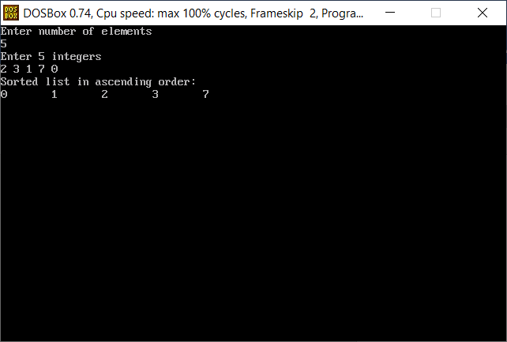

1. **USING RECURSION**

**Source code:**

#include<conio.h>

#include<stdio.h>

void insertion_sort(int a[],int i,int n){

int j,k,t;

if(i==n){

return;

}

t=a[i];

j=i-1;

while(j>=0&&a[j]>t){

a[j+1]=a[j];

j--;

}

a[j+1]=t;

for(k=0;k<n;k++){

printf("%d\t",a[k]);

}

printf("\n");

insertion_sort(a,i+1,n);

}

void main(){

clrscr();

int a[25],n,k;

printf("Enter the number of elements: ");

scanf("%d",&n);

printf("Enter the elements of the array:\n");

for(k=0;k<n;k++){

scanf("%d",&a[k]);

}

printf("\n");

insertion_sort(a,1,n);

getch();

}

**OUTPUT:**

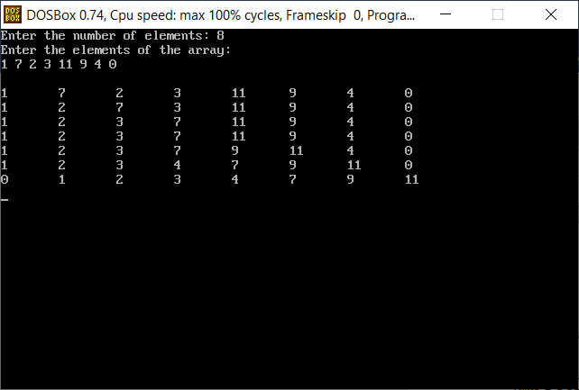

**Complexity:**

Best case: O(n)

Worst case: O(nˆ2)

Average case: O(nˆ2)