

School of Future Tech

Case Study Report

COFFEE BREW TIMER

Your Case Study Title

by

NANDINI SOLANKI

150096725189

Index
- Introduction to the Case Study.
- Problem Statement / Case Background (Abstract).
- Problem Statement / Case Study Design.
- Methods & Algorithms Technology Applied in the Problem Statement / Case Study.
- Problem Statement / Case Study Implementation Details and Snapshots.
- Problem Statement / Case Study Results and Conclusion.
- References

1. Introduction to the Case Study
The Coffee Brew Timer is a specialized production tool for baristas. It serves as a real-time dashboard to ensure consistent coffee quality by automating the timing of different extraction methods. Built with ReactJS, the application provides a synchronized interface where brewing parameters, live countdowns, and customer status are managed within a single stateful environment.

2. Problem Statement / Case Background
In a professional coffee environment, manual timing is often inconsistent.
- Precision Requirements: Different methods like Espresso (30s) and French Press (240s) require vastly different attention spans.
- Workflow Bottlenecks: Managing multiple customers simultaneously leads to "forgotten" brews, resulting in over-extraction.
- The Goal: To create a digital solution that provides visual progress tracking and automated notifications when a specific customer's order is "Ready".

3. Problem Statement / Case Study Design
The application architecture is designed around three core data structures:
- brewPresets: A constant array defining the name, duration, grind size, and brewing notes for each method.
- customers: A list of active orders associated with specific brew types.
- App State: A centralized state management system tracking secondsLeft, isRunning, and customerStatuses.
The UI is built using a Card-based Layout (via App.css) that adapts to mobile devices using CSS Media Queries, ensuring the timer is usable on both tablets and smartphones.

4. Methods & Algorithms Technology Applied
The project implements several advanced React patterns to ensure timing accuracy:
- setInterval with Cleanup: The core timer logic resides in a useEffect hook. It utilizes setInterval to decrement the time every 1000ms and crucially returns a clearInterval function to prevent memory leaks.
- Memoized Progress Calculation: The useMemo hook is used to calculate the visual progress percentage ($((Total - Left) / Total) * 100$). This ensures the progress bar re-renders only when the time changes.
- Functional State Updates: To avoid stale closures in the timer, setSecondsLeft uses the functional update pattern (currentSeconds => currentSeconds - 1).
- ARIA Accessibility: The application uses aria-live="polite" for the time display and role="status" for notifications, ensuring visually impaired baristas can use screen readers to track brew status.

5. Implementation Details and Snapshots
The logic is encapsulated in App.jsx, featuring several key functions:
- startBrew(brew): Resets the timer and begins a countdown for a selected preset.
- brewCustomerOrder(customer): Links a specific customer to a brew method, changing their status to "Preparing".
- formatTime(totalSeconds): A utility function that converts raw integers into a human-readable $MM:SS$ format using padStart.
Visual Styling (App.css):
The interface uses a "Coffee-inspired" palette:
- Backgrounds: Soft creams (#fffaf4) and deep espressos (#2a1a12).
- Progress Bar: A high-contrast orange (#b86b38) against a light track (#ead8c4) for instant visual feedback.
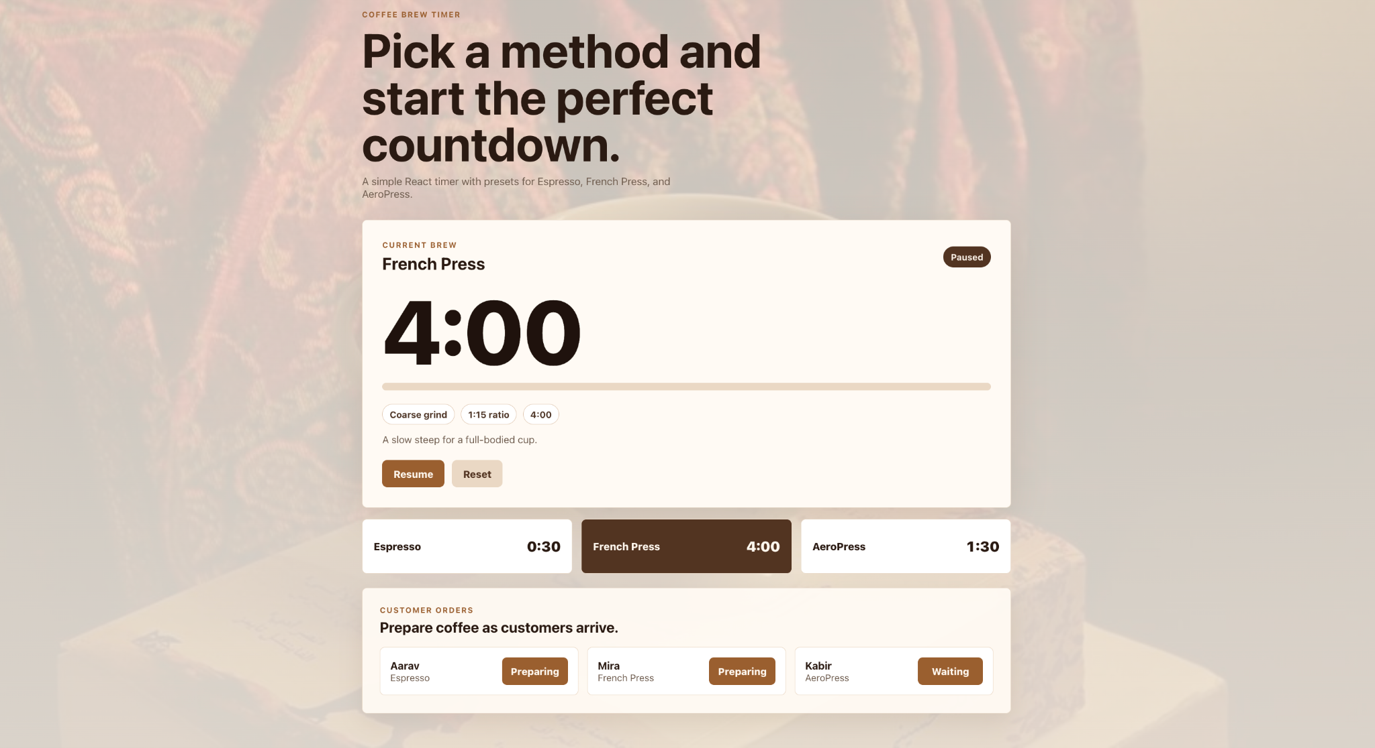

6. Results and Conclusion
The implementation of the Coffee Brew Timer results in a robust, user-friendly tool for specialty coffee preparation.
- Real-time Interaction: The application successfully handles state transitions between "Brewing," "Paused," and "Ready to pour".
- Order Management: By integrating a customer list, the app moves beyond a simple stopwatch into a functional Point of Sale (POS) companion.
- Conclusion: This project demonstrates how React’s declarative nature and hook-based architecture can solve complex timing and synchronization problems in a retail environment.

- 7. References
The following references were consulted during the design, development, and documentation of the Coffee Brew Timer application:
- Designing templates - www.pinterest.com
- Color theme - www.coolors.com

