**Car Rental Management System**

**Admin :** Admin can add a car, manage booking car and rent and also view feedback and enquiry.

**User :** User can view information of available car, booking car, easily get the car on rent and also give feedback and can enquiry.

**Functional Requirements :**

**View Available cars :** System design specifically for cars. The user can view available cars and user can book a car.

**Search a car :** User can search for a car.

**Search a location :** Customer can search a location to view available cars in that specific location.

**Reserve Car :** The customer can view available cars and reserve that car.

**Cancel Car :** Customer can cancel the car before an hour of pickup.

**Late Fee :** If customer can’t return the car within the time period, system will calculate the late penalty.

**Feedback :** The customer will give the feedback.

**Add car :** The Admin can add the car so that The user can see the available cars and book the car.

**Manage Rent :** The Admin can manage the rent so that the user can see the rent and book the car.

**Non-Functional Requirements :**

1. Our system is scalable.

2. It is more reliable and available all the time.

Client Needs :

1. RAM

2. Harddisk

Admin Needs :

1. RAM

2. Harddisk

**Car Rental System Flow Chart :**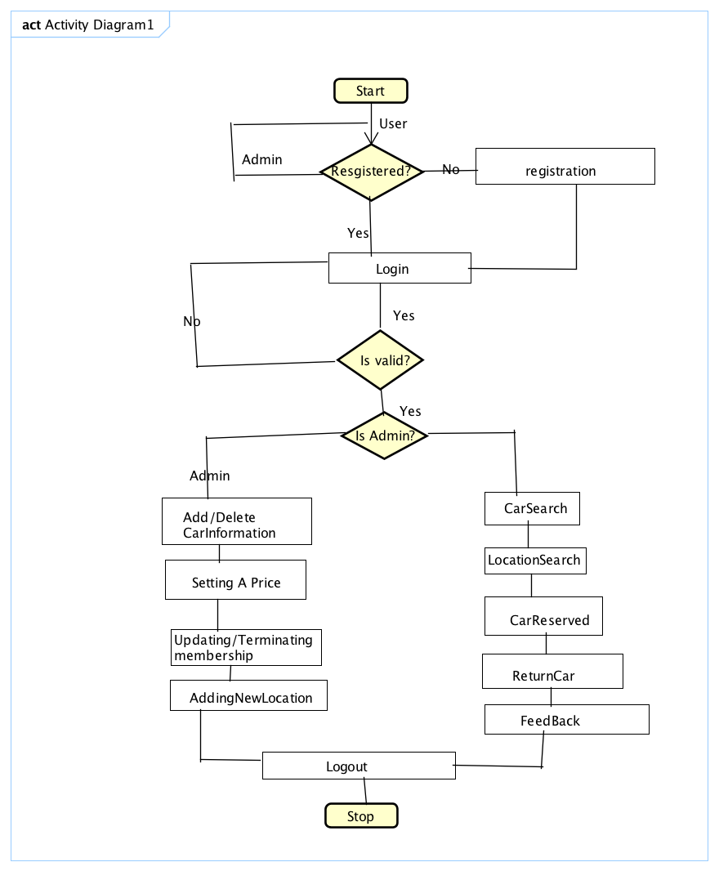

**Use Case Activity :**

**Login Activity :** Login Activity for Car Rental System, Which shows the flows of Login Activity, Where admin and user will able to login using their credentials name and password.

**i.** After login user can search for the cars and locations. User can redirect to different pages Booking, Search for cars, Rentals.

**ii.** After login as Admin using their credentials, They have all the abilities to rearrange the car details, change the price of the cars, Remove the car, Add the new car to the list or Location. Change the location of the car.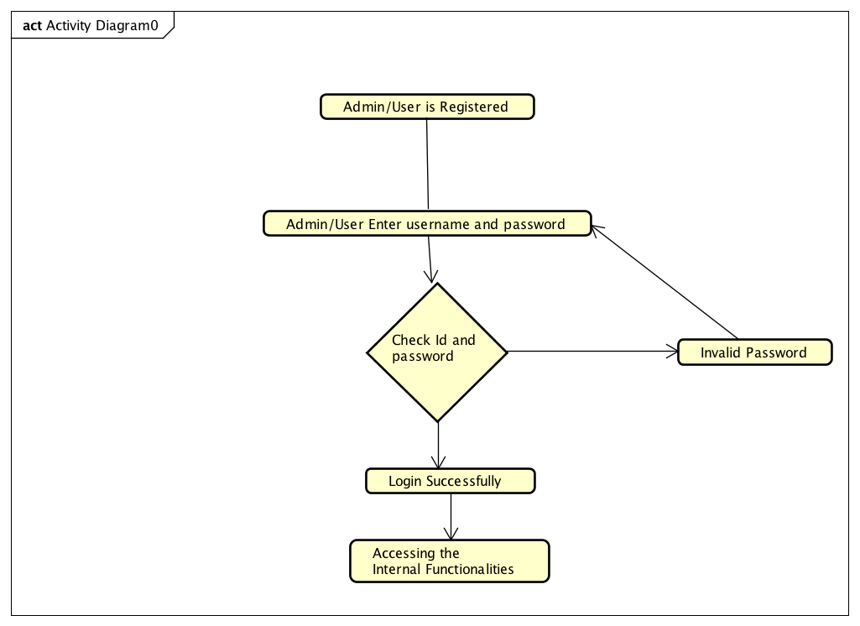

**Bookings Activity:**

**Precondition :** Login to the system

**Postcondition :** Customer registered successfully

1. User has the ability to search for the specific car type and car brand.
2. User has the ability to search for the location.
3. Add the car and location to cart
4. Successfully reserved the car.

**Extensions :** Customer can cancel the reservation.

**UseCase**

**Return Cars :** A customer return the car to the specific location

**Precondition :** The customer doesn’t need to use the car any longer

**Postcondition :** The company receives the car and the car is back into the system.

**Actors :** Admin, Customer

**Steps :**

1. Customer can select the location to return the car
2. System records the date and time.
3. According to the return date and time, system calculates the payment.

**Car Rental System Use Case Diagram :**

This Diagram represents interactions among the different elements and actors in the project. The main actors in this Use case diagram are Admins and Users. After logged in as admin/User, Who perform the different type of use cases such as Maintain Car Information, Car Booking, Payments, Locations, Membership, Feedback.

The relationship between among actors and Users

**Admin :** Use cases for Admin is Manage cars like vehicle type, Adding new vehicle, Removing a vehicle, assign rental locations, Change price of the vehicle.

**User :** Use cases for user can book the car, cancel the car reservation, search for car, return the car in specific location, Feedback. 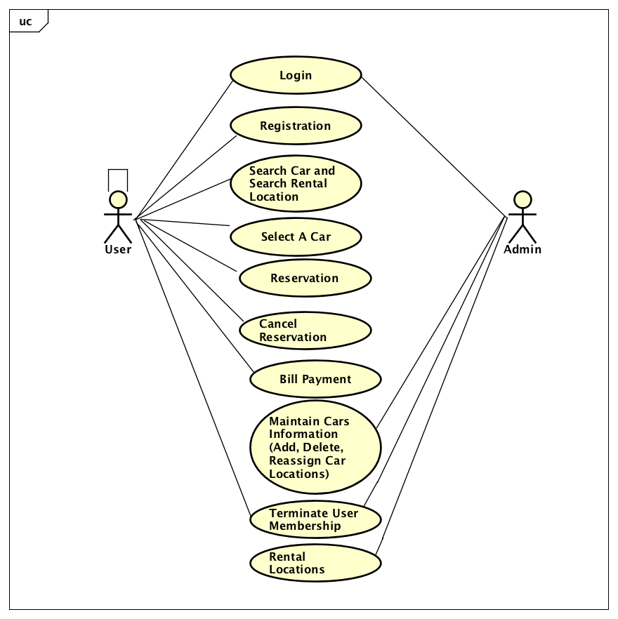

Feedback

**Car Rental Database System :**

**Driver_information : i**d, license_number, country, expiry_date, address, user_id

**Feedback :** id, reservation_id, experience, car_condition, comments, user_id

**Membership :** id, name, price, type

**Payment :** id, card_number, expiry_date, cvv, cad_holder_name, user_id

**price :** id, price_type, price, vehicle_type_id, late_fee

**rental_location :** id, name, address, rental_vehicle_capacity

**reservation :** id, vehicle_type_id, vehicle_id, reservation_date, reservation_time, location, lengthofstay, cancelled, charge, user_id, rental_locaiton_id, note, price, returned_vehicle_cond, feedback, is_returned, is_deleted, reason for_cancelation, return_datetime, fee_charged, is_completed

**vehicle_type :** id, name

**vehicle :** id, name, vehicle_type_id, make, mode, year, registration, mileage, last_time_ofservice, rental_location_id, reserved.

**users :** id, firstname, last name, email, username, password, phone, date_of_birth, is_delted, is_admin

**Description :**

1. The details of cars store into the vehicle tables and respective tables too.
2. Each entity has primary key and unique key
3. There are many-to -many, one-many, one-one between users, admins, vehicles
4. The entity users are associated with vehicles, reservation, vehicle_types, payment.

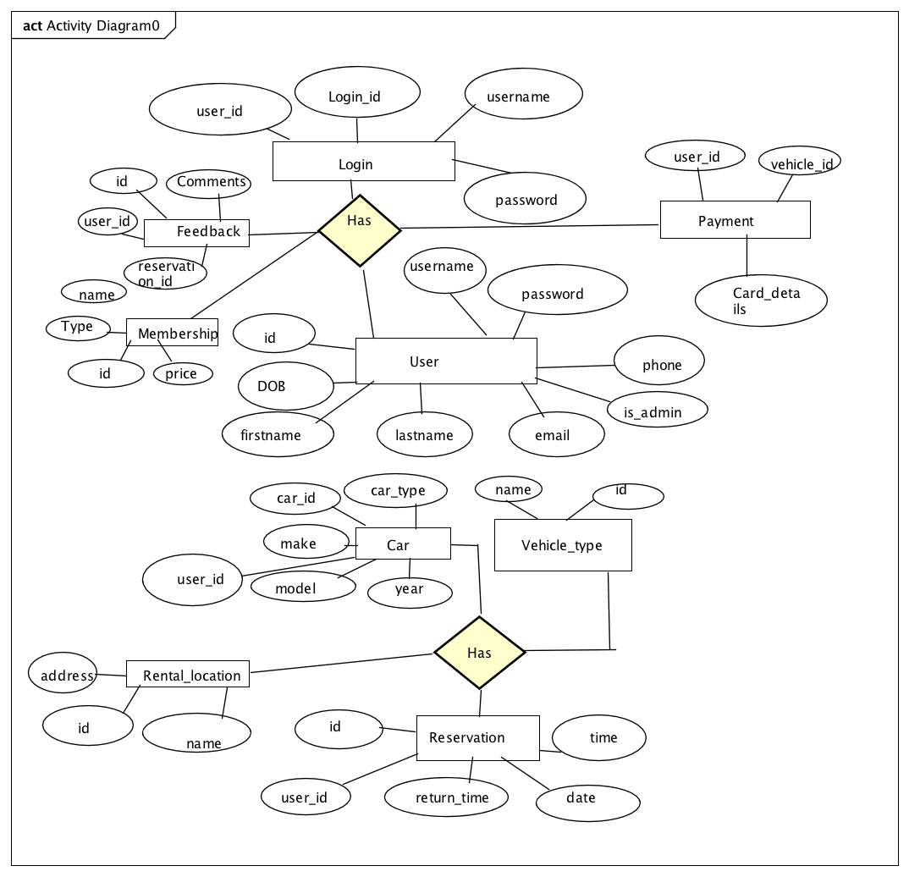**Admin Login : page**

**Admin - Add New Vehicle :**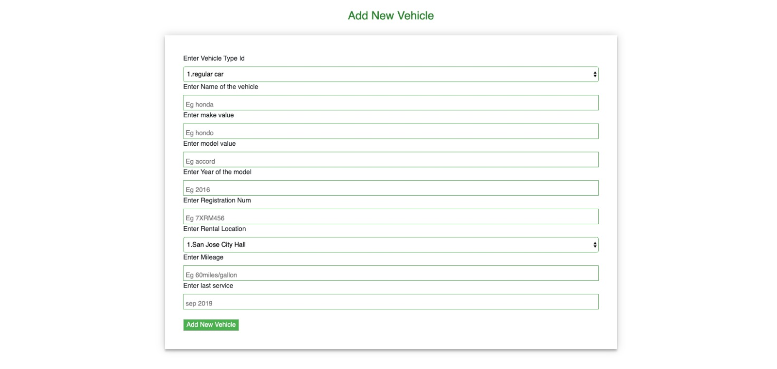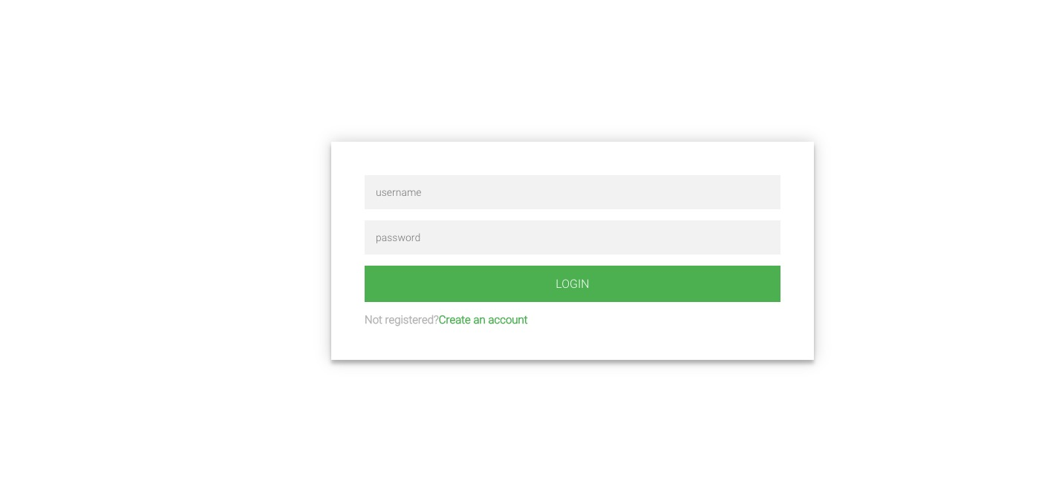

**Admin - Remove Vehicle :**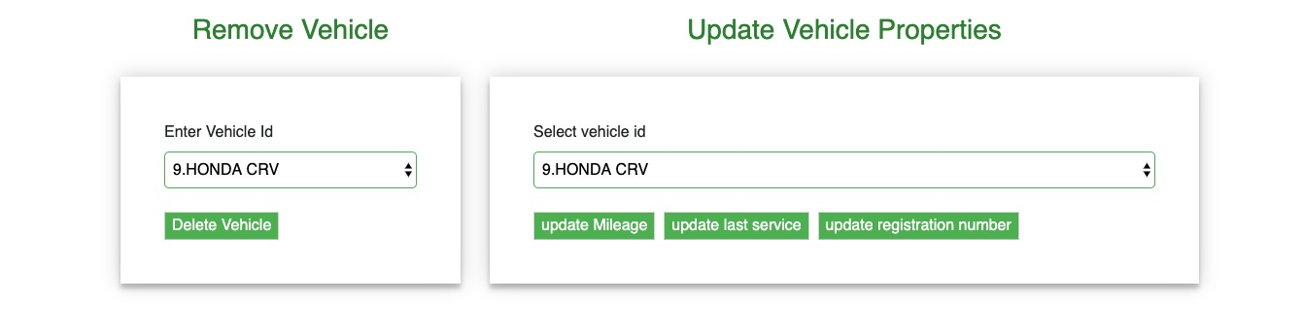

**Admin - Manage Pricing :**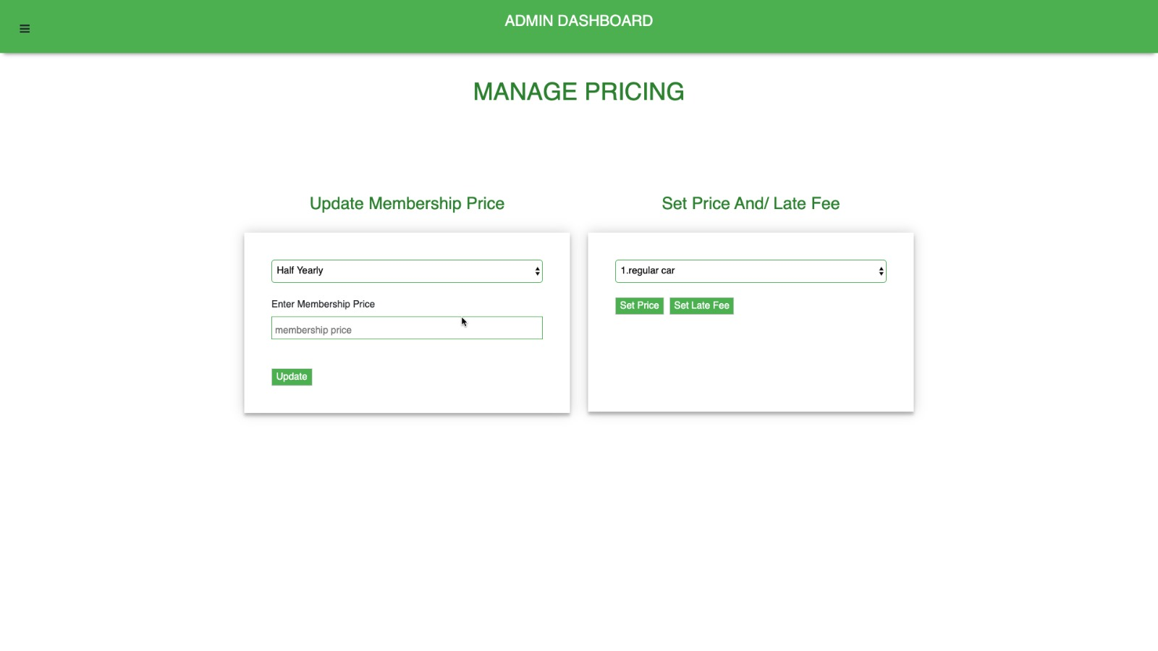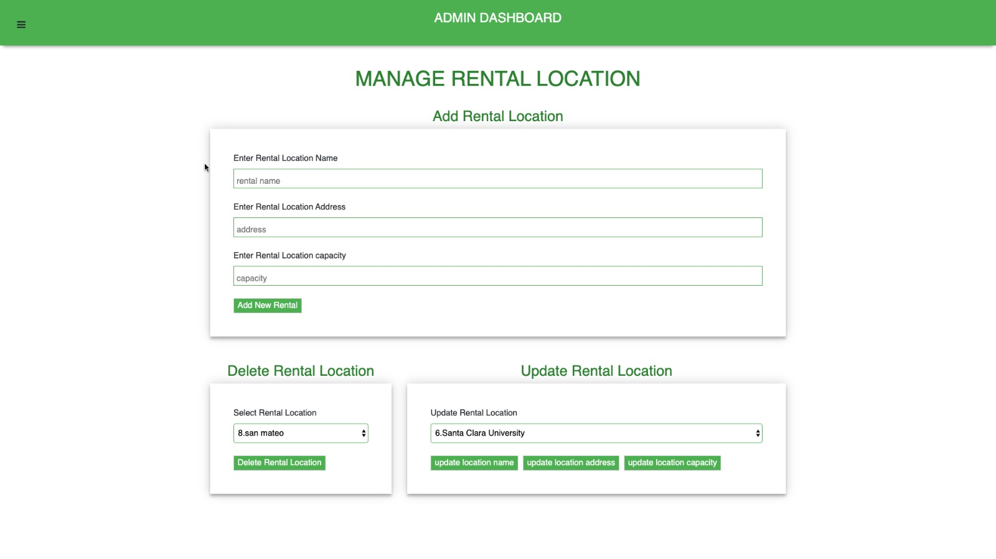

**Admin - Maintain Membership Information page**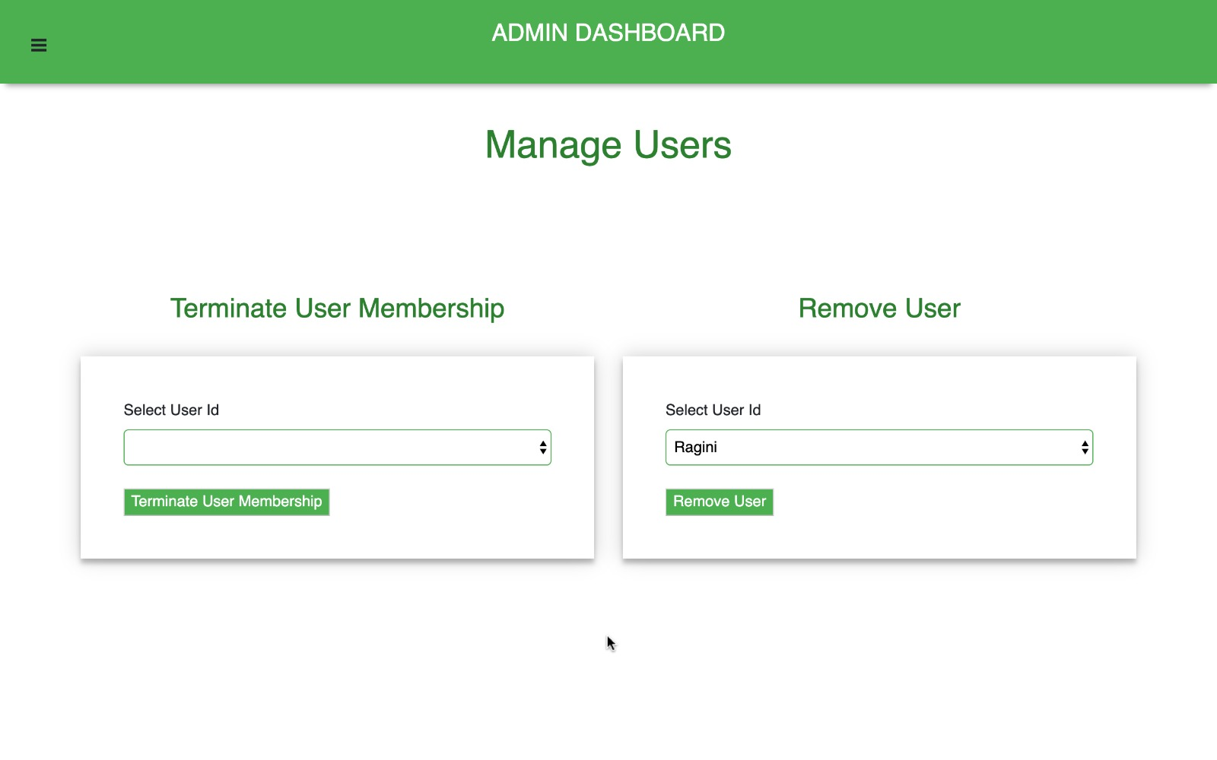

**Admin - Remove / Update vehicles :**



**User - Login Page :** 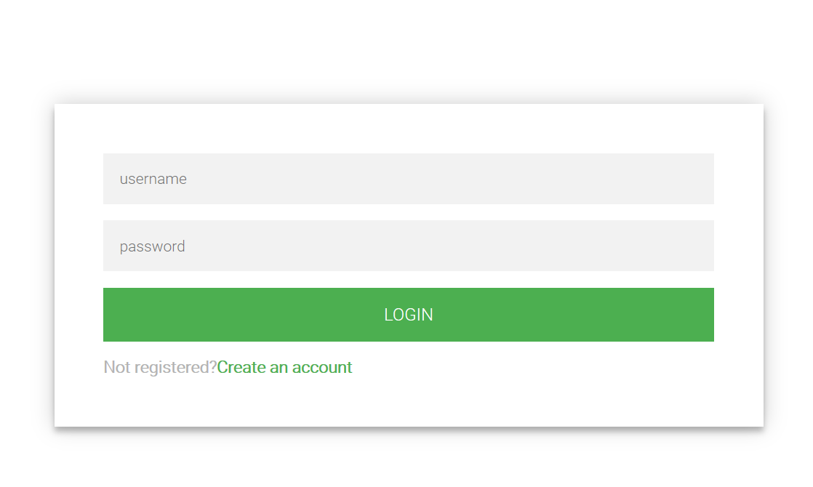

**User Registration Page :** A rental system user (a customer) should be able to register with the system. the user must establish the user name and password,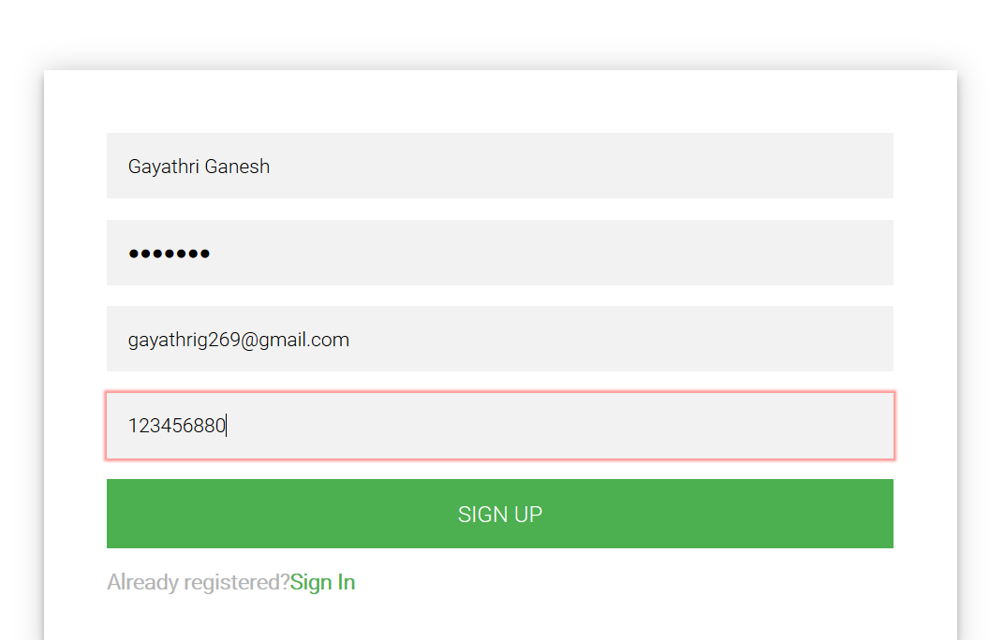

Customer provide his/her driver’s license state and number, email address, residence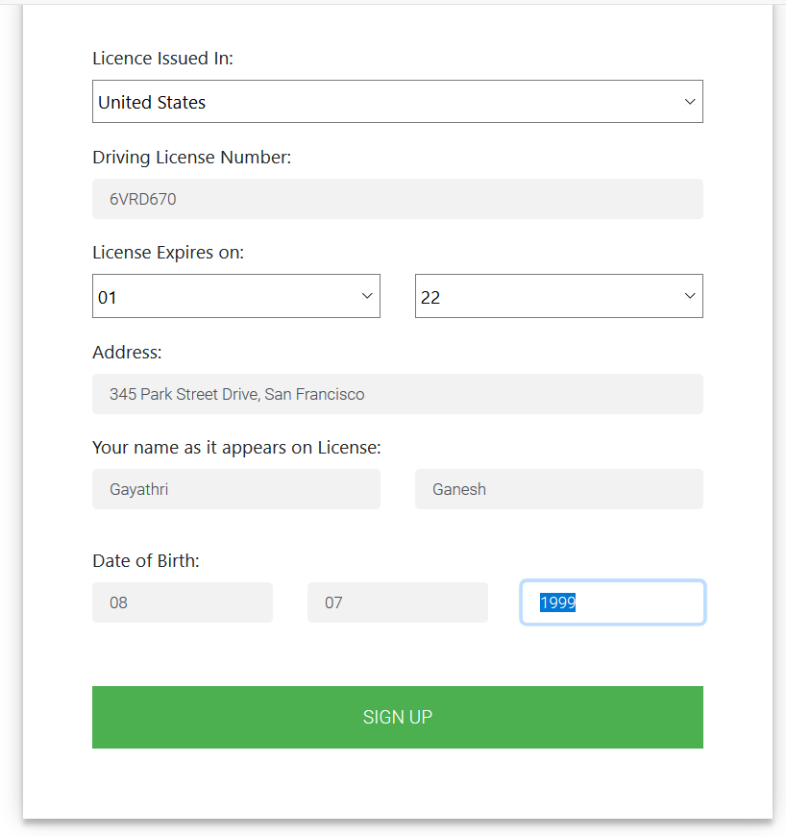

**UserMemberShip Page :**

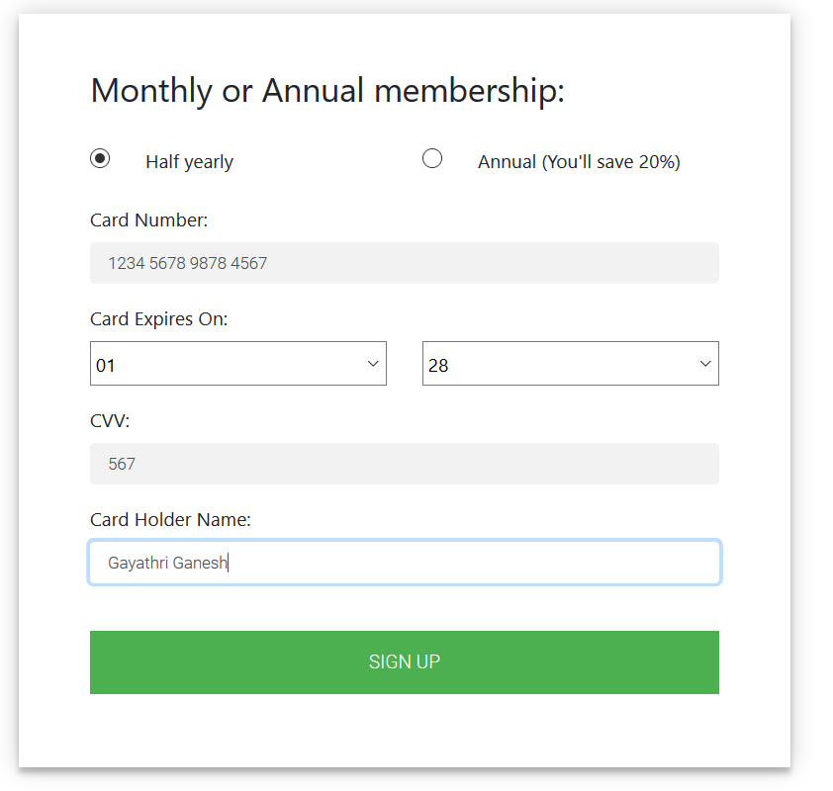

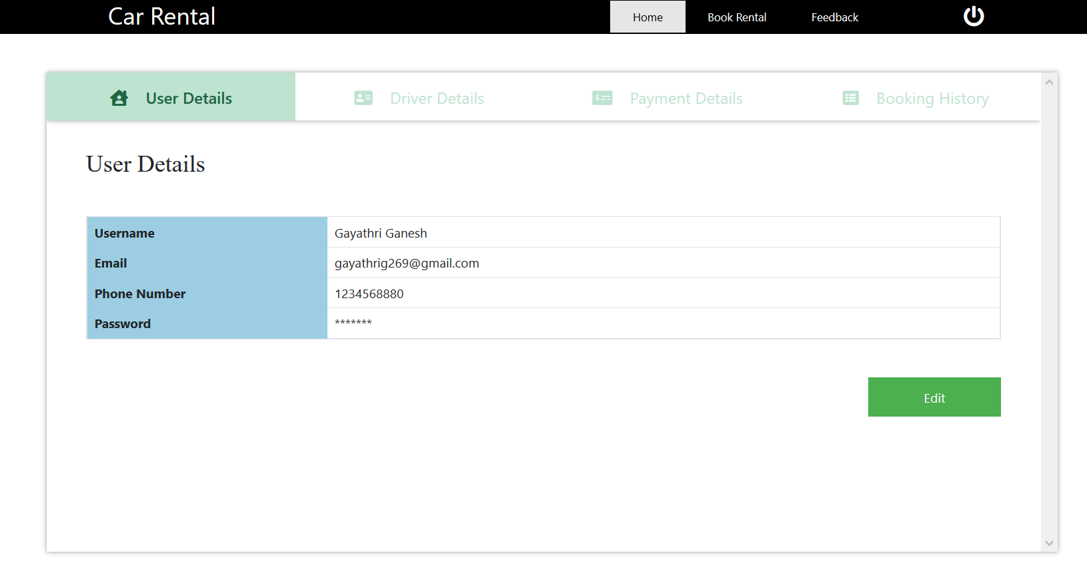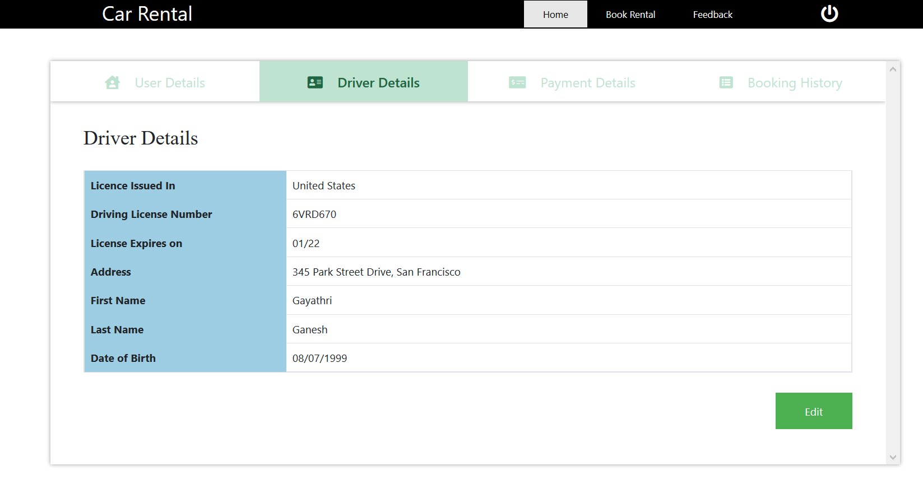

User - Home Page / Payment Details :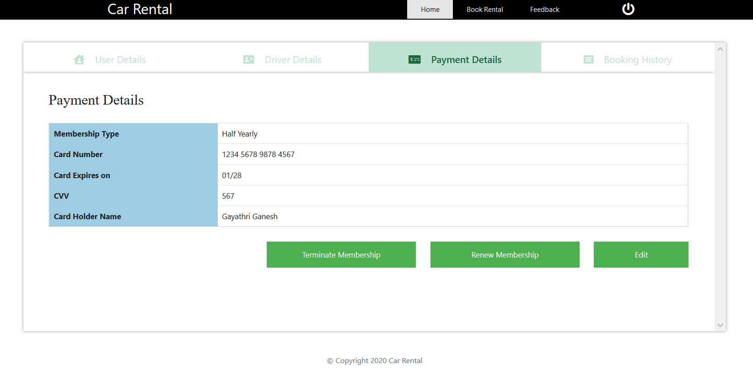

**User - Home Page / Edit Driver Information :**

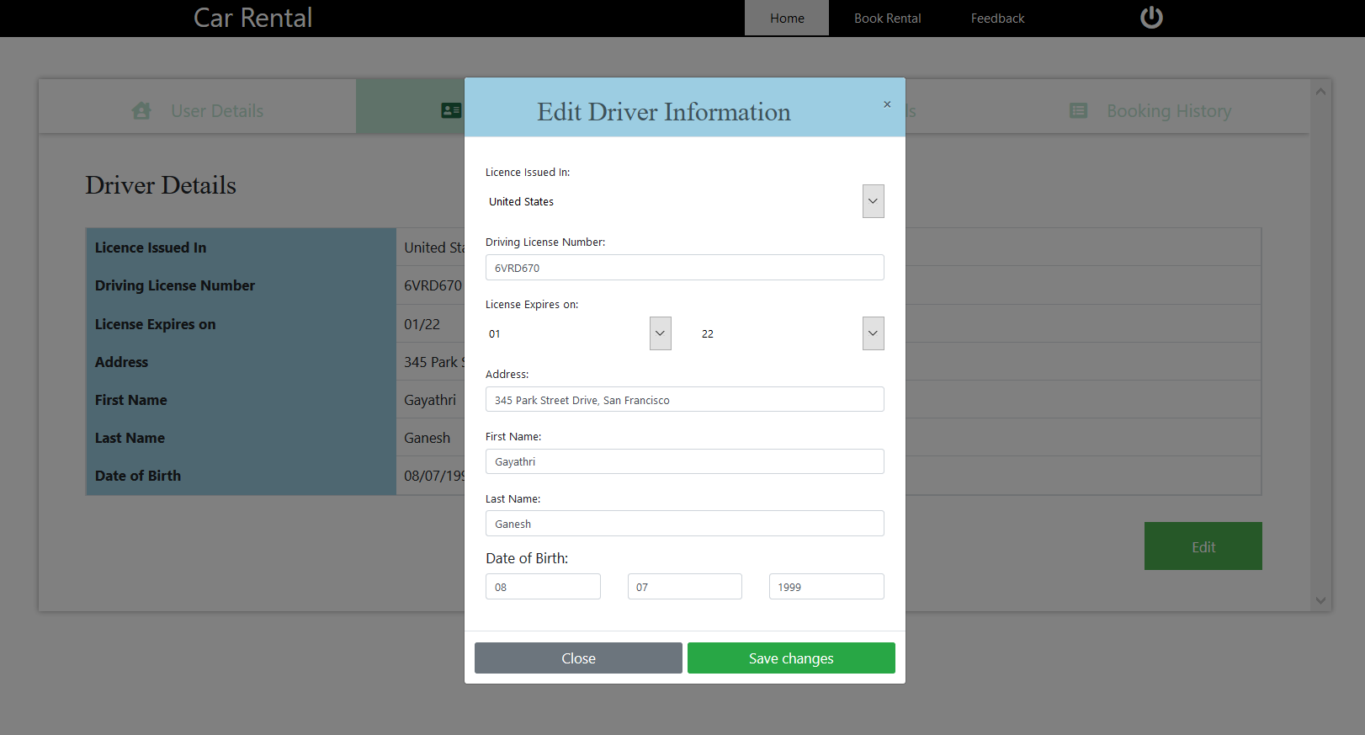

**User Home page / Payment Details / Renewal Membership :** 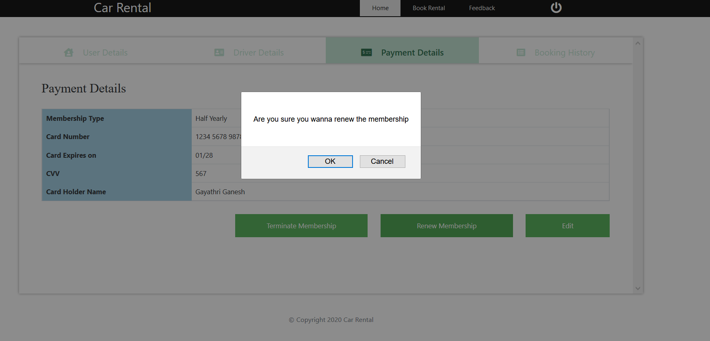

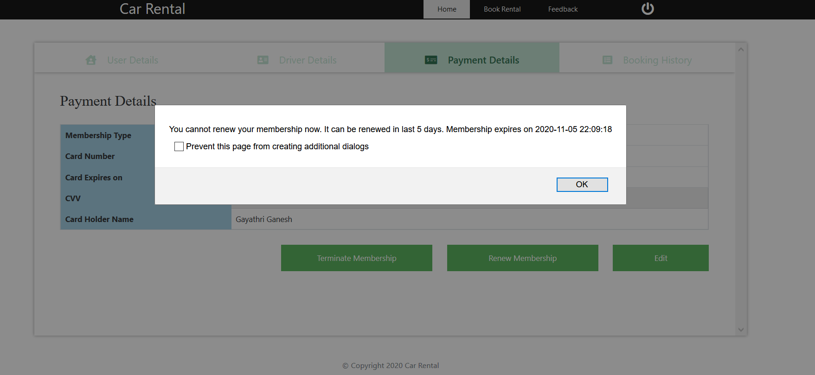

**User - Home Page / Payment Details / Edit Card Details :**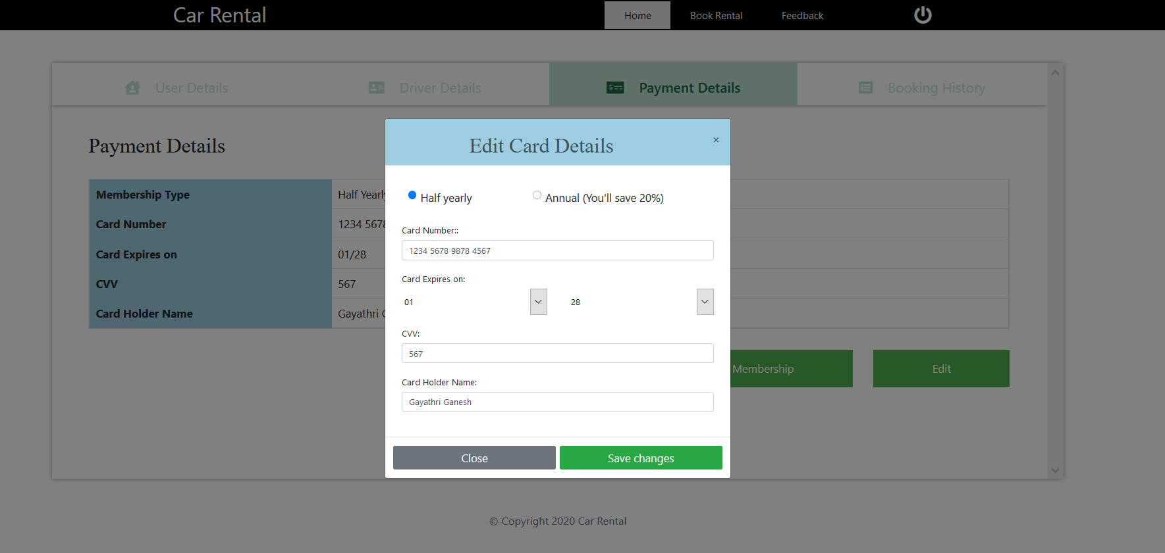

**User - Book Rental / Available Cars:** 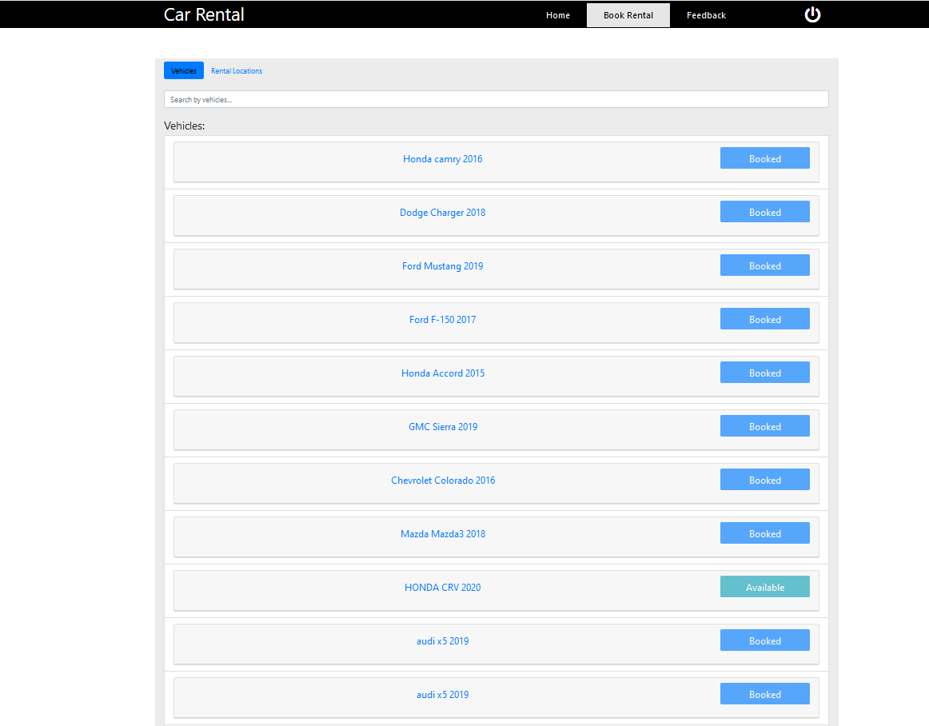

**User - Book Rentals / Rental Locations :** 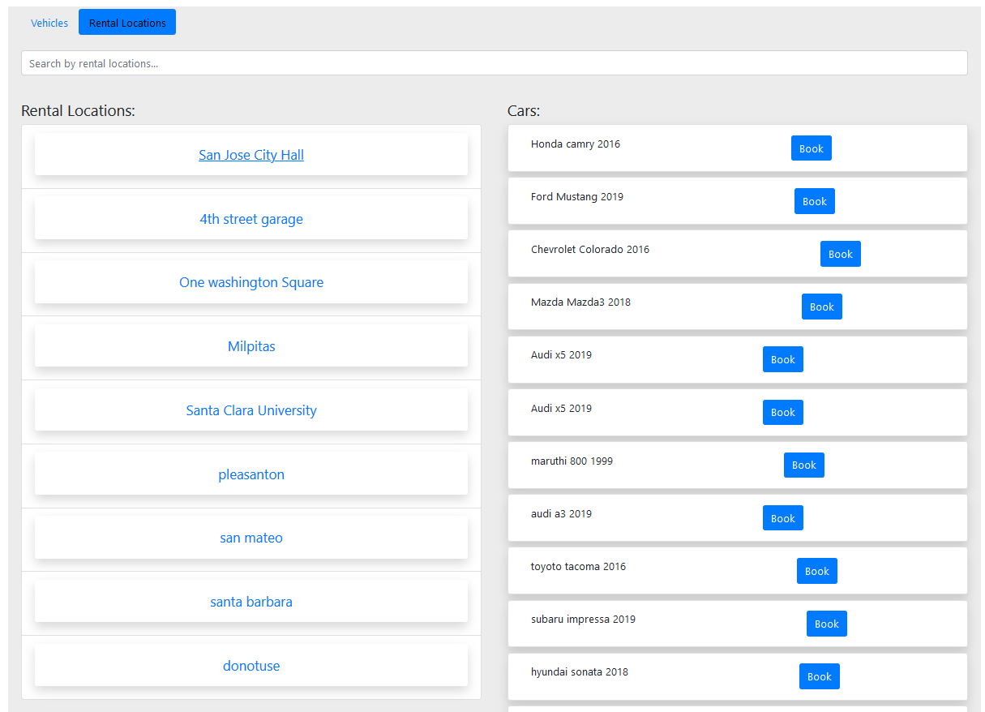

**User - Book Rentals / Select Available Car :** 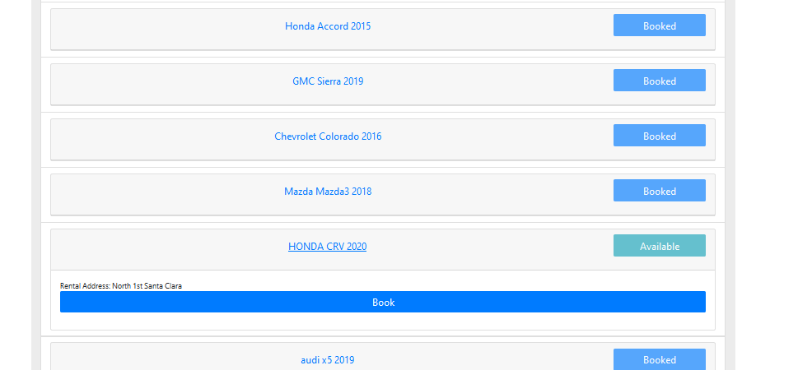

**User - Book Rentals - Enter Date/time/Hours :**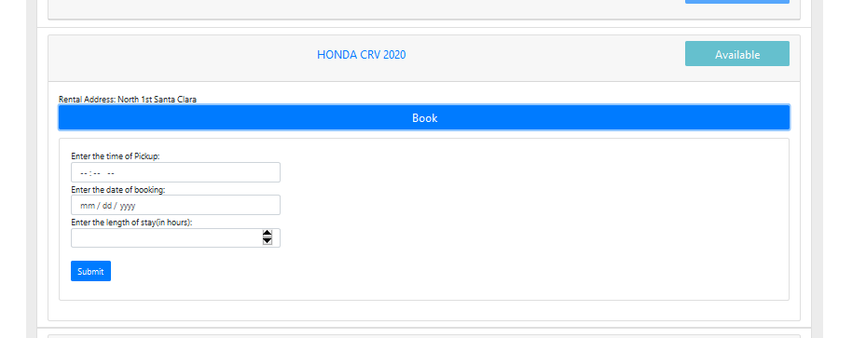

**Successfully Registered :**

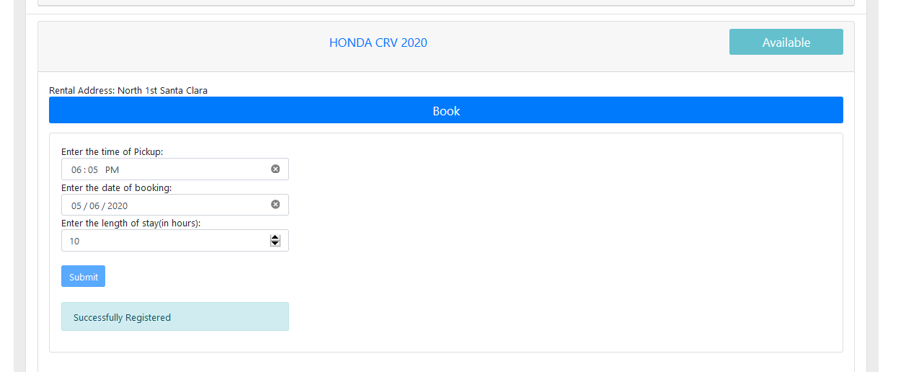

**User - Home / Booking History :**

The user should notify the system as soon as the car is returned to the rental location. The user is charged for the vehicle time starting with the reservation time and ending at the return time. If a vehicle is returned late, a late return fee may be applied in addition to the rental charge. The user may enter information about the condition of the returned vehicle. Also, the user should be able to provide comments about the vehicle and the rental service in general, if desired.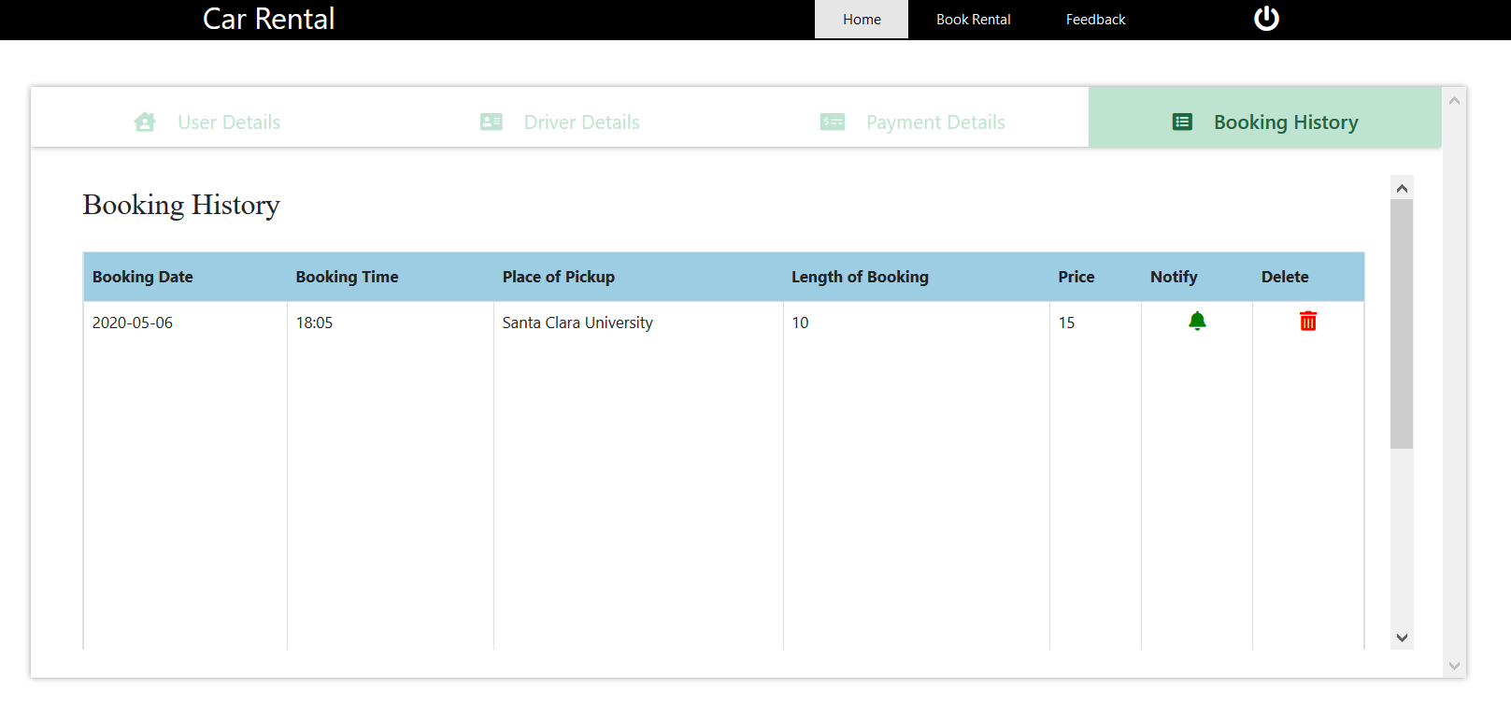

**User - Booking History / Return Vehicle :** 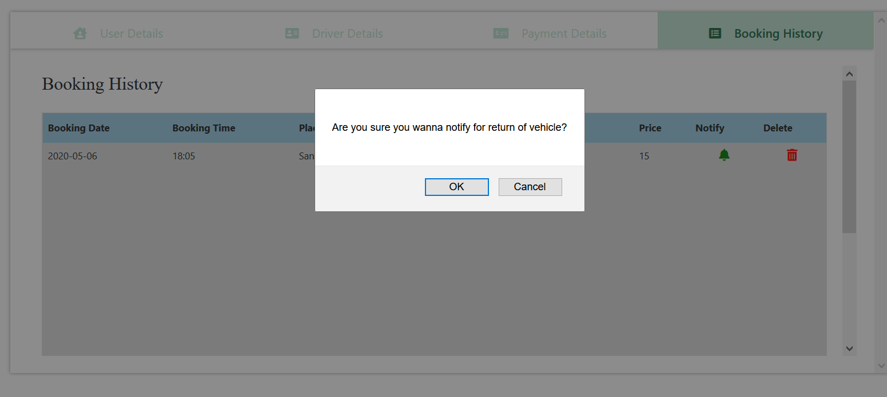

Feedback : User can Enter Feedback regarding that particular car.

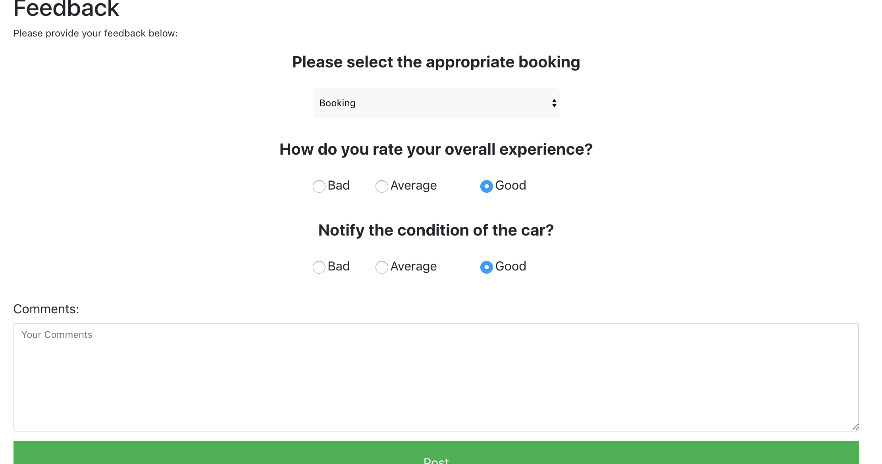

**Bibliography :**

Technologies : Node.js, Express, Pug, HTML, Javascript, AWS, Docker