Use Case Activity :

**Login Activity :** Login Activity for Car Rental System, Which shows the flows of Login Activity, Where admin and user will able to login using their credentials name and password.

i. After login user can search for the cars and locations. User can redirect to different pages Booking, Search for cars, Rentals.

ii. After login as Admin using their credentials, They have all the abilities to rearrange the car details, change the price of the cars, Remove the car, Add the new car to the list or Location. Change the location of the car.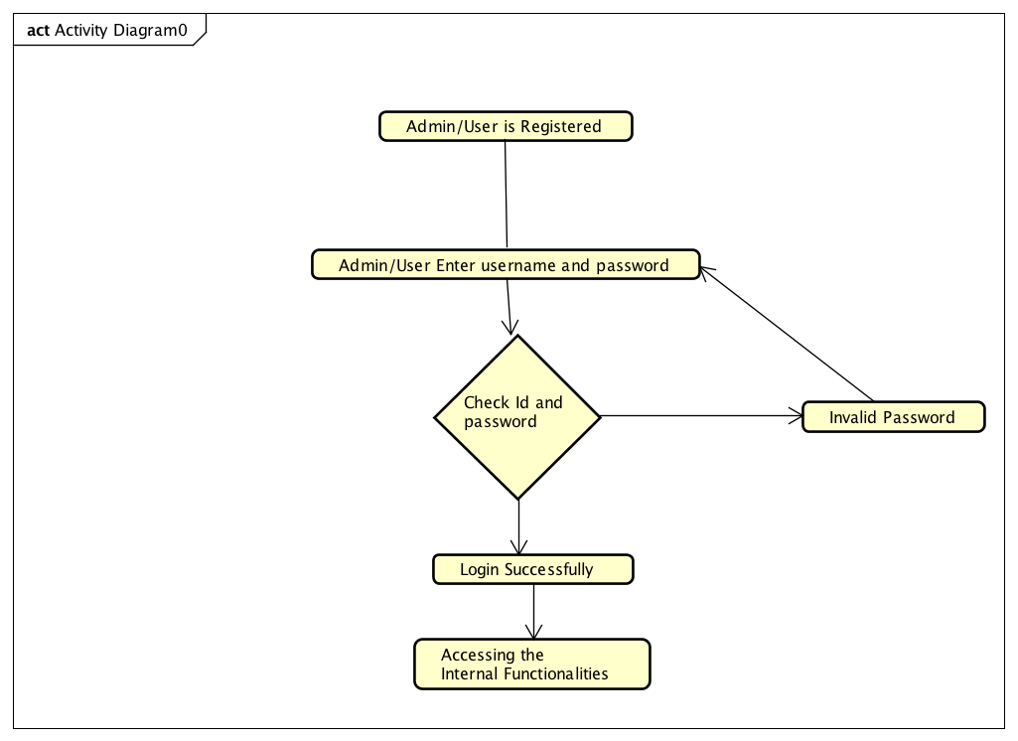

**Bookings Activity:**

1. User has the ability to search for the specific car type and car brand.
2. User has the ability to search for the location.

Once the user select location and car, He/she can Book that car.

1. user Can give Time, Date, How many days / hours and submit

**Car Rental System Use Case Diagram :**

This Diagram represents interactions among the different elements and actors in the project. The main actors in this Use case diagram are Admins and Users. After logged in as admin/User, Who perform the different type of use cases such as Maintain Car Information, Car Booking, Payments, Locations, Membership.

The relationship between among actors and Users

Admin : Use cases for Admin is Manage cars like vehicle type, Adding new vehicle, Removing a vehicle, assign rental locations, Change price of the vehicle.

User : Use cases for user is Booking,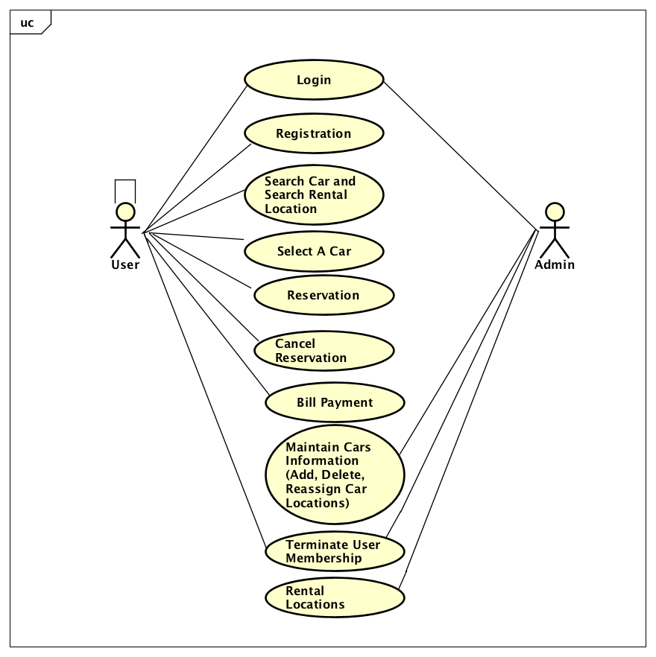

**Car Rental Database System :**

**Driver_information : i**d, license_number, country, expiry_date, address, user_id

**Feedback :** id, reservation_id, experience, car_condition, comments, user_id

**Membership :** id, name, price, type

**Payment :** id, card_number, expiry_date, cvv, cad_holder_name, user_id

**price :** id, price_type, price, vehicle_type_id, late_fee

**rental_location :** id, name, address, rental_vehicle_capacity

**reservation :** id, vehicle_type_id, vehicle_id, reservation_date, reservation_time, location, lengthofstay, cancelled, charge, user_id, rental_locaiton_id, note, price, returned_vehicle_cond, feedback, is_returned, is_deleted, reason for_cancelation, return_datetime, fee_charged, is_completed

**vehicle_type :** id, name

**vehicle :** id, name, vehicle_type_id, make, mode, year, registration, mileage, last_time_ofservice, rental_location_id, reserved.

**users :** id, firstname, last name, email, username, password, phone, date_of_birth, is_delted, is_admin

Description :

1. The details of cars store into the vehicle tables and respective tables too.
2. Each entity has primary key and unique key
3. There are many-to -many, one-many, one-one between users, admins, vehicles
4. The entity users are associated with vehicles, reservation, vehicle_types, payment.

