**Sales insights project**

Problem statement – alliq hardware supplies hardware peripherals to diff clients example surge stores, nomad stores, excel stores, electricalsara stores.

They have a headoffice in delhi and regional offices in diff states of india. Sales director manages the business from head office, the regional managers for each regional office per state.

Sales are declining in the company. But sales director is struggling with figuring out the issue. Since the business is huge, he talks to the regional managers they paint a rosy picture , they sugarcoat everything so he doesn’t have any idea what is happening at the ground level. He doesn’t have data insights.

If he asks numbers to the regional managers, they will give him too many excel files which are difficult to track, with no insights.

He wants to knows things like Top 5 customers by revue and sales, the weakest two regions, revenue breakdown by city, revenue breakdown by years and months, top 5 products by revenue , agg. Revenue in the last 365 days(year to date revenue) etc.

It will be better if he has a nice visualization where he can clicjk on a region and get numbers for that region, revenue or expense trends. He will get a better picture since data doesn’t lie.

Soi based on the visualization he can take data driven dicision like giving special discounts on regions not doing so well toi attract more customers.

[**Aims grid**](https://www.youtube.com/watch?v=6118I9HViuQ)

It helps us clarify a task and ask all the right questions. Helps us present it in front of others in a clear and concise way. Using these four components:

Purpose – To unlock sales insights that are not visible before for sales team for decision support & automate them to reduce manual time spent in data gathering.

Stake holders –

* Sales director
* Marketing team
* Customer service team
* Data & analytics team
* IT

End Result- An automated dashboard providing quick & latest sales insights in order to support data driven decision making.

Success Criteria –

* Dashboards uncovering sales order insights with latest data available.
* Sales team able to make better decisions & prove 10% cost savings of total spend
* Sales analyst stop data gathering manually in order to save 20% of their business time and reinvest it in value added activity.

IT team responsible for building and maintaining the sales management system where numbers, amounts , customers names, print invoice are entered. Behind this software there is a mysql database and this database has information regarding all the transactions, how many peripherals were sold, who is the customer, data and tine of particular transaction.

Data analyst team can directly hook tableau with mysql database and they can do the analysis and build the dashboard.

In real life a datawarehouse(OLAP- Online analytical processing system) is built, the mysql data is taken where the data engineers perform a process called ETL(it’s like copy and paste, same data transformed into a different format) which is stored in the data warehouse.

Why do we need this extra step? The sales management system that we have is called OLTP(Online transaction processing system), it’s a critical system where the day to day sales are being recorded. Data analysis is a compute intensive process, which if performed on the actual database can slow it down, and in turn hamper the business. The data transformed using ETL transforms it in such a way that the data analysis becomes easier.



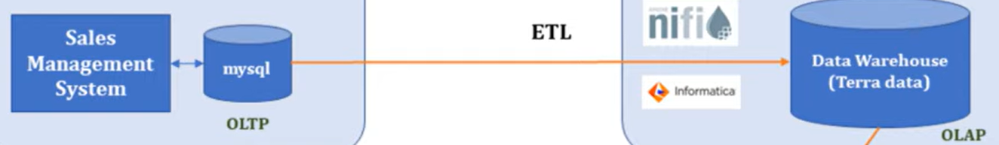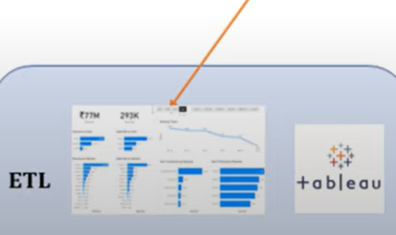



**Steps**

1. Perform basic queries in mysql
2. Extract the database into tableau
3. Perform data modelling , with transactions in between to form a star schema , transactions being the facts table and the rest being dimension tables.
4. Now we perform ETL(extracting from mysql, transform the data and load it into tableau):
5. Removing 0 and -1 values from transactions: Click on transactions table> data> edit data source filters> add> click on sales amount> atleast > change the number to 1> ok
6. Remove new York and paris from markets as business only in India: data> edit data source filters> add > click on markets_code> all>unselect Mark097 and Mark999 > ok
7. Convert USD TO INR: Click on transactions> click on drop down above currency> create calculated field> IF [Currency]== 'USD' THEN [Sales Amount]*88 ELSE [Sales Amount] END, name as Normalized Amount> ok

Tableau analysis

Ctrl+shift+b – to increase font size of entire graph

Ctrl+b – to reduce font size