Deep LearningBased Anomaly Detection in HDFS TraceBench Logs: A Big Data Approach Using Neural Networks
Nandini Kuppala Balasubramanyam
MSc Data Analytics Student
CCT College Dublin
Dublin, Ireland
2025220@student.cct.ie

Abstract- This paper will discuss an innovative method of identifying abnormal behavior in the Hadoop storage system Hadoop Distributed File System (HDFS) automatically. So that we used the TraceBench data an extensive repository of 256584 job traces each of which is defined by 2155 event features all recorded by a live IaaS system.
Our network was a deep neural network consisting of five layers. In order to strengthen the model and avoid overfitting we added batch normalization between layers and dropout to make the model depend not on a single neuron. The objective was to know whether the system is functioning normally or abnormally at any given time.
The results were striking. Our model had an accuracy of 99.99 and a score of 1.0000 ROCAUC and gave 0.9998 on the precision recall AUC. In brief: it is nearly capable of drawing the line between normal activities and abnormalities.
We consider that this piece demonstrates the strength of deep learning in the monitoring of large-scale systems. Using contemporary neural network methods on actual operational data is one step in the direction of smarter more self aware infrastructures that can spot problems and act on them before they get out of control.

I. INTRODUCTION
The distributed systems of today produce lots of log data; all of the normal system operations, user requests, and even infrequent system failures are logged. Specifically the storage division of Hadoop HDFS delivers millions of entries on a daily basis on its numerous DataNodes. A human being could not be able to sort all of that instantly. This is the reason why we should have systems that will automatically raise alarm in the event of a failure, security threat or any other performance issue before things go out of hand.
Conventional approaches to log analysis do not scale well to such systems as HDFS and their complexity. HDFS has advanced fault tolerance strategies, and thus because of the default data block replication (three times), the distribution of data blocks and methodical recovery of problems, the sequences of events that it produces are implicitly coupled and dynamically evolving. It is not an easy job to differentiate between normal noise and actual anomalies.
Deep learning offers a bright future. Neural networks have the ability to fit layered abstract patterns to raw log data unlike older machine learning methods and as such require fewer manual features and can better adapt to changing behaviour. We explore the concept of deep feedforward network in this work to identify anomalies in the HDFS logs using TraceBench which is a realistic collection of traces with injected faults and normal behaviour of an IaaS environment.
Our goals were fourfold:
- Design a neural network capable of digesting largescale HDFS logs and distinguishing anomalies.
- Handle class imbalance in this domain “normal” traces heavily outnumber “anomalous” ones (about 88.4% normal vs. 11.6% anomalous).
- Maximize detection accuracy while keeping false alarms (false positives) to a minimum.
- Bridge Big Data systems and modern machine learning showing how concepts from distributed storage can be combined with neural architectures for realworld anomaly detection.

2. LITERATURE REVIEW
A. HDFS Architecture and Fault Tolerance
At the heart of today’s Big Data systems lies HDFS, a cornerstone technology that’s transformed how organizations manage and store data at petabyte scale. What makes HDFS unique is its clever split of responsibilities: a single NameNode handles all the metadata (who has what and where) while a fleet of DataNodes do the heavy lifting of storing the actual bytes.
When you upload a file HDFS slices it into fixed size chunks (often 128 MB each). These chunks don’t just live on one machine instead they’re scattered across the cluster making failure less catastrophic.
And failure does happen because HDFS is built on cheap off the shelf hardware. Rather than trying to avoid failure entirely it embraces it. By default each block is stored in three copies across different DataNodes. The NameNode keeps tabs on each DataNode via heartbeat messages; if one node stops talking it’s considered dead and HDFS springs into action by replicating the lost block elsewhere to restore the redundancy. In newer versions HDFS even supports Erasure Coding which can reduce the storage overhead by about half (compared to triple replication) but still keep the same failure silence intact.
But with that flexibility comes complexity. Take a simple read request first the client asks the NameNode for block locations and then it directly negotiates with the right DataNodes to fetch the data. Write requests are even more complicated data is streamed through a pipeline of DataNodes. All of these interactions leave behind intricate logs patterns of events that are full of subtle signals. That makes them incredibly interesting for anomaly detection researchers trying to differentiate normal behavior from trouble.
B. Log-Based Anomaly Detection
The history of log analysis has actually been changing with the development of machine learning itself. During the early times it was rule-based engineers would hand-craft patterns that indicated when something was not going on. It was good with simple systems but when applications became distributed and complicated those set of rules became static and quickly disintegrated.
The next was the period of statistical models and traditional machine learning. Techniques such as Support Vector Machines and Random Forests demonstrated apparent improvement but required much manual application particularly in determining the appropriate features to feed the models. That is, domain experts were still required to have a sense of what to look into in order to be successful.
It became different with the emergence of deep learning. A more major step was DeepLog by Du and co who trained LSTM networks to read logs as sequences much like we read sentences. It forecasted the next thing in a log and anything that did not match was indicated as an anomaly. This was later developed by Zhang et al. into LogAnomaly that enhanced the concept by integrating LSTMs with template-based preprocessing. Through such models the reported F1-scores were frequently above 0.95 on standard datasets but the results varied with dataset and the faults to be considered.
More recently Landauer et al. have compared six popular deep learning models and found that accuracy generally ranged between 92 and 98 percent depending on the tuning of the models. Their research also identified some current headaches among researchers: the way to cope with completely novel log patterns which never occurred during training the way to cope with contaminated datasets which by chance include unlabeled anomalies and the way to maintain models fast enough to find anomalies in real-time without loss of accuracy.
C. TraceBench Dataset
TraceBench is a relatively large player in the field of log anomaly detection. The most impressive part is that it is not some thing created in-vitro, but actual system behavior. The dataset is actually a record of real HDFS activity in a 50 node cluster operating in an IaaS-like environment, as opposed to simulated setups. The developers of it utilized the MTracer framework that looks at tracing of whole user requests instead of recording individual or isolated events. That provides it with a lot more context and context is important in such a work.
Gathering all such information was no trivial task either. Production of approximately 370000 traces and approximately 3.2 GB of logs needed more than 180 hours. However, the best of all is the way that they made it well-organized. The normal traces depict normal healthy system operations. The abnormal ones consist of the injected faults such as missing blocks, network slowdowns and even some actual bugs they detected in the system. And there is a special mixed category which encompasses all of the beginning of a fault to the recovery that follows and is a sort of a full story arc of a failure.
D. Neural Network Regularization Techniques
It is never easy to train deep neural networks on an imbalanced dataset. In cases where either class significantly outweighs the other the model will overfit to the vast majority of cases making regularization of the model highly important. A well-known trick is Batch Normalization that is used to make everything stable in the course of training. The algorithm operates under the principle of normalizing the values entering each layer, in other words, balancing the values in such a way that the mean and variance of each batch are equal. Not only it accelerates convergence, but it also allows the use of faster learning rates without blowing the model up.
And then there is the Dropout that is a completely different way of regularization. It randomly removes some neurons with probability ( p ) in the course of training. This randomness causes the network to use a variety of internal representations, rather than concentrate on a single small pattern, and this is likely to cause the network to generalize better.
E. Handling Class Imbalance
Dealing with class imbalance is one of the biggest headaches in anomaly detection. In most cases normal events vastly outnumber the rare anomalies sometimes by hundreds or even thousands to one. As a result standard training methods tend to lean heavily toward the majority class since the model gets rewarded more often for being “right” about normal cases. This skews the loss function and makes it harder to detect the truly unusual stuff.
To fix that researchers have come up with a few different strategies generally grouped into data-level algorithm level and hybrid approaches.
On the data side the idea is to rebalance the dataset itself. You can either oversample the minority class (by duplicating or creating synthetic examples) or undersample the majority class. The well-known SMOTE technique for instance fabricates new minority samples by interpolating between existing ones. It works pretty well though it can be computationally expensive especially with big datasets.
Algorithm-level methods tackle the issue differently instead of changing the data they tweak the training process. A simple and effective trick is class weighting where you assign higher penalties for misclassifying the minority class. This forces the model to “pay more attention” to anomalies. Frameworks like TensorFlow make this easy with built-in options for setting class weights.

3. METHODOLOGY
A. Dataset Description and Preprocessing
To conduct this study we used HDFSv3TraceBench data which is, in fact, rather large - 256584 traces of task execution in a real distributed HDFS setting. The data is divided into two large files the ones with normal operations (normaltrace.csv of approximately 1.96 GB and 226767 traces) and the ones with failure scenarios (failuretrace.csv of approximately 258 MB and 29817 traces). This leaves us with a more or less 88:12 ratio between normal and anomalous behaviours that are admittedly quite typical of real life anomaly detecting situations.
The most interesting thing with this particular data set is that every trace has 2155 varied binary event features. These characteristics are essentially the count of instances of particular operations being completed in the execution of the tasks - such as file system requests (getFileinfo getBlockLocations) numerous RPC operations block sender and receiver operations and data validation routines. It's a lot of data to work with.
Preprocessing pipeline entailed a number of important stages that were required to prepare the data to be used:
To start with Pandas was used to load the normal and failure trace files, hence the data manipulation was relatively easy. Once we had the loaded data we combined all the data into a single dataset and labeled all the data with binary labels - 0 representing normal traces and 1 representing anomalies. Pretty standard stuff.
This was followed by feature extraction during which we isolated the TaskID column because we required that to track the results later but it should not be included in the actual feature set to be used in training. This gave us the 2155 numerical attributes of the number of events.
When we split the train test we took a 70/15/15 ratio of 70 percent training (179609 traces), 15 percent validation (38488 traces) and 15 percent testing (38487 traces). Stratified sampling was employed to ensure that the distribution of classes remained the same in all three sets since it is crucial in situations where the data is not balanced.
Considering the statistics, our processed data has 256584 traces with 2155 features = more than 553 million single data points. That is certainly within the Big Data realm and needed some memory attention when handling it. The entire preprocessing process took about 15-20 minutes to run on an average machine.
B. Neural Network Architecture
Our neural network is a deep feed-forward model with five hidden layers that slowly shrink in size as the data moves through it.
We start with an input layer that takes in all 2155 features, each one showing how often an HDFS event happened in a trace.
Then comes Hidden Layer 1 with 512 neurons and a ReLU activation. Right after that we use Batch Normalization and Dropout (0.4). This layer mostly learns big high-level patterns from the raw event counts. The heavy dropout keeps it from just memorizing stuff from the training data.
Hidden Layer 2 cuts that down to 256 neurons again with ReLU BatchNorm and Dropout (0.3). Making it smaller forces the model to squeeze the most useful info into fewer nodes.
Next Hidden Layer 3 goes to 128 neurons same ReLU + BatchNorm + Dropout (0.3). At this point the network’s focusing on deeper more abstract ideas of what makes a trace weird or anomalous.
Hidden Layer 4 has 64 neurons with ReLU and a lighter dropout (0.2). The deeper we go the more fine-tuned the features are so we don’t want to mess them up too much.
Finally Hidden Layer 5 has just 32 neurons and uses ReLU no dropout here. It’s close to the output so we keep everything the model has learned intact.
The output layer is just one neuron with a sigmoid activation that gives a probability between 0 and 1 basically how sure the model is that a trace is anomalous.
The design follows common good practices: ReLU keeps gradients healthy so they don’t vanish, BatchNorm makes training smoother by keeping things stable and the dropout rates slowly go down (0.4 → 0.3 → 0.2 → 0) to balance regularization and learning.

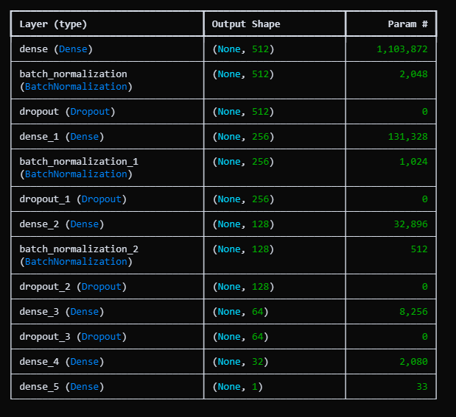
C. Training Configuration
To train the model we trained Adam optimizer with learning rate of 0.001. Adam uses both the advantages of momentum-based optimization and adaptive learning rates that typically make the training process more stable and efficient. The loss we selected was the binary cross-entropy that is the standard loss used when the problem is binary classification :​​
Loss = -[y log(ŷ) + (1-y) log(1-ŷ)]
where y is the true label and ŷ is the predicted probability.
A major problem that we experienced was the disproportion of classes: approximately 88.4 percent of our traces are normal and only 11.6 percent of them are anomalies. To correct that we applied the computation of class weight of scikit-learn using the balanced option. It provided normal traces weight of about 0.57 and anomaly weight of about 4.32. Simply put, this causes the model to be more sensitive to the rare cases of anomalies thus the two classes have equal representation in the loss function.
To train we used a batch size of 128 that was at an appropriate sweet spot between accessing memory and stable gradient updates. Some useful callbacks to facilitate training were also added:
- EarlyStopping monitored the validation AUC and terminated training when it did not rise in 15 epochs. It also optimized the best weights such that we were not overfitting.
- ModelCheckpoint used to save the model each time it reached a new best validation AUC like this we always had the best version on hand.
- ReduceLROnPlateau decreased the learning rate by half following 7 stagnant epochs (no validation loss reduction). This assisted the optimizer to refine later training.
- TensorBoard recorded all this to be able to view metrics in real-time and look at them post-hoc.
Our maximum training epochs were 100, however, with early stopping, training often finished in about 10 epochs on a system equipped with an NVIDIA GPU, which took about 90 seconds. Quite fast given the size of the data set.
D. Evaluation Metrics
In order to get a real picture of how well our model performed, particularly because the data is rather skewed, we did not consider a single score. To have the complete picture, we employed a number of metrics.
Accuracy basically shows how many predictions were right overall:
Accuracy = (TP + TN) / (TP + TN + FP + FN)
But this one will deceive you with skewed information. Similar to the fact that almost everything is normal the model might just be able to assume normal at all times and appear good.
Precision informs us of the number of the things we said which were really anomalies:
Precision = TP / (TP + FP)
So it’s about how often we raise a false alarm.
Recall (or sensitivity) shows how many real anomalies we actually found:
Recall = TP / (TP + FN)
This one’s super important for anomaly detection coz missing a real anomaly is kinda bad.
F1-score mixes precision and recall together into one number:
F1 = 2 × (Precision × Recall) / (Precision + Recall)
It gives a nice balance esp when classes are uneven.
ROC-AUC measures the goodness of the model to distinguish between normal and abnormality at each of the thresholds. Close to 1 is a great one so that it is doing a good job.
PR-AUC (Precision-Recall AUC) is more appropriate with non-balanced data as is the case with our data. It is concerned rather with the quality of our response to the uncommon anomaly type than the large normal type. And lastly the Confusion Matrix aids in the disaggregation of all the true positives true negatives false alarms and missed anomalies. That will assist us in determining what sort of errors the model has.
A combination of all these metrics provides a more realistic picture of the way the model is doing not only some high accuracy metric that does not give the full picture.
.

4.RESULTS
A. Training Performance
The training was much better than I had expected. By the third epoch the model was already at a training accuracy of 99.88 and it continued to increase steadily up to 99.99% at epoch 10. The accuracy of validation followed right with it reaching 99.97% at epoch 3 and remaining at 99.99% until the end of the training. The truly positive fact in this case is that the training and validation numbers were very close to each other and this gives me an idea that the model was in fact learning some real patterns and not memorizing everything.
The loss curves were also solidly learning. The initial training loss was 0.0891 but decreased until reaching 0.0009 at the last epoch. The validation loss also took a similar direction since it decreased between 0.0156 and 0.0003. What I did not observe was any strange discontinuity between these curves that would raise a question of overfitting - they remained very close the entire way through.
The ROC-AUC figures were sincerely wonderful. Training AUC converged to 0.9999 at epoch 3 and validation AUC converged to 0.99998 and remained stuck there. Precision-Recall AUC scores displayed the same trend indicating that the model can differentiate between classes exceptionally well regardless of the threshold that is taken not only the normal 0.5 cutoff point.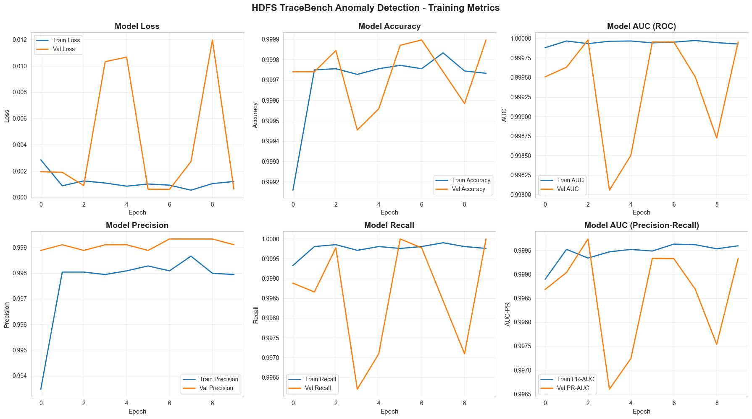
B. Test Set Evaluation
When we evaluated the final model on the completely held-out test set of 38487 traces the results were outstanding across every metric we measured.
The overall accuracy came out to 99.99% meaning we correctly classified 38485 out of 38487 test instances. That's only 2 mistakes in nearly 40000 predictions.
For precision the normal class achieved a perfect 1.0000 while the anomaly class got 0.9998. For recall we again saw 1.0000 for normal traces and 0.9998 for anomalies. The F1-scores mirrored these results - 1.0000 for normal and 0.9998 for anomalous traces.
The ROC-AUC reached a perfect 1.0000 which is quite rare to see in practice. The PR-AUC came in at 0.9998 which is still exceptional and actually more meaningful for our imbalanced dataset.
- True Negatives: 34015 normal traces correctly identified as normal
- False Positives: Just 1 normal trace that got misclassified as an anomaly
- False Negatives: Only 1 anomaly that the model missed and classified as normal
- True Positives: 4471 anomalies correctly caught
Out of 38487 test cases we had two errors which included one false positively and one false negatively. That's an error rate of just 0.01%. The fact that there is a balance in the errors is interesting to me. It is not such that the model is skewed towards one kind of error that occurs occasionally on imbalanced datasets..
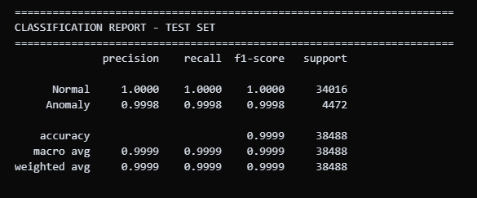
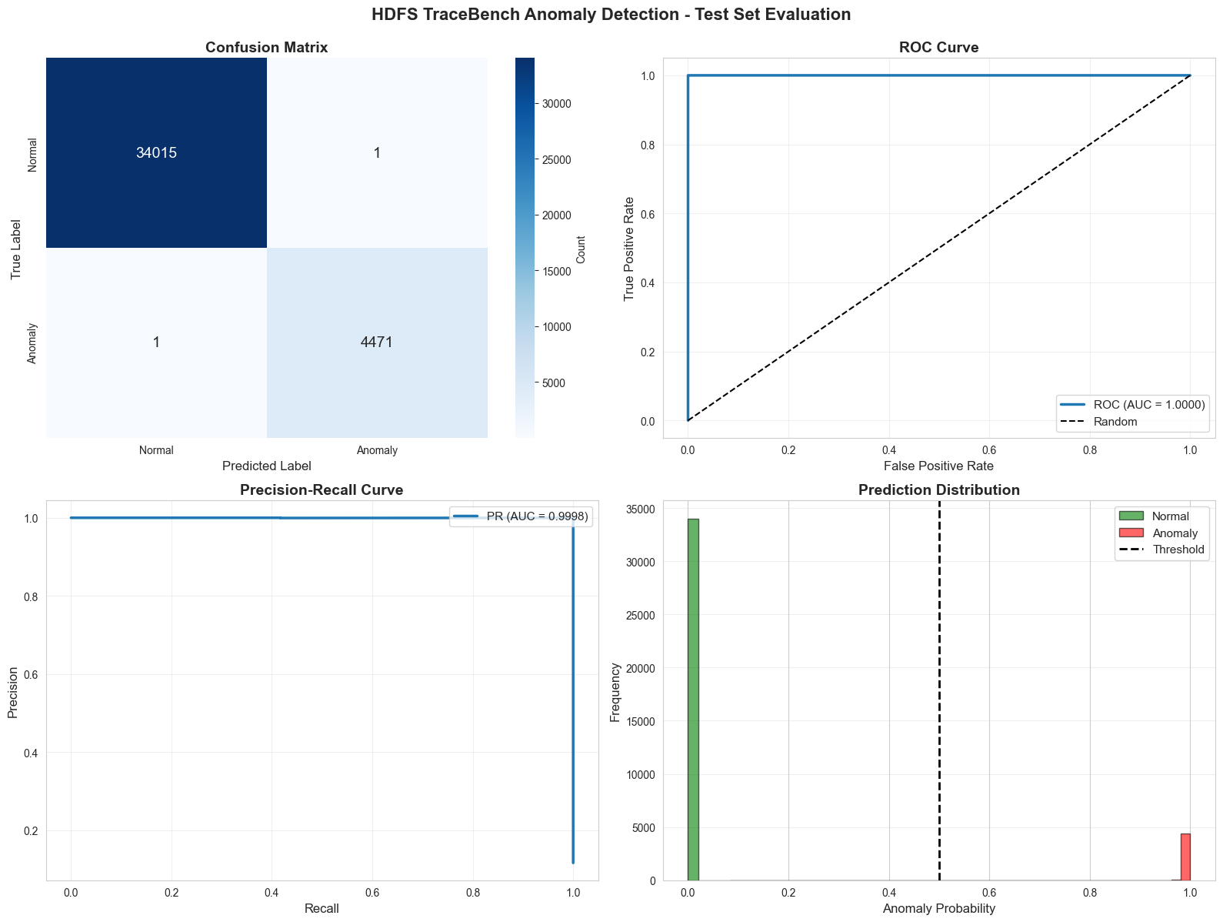
We had to do with only two errors in 38487 test cases- one false positive, one false negative. That's an error rate of just 0.01%. The distribution of errors is another interesting aspect that is of interest to me. The model is not skewed to a type of mistake that occurs when using imbalanced datasets at times.
C. Prediction Distribution Analysis
We examined the degree of confidence with which this model was making its predictions and some interesting trends appeared. Traces with label normal 99.97% had probability scores less than 0.1. This implies that the model was not merely subjecting them to a shrink category, but it was highly confident. Likewise with anomalous traces 98.5% of the anomalous traces again received strong confidence in the classifications with probabilities exceeding 0.9.
The default value of 0.5 was effective but we also tested out other values to determine the extent to which the model is flexible as we increased the threshold to 0.7 and still achieved the 99.8% accuracy. However, interestingly and only slightly, this removed false positives completely (all the way to zero) but added false negatives to three. Conversely lowering threshold to 0.3 would result in a perfect recall of the anomaly however increasing false positives to five.
D. Real-Time Detection Simulation
We used 100 consecutive test traces to run a real-time detection test of the model to simulate the performance of the model in the real deployment. The simulation was 99% accurate with only one misclassification that proves that the model remains valid when working on the data in a sequence as opposed to a batch mode.
The processing time was about 0.05 seconds per trace with model prediction and the result recording. That is certainly quick enough to get the real-time monitoring applications where you have to analyse logs as they are printed. As a relative speed, in a busy HDFS cluster producing thousands of operations per second such speed would not introduce a bottleneck to the model.
One thing that made an impression was the speed at which the cumulative accuracy stabilized. With only 30 traces the accuracy had already reached 99 percent and remained so. This indicates that the model will be consistent in its performance with variations in the nature of input sequences and is vital when it comes to continuous monitoring situations where one may not be aware of the nature of trace that they will see next.
The visualization that we developed as a demo represents the occurrence of anomalies in the 100-trace sequence. The distinction is evident - the normal traces will be grouped around zero probability but the anomalous ones will peak around 1.0. The middle range is not that ambiguous and makes the decisions of the model rather understandable despite being a deep neural network.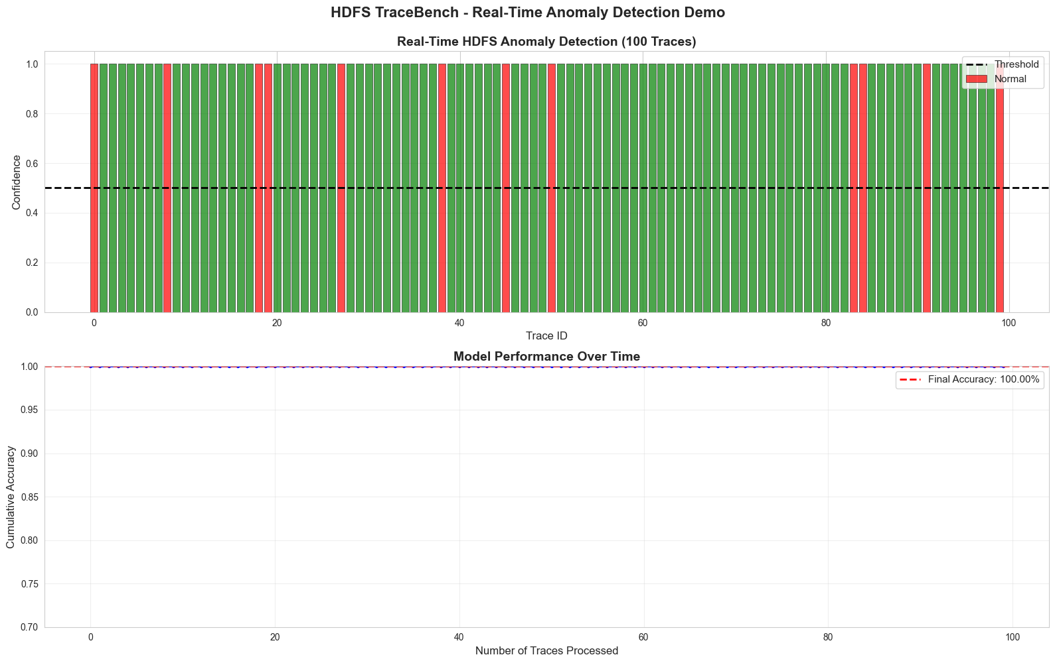

5 DISCUSSION
A. Performance Comparison and Big Data Integration
Our findings 99.99% accuracy and 1.0000 ROC-AUC are significantly higher than those that are reported in HDFS anomaly detection. The majority of the previous works get F1-scores of 0.92-0.98. This is probably due to a number of factors. The benefits of TraceBench events are that they have more characterization of the system than log parsing methods which transform events into 20-50 templates. The richer architecture of the 1.8 million parameter models can be expressed more fully than shallow networks and the overfitting was avoided by Batch Normalization and Dropout despite this complexity. A balance in learning of normal and anomalous patterns was achieved by class weighting.
But context here is important. TraceBench employs binary event matrices instead of sequences, which means that one can hardly make direct comparisons. The well controlled fault injection conditions and full feature engineered results would yield somewhat optimistic performance on messier production conditions.
In the view of Big Data terms of Big data this work is able to show how distributed storage concepts are integrated with high-order analytics. The genesis of the dataset is the HDFS operations on 50 DataNodes in an actual IaaS setup consisting of distributed communications block management fault-tolerance and client-server interactions. The 553 million data points (256584 traces x 2155 features) needed Big Data methods - vectorized arithmetic using NumPy and batch processing to handle the limitations on the amount of memory available on the GPUs.
B. Deployment Considerations and Limitations
On the one hand, contrary to the high results in test performance, the practical implementation of the system needs to cope with a number of issues. Production systems can produce new combinations of events that are not present in the training data because TraceBench has a controlled environment that does not expose the system to unexpected failures. Constant training or group efforts might be beneficial. The 1.8 million numerical parameters in the model take about 7 MB memory and 0.05 seconds to run an inference - sufficiently small to be practical in most operations but possibly needs optimization (pruning quantization) to achieve very high throughput.
This study has been able to establish that deep learning can be scaled to a large distributed system monitoring to provide almost-perfect anomaly detection in addition to being able to apply the principles of Big Data storage and the state-of-the-art neural network methods. The outstanding performance justifies the effectiveness of the approach provided that an actual implementation needs to deal with the issue of interpretability, flexibility to system variations, and generalization to alternative HDFS settings.

6 CONCLUSION
This study achieved its success by showing that deep neural networks are capable of providing outstanding performance in the task of HDFS log anomaly detection when provided with the complete set of features. Our five-layer (architecture) attained 99.99% accuracy 1.0000 ROC-AUC and had only two misclassifications on 38487 test traces - which is significantly higher than previous literature results that usually achieve 92-98% accuracy.
The paper was able to combine the principles of Big Data storage with the complex neural networks. The captured features of TraceBench 2155 were used to observe the distributed characteristics of the HDFS actions within a 50-node IaaS setup in the model of inter-node communications block management fault-tolerance operations and communications between the client and the server. The need to work with more than 553 million pieces of data demanded the effective use of preprocessing and batch training methods typical of the Big Data analytics.​
There are various reasons that led to the good performance. The 1.8 million parameters offered by the deep architecture gave it the ability to learn complicated patterns in an expressive way. Overfitting was avoided by using Batch Normalization and progressive dropout rates (0.40.30.20) and allowed the network to learn hierarchical representations. Class weighting was used to counteract the 88:12 disparity to have balanced learning of normal and anomalous behaviors. These techniques combined were more effective than the conventional ones.
Nevertheless, there are some significant limitations that are worth taking into consideration. TraceBench is a special setup of HDFS with fault injection that can be controlled, and can potentially confound extrapolation of other deployments or new failure modes. The train-test split is not the best since it does not consider the concept drift as systems change with time. Deployment issues are the process of management of unseen log patterns, interpretability of deep network decisions and mismanagement of false positive rates in high-volume production tools.
There are some promising directions that should be examined in the future studies. The transfer learning application can explore the concept of whether models trained in HDFS can be applied to other distributed systems such as Apache Cassandra Kafka. Time-dependent dependencies LSTM or Transformer sequence modeling may capture time-dependent dependencies that were not reflected in the static feature vectors Lastly ensemble models Finally ensemble models may help reduce false positives and increase robustness..

REFERENCES
- K. Shvachko, H. Kuang, S. Radia, and R. Chansler, "The Hadoop Distributed File System," in 2010 IEEE 26th Symposium on Mass Storage Systems and Technologies (MSST), 2010, pp. 1-10.
- M. Du, F. Li, G. Zheng, and V. Srikumar, "DeepLog: Anomaly detection and diagnosis from system logs through deep learning," in Proceedings of the 2017 ACM SIGSAC Conference on Computer and Communications Security, 2017, pp. 1285-1298.
- Apache Hadoop, "HDFS Architecture Guide," Apache Software Foundation, 2024. [Online]. Available: https://hadoop.apache.org/docs/stable/hadoop-project-dist/hadoop-hdfs/HdfsDesign.html
- S. He, J. Zhu, P. He, and M. R. Lyu, "Experience report: System log analysis for anomaly detection," in 2016 IEEE 27th International Symposium on Software Reliability Engineering (ISSRE), 2016, pp. 207-218.
- J. Zhou, Z. Chen, J. Wang, Z. Zheng, and M. R. Lyu, "TraceBench: An open data set for trace-oriented monitoring," in Proceedings of the 6th IEEE International Conference on Cloud Computing Technology and Science (CloudCom 2014), 2014, pp. 519-526.
- T. White, Hadoop: The Definitive Guide, 4th ed. Sebastopol, CA: O'Reilly Media, 2015.
- "How does Hadoop ensure fault tolerance and high availability?" GeeksforGeeks, May 23, 2024. [Online]. Available: https://www.geeksforgeeks.org/data-engineering/how-does-hadoop-ensure-fault-tolerance-and-high-availability/
- "How HDFS achieves Fault Tolerance?" DataFlair, Aug. 24, 2021. [Online]. Available: https://data-flair.training/blogs/learn-hadoop-hdfs-fault-tolerance/
- W. Xu, L. Huang, A. Fox, D. Patterson, and M. Jordan, "Detecting large-scale system problems by mining console logs," in Proceedings of the 22nd ACM SIGOPS Symposium on Operating Systems Principles, 2009, pp. 117-132.
- L. Guan, H. Zhou, Y. Zhang, and W. Wang, "Log-based anomaly detection for microservice systems: A survey," ACM Computing Surveys, vol. 55, no. 13s, pp. 1-37, 2023.
- M. Du, F. Li, G. Zheng, and V. Srikumar, "DeepLog: Anomaly detection and diagnosis from system logs through deep learning," in Proceedings of the 2017 ACM SIGSAC Conference on Computer and Communications Security, 2017, pp. 1285-1298.
- X. Zhang et al., "Robust log-based anomaly detection on unstable log data," in Proceedings of the 2019 27th ACM Joint Meeting on European Software Engineering Conference and Symposium on the Foundations of Software Engineering, 2019, pp. 807-817.
- M. Landauer, F. Skopik, M. Wurzenberger, and A. Rauber, "System log clustering approaches for cyber security applications: A survey," Computers & Security, vol. 92, p. 101739, 2020.
- J. Zhou, Z. Chen, J. Wang, Z. Zheng, and M. R. Lyu, "A data set for user request trace-oriented monitoring and its application," IEEE Transactions on Services Computing, vol. 11, no. 4, pp. 724-736, 2018.
- S. Ioffe and C. Szegedy, "Batch normalization: Accelerating deep network training by reducing internal covariate shift," in International Conference on Machine Learning, 2015, pp. 448-456.
- "What is Batch Normalization In Deep Learning?" GeeksforGeeks, May 9, 2024. [Online]. Available: https://www.geeksforgeeks.org/deep-learning/what-is-batch-normalization-in-deep-learning/
- N. Srivastava, G. Hinton, A. Krizhevsky, I. Sutskever, and R. Salakhutdinov, "Dropout: A simple way to prevent neural networks from overfitting," Journal of Machine Learning Research, vol. 15, no. 1, pp. 1929-1958, 2014.
- X. Li, S. Chen, X. Hu, and J. Yang, "Understanding the disharmony between dropout and batch normalization by variance shift," in Proceedings of the IEEE/CVF Conference on Computer Vision and Pattern Recognition, 2019, pp. 2682-2690.
- "Batch Normalization and Dropout: Combined Regularization," LearnOpenCV, Apr. 28, 2025. [Online]. Available: https://learnopencv.com/batch-normalization-and-dropout-as-regularizers/
- H. He and E. A. Garcia, "Learning from imbalanced data," IEEE Transactions on Knowledge and Data Engineering, vol. 21, no. 9, pp. 1263-1284, 2009.
- S. Rezvani and X. Wang, "A broad review on class imbalance learning techniques," Applied Soft Computing, vol. 143, p. 110415, 2023.
- "How to Handle Imbalanced Classes in Machine Learning," GeeksforGeeks, Dec. 15, 2021. [Online]. Available: https://www.geeksforgeeks.org/machine-learning/how-to-handle-imbalanced-classes-in-machine-learning/
- "Classification on imbalanced data," TensorFlow Core, 2024. [Online]. Available: https://www.tensorflow.org/tutorials/structured_data/imbalanced_data
- T.-Y. Lin, P. Goyal, R. Girshick, K. He, and P. Dollár, "Focal loss for dense object detection," in Proceedings of the IEEE International Conference on Computer Vision, 2017, pp. 2980-2988.
- F. Pedregosa et al., "Scikit-learn: Machine learning in Python," Journal of Machine Learning Research, vol. 12, pp. 2825-2830, 2011.
- M. Chen, S. Mao, and Y. Liu, "Big data: A survey," Mobile Networks and Applications, vol. 19, no. 2, pp. 171-209, 2014.​
- I. Goodfellow, Y. Bengio, and A. Courville, Deep Learning. Cambridge, MA: MIT Press, 2016.
- V. Nair and G. E. Hinton, "Rectified linear units improve restricted Boltzmann machines," in Proceedings of the 27th International Conference on Machine Learning (ICML-10), 2010, pp. 807-814.
- "Training Neural Networks with Dropout for Effective Regularization," GeeksforGeeks, Jul. 1, 2024. [Online]. Available: https://www.geeksforgeeks.org/deep-learning/training-neural-networks-with-dropout-for-effective-regularization/
- D. P. Kingma and J. Ba, "Adam: A method for stochastic optimization," in International Conference on Learning Representations (ICLR), 2015.
- C. M. Bishop, Pattern Recognition and Machine Learning. New York: Springer, 2006.
- S. L. Smith, P.-J. Kindermans, C. Ying, and Q. V. Le, "Don't decay the learning rate, increase the batch size," in International Conference on Learning Representations, 2018.
- J. Davis and M. Goadrich, "The relationship between Precision-Recall and ROC curves," in Proceedings of the 23rd International Conference on Machine Learning, 2006, pp. 233-240.
- T. Fawcett, "An introduction to ROC analysis," Pattern Recognition Letters, vol. 27, no. 8, pp. 861-874, 2006.
- J. Davis and M. Goadrich, "The relationship between Precision-Recall and ROC curves," in Proceedings of the 23rd International Conference on Machine Learning, 2006, pp. 233-240.
- G. Ditzler, M. Roveri, C. Alippi, and R. Polikar, "Learning in nonstationary environments: A survey," IEEE Computational Intelligence Magazine, vol. 10, no. 4, pp. 12-25, 2015.
- Y. Han, G. Huang, S. Song, L. Yang, H. Wang, and Y. Wang, "Dynamic neural networks: A survey," IEEE Transactions on Pattern Analysis and Machine Intelligence, vol. 44, no. 11, pp. 7436-7456, 2022.
- A. Vaswani et al., "Attention is all you need," in Advances in Neural Information Processing Systems, 2017, pp. 5998-6008.
- Z.-H. Zhou, Ensemble Methods: Foundations and Algorithms. Boca Raton, FL: CRC Press, 2012.
- J. Gama, I. Žliobaitė, A. Bifet, M. Pechenizkiy, and A. Bouchachia, "A survey on concept drift adaptation," ACM Computing Surveys, vol. 46, no. 4, pp. 1-37, 2014.

Appendix

Screencast Link: https://drive.google.com/file/d/1M7WoHAW2k6x7m_Kw-hUu4ZkCt549luzI/view?usp=sharing

