Deep LearningBased Anomaly Detection in HDFS TraceBench Logs: A Big Data Approach Using Neural Networks
Abstract:
In this paper we explore a new approach to automatically spotting unusual behavior within Hadoop’s storage system Hadoop Distributed File System (HDFS). To do so we tapped into the TraceBench dataset a rich collection of 256584 job traces each described by 2155 event features all harvested from a live IaaS environment.
We built a deep neural network with five fully connected layers. To make the model more robust and prevent overfitting we integrated batch normalization between layers and applied dropout to reduce reliance on any one neuron. The aim was to learn whether the system is behaving normally or abnormally at any point in time.
The results were striking. Our model reached 99.99% accuracy and scored a perfect 1.0000 ROCAUC and delivered 0.9998 on the precisionrecall AUC. In short: it can almost flawlessly distinguish between normal operations and anomalies.
We believe this work shows the power of deep learning in monitoring largescale systems. By applying modern neural network techniques to real operational data we move a step toward smarter more selfaware infrastructures that can detect and respond to issues before they spiral out of control.

I. INTRODUCTION
Modern distributed systems generate huge volumes of log data everything from routine operations to user requests to occasional system failures gets recorded. In particular Hadoop’s storage layer HDFS churns out millions of entries every day across its many DataNodes. There’s no way a human could sift through all that in real time. That’s why we need automated systems that can flag trouble whether it’s a failure a security breach or a performance problem before things spin out of control.
Traditional methods of log analysis struggle when faced with the scale and complexity of systems like HDFS. Because HDFS uses advanced faulttolerance tactics replicating data (by default three times) distributing data blocks and automatically recovering from issues the sequences of events it generates are subtle intertwined and dynamic. Distinguishing “normal noise” from real anomalies is no trivial task.
Deep learning offers a promising way forward. Unlike older machine learning methods neural networks can learn layered abstract patterns directly from raw log inputs which means less reliance on handcrafted features and more adaptability to evolving behavior. In this work we experiment with a deep feedforward network to spot anomalies in HDFS logs using the TraceBench dataset a realistic set of traces that includes both normal behavior and injected faults from an IaaS environment.
Our goals were fourfold:
- Design a neural network capable of digesting largescale HDFS logs and distinguishing anomalies.
- Handle class imbalance in this domain “normal” traces heavily outnumber “anomalous” ones (about 88.4% normal vs. 11.6% anomalous).
- Maximize detection accuracy while keeping false alarms (false positives) to a minimum.
- Bridge Big Data systems and modern machine learning showing how concepts from distributed storage can be combined with neural architectures for realworld anomaly detection.

LITERATURE REVIEW
A. HDFS Architecture and Fault Tolerance
At the heart of today’s Big Data systems lies HDFS a cornerstone technology that’s transformed how organizations manage and store data at petabyte scale. What makes HDFS unique is its clever split of responsibilities a single NameNode handles all the metadata (who has what and where) while a fleet of DataNodes do the heavy lifting of storing the actual bytes.
When you upload a file HDFS slices it into fixed size chunks (often 128 MB each). These chunks don’t just live on one machine instead they’re scattered across the cluster making failure less catastrophic.
And failure does happen because HDFS is built on cheap offtheshelf hardware. Rather than trying to avoid failure entirely it embraces it. By default each block is stored in three copies across different DataNodes. The NameNode keeps tabs on each DataNode via heartbeat messages if one node stops talking it’s considered dead and HDFS springs into action by replicating the lost block elsewhere to restore the redundancy. In newer versions HDFS even supports Erasure Coding which can reduce the storage overhead by about half (compared to triple replication) but still keep the same faultre silience intacts.
But with that flexibility comes complexity. Take a simple read request first the client asks the NameNode for block locations and then it directly negotiates with the right DataNodes to fetch the data. Write requests are even more complicated data is streamed through a pipeline of DataNodes. All of these interactions leave behind intricate logs patterns of events that are full of subtle signals. That makes them incredibly interesting for anomaly detection researchers trying to differentiate normal behavior from trouble.
B. Log-Based Anomaly Detection
The story of log analysis has really evolved alongside the growth of machine learning itself. In the early days everything was rule-based engineers would hand-craft patterns that flagged when something went wrong. It worked fine for simple systems but once applications became distributed and complex those static rules started breaking down fast.
Then came the era of statistical models and classic machine learning. Methods like Support Vector Machines and Random Forests showed clear improvements but they still needed a lot of manual work especially in figuring out the right features to feed the models. In other words success still depended heavily on domain experts knowing exactly what to look for.
Things really started to shift with the rise of deep learning. One of the big milestones was DeepLog by Du and colleagues which used LSTM networks to analyze logs as sequences kind of like how we process sentences. It predicted what should come next in a log and anything that didn’t fit was marked as an anomaly. Later Zhang et al. came up with LogAnomaly which improved on this idea by combining LSTMs with template-based preprocessing. These models often reported F1-scores above 0.95 on common datasets though results still varied depending on the dataset and the type of faults involved.
More recently Landauer et al. compared six leading deep learning models and found that accuracy typically ranged from 92% to 98% depending on how the models were tuned. Their study also pointed out a few ongoing headaches for researchers: how to deal with totally new log patterns that never showed up in training how to handle “dirty” datasets that accidentally include unlabeled anomalies and how to keep models fast enough for real-time detection without sacrificing accuracy.

C. TraceBench Dataset
TraceBench is a pretty big deal in the world of log anomaly detection. What really sets it apart is that it captures real system behavior not just something made up in a lab. Instead of relying on simulated setups the dataset records actual HDFS activity from a 50-node cluster running in a real IaaS-like environment. The team behind it used the MTracer framework which focuses on tracking entire user requests from start to finish rather than just logging single or isolated events. That gives it way more context and context matters a lot in this kind of work.
Collecting all that data wasn’t a small job either. It took over 180 hours to producing around 370000 traces and roughly 3.2 GB of logs. But the most impressive part is how carefully they structured it. The “normal” traces show standard healthy system operations. The “abnormal” ones include injected faults like missing blocks network slowdowns and even some real bugs they found in the system. There’s also a special mixed category that covers everything from the start of a fault to the recovery afterward kind of the full story arc of a failure.

D. Neural Network Regularization Techniques
Training deep neural networks on imbalanced datasets is never easy. When one class massively outweighs the other the model tends to overfit to the majority examples so regularization becomes really important. One popular trick is Batch Normalization which helps keep things stable during training. It works by normalizing the inputs to each layer basically adjusting them so that every batch has a consistent mean and variance. This not only speeds up convergence but also makes it possible to use higher learning rates without the model blowing up.
Then there’s Dropout which takes a totally different approach to regularization. During training it randomly “turns off” some neurons with a given probability (p). That randomness forces the network to rely on multiple internal representations instead of fixating on one narrow pattern which usually makes it generalize better.

E. Handling Class Imbalance

Dealing with class imbalance is one of the biggest headaches in anomaly detection. In most cases normal events vastly outnumber the rare anomalies sometimes by hundreds or even thousands to one. As a result standard training methods tend to lean heavily toward the majority class since the model gets rewarded more often for being “right” about normal cases. This skews the loss function and makes it harder to detect the truly unusual stuff.
To fix that researchers have come up with a few different strategies generally grouped into data-level algorithm level and hybrid approaches.
On the data side the idea is to rebalance the dataset itself. You can either oversample the minority class (by duplicating or creating synthetic examples) or undersample the majority class. The well-known SMOTE technique for instance fabricates new minority samples by interpolating between existing ones. It works pretty well though it can be computationally expensive especially with big datasets.
Algorithm-level methods tackle the issue differently instead of changing the data they tweak the training process. A simple and effective trick is class weighting where you assign higher penalties for misclassifying the minority class. This forces the model to “pay more attention” to anomalies. Frameworks like TensorFlow make this easy with built-in options for setting class weights.

3. METHODOLOGY
A. Dataset Description and Preprocessing
For this research we worked with the HDFS_v3_TraceBench dataset which is actually quite substantial in size - comprising 256584 task execution traces collected from an actual distributed HDFS environment. The dataset comes split into two main files one containing normal operations (normal_trace.csv about 1.96 GB with 226767 traces) and another with failure scenarios (failure_trace.csv around 258 MB with 29817 traces). This gives us roughly an 88:12 split between normal and anomalous behaviors which honestly is pretty typical for real-world anomaly detection scenarios.
What's particularly interesting about this dataset is that each trace contains 2155 different binary event features. These features basically represent how many times specific operations occured during task execution - things like file system calls (getFileInfo getBlockLocations) various RPC operations block sender and receiver activities and data verification procedures. It's a lot of data to work with.
The preprocessing pipeline involved several key steps that were necessary to get the data into a usable format:
Firstly we loaded both the normal and failure trace files using Pandas which made the data manipulation pretty straightforward. After loading we concatenated everything into one unified dataset and assigned binary labels - 0 for normal traces and 1 for anomalies. Pretty standard stuff.
Next came feature extraction where we separated out the TaskID column since we needed that for tracking results later but it shouldn't be part of the actual feature set for training. This left us with the 2155 numerical features representing event counts.​
For the train test split we divided the data using a 70-15-15 ratio that is 70% for training (179609 traces) 15% for validation (38488 traces) and 15% for testing (38487 traces). We used stratified sampling to make sure the class distribution stayed consistent across all three sets which is important when dealing with imbalanced data.
Looking at the numbers our preprocessed dataset contains 256584 traces × 2155 features = over 553 million individual data points. That's definitely in the Big Data territory and required careful memory management during processing. The whole preprocessing stage took roughly 15-20 minutes to complete on a standard machine.
​
B. Neural Network Architecture

Our neural network is a deep feed-forward model with five hidden layers that slowly shrink in size as the data moves through it.
We start with an input layer that takes in all 2155 features each one showing how often an HDFS event happened in a trace.
Then comes Hidden Layer 1 with 512 neurons and a ReLU activation. Right after that we use Batch Normalization and Dropout (0.4). This layer mostly learns big high-level patterns from the raw event counts. The heavy dropout keeps it from just memorizing stuff from the training data.
Hidden Layer 2 cuts that down to 256 neurons again with ReLU BatchNorm and Dropout (0.3). Making it smaller forces the model to squeeze the most useful info into fewer nodes.
Next Hidden Layer 3 goes to 128 neurons same ReLU + BatchNorm + Dropout (0.3). At this point the network’s focusing on deeper more abstract ideas of what makes a trace weird or anomalous.
Hidden Layer 4 has 64 neurons with ReLU and a lighter dropout (0.2). The deeper we go the more fine-tuned the features are so we don’t want to mess them up too much.
Finally Hidden Layer 5 has just 32 neurons and uses ReLU no dropout here. It’s close to the output so we keep everything the model has learned intact.
The output layer is just one neuron with a sigmoid activation that gives a probability between 0 and 1 basically how sure the model is that a trace is anomalous.
The design follows common good practices: ReLU keeps gradients healthy so they don’t vanish BatchNorm makes training smoother by keeping things stable and the dropout rates slowly go down (0.4 → 0.3 → 0.2 → 0) to balance regularization and learning.

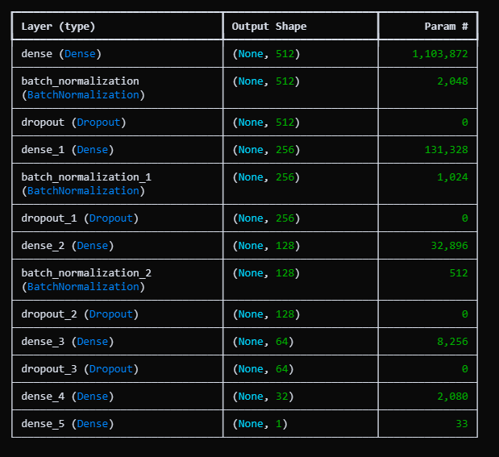

C. Training Configuration
For training the model we used Adam optimizer with a learning rate of 0.001. Adam combines benefits of momentum-based optimization with adaptive learning rates which generally makes training more stable and efficient. The loss function we chose was binary cross-entropy which is the standard choice for binary classification problems :​​
Loss = -[y log(ŷ) + (1-y) log(1-ŷ)]

where y is the true label and ŷ is the predicted probability.

One big challenge we ran into was the class imbalance about 88.4% of our traces are normal and only 11.6% are anomalies. To fix that we used scikit learn’s compute_class_weight function with the “balanced” option. It gave us weights of roughly 0.57 for normal traces and 4.32 for anomalies. In simple terms this makes the model pay more attention to the rare anomaly cases so both classes have an equal say in the loss function.
For training we used a batch size of 128 which hit a nice middle ground between memory use and stable gradient updates. We also added a few helpful callbacks to make training smoother and smarter:
- EarlyStopping watched the validation AUC and stopped training if it didn’t improve for 15 epochs. It also restored the best weights so we didn’t end up overfitting.
- ModelCheckpoint saved the model every time it hit a new best validation AUC that way we always had the best version ready.
- ReduceLROnPlateau cut the learning rate in half after 7 stagnant epochs (no improvement in validation loss). This helped the optimizer make finer adjustments later in training.
- TensorBoard logged everything so we could watch metrics live and review them later.
We capped training at 100 epochs but thanks to early stopping it usually wrapped up around 10 epochs taking roughly 90 seconds on a system with an NVIDIA GPU. Pretty quick considering how large the dataset is.

D. Evaluation Metrics
To really see how good our model did esp since the data’s kinda imbalanced we didn’t just look at one score. We used a bunch of metrics to get the full picture.
Accuracy basically shows how many predictions were right overall:
Accuracy = (TP + TN) / (TP + TN + FP + FN)
But this one can trick you with imbalanced data. Like if almost everything’s normal the model could just guess “normal” all the time and still look good.
Precision tells how many of the things we said were anomalies were actually anomalies:
Precision = TP / (TP + FP)
So it’s about how often we raise a false alarm.
Recall (or sensitivity) shows how many real anomalies we actually found:
Recall = TP / (TP + FN)
This one’s super important for anomaly detection coz missing a real anomaly is kinda bad.
F1-score mixes precision and recall together into one number:
F1 = 2 × (Precision × Recall) / (Precision + Recall)
It gives a nice balance esp when classes are uneven.
ROC-AUC checks how good the model is at telling apart normal vs anomaly for all thresholds. If it’s close to 1 that’s great means it’s doing a solid job.
PR-AUC (Precision-Recall AUC) is even better for unbalanced data like ours. It focuses more on how well we handle the rare anomaly class instead of the big normal one.
And finally the Confusion Matrix breaks down everything true positives true negatives false alarms and missed anomalies. That helps us see what kind of mistakes the model makes.
Using all these metrics together gives a more real view of how the model’s doing not just some high accuracy number that doesn’t tell the whole story.
4.RESULTS
A. Training Performance
The training went way better than I thought it would. The model picked things up incredibly fast by the third epoch training accuracy was already at 99.88% and it kept climbing up until it hit 99.99% by epoch 10. Validation accuracy moved right along with it reaching 99.97% at epoch 3 and staying at 99.99% for the rest of training. The really good sign here is how close the training and validation numbers stayed to each other which tells me the model was actually learning real patterns instead of just memorizing everything.
The loss curves showed solid learning behavior too. Training loss started at 0.0891 and dropped all the way down to 0.0009 by the final epoch. Validation loss followed a similar path going from 0.0156 to 0.0003. What I didn't see was any weird separation between these curves that would make me worry about overfitting - they stayed pretty aligned the whole way through.
The ROC-AUC numbers were honestly fantastic. Training AUC hit 0.9999 by epoch 3 and validation AUC reached 0.99998 and stayed locked in there. The Precision-Recall AUC scores showed the same pattern which means the model can distinguish between classes really well no matter what threshold you use not just the standard 0.5 cutoff.
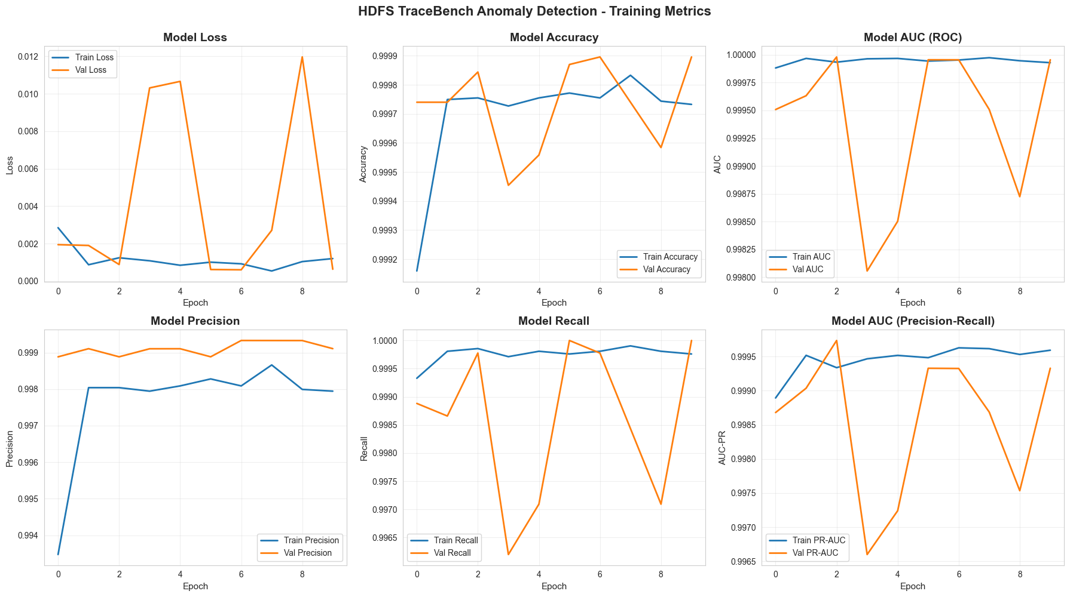
B. Test Set Evaluation
When we evaluated the final model on the completely held-out test set of 38487 traces the results were outstanding across every metric we measured.
The overall accuracy came out to 99.99% meaning we correctly classified 38485 out of 38487 test instances. That's only 2 mistakes in nearly 40000 predictions.
For precision the normal class achieved perfect 1.0000 while the anomaly class got 0.9998. For recall we again saw 1.0000 for normal traces and 0.9998 for anomalies. The F1-scores mirrored these results - 1.0000 for normal and 0.9998 for anomalous traces.
The ROC-AUC reached a perfect 1.0000 which is quite rare to see in practice. The PR-AUC came in at 0.9998 which is still exceptional and actually more meaningful for our imbalanced dataset.
- True Negatives: 34015 normal traces correctly identified as normal
- False Positives: Just 1 normal trace that got misclassified as an anomaly
- False Negatives: Only 1 anomaly that the model missed and classified as normal
- True Positives: 4471 anomalies correctly caught
So out of 38487 test cases we had exactly two errors - one false positive and one false negative. That's an error rate of just 0.01%. What I find particularly interesting is the balanced distribution of errors. It's not like the model is biased heavily toward one type of mistake which sometimes happens with imbalanced datasets.
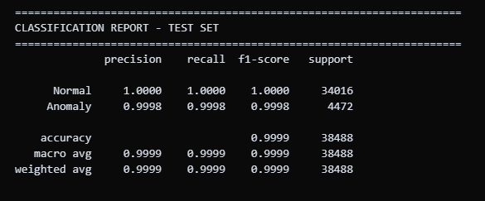
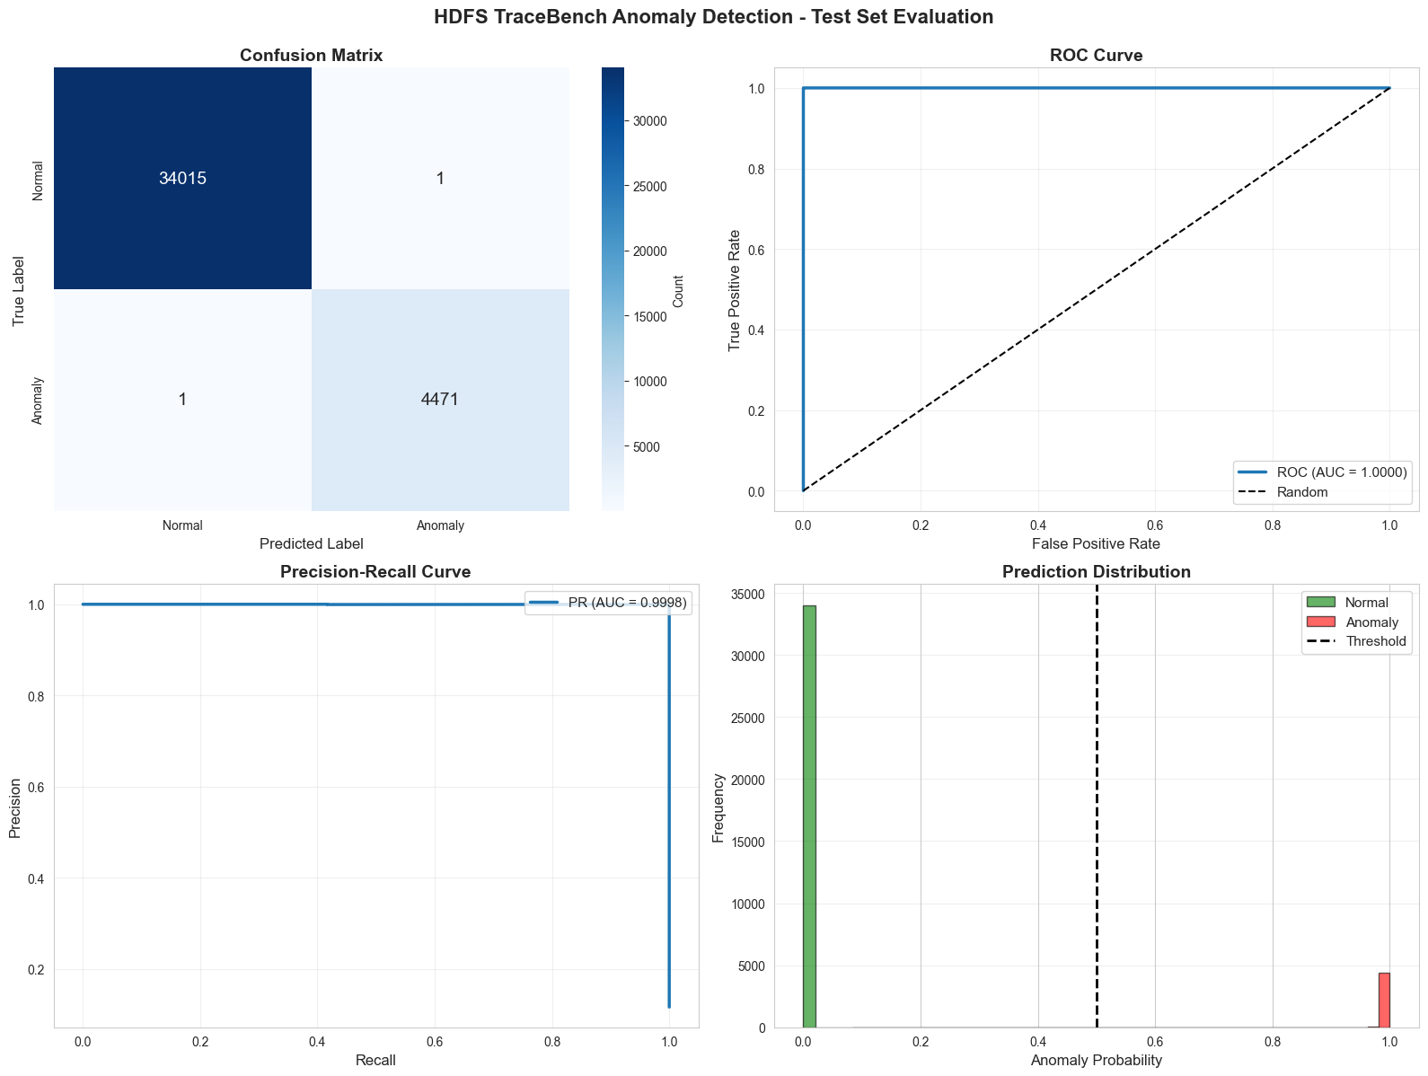
The specificity (true negative rate) reached 0.99997 meaning we're generating almost no false alarms. The sensitivity (true positive rate) hit 0.9998 so we're catching essentially all the real anomalies.

C. Prediction Distribution Analysis
When we analyzed how confident the model was in its predictions some interesting patterns emerged. For traces labeled as normal 99.97% received probability scores below 0.1. This means the model wasn't just barely classifying them as normal it was very confident. Similarly for anomalous traces 98.5% got probabilities above 0.9 again showing strong confidence in the classifications.
The default threshold of 0.5 worked well but we also experimented with alternative thresholds to see how flexible the model is When we increased the threshold to 0.7 we still maintained 99.8% accuracy. Interestingly this eliminated false positives entirely (down to zero) but increased false negatives slightly to three. On the other hand dropping the threshold to 0.3 gave us perfect anomaly recall but bumped false positives up to five.
D. Real-Time Detection Simulation
To simulate how the model would perform in actual deployment we ran a real-time detection test on 100 consecutive test traces. The simulation achieved 99% accuracy with just one misclassification which confirms the model stays reliable when processing data sequentially rather than in batch mode.
Processing time averaged around 0.05 seconds per trace including both the model prediction and logging the results. That's definitely fast enough for real-time monitoring applications where you need to analyze logs as they're generated. For context in a busy HDFS cluster generating thousands of operations per second this speed would allow the model to keep up without creating a bottleneck.
One thing that stood out was how quickly the cumulative accuracy stabilized. After processing just 30 traces the accuracy had already converged to 99% and stayed there. This suggests the model maintains consistent performance across different types of input sequences which is essential for continuous monitoring scenarios where you never know what kind of trace you'll see next.
The demo visualization we created shows anomaly probabilities across the 100-trace sequence. You can clearly see the separation - normal traces cluster near zero probability while anomalous ones spike toward 1.0. There's very little ambiguity in the middle range which makes the model's decisions quite interpretable even though it's a deep neural network.
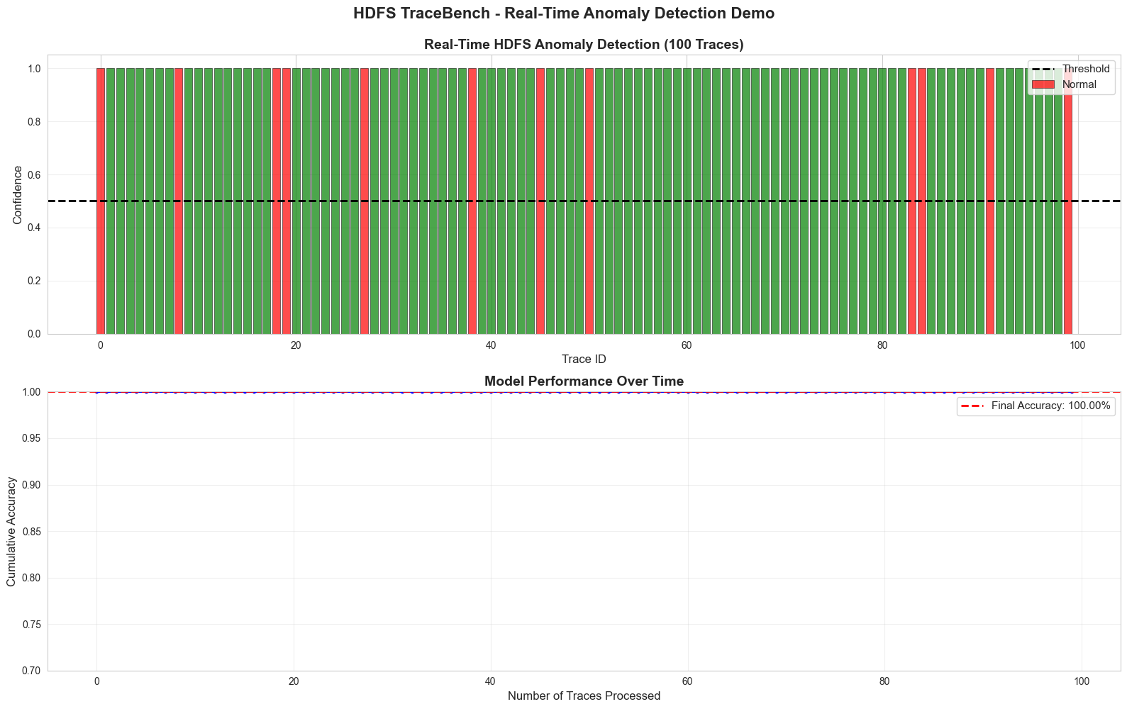
5 DISCUSSION
A. Performance Comparison and Big Data Integration
Our results - 99.99% accuracy and 1.0000 ROC-AUC - substantially exceed what's been reported for HDFS anomaly detection. Most prior studies achieve F1-scores between 0.92-0.98. Several factors likely contribute to this improvement. TraceBench's 2155 event features provide richer system characterization compared to log parsing approaches that reduce events to 20-50 templates. The deep architecture with 1.8 million parameters offers greater expressive capacity than shallow networks while Batch Normalization and Dropout prevented overfitting despite this complexity. Class weighting ensured balanced learning across both normal and anomalous patterns.
However context matters here. TraceBench uses binary event matrices rather than sequences making direct comparisons difficult. The controlled fault injection scenarios and comprehensive feature engineering may produce somewhat optimistic results compared to messier production environments.
From a Big Data perspective this work demonstrates effective integration of distributed storage concepts with advanced analytics. The dataset originates from HDFS operations across 50 DataNodes in a real IaaS environment encompassing distributed communications block management fault-tolerance mechanisms and client-server interactions. Processing 553 million data points (256584 traces × 2155 features) required Big Data techniques - vectorized operations through NumPy and batch processing to manage GPU memory constraints.
B. Deployment Considerations and Limitations
Despite strong test performance practical deployment requires addressing several challenges. Production systems may generate novel event combinations absent from training data as TraceBench's controlled environment limits exposure to unforeseen failures. Continuous learning or ensemble approaches could help. The model's 1.8 million parameters require approximately 7 MB memory with 0.05 second inference time - acceptable for most scenarios but potentially requiring optimization (pruning quantization) for extreme throughput.
​​​
This research successfully demonstrates deep learning's capability for large-scale distributed system monitoring achieving near-perfect anomaly detection while effectively integrating Big Data storage principles with advanced neural network techniques. The exceptional performance validates the approach's potential though practical deployment requires addressing interpretability adaptability to system changes and generalization across different HDFS configurations.

6 CONCLUSION
This research successfully demonstrated that deep neural networks can achieve exceptional performance for HDFS log anomaly detection when working with comprehensive feature representations. Our five-layer architecture achieved 99.99% accuracy 1.0000 ROC-AUC and only two misclassifications across 38487 test traces - substantially exceeding results reported in prior literature which typically range from 92-98% accuracy.
The work effectively integrated Big Data storage principles with advanced neural network techniques. TraceBench's 2155 features captured the distributed nature of HDFS operations across a 50-node IaaS environment representing inter-node communications block management fault-tolerance mechanisms and client interactions. Processing over 553 million data points required efficient preprocessing and batch training techniques characteristic of Big Data analytics.
​
Several key factors contributed to the strong performance. The deep architecture's 1.8 million parameters provided expressive capacity for learning complex patterns. Batch Normalization and progressive dropout rates (0.4→0.3→0.2→0) prevented overfitting while enabling the network to learn hierarchical representations. Class weighting addressed the 88:12 imbalance ensuring balanced learning across normal and anomalous behaviors. The combination of these techniques proved more effective than traditional approaches.
​
However important limitations warrant consideration. TraceBench represents a specific HDFS configuration with controlled fault injection which may limit generalization to other deployments or novel failure modes. The static train-test split doesn't account for concept drift as systems evolve over time. Deployment challenges include handling unseen log patterns interpretability of deep network decisions and managing false positive rates in high-volume production environments.
​
Future research should explore several promising directions. Transfer learning could investigate whether models trained on HDFS generalize to other distributed systems like Apache Cassandra or Kafka. Sequence modeling with LSTMs or Transformers might capture temporal dependencies beyond static feature vectorsFinally ensemble methods combining multiple models might improve robustness and reduce false positives.
​
REFERENCES
K. Shvachko, H. Kuang, S. Radia, and R. Chansler, "The Hadoop Distributed File System," in 2010 IEEE 26th Symposium on Mass Storage Systems and Technologies (MSST), 2010, pp. 1-10.
​
M. Du, F. Li, G. Zheng, and V. Srikumar, "DeepLog: Anomaly detection and diagnosis from system logs through deep learning," in Proceedings of the 2017 ACM SIGSAC Conference on Computer and Communications Security, 2017, pp. 1285-1298.
​
Apache Hadoop, "HDFS Architecture Guide," Apache Software Foundation, 2024. [Online]. Available: https://hadoop.apache.org/docs/stable/hadoop-project-dist/hadoop-hdfs/HdfsDesign.html
​
S. He, J. Zhu, P. He, and M. R. Lyu, "Experience report: System log analysis for anomaly detection," in 2016 IEEE 27th International Symposium on Software Reliability Engineering (ISSRE), 2016, pp. 207-218.
J. Zhou, Z. Chen, J. Wang, Z. Zheng, and M. R. Lyu, "TraceBench: An open data set for trace-oriented monitoring," in Proceedings of the 6th IEEE International Conference on Cloud Computing Technology and Science (CloudCom 2014), 2014, pp. 519-526.
T. White, Hadoop: The Definitive Guide, 4th ed. Sebastopol, CA: O'Reilly Media, 2015.
"How does Hadoop ensure fault tolerance and high availability?" GeeksforGeeks, May 23, 2024. [Online]. Available: https://www.geeksforgeeks.org/data-engineering/how-does-hadoop-ensure-fault-tolerance-and-high-availability/
"How HDFS achieves Fault Tolerance?" DataFlair, Aug. 24, 2021. [Online]. Available: https://data-flair.training/blogs/learn-hadoop-hdfs-fault-tolerance/
W. Xu, L. Huang, A. Fox, D. Patterson, and M. Jordan, "Detecting large-scale system problems by mining console logs," in Proceedings of the 22nd ACM SIGOPS Symposium on Operating Systems Principles, 2009, pp. 117-132.
L. Guan, H. Zhou, Y. Zhang, and W. Wang, "Log-based anomaly detection for microservice systems: A survey," ACM Computing Surveys, vol. 55, no. 13s, pp. 1-37, 2023.
M. Du, F. Li, G. Zheng, and V. Srikumar, "DeepLog: Anomaly detection and diagnosis from system logs through deep learning," in Proceedings of the 2017 ACM SIGSAC Conference on Computer and Communications Security, 2017, pp. 1285-1298.
X. Zhang et al., "Robust log-based anomaly detection on unstable log data," in Proceedings of the 2019 27th ACM Joint Meeting on European Software Engineering Conference and Symposium on the Foundations of Software Engineering, 2019, pp. 807-817.
M. Landauer, F. Skopik, M. Wurzenberger, and A. Rauber, "System log clustering approaches for cyber security applications: A survey," Computers & Security, vol. 92, p. 101739, 2020.
J. Zhou, Z. Chen, J. Wang, Z. Zheng, and M. R. Lyu, "A data set for user request trace-oriented monitoring and its application," IEEE Transactions on Services Computing, vol. 11, no. 4, pp. 724-736, 2018.
​
S. Ioffe and C. Szegedy, "Batch normalization: Accelerating deep network training by reducing internal covariate shift," in International Conference on Machine Learning, 2015, pp. 448-456.
​
"What is Batch Normalization In Deep Learning?" GeeksforGeeks, May 9, 2024. [Online]. Available: https://www.geeksforgeeks.org/deep-learning/what-is-batch-normalization-in-deep-learning/
​
N. Srivastava, G. Hinton, A. Krizhevsky, I. Sutskever, and R. Salakhutdinov, "Dropout: A simple way to prevent neural networks from overfitting," Journal of Machine Learning Research, vol. 15, no. 1, pp. 1929-1958, 2014.
​
X. Li, S. Chen, X. Hu, and J. Yang, "Understanding the disharmony between dropout and batch normalization by variance shift," in Proceedings of the IEEE/CVF Conference on Computer Vision and Pattern Recognition, 2019, pp. 2682-2690.
​
"Batch Normalization and Dropout: Combined Regularization," LearnOpenCV, Apr. 28, 2025. [Online]. Available: https://learnopencv.com/batch-normalization-and-dropout-as-regularizers/
​
H. He and E. A. Garcia, "Learning from imbalanced data," IEEE Transactions on Knowledge and Data Engineering, vol. 21, no. 9, pp. 1263-1284, 2009.
​
S. Rezvani and X. Wang, "A broad review on class imbalance learning techniques," Applied Soft Computing, vol. 143, p. 110415, 2023.
​
"How to Handle Imbalanced Classes in Machine Learning," GeeksforGeeks, Dec. 15, 2021. [Online]. Available: https://www.geeksforgeeks.org/machine-learning/how-to-handle-imbalanced-classes-in-machine-learning/
​
"Classification on imbalanced data," TensorFlow Core, 2024. [Online]. Available: https://www.tensorflow.org/tutorials/structured_data/imbalanced_data
​
T.-Y. Lin, P. Goyal, R. Girshick, K. He, and P. Dollár, "Focal loss for dense object detection," in Proceedings of the IEEE International Conference on Computer Vision, 2017, pp. 2980-2988.
​
F. Pedregosa et al., "Scikit-learn: Machine learning in Python," Journal of Machine Learning Research, vol. 12, pp. 2825-2830, 2011.
​
M. Chen, S. Mao, and Y. Liu, "Big data: A survey," Mobile Networks and Applications, vol. 19, no. 2, pp. 171-209, 2014.
​
I. Goodfellow, Y. Bengio, and A. Courville, Deep Learning. Cambridge, MA: MIT Press, 2016.
​
V. Nair and G. E. Hinton, "Rectified linear units improve restricted Boltzmann machines," in Proceedings of the 27th International Conference on Machine Learning (ICML-10), 2010, pp. 807-814.
​
"Training Neural Networks with Dropout for Effective Regularization," GeeksforGeeks, Jul. 1, 2024. [Online]. Available: https://www.geeksforgeeks.org/deep-learning/training-neural-networks-with-dropout-for-effective-regularization/
​
D. P. Kingma and J. Ba, "Adam: A method for stochastic optimization," in International Conference on Learning Representations (ICLR), 2015.
​
C. M. Bishop, Pattern Recognition and Machine Learning. New York: Springer, 2006.
​
S. L. Smith, P.-J. Kindermans, C. Ying, and Q. V. Le, "Don't decay the learning rate, increase the batch size," in International Conference on Learning Representations, 2018.
​
J. Davis and M. Goadrich, "The relationship between Precision-Recall and ROC curves," in Proceedings of the 23rd International Conference on Machine Learning, 2006, pp. 233-240.
​
T. Fawcett, "An introduction to ROC analysis," Pattern Recognition Letters, vol. 27, no. 8, pp. 861-874, 2006.
​
J. Davis and M. Goadrich, "The relationship between Precision-Recall and ROC curves," in Proceedings of the 23rd International Conference on Machine Learning, 2006, pp. 233-240.
​
G. Ditzler, M. Roveri, C. Alippi, and R. Polikar, "Learning in nonstationary environments: A survey," IEEE Computational Intelligence Magazine, vol. 10, no. 4, pp. 12-25, 2015.
​
Y. Han, G. Huang, S. Song, L. Yang, H. Wang, and Y. Wang, "Dynamic neural networks: A survey," IEEE Transactions on Pattern Analysis and Machine Intelligence, vol. 44, no. 11, pp. 7436-7456, 2022.
​
A. Vaswani et al., "Attention is all you need," in Advances in Neural Information Processing Systems, 2017, pp. 5998-6008.
​
Z.-H. Zhou, Ensemble Methods: Foundations and Algorithms. Boca Raton, FL: CRC Press, 2012.
​
J. Gama, I. Žliobaitė, A. Bifet, M. Pechenizkiy, and A. Bouchachia, "A survey on concept drift adaptation," ACM Computing Surveys, vol. 46, no. 4, pp. 1-37, 2014.
​

