COMPARATIVE ANALYSIS OF SIMPLE AND MULTIPLE LINEAR
REGRESSION USING DATA VISUALIZATION AND
EXPLORATORY DATA ANALYSIS

CREDIT ACTIVITY – I
Subject: DS-301-MJ-T: Data Visualization and Modelling
Class: T.Y. B.Sc. (Data Science) – Semester V
Academic Year: 2026–27
SUBMITTED BY
Name: Nandini Aabasaheb Devkar
Roll No.: 10

SUBMITTED TO
Department of Computer Science
1. Introduction
Data Visualization and Exploratory Data Analysis are important stages in the Data Science process. Data visualization helps to represent data using graphs and charts, while Exploratory Data Analysis helps to understand patterns, relationships, distributions and unusual observations in a dataset.
Regression analysis is a supervised machine learning technique used to study the relationship between a dependent variable and one or more independent variables. It can also be used for prediction.
In this activity, a House Price Prediction dataset is selected for performing regression analysis. The main objective is to compare Simple Linear Regression and Multiple Linear Regression using appropriate data visualization and evaluation metrics.
The target variable selected for this analysis is price.
Different property-related variables such as number of bedrooms, bathrooms, living area, lot area, floors, waterfront, view and condition are available in the dataset.
Two regression models are developed in this project. The first model is Simple Linear Regression, where "sqft_living" is used as the independent variable and "price" is used as the dependent variable. The second model is Multiple Linear Regression, where multiple variables such as "sqft_living", "bedrooms", "bathrooms", "floors" and "condition" are used to predict "price".
Both models are evaluated using four important performance measures:
• R² Score
• Mean Absolute Error (MAE)
• Mean Squared Error (MSE)
• Root Mean Squared Error (RMSE)
Finally, the performance of both models is compared to identify which model is more suitable for the selected dataset.
The analysis was performed using Python, Pandas, NumPy, Matplotlib, Seaborn and Scikit-learn in Jupyter Notebook. The notebook uses Python and the required machine learning libraries for the complete analysis.
2. Dataset Overview
The selected dataset is a House Price Prediction dataset. It contains information about residential properties and their characteristics.
The dataset was loaded into Python using Pandas.
df = pd.read_csv("data.csv") The first few records were displayed using "df.head()" to understand the structure and values of the dataset.
Dataset Information
Description | Value
Total Rows | 4,600
Total Columns | 18
Target Variable | price
Data Type | Numerical + Categorical
Missing Values | 0
Duplicate Rows | 0

The notebook confirms that the dataset contains 4,600 records and 18 columns.
Important Variables
The dataset contains the following variables:
1. "date"
2. "price"
3. "bedrooms"
4. "bathrooms"
5. "sqft_living"
6. "sqft_lot"
7. "floors"
8. "waterfront"
9. "view"
10. "condition"
11. "sqft_above"
12. "sqft_basement"
13. "yr_built"
14. "yr_renovated"
15. "street"
16. "city"
17. "statezip"
18. "country"
The variable price is selected as the target variable because the objective of the project is to analyse and predict house prices.
Dataset Summary
The descriptive statistics show that the average house price is approximately 551,963, while the average living area is approximately 2,139 square feet. The dataset also contains variation in bedrooms, bathrooms, lot size, floors and other property characteristics.
3. Data Preprocessing
Data preprocessing is performed before Exploratory Data Analysis and model building. The main purpose of preprocessing is to make sure that the dataset is clean and suitable for analysis.
The following preprocessing steps were performed.
3.1 Checking Dataset Structure
The shape, column names and data types were checked.
The dataset contains: 4,600 rows × 18 columns The dataset contains both numerical and text-based columns.
Numerical variables include price, bedrooms, bathrooms, sqft_living, sqft_lot, floors and other property-related variables.
3.2 Missing Value Check
Missing values were checked using:
df.isnull().sum()
The output shows 0 missing values in every column.
Therefore, no missing-value imputation was required.
3.3 Duplicate Value Check
Duplicate records were checked using:
df.duplicated().sum()
The output was: Duplicate Rows: 0 Therefore, there were no duplicate records in the original dataset.
3.4 Removing Duplicates and Missing Values
For consistency, the notebook applies: df = df.drop_duplicates() df = df.dropna() After preprocessing, the final dataset remained: 4,600 rows × 18 columns This confirms that no records were removed because the dataset already contained no duplicates or missing values.
Preprocessing Result

Step | Result
Original Dataset | 4600 × 18
Missing Values | 0
Duplicate Rows | 0
Final Dataset | 4600 × 18

Interpretation:
The dataset was already clean and therefore no major data-cleaning operation was required.
4. Exploratory Data Analysis
Exploratory Data Analysis (EDA) was performed to understand the distribution of house prices and the relationship between important variables.
EDA is useful for identifying:
• Data distribution
• Trends
• Relationships
• Outliers
• Variations
• Important predictive variables
Different graphical techniques were used in the notebook.
4.1 Distribution of House Prices
A histogram with KDE was created for the "price" variable.
sns.histplot(df["price"], kde=True)
The graph shows how house prices are distributed across the dataset.
Observation
The house prices show a wide range. Most observations are concentrated in a lower price range, while a smaller number of properties have very high prices.
This indicates that the price variable contains considerable variation and some extreme values.
Output to add:
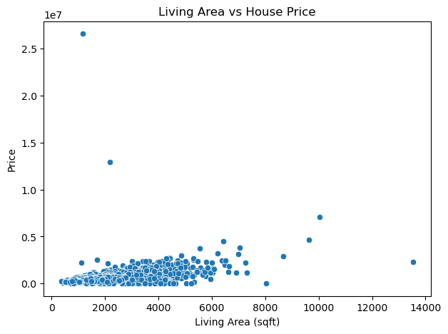
Figure 1: Distribution of House Prices

Interpretation:
The distribution is not perfectly symmetric. The presence of high-price properties can influence regression performance.
4.2 Living Area vs House Price
A scatter plot was created between "sqft_living" and "price".
sns.scatterplot(x=df["sqft_living"],
y=df["price"]) Here:
• X-axis = Living Area in square feet
• Y-axis = House Price
The notebook specifically labels this graph “Living Area vs House Price.”
Observation
The scatter plot indicates a positive relationship between living area and house price. In general, houses with larger living areas tend to have higher prices.
However, the points are widely scattered. This indicates that living area alone cannot explain all variations in house prices.

Output to add:
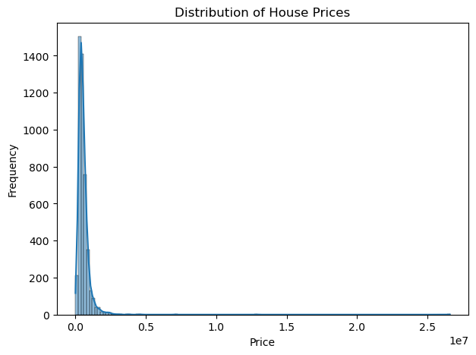
Figure 2: Living Area vs House Price
5. Data Visualization Findings
Data visualization provides a better understanding of the selected dataset.
5.1 Price Distribution
The price distribution graph shows that house prices vary considerably. Some properties have much higher prices than the majority of observations.
This suggests the possibility of extreme values in the target variable.
5.2 Living Area and Price
The scatter plot between "sqft_living" and "price" shows a general positive relationship.
When living area increases, house price generally tends to increase.
However, there are many observations where houses with similar living areas have different prices. This suggests that other factors also influence house price.
5.3 Descriptive Statistics
The descriptive statistics provide useful information about the numerical variables.
Important values include:

Variable | Mean | Minimum | Maximum
Price | 551,963 | 0 | 26,590,000
Bedrooms | 3.40 | 0 | 9
Bathrooms | 2.16 | 0 | 8
Sqft Living | 2,139 | 370 | 13,540
Floors | 1.51 | 1 | 3.5
Condition | 3.45 | 1 | 5

These values are obtained from the notebook's "describe()" output.
5.4 EDA Conclusion
The EDA shows that:
• House prices have high variation.
• Living area has a positive relationship with price.
• Other variables are also likely to influence price.
• Some extreme values are present.
• Using only one variable may not be sufficient for accurate
prediction.
Therefore, both Simple Linear Regression and Multiple Linear Regression are implemented for comparison.
Output to add:
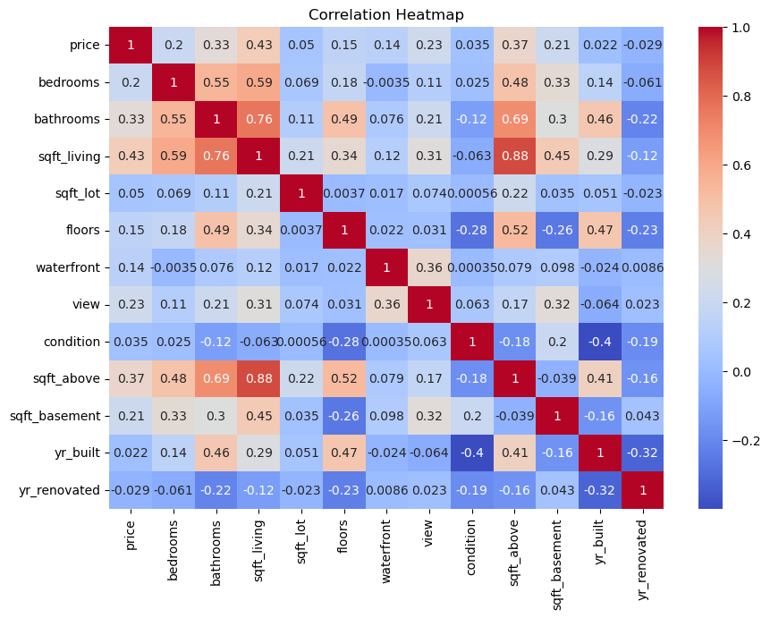

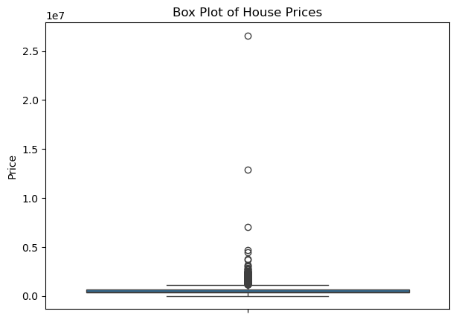
Figure 3: Additional EDA visualization from notebook
6. Simple Linear Regression
Simple Linear Regression is a statistical and machine learning method used to predict a dependent variable using one independent variable.
The general equation is:
Y = β₀ + β₁X
Where:
• Y = dependent variable
• X = independent variable
• β₀ = intercept
• β₁ = coefficient
Variables Selected
For this project: Independent Variable: "sqft_living" Dependent Variable: "price" The objective is to understand whether living area can be used to predict house price.
Train-Test Split
The dataset was divided into training and testing data.
• Training data = 80%
• Testing data = 20%
The training dataset is used to build the regression model, while the testing dataset is used to evaluate its performance.
Model Building
The Linear Regression model was created using Scikit-learn.
The model learns the relationship between living area and house price.
Model Evaluation
The Simple Linear Regression model produced the following results:
Metric | Result
R² Score | 0.0291
MAE | 225,375.25
MSE | 990,204,087,727.14
RMSE | 995,089.99

Interpretation The R² score is 0.0291, which is low. It means that "sqft_living" alone explains only a small amount of variation in house prices.
The MAE is approximately 225,375, which indicates a relatively large average prediction error.
The RMSE is approximately 995,090, showing that the model has substantial prediction errors.
Therefore, Simple Linear Regression using only living area is not sufficient for accurate house price prediction.
Output to add:
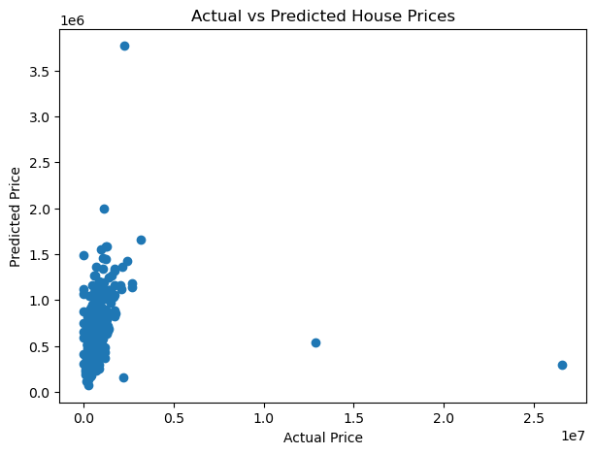
Figure 4: Simple Linear Regression / Actual vs Predicted
7. Simple Linear Regression – Result Analysis
The Simple Linear Regression model uses only one predictor, "sqft_living".
Main Result
R² = 0.0291 This means that the model explains only a small proportion of the variation in house price.
The scatter plot of living area and price shows that there is a general upward trend, but the observations are widely spread.
Why is the performance low?
House prices are affected by many factors.
For example:
• Location
• Number of bedrooms
• Number of bathrooms
• House condition
• Waterfront availability
• View
• Lot size
• Year built
• Renovation
• Floors
Therefore, using only living area cannot capture the complete relationship between property characteristics and price.
Advantages of Simple Linear Regression
• Easy to understand
• Easy to implement
• Simple mathematical interpretation
• Useful for studying one important relationship
Limitations
• Uses only one predictor
• Cannot capture the effect of other variables
• Sensitive to outliers
• Low predictive performance for this dataset
Result
Simple Linear Regression provides a basic understanding of the relationship between living area and house price, but it is not sufficient as a final prediction model.
Output to add:
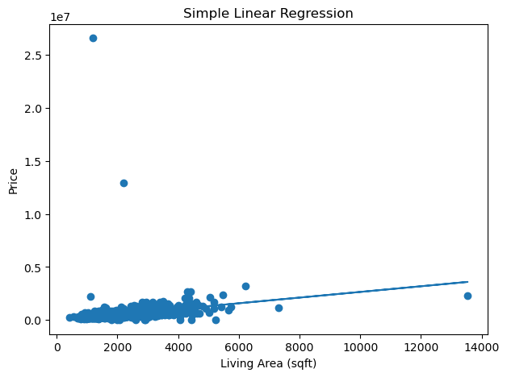
Figure 5: Regression Line / Prediction Output from Notebook
8. Multiple Linear Regression
Multiple Linear Regression is an extension of Simple Linear Regression. It uses multiple independent variables to predict a dependent variable.
The general equation is:
Y = β₀ + β₁X₁ + β₂X₂ + β₃X₃ + ... + βₙXₙ
Variables Selected
The following independent variables were selected:
1. "sqft_living"
2. "bedrooms"
3. "bathrooms"
4. "floors"
5. "condition"
Target Variable
"price" The objective is to determine whether using multiple property characteristics improves house price prediction compared with using only "sqft_living".
Train-Test Split
The dataset was divided into:
• 80% Training Data
• 20% Testing Data
The model was trained on the training data and evaluated on the testing data.
Evaluation Results
Metric | Multiple Linear Regression
R² Score | 0.0293
MAE | 222,208.43
MSE | 989,974,118,183.76
RMSE | 994,974.43

Interpretation The Multiple Linear Regression model has an R² score of 0.0293. This is slightly higher than the Simple Linear Regression R² score of 0.0291. The MAE, MSE and RMSE values are also slightly lower than those of Simple Linear Regression. This indicates that adding multiple variables improves the model slightly.However, the overall predictive performance remains low.
9. Model Evaluation
Four evaluation metrics were used to compare the two regression models.
9.1 R² Score
R² Score measures how much variation in the dependent variable is explained by the model. A higher R² generally indicates better model performance.
9.2 Mean Absolute Error
MAE represents the average absolute difference between actual and predicted values. Lower MAE indicates better performance.

9.3 Mean Squared Error
MSE calculates the average squared difference between actual and predicted values. Lower MSE indicates better performance.
9.4 Root Mean Squared Error
RMSE is the square root of MSE.Lower RMSE indicates better prediction performance.
Comparative Results
Evaluation Metric | Simple Linear Regression | Multiple Linear
R² Score | 0.0291 | 0.0293
MAE | 225,375.25 | 222,208.43
MSE | 990,204,087,727.14 | 989,974,118,183.76
RMSE | 995,089.99 | 994,974.43

Result
Multiple Linear Regression performs slightly better according to all four evaluation metrics.
It has:
• Higher R²
• Lower MAE
• Lower MSE
• Lower RMSE
Therefore, Multiple Linear Regression is the better model among the two models implemented in this project.
Output to add:
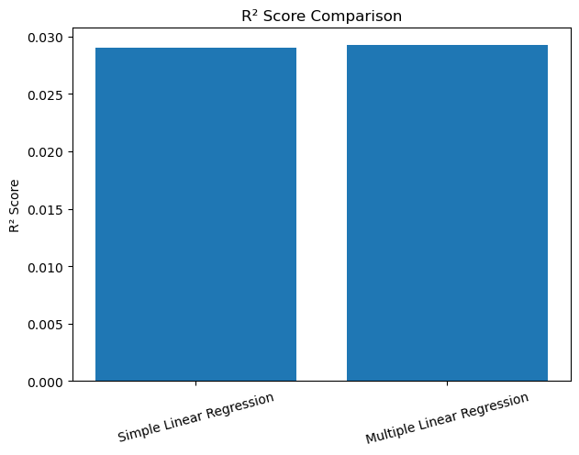
Figure 6: Model Performance Comparison Chart
10. Comparative Analysis
The main purpose of the activity is to compare Simple Linear Regression and Multiple Linear Regression.
Simple Linear Regression Simple Linear Regression uses only one independent variable: "sqft_living" Its R² score is:
0.0291 The model provides a basic relationship between living area and house price.
However, house prices are affected by many factors, so using one variable is not enough.
Multiple Linear Regression Multiple Linear Regression uses:
• "sqft_living"
• "bedrooms"
• "bathrooms"
• "floors"
• "condition"
Its R² score is:
0.0293 The model performs slightly better because it considers multiple property characteristics.
Comparison
The difference between the two models is small.
The improvement in R² is:

0.0293 − 0.0291 = 0.0002
The MAE also decreases from 225,375.25 to 222,208.43.
Similarly, MSE and RMSE are slightly lower for Multiple Linear Regression.
Which Model is More Suitable?
For the selected dataset, Multiple Linear Regression is more suitable than Simple Linear Regression because it uses multiple relevant features and provides slightly better evaluation results.
However, the low R² value indicates that the selected variables do not explain house prices sufficiently.
Therefore, Multiple Linear Regression is the better model among the two tested models, but it is not an ideal final model for accurate house price prediction.
11. Major Findings
The major findings of the analysis are:
1. The dataset contains 4,600 rows and 18 columns.
2. The target variable is price.
3. The dataset contains 0 missing values.
4. The dataset contains 0 duplicate rows.
5. The final dataset remains 4,600 × 18 after preprocessing.
6. House prices show considerable variation.
7. "sqft_living" shows a positive relationship with "price".
8. Simple Linear Regression gives an R² score of 0.0291.
9. Multiple Linear Regression gives an R² score of 0.0293.
10. Multiple Linear Regression has lower MAE, MSE and RMSE.
11. Multiple Linear Regression performs slightly better.
12. The low R² value indicates that more relevant features are required.
13. House price prediction is influenced by multiple factors.
14. Data visualization helps identify relationships and variations before modelling.
12. Limitations
The following limitations were observed:
• Only selected numerical variables were used in Multiple
Linear Regression.
• Categorical variables such as city and statezip were not
included in the final regression model.
• Extreme values may affect regression performance.
• Linear regression may not capture complex non-linear
relationships.
• The R² score is low.
• The selected features are not sufficient for highly
accurate prediction.
13. Future Scope
The model can be improved by including additional features such as:
• City
• State/ZIP
• Waterfront
• View
• Lot size
• Basement area
• Year built
• Renovation year
• Location-related information
Advanced machine learning algorithms can also be tested, such as:
• Decision Tree Regression
• Random Forest Regression
• Gradient Boosting
• XGBoost
• Support Vector Regression
Feature engineering, outlier treatment and hyperparameter tuning can also be performed to improve prediction accuracy.

14. Conclusion
This project successfully demonstrates the application of Data Visualization, Exploratory Data Analysis and Linear Regression to a House Price Prediction dataset.
The dataset was first loaded and inspected using Python.
Data preprocessing was performed by checking missing values and duplicate records. The analysis confirmed that there were no missing values and no duplicate rows.
Exploratory Data Analysis was then performed using appropriate visualization techniques. The price distribution showed considerable variation in house prices, while the scatter plot of living area and house price showed a general positive relationship.
Two regression models were developed. Simple Linear Regression used "sqft_living" as the independent variable. Multiple Linear Regression used "sqft_living", "bedrooms", "bathrooms", "floors" and "condition".
The Simple Linear Regression model achieved an R² score of 0.0291, whereas the Multiple Linear Regression model achieved an R² score of
0.0293. Multiple Linear Regression also produced slightly lower MAE, MSE and
RMSE values.
Therefore, Multiple Linear Regression performed better than Simple Linear Regression for the selected dataset.
However, both models have low R² scores. This indicates that house price is affected by many other factors that are not included in the selected models. Including additional features and using advanced machine learning algorithms can improve future prediction performance.
Overall, this activity provided practical understanding of the complete data analysis process, including dataset loading, preprocessing, EDA, visualization, regression modelling, model evaluation and comparative analysis.
15. References
1. House Price Prediction dataset used for the analysis.
2. Python Pandas documentation.
3. NumPy documentation.
4. Matplotlib documentation.
5. Seaborn documentation.
6. Scikit-learn documentation.
7. Jupyter Notebook used for data analysis and modelling.
16. Submission Components
The complete activity consists of:
• Python Notebook (".ipynb")
• Dataset used (".csv")
• Analytical Report (".pdf")
The Python Notebook and analytical report contain consistent dataset information, analysis, visualizations and model evaluation results.
End of Report

