1: Common Network IssuesTheory: Common hardware and software issues.Practical : Identify faulty devices in a simulated network.Task: Create a troubleshooting checklist.

Tasks

1. List 5 common hardware issues that can cause network problems in a typical office setup, and for each, describe one symptom that helps identify it.

ANS:

Hardware Issue | Description | Common Symptom
Damaged Ethernet Cable | Cable is broken, bent, or has faulty connectors. | PC shows "Network Cable Unplugged" or no network connection.
Faulty Network Interface Card (NIC) | Network adapter is damaged or malfunctioning. | Device cannot connect to the network even with a working cable.
Defective Switch Port | One switch port stops forwarding traffic. | Only devices connected to that specific port lose connectivity.
Router Hardware Failure | Router components fail or overheat. | Entire network loses internet access.
Power Supply Failure | Network device does not receive proper power. | Device LEDs are off and network communication stops.

2. Open Cisco Packet Tracer or any network simulator, set up a small network with 3 PCs, 1 switch, and 1 router, and intentionally disconnect one device. Use the simulator's troubleshooting tools to identify which device is faulty and document the steps you took.

ANS:

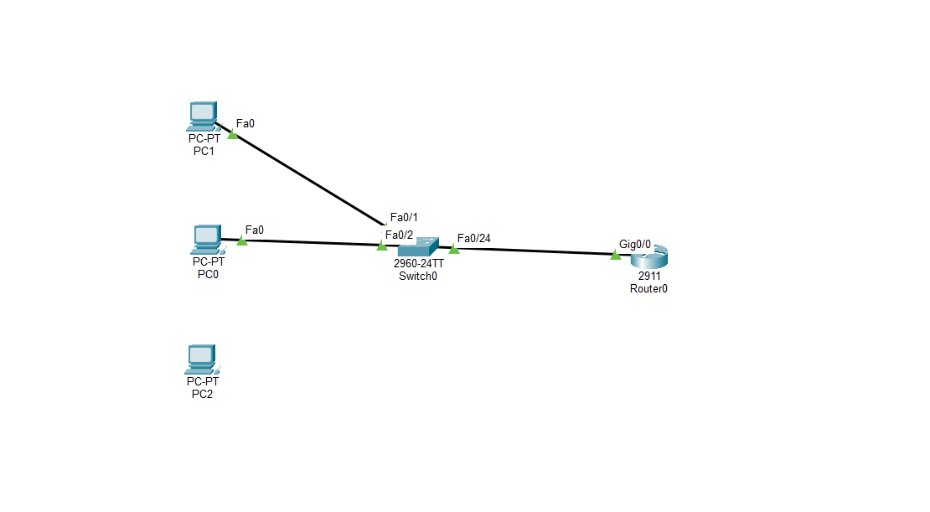

1. Configure IP Addresses
Device | IP Address | Subnet Mask | Gateway
PC0 | 192.168.1.10 | 255.255.255.0 | 192.168.1.1
PC1 | 192.168.1.11 | 255.255.255.0 | 192.168.1.1
PC2 | 192.168.1.12 | 255.255.255.0 | 192.168.1.1
Router G0/0 | 192.168.1.1 | 255.255.255.0 | N/A
2. Test Connectivity
On PC0:
ping 192.168.1.1
Result: Successful
On PC1:
ping 192.168.1.1
Result: Successful
On PC2:
ping 192.168.1.1
Result:
Request timed out.
3. Observe Physical Connections
- PC0 link lights are green.
- PC1 link lights are green.
- Router link is green.
- PC2 has no cable connected.
4. Identify the Fault
Faulty Device: PC2
Reason: PC2 is disconnected from the switch and cannot communicate with the network.
5. Corrective Action
- Connect PC2 FastEthernet0 to Switch Fa0/3 using a Copper Straight-Through cable.
- Wait for the link light to turn green.
- Ping the router again.
Expected result:
ping 192.168.1.1
Reply from 192.168.1.

Conclusion
The network was created successfully with 3 PCs, 1 switch, and 1 router. A fault was intentionally introduced by disconnecting PC2. Connectivity tests and physical inspection identified PC2 as the faulty device. Reconnecting the cable restored normal network communication.
One thing to check: In your screenshot, I cannot tell whether IP addresses and the router interface have been configured. If not, configure them first; otherwise even PC0 and PC1 won't be able to ping the router.

3. Create a troubleshooting checklist for diagnosing slow internet issues in a home WiFi network, including at least 8 steps covering both hardware and software checks.<br><br><em><strong>Hint:</strong> Think about checking cables, router status lights, device settings, and running ping or speed tests.</em>

ANS:

Troubleshooting Checklist for Diagnosing Slow Internet Issues in a Home WiFi Network
Hardware Checks

1. Check Router and Modem Status Lights
- Verify that the Power, Internet/WAN, and WiFi LEDs are on and functioning normally.
- Look for any red, orange, or blinking warning lights.
2. Inspect Cables and Connections
- Ensure all Ethernet and power cables are securely connected.
- Check for damaged or loose cables.
3. Restart the Modem and Router
- Turn off both devices for 30 seconds.
- Power on the modem first, then the router.
4. Check WiFi Signal Strength
- Move closer to the router.
- Ensure there are no major obstacles or interference sources (walls, microwaves, cordless phones).
5. Reduce Network Congestion
- Disconnect unused devices from the WiFi network.
- Pause large downloads or streaming on other devices.

Software and Network Checks

6. Verify Device Network Settings
- Ensure the device is connected to the correct WiFi network.
- Confirm that Airplane Mode is disabled.
7. Run a Speed Test
- Use an online speed test service.
- Compare the results with your ISP's advertised speed.
8. Perform a Ping Test
Open Command Prompt and run:
ping 8.8.8.8
- Check for high latency or packet loss.

9. Test Multiple Devices
- Check whether the slow speed occurs on one device or all devices.
- This helps determine if the issue is device-specific or network-wide.
10. Clear DNS Cache
Open Command Prompt and run:
ipconfig /flushdns
11. Update Network Adapter Drivers
- Check for updates to the WiFi adapter drivers.
- Install any available updates.
12. Scan for Malware or Background Applications
- Run an antivirus scan.
- Close applications consuming excessive bandwidth.

Conclusion
If the issue persists after completing the checklist:
- Contact your Internet Service Provider (ISP) to check for outages or line issues.
- Consider upgrading router firmware or replacing outdated networking equipment.

4. You receive a complaint that a user cannot access Instagram and YouTube on their laptop, but WhatsApp Web works fine. Write down the first 5 troubleshooting steps you would perform to identify if the issue is with hardware, software, or network configuration.

ANS:

Troubleshooting Steps: Unable to Access Instagram and YouTube, but WhatsApp Web Works
Since WhatsApp Web is working, the internet connection is partially functional. The issue may be related to the browser, DNS settings, firewall, or network configuration.
1. Check General Internet Connectivity
- Open other websites such as Google, Wikipedia, or Gmail.
- Verify whether only Instagram and YouTube are affected.
Purpose: Determines if the problem is limited to specific websites or affects the entire internet connection.

2. Test the Websites in a Different Browser
- Try accessing Instagram and YouTube using another browser (Chrome, Edge, Firefox, etc.).
- Clear the browser cache and cookies if necessary.
Purpose: Identifies whether the issue is caused by browser settings or corrupted cache files.

3. Check DNS Resolution
Open Command Prompt and run:
ping youtube.com
ping instagram.com
- If the domain names do not resolve, there may be a DNS issue.
- Change DNS settings to:
  - 8.8.8.8
  - 8.8.4.4
Purpose: Verifies whether DNS configuration is preventing access to specific websites.

4. Check Firewall, Antivirus, or Proxy Settings
- Review Windows Firewall rules.
- Temporarily disable antivirus web protection (for testing).
- Check if a proxy server is configured:
  - Settings → Network & Internet → Proxy
Purpose: Determines whether security software or proxy settings are blocking access.

5. Test on Another Device or Network
- Try opening Instagram and YouTube on another device connected to the same WiFi.
- Alternatively, connect the laptop to a mobile hotspot and test again.
Purpose: Helps identify whether the issue is with the laptop itself or the home network configuration.

Conclusion
By performing these five steps, you can determine whether the issue is caused by:
- Hardware problems (unlikely since WhatsApp Web works),
- Software/browser issues,
- DNS or network configuration problems,
- Firewall/proxy restrictions, or
- Device-specific settings.

