3: Using Advanced ToolsTheory :Introduction to tools like Wireshark, Nmap.Practical :Use Wireshark to capture and analyze network traffic.Task: Document key findings from a packet capture.Pending

Tasks

1. Install Wireshark on your computer and capture 2 minutes of network traffic while you browse Instagram or YouTube. Save the capture file as insta_traffic.pcap.

ANS:

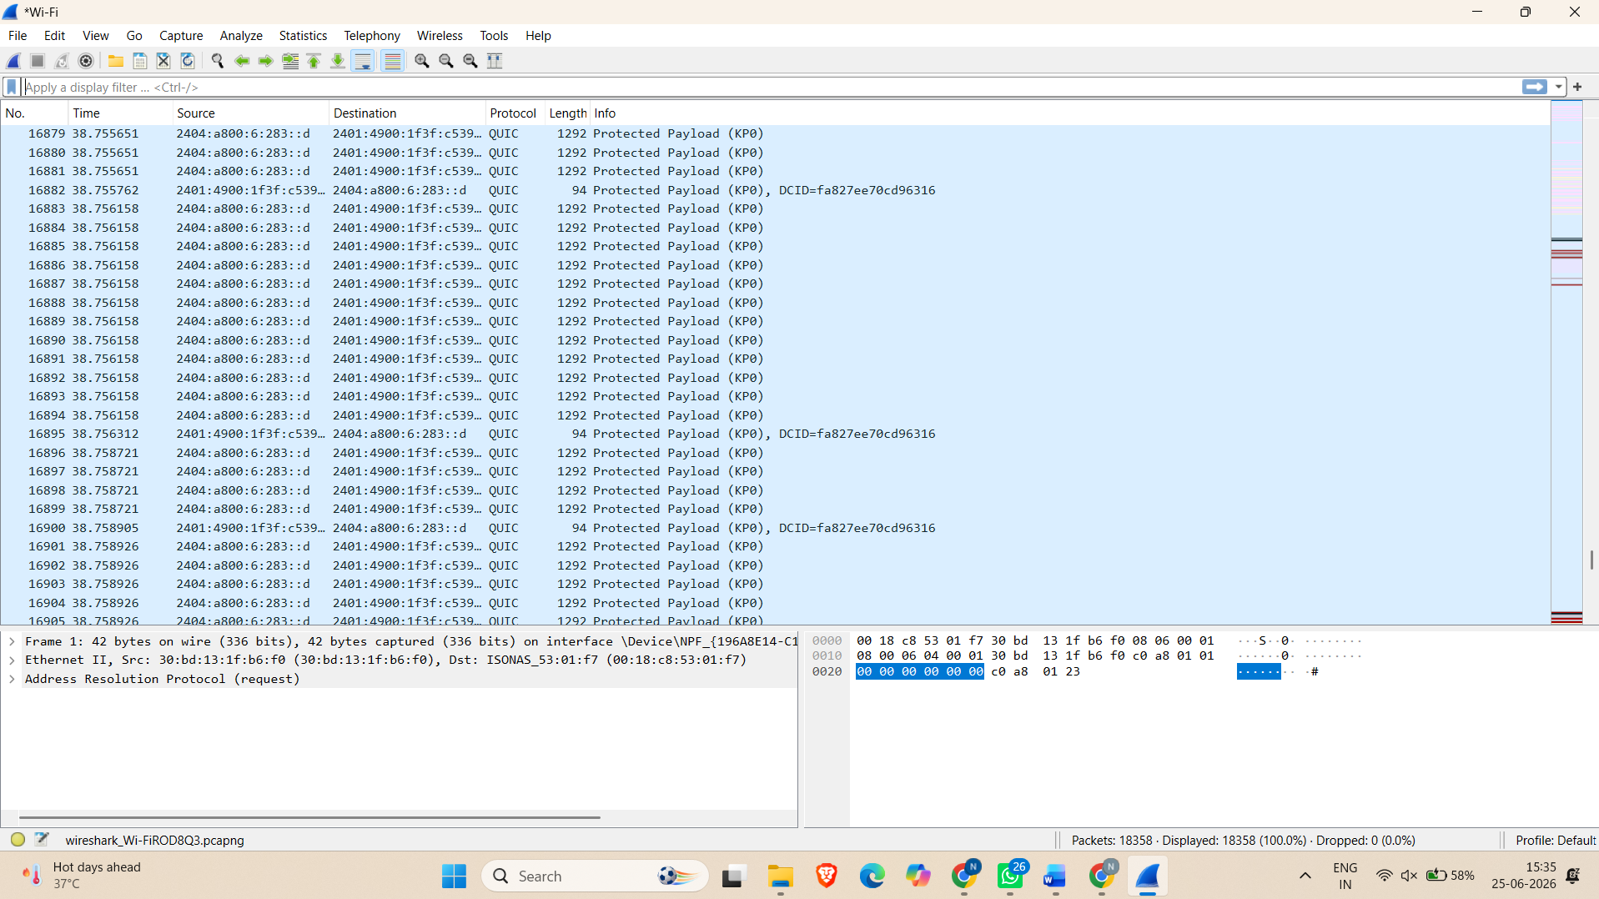

2. Use Wireshark to filter and list all HTTP or HTTPS requests made by your browser during the capture. Write down the domains you see most frequently.

ANS:

