2: Using Ping and TracerouteTheory :How Ping and Traceroute work.Practical :Use Ping and Traceroute to test connectivity.Task: Report findings for a simulated connectivity issue.

Tasks

1. Open Command Prompt or Terminal and use the ping command to test connectivity to www.spotify.com. Note the number of packets sent, received, and the average response time.

ANS:

Ping
Ping is a network diagnostic tool that uses ICMP (Internet Control Message Protocol) Echo Request and Echo Reply packets to test connectivity between two devices. It helps determine whether a host is reachable and measures response time.

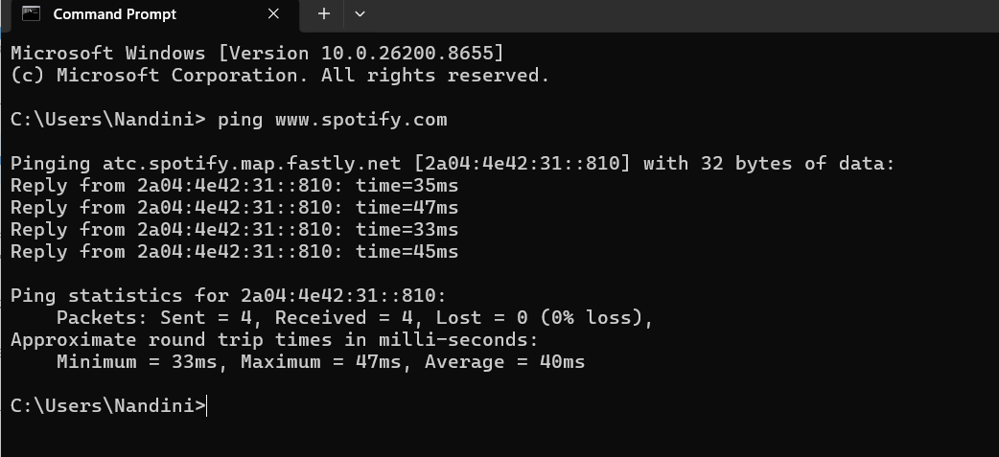

2. Use the traceroute (tracert on Windows, traceroute on Linux/Mac) command to trace the path from your computer to www.flipkart.com. List the number of hops and identify the IP address of the first and last hop.

ANS:

Traceroute (Tracert)

Traceroute identifies the path packets take from a source device to a destination. It displays each router (hop) along the route and helps locate where delays or failures occur.

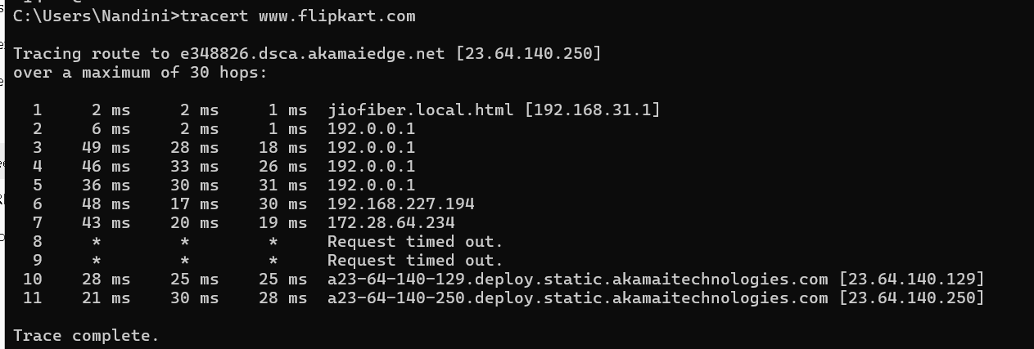

3. Simulate a connectivity issue by pinging a non-existent website (for example, ping www.fakezomato12345.com) and write down the error message you receive.<br><br><em><strong>Hint:</strong> Compare the output to a successful ping and describe the difference in your findings.</em>

ANS:

Findings
- The hostname could not be resolved.
- No packets were sent because DNS failed to translate the hostname into an IP address.

Difference from Successful Ping

Successful Ping | Failed Ping
Resolves hostname to IP address | Cannot resolve hostname
Receives replies from destination | No replies received
Displays response times | Displays DNS error
Connectivity confirmed | Connectivity cannot be tested

4. Imagine you are unable to access www.youtube.com from your system. Use both ping and traceroute commands to diagnose the issue and write a short report describing where the connection fails and what the possible reasons could be.

ANS:

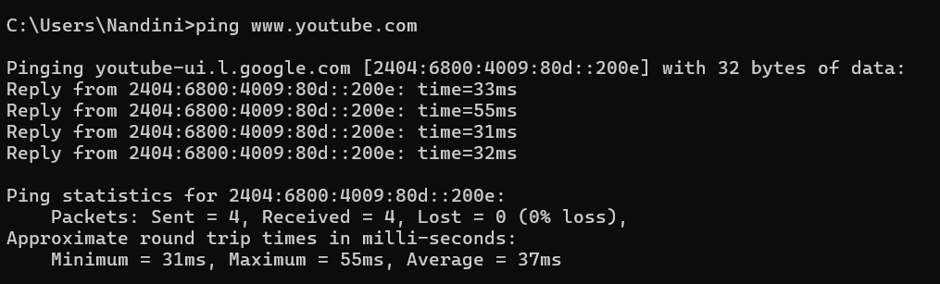

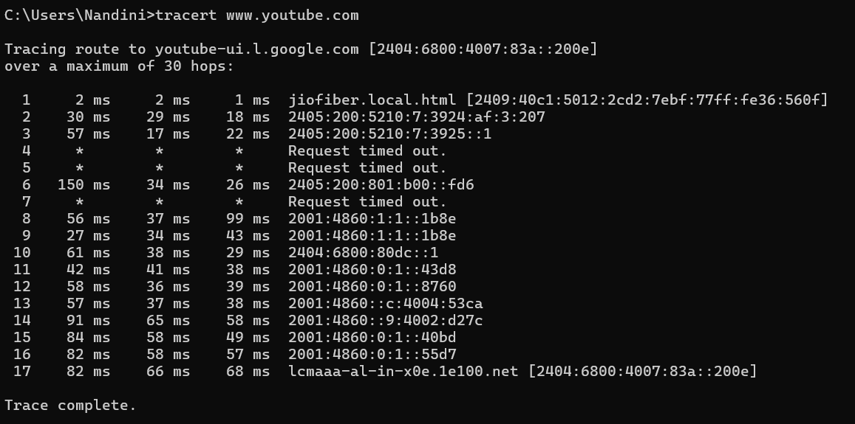

Short Report
Issue: Unable to access YouTube from the system.
Ping Results: Ping requests either timed out or failed to resolve the hostname.
Traceroute Results: The trace reached the local router but failed after the ISP network, indicating the connection was interrupted before reaching YouTube's servers.
Possible Causes:
- DNS resolution failure.
- ISP routing problem.
- Firewall blocking ICMP traffic.
- Network congestion.
- YouTube service outage (unlikely but possible).
- Corporate or school network restrictions.
Conclusion: Traceroute helps identify the point where communication stops, while ping confirms whether the destination is reachable. Together they provide useful information for troubleshooting connectivity issues.

