Assignment 1

**Module -1: Understanding of Hardware and Its Components**

**Section 1: Multiple Choice**

Q.1. Which of the following is NOT a component of the CPU?

1. ALU
2. RAM
3. CU
4. 1 and 3 both

**ANS: 2. RAM**

Q2. What is the function of RAM in a computer

**ANS:** **It stores data and programs temporarily while the computer is working.**

Q3. Which of the following is a primary storage device?

1. HDD
2. SSD
3. SD card
4. 1 and 2 both

**ANS: 4. 1 and 2 both (HDD and SSD)**

Q4. What is the purpose of a GPU?

**ANS:** **It helps the computer show graphics, images and videos smoothly.**

**Section 2: True or False**

Q5. True or False: The motherboard is the main circuit board of a computer where other components are attached.

**ANS: TRUE**

Q6. True or False: A UPS (Uninterruptible Power Supply) is a hardware device that provides emergency power to a load when the input power source fails.

**ANS: TRUE**

Q7. True or False: An expansion card is a circuit board that enhances the functionality of a component.

**ANS: TRUE**

**Section 3: Short Answer**

Q8. Explain the difference between HDD and SSD.

ANS:

|  |  |  |
| --- | --- | --- |
| **Features** | **HDD (Hard Disk Drive)** | **SSD (Solid State Drive)** |
| Speed | It is slower and take more time to load the data. | It is faster and take load data quickly and fast. |
| Power Consumption | Consumes more power. | Uses less power, improving battery life. |
| I/O Performance | 400 io/s | 6000 io/s |
| Access Time | 5.5-8.0 ms | 0.1 ms |
| Backup Rates | 20-24 Hours | 6 Hours |

Q9. Describe the function of BIOS in a computer system.

ANS: The BIOS (Basic Input/Output System) is a in-built program that start working when you turn on your computer. It checks that all important parts like keyboard, memory and drives are working properly or not. When everything is working, it helps load the operating system like Windows and Linux, so you can use the computer.

Q10. List and briefly explain three input devices commonly used with computers.

ANS:

* Here is a list of Input devices commonly used with computers

1. Mouse
2. Keyboard
3. Touchpad
4. Scanner
5. Microphone
6. Touch Screen
7. Game Controller
8. Webcam

* Briefly explain three input devices commonly used with computer

1. Mouse: A mouse is a pointing device used to move a cursor on the screen and select, drag, or open files and programs. It usually has buttons and a scroll wheel for different functions.
2. Keyboard: A keyboard allows users to enter text, numbers, and commands into a computer. It has keys for letters, numbers, symbols.
3. Scanner: A scanner is used to convert physical documents or images into digital format. It captures the image or text and sends it to the computer for editing, storing, or sharing.

**Section 4: Practical Application**

Q11. Identify and label the following components on a diagram of a motherboard:

* CPU
* RAM slots
* SATA connectors
* PCI-E slot

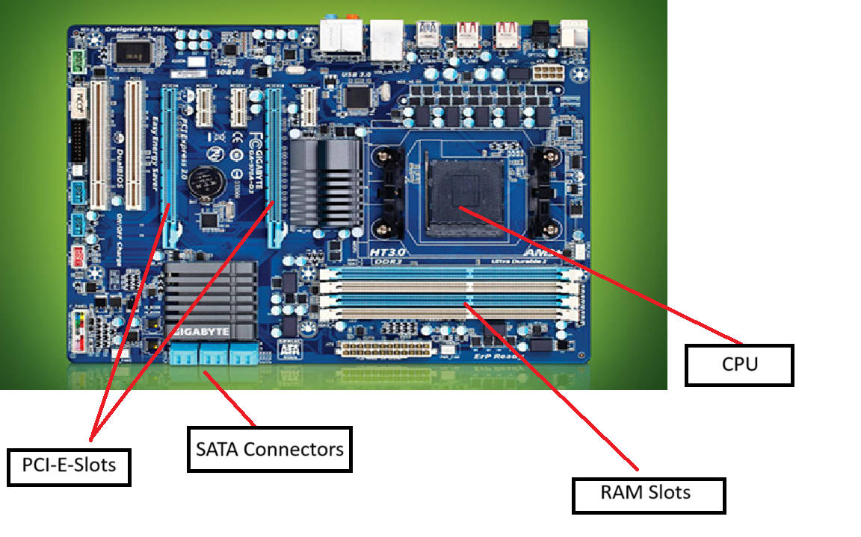

Q12.Demonstrate how to install a RAM module into a computer.

ANS:

STEP 1: Turn off the PC

STEP 2: Open the PC’s Case

STEP 3: Touch the metal or use the anti-static strap

STEP 4: Find the RAM slots Which is near the CPU

STEP 5: Open the RAM Slot Clips

STEP 6: Hod the RAM stick by the edges

STEP 7: Press down the clips to insert the RAM

STEP 8: Close the PC’s Case

STEP 9: Turn on the PC

STEP 10: Check the RAM shows in the PC

**Section 5: Essay**

Q13. Discuss the importance of proper cooling mechanisms in a computer system. Include examples of cooling methods and their effectiveness.

ANS: Proper cooling in computer system is very important to run it safely and smoothly. When a computer works like heavy task such as gaming, editing or any other programs, their parts such as CPU, GPU or power supply can be very hot at that time. If the heat is not removed from the computer, it can cause the problem or slow down the computer or sometime damage the parts of the computer. That’s why computer uses various type of cooling methods to stay cool and safe to the computer. The most common cooling method is air cooling, where fans push the hot air out of the computer and pull cool air in to keep the parts from getting too hot. Heat sinks are metal blocks that sit on hot parts and help pull the heat away. Thermal paste is a soft cream that helps the CPU and cooler share heat better. Big or fast computers use liquid cooling because it works better. It uses water or special liquid to cool down the computer fast and easily. Laptops can stay cool by placing a fan pad under them. These all-cooling methods are help to stop computer heat and help to work for a long time.

Q14. Explain the concept of bus width and its significance in computer architecture.

ANS: In computers, the word bus width means how much data the computer can move at one time. Inside the computer, there are tiny roads called buses that carry data between parts like the CPU, RAM, and other components. The bus width is like the number of lanes on a road. A 32-bit bus can move 32 bits of data at once, while a 64-bit bus can move 64 bits at the same time. A wider bus means the computer can move more data faster, just like more cars can move faster on a big highway with more lanes. If the bus is narrow, it slows things down like traffic on a one-lane road. But a wide bus keeps data flowing quickly and smoothly. This helps the computer load files faster, open programs quickly, and run tasks more easily. For example, a 64-bit processor has a 64-bit bus, so it can handle more data and memory than a 32-bit one. That’s why newer computers with wider bus widths perform better, especially for things like gaming, editing, or multitasking. There are also other buses like the address bus, which tells where the data is stored in memory. The width of the address bus decides how much memory the computer can use. A 32-bit address bus can use up to 4 GB of RAM, while a 64-bit one can use much more—like terabytes of memory. So, bus width is not only about speed, but also about how much the computer can handle. In simple words, bus width is like the size of the computer's data road—the wider it is, the more data can travel at once, and the better the computer works. It’s a very important part of how a computer is built and how fast and powerful it can be.

