***DOCUMENTATION***

***Description:****the concept about join in mysql and union&union all.*

***Join:****join statement is used to combine data or rows from or more tables based on a common*

*Field between them*

*There are different types of joins are their:*

* *INNER JOIN*
* *LEFT JOIN*
* *RIGHT JOIN*
* *FULL JOIN*

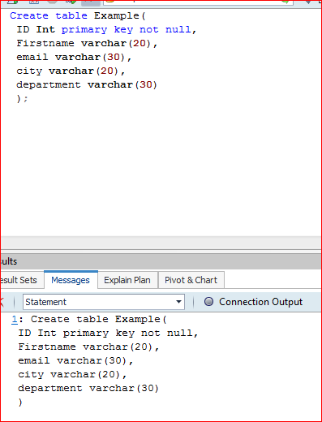

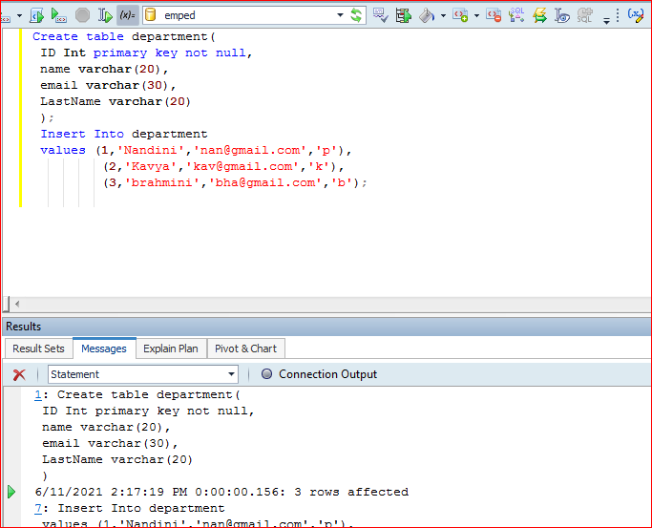

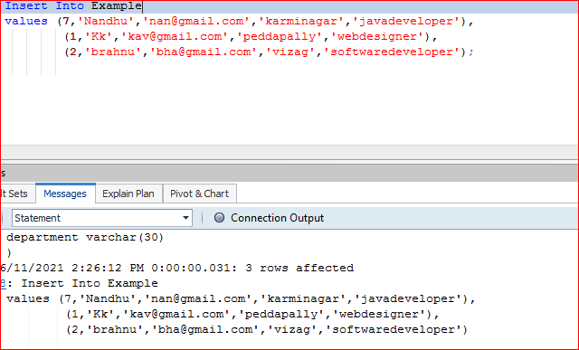

***INNER JOIN:*** *inner join is used to display matching records from both tables this is also called*

*A simple join.*

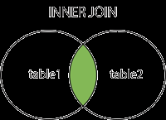

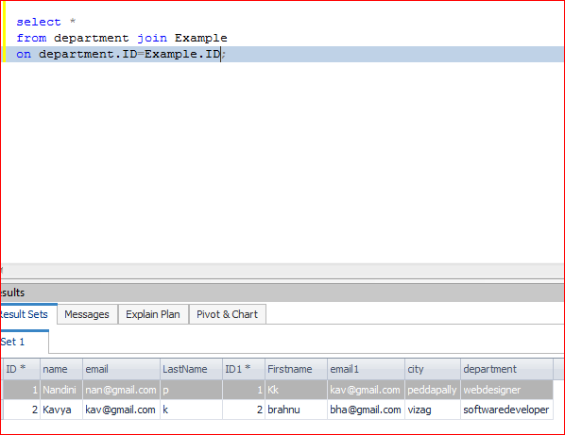

***LEFT JOIN:****Returns all records from the left table ,and the matched records from the right*

Table.

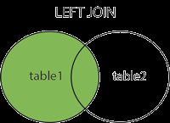

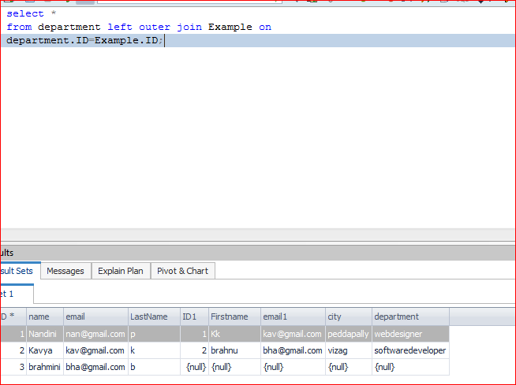

***RIGHT JOIN:****Returns all records from the right table ,and the matched records from the left*

*Table.*

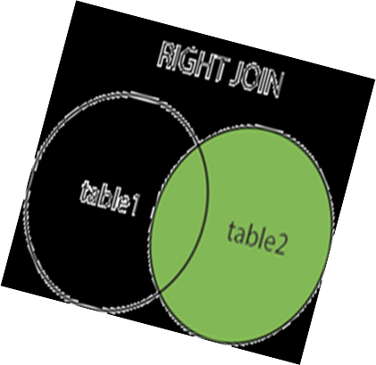

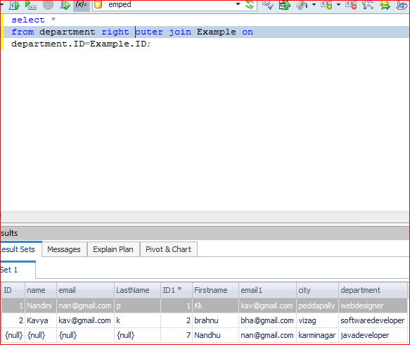

***FULL JOIN:*** *Returns all records when there is a match in either left or right table.*

