**Ex.No: 01**

**DEVELOP AN APPLICATION THAT USES GUI COMPONENTS, FONT AND COLORS**

**Aim:**

To develop an application that uses GUI components fonts and colors.

**Procedure:**

* Open Android Studio and then click on File -> New ->Newproject**.**
* Type the Application name as “MyApplication**″** and click Next**.**
* Select the Empty Activity and click Next.
* Click Finish
* To design the layout: Click on app -> res -> layout -> activity_main.xml.
* Now click on Text and type the code given below
* Click on app -> java -> com.example.myapplication -> MainActivity and type the code given below
* Run the application to see the output in the android emulator.

**Code:**

**Main Activity.java**

package com.example.myapplication;

import android.graphics.Color;

import androidx.appcompat.app.AppCompatActivity;

import android.os.Bundle;

import android.view.View;

import android.widget.Button;

import android.widget.TextView;

public class MainActivity extends AppCompatActivity

{

int ch=1;

float font=30;

@Override

protected void onCreate(Bundle savedInstanceState)

{

super.onCreate(savedInstanceState);

setContentView(R.layout.activity_main);

final TextView t= (TextView) findViewById(R.id.textView);

Button b1= (Button) findViewById(R.id.button1);

b1.setOnClickListener(new View.OnClickListener() {

@Override

public void onClick(View v) {

t.setTextSize(font);

font = font + 5;

if (font == 50)

font = 30;

}

});

Button b2= (Button) findViewById(R.id.button2);

b2.setOnClickListener(new View.OnClickListener() {

@Override

public void onClick(View v) {

switch (ch) {

case 1:

t.setTextColor(Color.RED);

break;

case 2:

t.setTextColor(Color.GREEN);

break;

case 3:

t.setTextColor(Color.BLUE);

break;

case 4:

t.setTextColor(Color.CYAN);

break;

case 5:

t.setTextColor(Color.YELLOW);

break;

case 6:

t.setTextColor(Color.MAGENTA);

break;

}

ch++;

if (ch == 7)

ch = 1;

}

});

}

}

**Activity_main.xml:**

<?xml version="1.0" encoding="utf-8"?>

<LinearLayout xmlns:android="http://schemas.android.com/apk/res/android"

android:orientation="vertical"

android:layout_width="match_parent"

android:layout_height="match_parent">

<TextView

android:id="@+id/textView"

android:layout_width="match_parent"

android:layout_height="wrap_content"

android:layout_margin="30dp"

android:gravity="center"

android:text="Hello World!"

android:textSize="25sp"

android:textStyle="bold" />

<Button

android:id="@+id/button1"

android:layout_width="match_parent"

android:layout_height="wrap_content"

android:layout_margin="20dp"

android:gravity="center"

android:text="Change font size"

android:textSize="25sp" />

<Button

android:id="@+id/button2"

android:layout_width="match_parent"

android:layout_height="wrap_content"

android:layout_margin="20dp"

android:gravity="center"

android:text="Change color"

android:textSize="25sp" />

</LinearLayout>

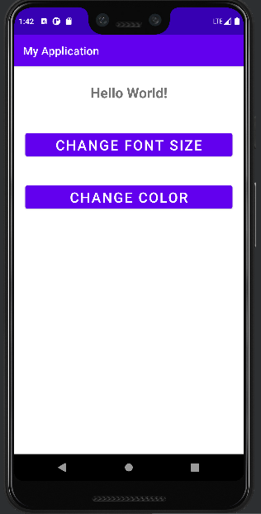**Output:**

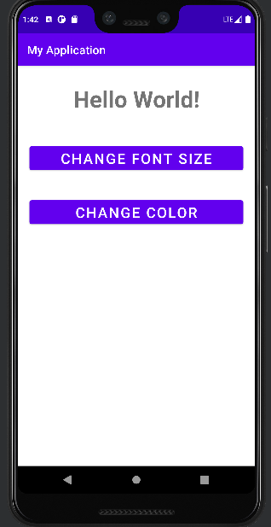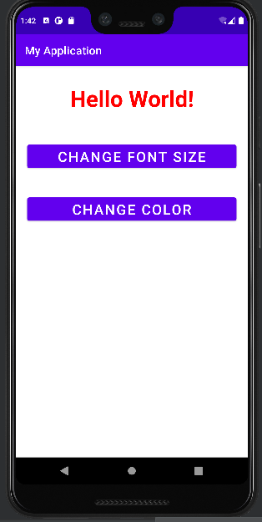

**Result:**

Thus, the application that uses GUI components fonts and colors has been implemented successfully.

**Ex.No: 02**

**DEVELOP AN APPLICATION THAT USES LAYOUT MANAGERS AND EVENT LISTENERS**

**Aim:**

To develop a Simple Android Application that uses Layout Managers and Event Listeners.

**Procedure:**

* Open Android Studio and then click on File -> New -> New project.
* Type the Application name as “My Application″ and click Next.
* Select the Empty Activity and click Next.
* Click Finish
* To design the layout: Click on app -> res -> layout -> activity_main.xml.
* Now click on Text and type the code given below
* For creating the Second Activity, Click on File -> New -> Activity -> Empty Activity.
* Type the Activity Name as SecondActivityand click Finish button.
* Now click on Text and type the code given below
* Click on app -> java -> com.example.myapplication -> MainActivity and type the code given below
* Run the application to see the output in the android emulator.

**Code:**

**MainActivity.java**

package com.example.myapplication;  
  
import android.content.Intent;  
import androidx.appcompat.app.AppCompatActivity;  
import android.os.Bundle;  
import android.view.View;  
import android.widget.ArrayAdapter;  
import android.widget.Button;  
import android.widget.EditText;  
import android.widget.Spinner;  
  
public class MainActivity extends AppCompatActivity {  
  
 //Defining the Views  
 EditText e1,e2;  
 Button bt;  
 Spinner s;  
  
 //Data for populating in Spinner  
 String [] dept_array={"CSE","ECE","IT","Mech","Civil"};  
 String name,reg,dept;  
 @Override  
 protected void onCreate(Bundle savedInstanceState) {  
 super.onCreate(savedInstanceState);  
 setContentView(R.layout.*activity_main*);  
  
 //Referring the Views  
 e1= (EditText) findViewById(R.id.*editText*);  
 e2= (EditText) findViewById(R.id.*editText2*);  
  
 bt= (Button) findViewById(R.id.*button*);  
  
 s= (Spinner) findViewById(R.id.*spinner*);  
  
 //Creating Adapter for Spinner for adapting the data from array to Spinner  
 ArrayAdapter adapter= new ArrayAdapter(MainActivity.this,android.R.layout.*simple_spinner_item*,dept_array);  
 s.setAdapter(adapter);  
  
 //Creating Listener for Button  
 bt.setOnClickListener(new View.OnClickListener() {  
 @Override  
 public void onClick(View v) {  
  
 //Getting the Values from Views(Edittext & Spinner)  
 name=e1.getText().toString();  
 reg=e2.getText().toString();  
 dept=s.getSelectedItem().toString();  
  
 //Intent For Navigating to Second Activity  
 Intent i = new Intent(MainActivity.this,SecondActivity.class);  
  
 //For Passing the Values to Second Activity  
 i.putExtra("name_key", name);  
 i.putExtra("reg_key",reg);  
 i.putExtra("dept_key", dept);  
  
 startActivity(i);  
  
 }  
 });  
 }  
}

**Activity_main.xml:**

<?xml version="1.0" encoding="utf-8"?>  
<RelativeLayout xmlns:android="http://schemas.android.com/apk/res/android"  
 xmlns:tools="http://schemas.android.com/tools"  
 android:layout_width="match_parent"  
 android:layout_height="match_parent"  
 tools:context=".MainActivity">  
  
 <LinearLayout  
 android:layout_width="match_parent"  
 android:layout_height="100dp">  
 <TextView  
 android:id="@+id/textView"  
 android:layout_width="match_parent"  
 android:layout_height="wrap_content"  
 android:layout_margin="30dp"  
 android:text="Details Form"  
 android:textSize="25sp"  
 android:gravity="center"/>  
 </LinearLayout>  
  
 <GridLayout  
 android:id="@+id/gridLayout"  
 android:layout_width="match_parent"  
 android:layout_height="match_parent"  
 android:layout_marginTop="100dp"  
 android:layout_marginBottom="200dp"  
 android:columnCount="2"  
 android:rowCount="3">  
 <TextView  
 android:id="@+id/textView1"  
 android:layout_width="wrap_content"  
 android:layout_height="wrap_content"  
 android:layout_margin="10dp"  
 android:layout_row="0"  
 android:layout_column="0"  
 android:text="Name"  
 android:textSize="20sp"  
 android:gravity="center"/>  
  
 <EditText  
 android:id="@+id/editText"  
 android:layout_width="wrap_content"  
 android:layout_height="wrap_content"  
 android:layout_margin="10dp"  
 android:layout_row="0"  
 android:layout_column="1"  
 android:ems="10"/>  
  
 <TextView  
 android:id="@+id/textView2"  
 android:layout_width="wrap_content"  
 android:layout_height="wrap_content"  
 android:layout_margin="10dp"  
 android:layout_row="1"  
 android:layout_column="0"  
 android:text="Reg.No"  
 android:textSize="20sp"  
 android:gravity="center"/>  
  
 <EditText  
 android:id="@+id/editText2"  
 android:layout_width="wrap_content"  
 android:layout_height="wrap_content"  
 android:layout_margin="10dp"  
 android:layout_row="1"  
 android:layout_column="1"  
 android:inputType="number"  
 android:ems="10"/>  
  
 <TextView  
 android:id="@+id/textView3"  
 android:layout_width="wrap_content"  
 android:layout_height="wrap_content"  
 android:layout_margin="10dp"  
 android:layout_row="2"  
 android:layout_column="0"  
 android:text="Dept"  
 android:textSize="20sp"  
 android:gravity="center"/>  
  
 <Spinner  
 android:id="@+id/spinner"  
 android:layout_width="wrap_content"  
 android:layout_height="wrap_content"  
 android:layout_margin="10dp"  
 android:layout_row="2"  
 android:layout_column="1"  
 android:spinnerMode="dropdown"/>  
  
 </GridLayout>  
  
 <Button  
 android:id="@+id/button"  
 android:layout_width="wrap_content"  
 android:layout_height="wrap_content"  
 android:layout_alignParentBottom="true"  
 android:layout_centerInParent="true"  
 android:layout_marginBottom="150dp"  
 android:text="Submit"/>  
  
</RelativeLayout>

**SecondActivity.java**

package com.example.myapplication;  
  
import android.content.Intent;  
import androidx.appcompat.app.AppCompatActivity;  
import android.os.Bundle;  
import android.widget.TextView;  
  
public class SecondActivity extends AppCompatActivity {  
  
 TextView t1,t2,t3;  
  
 String name,reg,dept;  
  
 @Override  
 protected void onCreate(Bundle savedInstanceState) {  
 super.onCreate(savedInstanceState);  
 setContentView(R.layout.*activity_second*);  
  
 t1= (TextView) findViewById(R.id.*textView1*);  
 t2= (TextView) findViewById(R.id.*textView2*);  
 t3= (TextView) findViewById(R.id.*textView3*);  
  
 //Getting the Intent  
 Intent i = getIntent();  
  
 //Getting the Values from First Activity using the Intent received  
 name=i.getStringExtra("name_key");  
 reg=i.getStringExtra("reg_key");  
 dept=i.getStringExtra("dept_key");  
  
 //Setting the Values to Intent  
 t1.setText(name);  
 t2.setText(reg);  
 t3.setText(dept);  
  
 }  
}

**Activity_second.xml:**

<?xml version="1.0" encoding="utf-8"?>  
<LinearLayout xmlns:android="http://schemas.android.com/apk/res/android"  
 xmlns:tools="http://schemas.android.com/tools"  
 android:layout_width="match_parent"  
 android:layout_height="match_parent"  
 tools:context="com.example.myapplication.SecondActivity"  
 android:orientation="vertical"  
 android:gravity="center">  
  
 <TextView  
 android:id="@+id/textView1"  
 android:layout_width="wrap_content"  
 android:layout_height="wrap_content"  
 android:layout_margin="20dp"  
 android:text="New Text"  
 android:textSize="30sp"/>  
  
 <TextView  
 android:id="@+id/textView2"  
 android:layout_width="wrap_content"  
 android:layout_height="wrap_content"  
 android:layout_margin="20dp"  
 android:text="New Text"  
 android:textSize="30sp"/>  
  
 <TextView  
 android:id="@+id/textView3"  
 android:layout_width="wrap_content"  
 android:layout_height="wrap_content"  
 android:layout_margin="20dp"  
 android:text="New Text"  
 android:textSize="30sp"/>  
  
</LinearLayout>

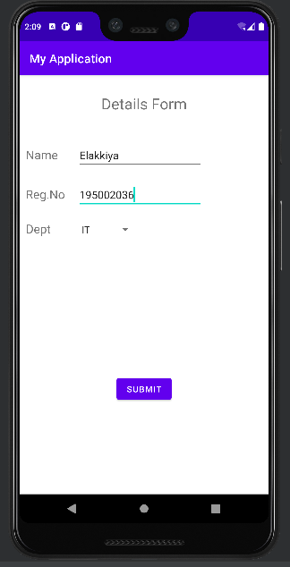**Output:**

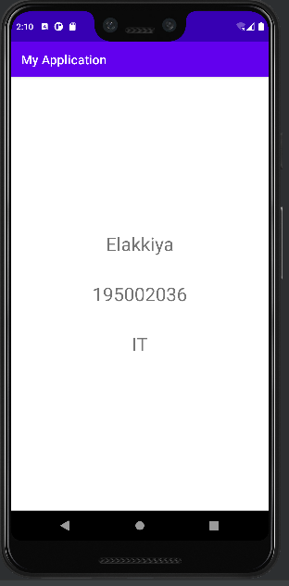**:**

**Result:**

Thus, a Simple Android Application that uses Layout Managers and Event Listeners has been implemented successfully.

**Ex.No: 03**

**DEVELOP A NATIVE CALCULATOR APPLICATION**

**Aim:**

To develop a Simple Android Application for Native Calculator.

**Procedure:**

* Open Android Studio and then click on File -> New ->Newproject**.**
* Type the Application name as “MyApplication**″** and click Next**.**
* Select the Empty Activity and click Next.
* Click Finish
* To design the layout: Click on app -> res -> layout -> activity_main.xml.
* Now click on Text and type the code given below
* Click on app -> java -> com.example.myapplication -> MainActivity and type the code given below
* Run the application to see the output in the android emulator.

**Code:**

**MainActivity.java**

package com.example.myapplication;

import android.os.Bundle;

import androidx.appcompat.app.AppCompatActivity;

import android.text.TextUtils;

import android.view.View;

import android.view.View.OnClickListener;

import android.widget.Button;

import android.widget.EditText;

import android.widget.TextView;

public class MainActivity extends AppCompatActivity implements OnClickListener

{

//Defining the Views

EditText Num1;

EditText Num2;

Button Add;

Button Sub;

Button Mul;

Button Div;

TextView Result;

@Override

public void onCreate(Bundle savedInstanceState)

{

super.onCreate(savedInstanceState);

setContentView(R.layout.activity_main);

//Referring the Views

Num1 = (EditText) findViewById(R.id.editText1);

Num2 = (EditText) findViewById(R.id.editText2);

Add = (Button) findViewById(R.id.Add);

Sub = (Button) findViewById(R.id.Sub);

Mul = (Button) findViewById(R.id.Mul);

Div = (Button) findViewById(R.id.Div);

Result = (TextView) findViewById(R.id.textView);

// set a listener

Add.setOnClickListener(this);

Sub.setOnClickListener(this);

Mul.setOnClickListener(this);

Div.setOnClickListener(this);

}

@Override

public void onClick (View v)

{

float num1 = 0;

float num2 = 0;

float result = 0;

String oper = "";

//check if the fields are empty

if(TextUtils.isEmpty(Num1.getText().toString())||TextUtils.isEmpty(Num2.getText().toString()))

return;

// read EditText and fill variables with numbers

num1 = Float.parseFloat(Num1.getText().toString());

num2 = Float.parseFloat(Num2.getText().toString());

// defines the button that has been clicked and performs the corresponding operation

// write operation into oper, we will use it later for output

switch (v.getId())

{

case R.id.Add:

oper = "+";

result = num1 + num2;

break;

case R.id.Sub:

oper = "-";

result = num1 - num2;

break;

case R.id.Mul:

oper = "*";

result = num1 * num2;

break;

case R.id.Div:

oper = "/";

result = num1 / num2;

break;

default:

break;

}

// form the output line

Result.setText(num1 + " " + oper + " " + num2 + " = " + result);

}

}

**Activity_main.xml:**

<?xml version="1.0" encoding="utf-8"?>

<LinearLayout

xmlns:android="http://schemas.android.com/apk/res/android"

android:orientation="vertical"

android:layout_width="match_parent"

android:layout_height="match_parent"

android:layout_margin="20dp">

<LinearLayout

android:id="@+id/linearLayout1"

android:layout_width="match_parent"

android:layout_height="wrap_content"

android:layout_margin="20dp">

<EditText

android:id="@+id/editText1"

android:layout_width="match_parent"

android:layout_height="wrap_content"

android:layout_weight="1"

android:inputType="numberDecimal"

android:textSize="20sp" />

<EditText

android:id="@+id/editText2"

android:layout_width="match_parent"

android:layout_height="wrap_content"

android:layout_weight="1"

android:inputType="numberDecimal"

android:textSize="20sp" />

</LinearLayout>

<LinearLayout

android:id="@+id/linearLayout2"

android:layout_width="match_parent"

android:layout_height="wrap_content"

android:layout_margin="20dp">

<Button

android:id="@+id/Add"

android:layout_width="match_parent"

android:layout_height="wrap_content"

android:layout_weight="1"

android:text="+"

android:textSize="30sp"/>

<Button

android:id="@+id/Sub"

android:layout_width="match_parent"

android:layout_height="wrap_content"

android:layout_weight="1"

android:text="-"

android:textSize="30sp"/>

<Button

android:id="@+id/Mul"

android:layout_width="match_parent"

android:layout_height="wrap_content"

android:layout_weight="1"

android:text="*"

android:textSize="30sp"/>

<Button

android:id="@+id/Div"

android:layout_width="match_parent"

android:layout_height="wrap_content"

android:layout_weight="1"

android:text="/"

android:textSize="30sp"/>

</LinearLayout>

<TextView

android:id="@+id/textView"

android:layout_width="match_parent"

android:layout_height="wrap_content"

android:layout_marginTop="50dp"

android:text="Answer is"

android:textSize="30sp"

android:gravity="center"/>

</LinearLayout>

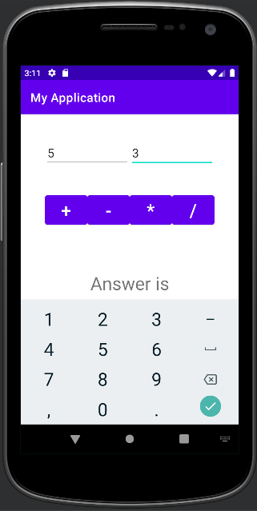**Output:**

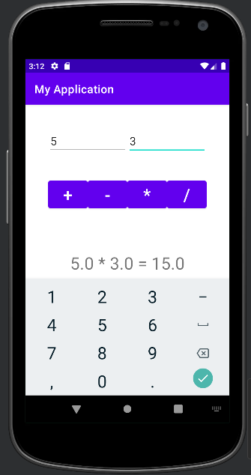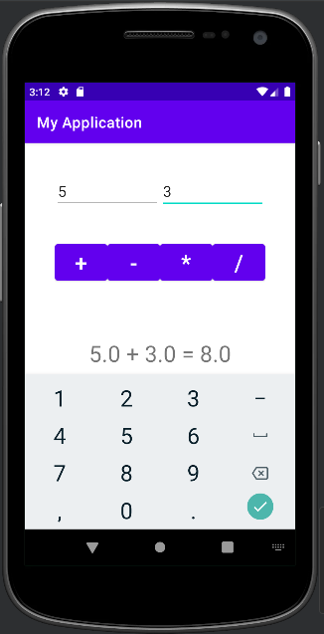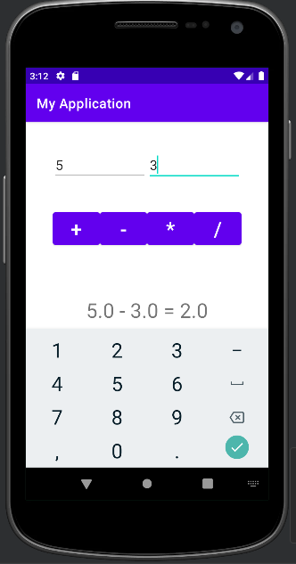

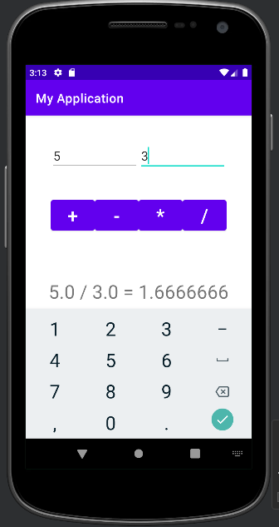 **Result:**

Thus, a Simple Android Application for Native Calculator has been implemented successfully.

**Ex.No: 04**

**WRITE AN APPLICATION THAT DRAWS BASIC GRAPHICAL PRIMITIVES ON THE SCREEN**

**Aim:**

To develop a Simple Android Application that draws basic Graphical Primitives on the screen.

**Procedure:**

* Open Android Studio and then click on File -> New ->Newproject**.**
* Type the Application name as “MyApplication**″** and click Next**.**
* Select the Empty Activity and click Next.
* Click Finish
* To design the layout: Click on app -> res -> layout -> activity_main.xml.
* Now click on Text and type the code given below
* Click on app -> java -> com.example.myapplication -> MainActivity and type the code given below
* Run the application to see the output in the android emulator.

**Code:**

**MainActivity.java**

package com.example.myapplication;  
  
import android.app.Activity;  
import android.graphics.Bitmap;  
import android.graphics.Canvas;  
import android.graphics.Color;  
import android.graphics.Paint;  
import android.graphics.drawable.BitmapDrawable;  
import android.os.Bundle;  
import android.widget.ImageView;  
  
public class MainActivity extends Activity  
{  
 @Override  
 public void onCreate(Bundle savedInstanceState)  
 {  
 super.onCreate(savedInstanceState);  
 setContentView(R.layout.*activity_main*);  
  
 //Creating a Bitmap  
 Bitmap bg = Bitmap.*createBitmap*(720, 1280, Bitmap.Config.*ARGB_8888*);  
  
 //Setting the Bitmap as background for the ImageView  
 ImageView i = (ImageView) findViewById(R.id.*imageView*);  
 i.setBackgroundDrawable(new BitmapDrawable(bg));  
  
 //Creating the Canvas Object  
 Canvas canvas = new Canvas(bg);  
  
 //Creating the Paint Object and set its color & TextSize  
 Paint paint = new Paint();  
 paint.setColor(Color.*BLUE*);  
 paint.setTextSize(50);  
  
 //To draw a Rectangle  
 canvas.drawText("Rectangle", 420, 150, paint);  
 canvas.drawRect(400, 200, 650, 700, paint);  
  
 //To draw a Circle  
 canvas.drawText("Circle", 120, 150, paint);  
 canvas.drawCircle(200, 350, 150, paint);  
  
 //To draw a Square  
 canvas.drawText("Square", 120, 800, paint);  
 canvas.drawRect(50, 850, 350, 1150, paint);  
  
 //To draw a Line  
 canvas.drawText("Line", 480, 800, paint);  
 canvas.drawLine(520, 850, 520, 1150, paint);  
 }  
}

**activity_main.xml:**

<?xml version="1.0" encoding="utf-8"?>  
<RelativeLayout xmlns:android="http://schemas.android.com/apk/res/android"  
 android:layout_width="match_parent"  
 android:layout_height="match_parent">  
  
 <ImageView  
 android:layout_width="match_parent"  
 android:layout_height="match_parent"  
 android:id="@+id/imageView" />  
</RelativeLayout>

**Output:**

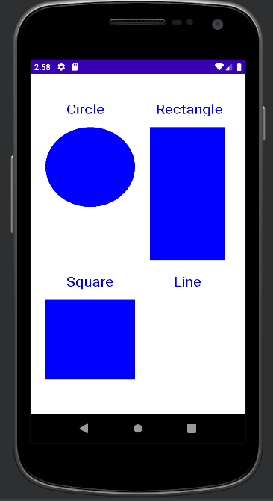

**Result:**

Thus, a Simple Android Application that draws basic Graphical Primitives on the screen has been implemented successfully.

**Ex.No: 05**

**DEVELOP AN APPLICATION THAT MAKES USE OF DATABASE**

**Aim:**

To develop a Simple Android Application that makes use of Database.

**Procedure:**

* Open Android Studio and then click on File -> New ->Newproject**.**
* Type the Application name as “MyApplication**″** and click Next**.**
* Select the Empty Activity and click Next.
* Click Finish
* To design the layout: Click on app -> res -> layout -> activity_main.xml.
* Now click on Text and type the code given below
* Click on app -> java -> com.example.myapplication -> MainActivity and type the code given below
* Run the application to see the output in the android emulator

**Code:**

**MainActivity.java**

package com.example.myapplication;

import android.app.Activity;

import android.app.AlertDialog.Builder;

import android.content.Context;

import android.database.Cursor;

import android.database.sqlite.SQLiteDatabase;

import android.os.Bundle;

import android.view.View;

import android.view.View.OnClickListener;

import android.widget.Button;

import android.widget.EditText;

public class MainActivity extends Activity implements OnClickListener

{

EditText Rollno,Name,Marks;

Button Insert,Delete,Update,View,ViewAll;

SQLiteDatabase db;

/** Called when the activity is first created. */

@Override

public void onCreate(Bundle savedInstanceState)

{

super.onCreate(savedInstanceState);

setContentView(R.layout.activity_main);

Rollno=(EditText)findViewById(R.id.Rollno);

Name=(EditText)findViewById(R.id.Name);

Marks=(EditText)findViewById(R.id.Marks);

Insert=(Button)findViewById(R.id.Insert);

Delete=(Button)findViewById(R.id.Delete);

Update=(Button)findViewById(R.id.Update);

View=(Button)findViewById(R.id.View);

ViewAll=(Button)findViewById(R.id.ViewAll);

Insert.setOnClickListener(this);

Delete.setOnClickListener(this);

Update.setOnClickListener(this);

View.setOnClickListener(this);

ViewAll.setOnClickListener(this);

// Creating database and table

db=openOrCreateDatabase("StudentDB", Context.MODE_PRIVATE, null);

db.execSQL("CREATE TABLE IF NOT EXISTS student(rollno VARCHAR,name VARCHAR,marks VARCHAR);");

}

public void onClick(View view)

{

// Inserting a record to the Student table

if(view==Insert)

{

// Checking for empty fields

if(Rollno.getText().toString().trim().length()==0||

Name.getText().toString().trim().length()==0||

Marks.getText().toString().trim().length()==0)

{

showMessage("Error", "Please enter all values");

return;

}

db.execSQL("insert into students ('"+Rollno.getText()+"','"+Name.getText()+

"','"+Marks.getText()+"');");

showMessage("Success", "Record added");

clearText();

}

// Deleting a record from the Student table

if(view==Delete)

{

// Checking for empty roll number

if(Rollno.getText().toString().trim().length()==0)

{

showMessage("Error", "Please enter Rollno");

return;

}

Cursor c=db.rawQuery("SELECT * FROM student WHERE rollno='"+Rollno.getText()+"'", null);

if(c.moveToFirst())

{

db.execSQL("DELETE FROM student WHERE rollno='"+Rollno.getText()+"'");

showMessage("Success", "Record Deleted");

}

else

{

showMessage("Error", "Invalid Rollno");

}

clearText();

}

// Updating a record in the Student table

if(view==Update)

{

// Checking for empty roll number

if(Rollno.getText().toString().trim().length()==0)

{

showMessage("Error", "Please enter Rollno");

return;

}

Cursor c=db.rawQuery("SELECT * FROM student WHERE rollno='"+Rollno.getText()+"'", null);

if(c.moveToFirst()) {

db.execSQL("UPDATE student SET name='" + Name.getText() + "',marks='" + Marks.getText() +

"' WHERE rollno='"+Rollno.getText()+"'");

showMessage("Success", "Record Modified");

}

else {

showMessage("Error", "Invalid Rollno");

}

clearText();

}

// Display a record from the Student table

if(view==View)

{

// Checking for empty roll number

if(Rollno.getText().toString().trim().length()==0)

{

showMessage("Error", "Please enter Rollno");

return;

}

Cursor c=db.rawQuery("SELECT * FROM student WHERE rollno='"+Rollno.getText()+"'", null);

if(c.moveToFirst())

{

Name.setText(c.getString(1));

Marks.setText(c.getString(2));

}

else

{

showMessage("Error", "Invalid Rollno");

clearText();

}

}

// Displaying all the records

if(view==ViewAll)

{

Cursor c=db.rawQuery("SELECT * FROM student", null);

if(c.getCount()==0)

{

showMessage("Error", "No records found");

return;

}

StringBuffer buffer=new StringBuffer();

while(c.moveToNext())

{

buffer.append("Rollno: "+c.getString(0)+"\n");

buffer.append("Name: "+c.getString(1)+"\n");

buffer.append("Marks: "+c.getString(2)+"\n\n");

}

showMessage("Student Details", buffer.toString());

}

}

public void showMessage(String title,String message)

{

Builder builder=new Builder(this);

builder.setCancelable(true);

builder.setTitle(title);

builder.setMessage(message);

builder.show();

}

public void clearText()

{

Rollno.setText("");

Name.setText("");

Marks.setText("");

Rollno.requestFocus();

}

}.

**activity_main.xml:**

<?xml version="1.0" encoding="utf-8"?>  
<AbsoluteLayout xmlns:android="http://schemas.android.com/apk/res/android"  
 android:layout_width="match_parent"  
 android:layout_height="match_parent">  
 <TextView  
 android:layout_width="wrap_content"  
 android:layout_height="wrap_content"  
 android:layout_x="50dp"  
 android:layout_y="20dp"  
 android:text="Student Details"  
 android:textSize="30sp" />  
  
 <TextView  
 android:layout_width="wrap_content"  
 android:layout_height="wrap_content"  
 android:layout_x="20dp"  
 android:layout_y="110dp"  
 android:text="Enter Rollno:"  
 android:textSize="20sp" />  
  
 <EditText  
 android:id="@+id/Rollno"  
 android:layout_width="150dp"  
 android:layout_height="wrap_content"  
 android:layout_x="175dp"  
 android:layout_y="100dp"  
 android:inputType="number"  
 android:textSize="20sp" />  
  
 <TextView  
 android:layout_width="wrap_content"  
 android:layout_height="wrap_content"  
 android:layout_x="20dp"  
 android:layout_y="160dp"  
 android:text="Enter Name:"  
 android:textSize="20sp" />  
  
 <EditText  
 android:id="@+id/Name"  
 android:layout_width="150dp"  
 android:layout_height="wrap_content"  
 android:layout_x="175dp"  
 android:layout_y="150dp"  
 android:inputType="text"  
 android:textSize="20sp" />  
  
 <TextView  
 android:layout_width="wrap_content"  
 android:layout_height="wrap_content"  
 android:layout_x="20dp"  
 android:layout_y="210dp"  
 android:text="Enter Marks:"  
 android:textSize="20sp" />  
  
 <EditText  
 android:id="@+id/Marks"  
 android:layout_width="150dp"  
 android:layout_height="wrap_content"  
 android:layout_x="175dp"  
 android:layout_y="200dp"  
 android:inputType="number"  
 android:textSize="20sp" />  
  
 <Button  
 android:id="@+id/Insert"  
 android:layout_width="150dp"  
 android:layout_height="wrap_content"  
 android:layout_x="25dp"  
 android:layout_y="300dp"  
 android:text="Insert"  
 android:textSize="30dp" />  
  
 <Button  
 android:id="@+id/Delete"  
 android:layout_width="150dp"  
 android:layout_height="wrap_content"  
 android:layout_x="200dp"  
 android:layout_y="300dp"  
 android:text="Delete"  
 android:textSize="30dp" />  
  
 <Button  
 android:id="@+id/Update"  
 android:layout_width="150dp"  
 android:layout_height="wrap_content"  
 android:layout_x="25dp"  
 android:layout_y="400dp"  
 android:text="Update"  
 android:textSize="30dp" />  
  
 <Button  
 android:id="@+id/View"  
 android:layout_width="150dp"  
 android:layout_height="wrap_content"  
 android:layout_x="200dp"  
 android:layout_y="400dp"  
 android:text="View"  
 android:textSize="30dp" />  
  
 <Button  
 android:id="@+id/ViewAll"  
 android:layout_width="200dp"  
 android:layout_height="wrap_content"  
 android:layout_x="100dp"  
 android:layout_y="500dp"  
 android:text="View All"  
 android:textSize="30dp" />  
  
</AbsoluteLayout>

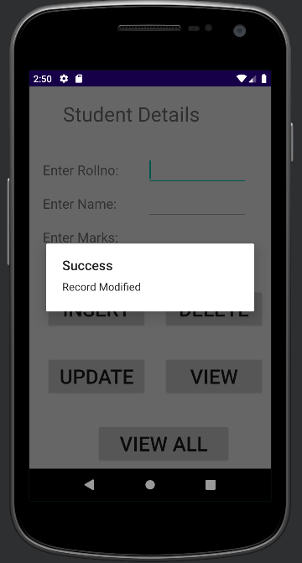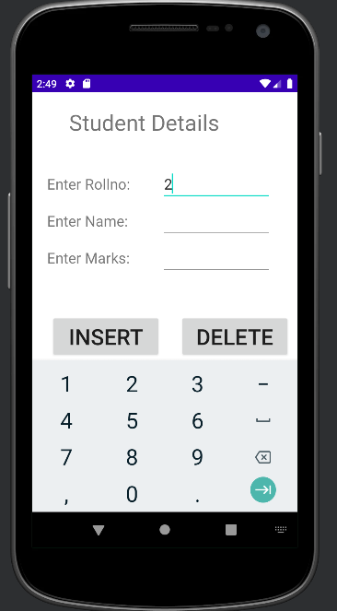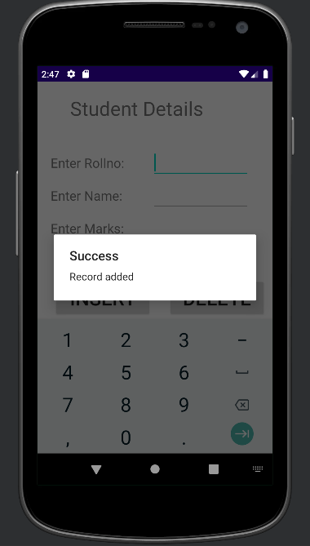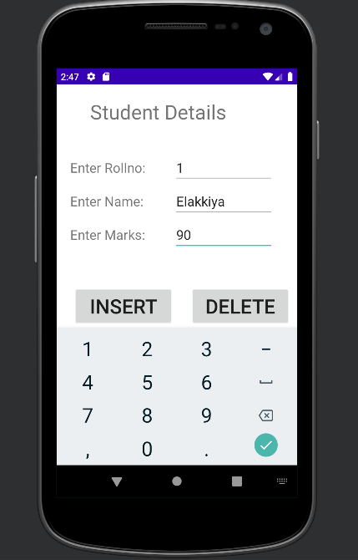**Output:**

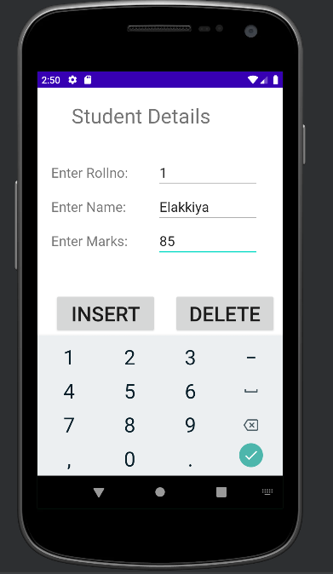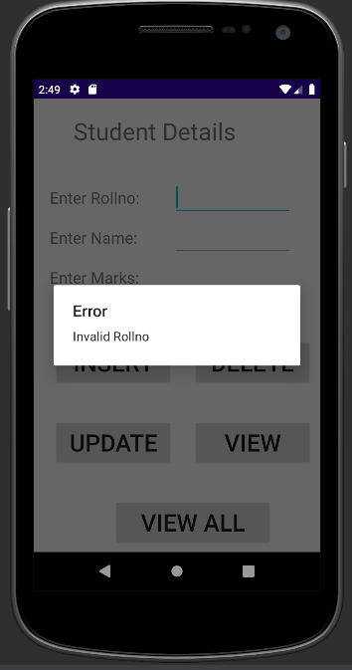

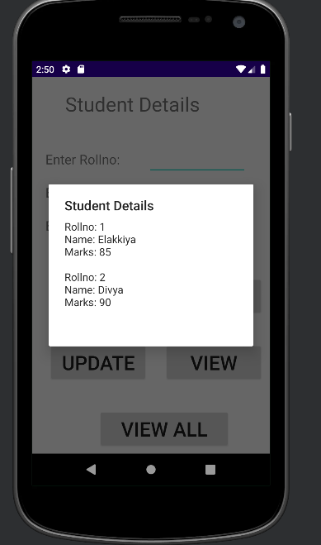

**Result:**

Thus, a simple Android Application that makes use of Database has been implemented successfully.