**Ex.No: 06**

**DEVELOP AN APPLICATION THAT USES RSS FEED**

**Aim:**

To develop an application that uses RSS feed.

**Procedure:**

* Open Android Studio and then click on File -> New -> New project
* Then type the Application name as “My Application″ and click Next.
* Then select the Minimum SDK as shown below and click Next.
* Then select the Empty Activity and click Next.
* Finally click Finish. It will take some time to build and load the project.
* Click on app -> res -> layout -> activity_main.xml
* Now click on Text as shown below. Delete the code which is there and type the code as given below.
* Click on app -> manifests -> AndroidManifest.xml
* Now include the INTERNET permissions in the AndroidManifest.xml file
* Click on app -> java -> com.example.myapplication -> MainActivity.
* Delete the code which is there and type the code as given below.
* Now run the application to see the output

**Code:**

**MainActivity.java**

package com.example.myapplication;

import android.app.ListActivity;

import android.content.Intent;

import android.net.Uri;

import android.os.AsyncTask;

import android.os.Bundle;

import android.view.View;

import android.widget.ArrayAdapter;

import android.widget.ListView;

import org.xmlpull.v1.XmlPullParser;

import org.xmlpull.v1.XmlPullParserException;

import org.xmlpull.v1.XmlPullParserFactory;

import java.io.IOException;

import java.io.InputStream;

import java.net.MalformedURLException;

import java.net.URL;

import java.util.ArrayList;

import java.util.List;

public class MainActivity extends ListActivity

{

List headlines;

List links;

@Override

protected void onCreate(Bundle savedInstanceState)

{

super.onCreate(savedInstanceState);

new MyAsyncTask().execute();

}

class MyAsyncTask extends AsyncTask<Object,Void,ArrayAdapter>

{

@Override

protected ArrayAdapter doInBackground(Object[] params)

{

headlines = new ArrayList();

links = new ArrayList();

try

{

URL url = new URL("https://codingconnect.net/feed");

XmlPullParserFactory factory = XmlPullParserFactory.newInstance();

factory.setNamespaceAware(false);

XmlPullParser xpp = factory.newPullParser();

xpp.setInput(getInputStream(url), "UTF_8");

boolean insideItem = false;

int eventType = xpp.getEventType();

while (eventType != XmlPullParser.END_DOCUMENT)

{

if (eventType == XmlPullParser.START_TAG)

{

if (xpp.getName().equalsIgnoreCase("item"))

{

insideItem = true;

}

else if (xpp.getName().equalsIgnoreCase("title"))

{

if (insideItem)

headlines.add(xpp.nextText()); //extract the headline

}

else if (xpp.getName().equalsIgnoreCase("link"))

{

if (insideItem)

links.add(xpp.nextText()); //extract the link of article

}

}

else if(eventType==XmlPullParser.END_TAG && xpp.getName().equalsIgnoreCase("item"))

{

insideItem=false;

}

eventType = xpp.next(); //move to next element

}

}

catch (MalformedURLException e)

{

e.printStackTrace();

}

catch (XmlPullParserException e)

{

e.printStackTrace();

}

catch (IOException e)

{

e.printStackTrace();

}

return null;

}

protected void onPostExecute(ArrayAdapter adapter)

{

adapter = new ArrayAdapter(MainActivity.this, android.R.layout.simple_list_item_1, headlines);

setListAdapter(adapter);

}

}

@Override

protected void onListItemClick(ListView l, View v, int position, long id)

{

Uri uri = Uri.parse((links.get(position)).toString());

Intent intent = new Intent(Intent.ACTION_VIEW, uri);

startActivity(intent);

}

public InputStream getInputStream(URL url)

{

try

{

return url.openConnection().getInputStream();

}

catch (IOException e)

{

return null;

}

}

}

**Activity_main.xml:**

<?xml version="1.0" encoding="utf-8"?>

<LinearLayout xmlns:android="http://schemas.android.com/apk/res/android"

android:layout_width="fill_parent"

android:layout_height="fill_parent"

android:orientation="vertical" >

<ListView

android:id="@+id/listView"

android:layout_width="match_parent"

android:layout_height="wrap_content" />

</LinearLayout>

**AndroidManifest.xml**

<?xml version="1.0" encoding="utf-8"?>

<manifest xmlns:android="http://schemas.android.com/apk/res/android"

package="com.example.myapplication">

<uses-permission android:name="android.permission.INTERNET"/>

<application>

<activity

android:name=".MainActivity"

android:exported="true"

android:theme="@style/Theme.MyApplication">

<intent-filter>

<action android:name="android.intent.action.MAIN" />

<category android:name="android.intent.category.LAUNCHER" />

</intent-filter>

</activity>

</application>

</manifest>

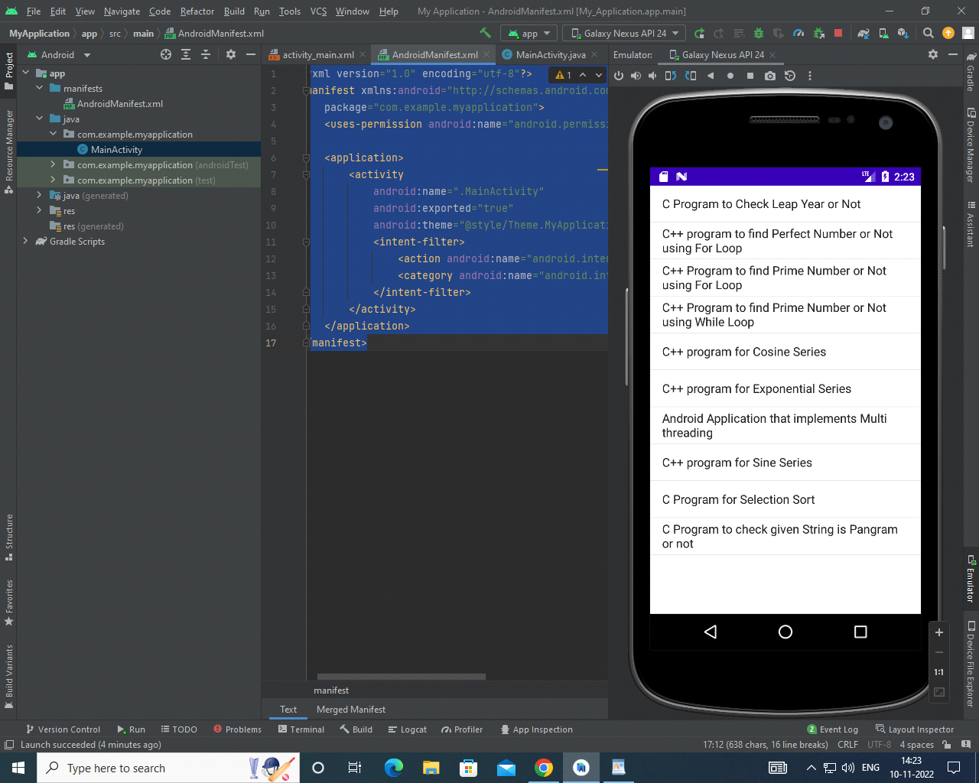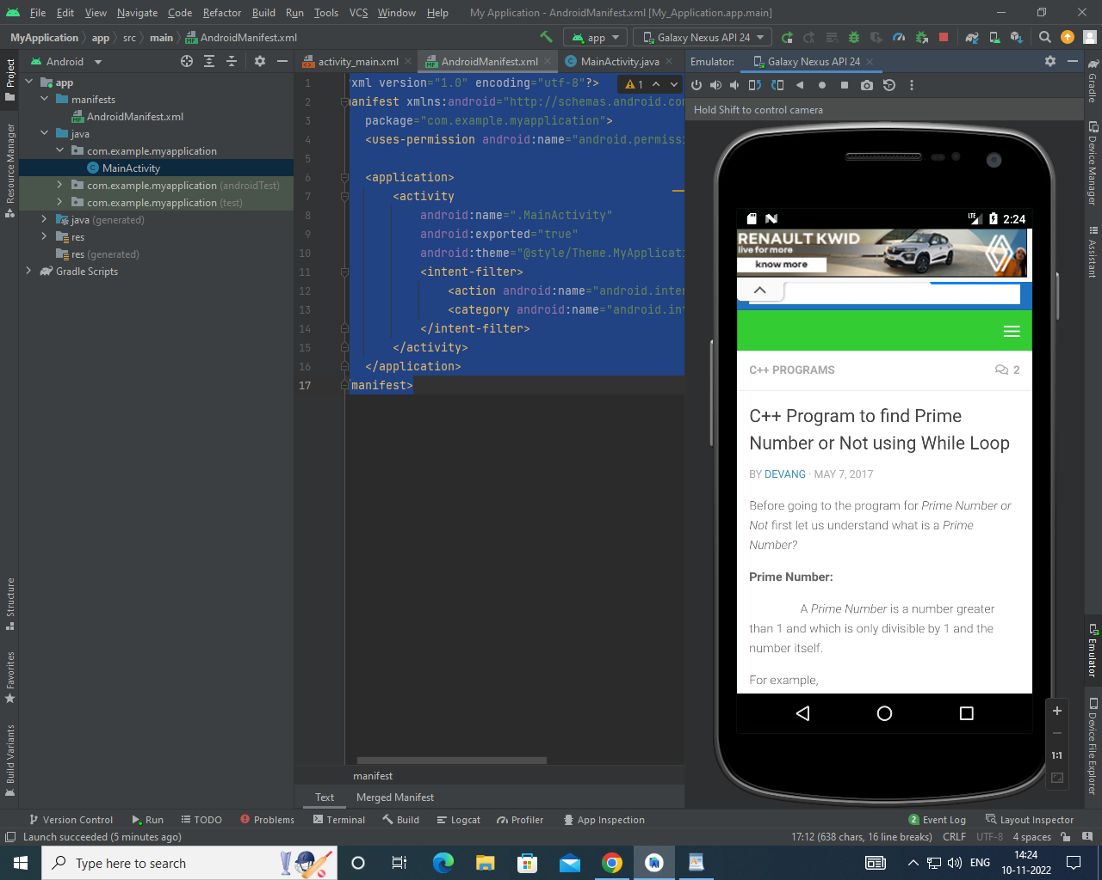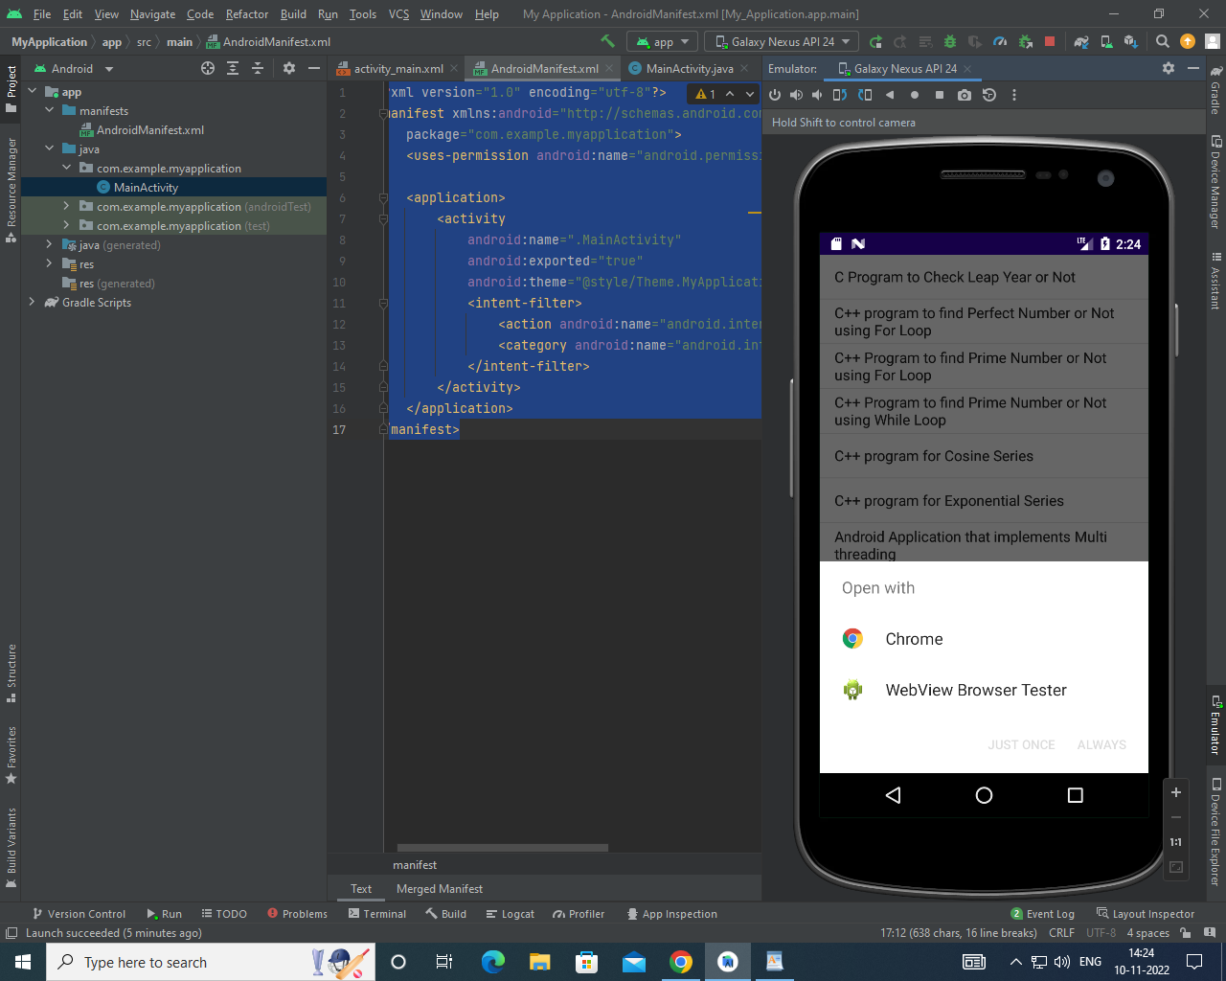**Output:**

**Result:**

Thus, an application that uses RSS feed has been implemented successfully.

**Ex. No: 07**

**DEVELOP AN APPLICATION THAT IMPLEMENTS**

**MULTI THREADING**

**Aim:**

To develop an application that implements multithreading.

**Procedure:**

* Open Android Studio and then click on **File -> New -> New project.**
* Then type the Application name as “My Application″ and click Next.
* Then select the Minimum SDK as shown below and click Next.
* Then select the Empty Activity and click Next.
* Finally click Finish. It will take some time to build and load the project
* Click on app -> res -> layout -> activity_main.xml
* Now click on **Text** as shown below. Then delete the code which is there and type the code as given below.
* Click on app -> java -> com.example.exno7 -> MainActivity.
* Then delete the code which is there and type the code as given below.
* Before Running the Application, Copy the Images given below and Paste it in “app -> res -> drawable” by pressing “right click mouse button on drawable” and selecting the “Paste” option.
* Now run the application to see the output.

**Code:**

**MainActivity.java**

package com.example.myapplication;  
import android.os.Bundle;  
import androidx.appcompat.app.AppCompatActivity;  
import android.view.View;  
import android.widget.Button;  
import android.widget.ImageView;  
public class MainActivity extends AppCompatActivity  
{  
 ImageView img;  
 Button bt1,bt2;  
 @Override  
 protected void onCreate(Bundle savedInstanceState)  
 {  
 super.onCreate(savedInstanceState);  
 setContentView(R.layout.*activity_main*);  
 bt1 = (Button)findViewById(R.id.*button*);  
 bt2= (Button) findViewById(R.id.*button2*);  
 img = (ImageView)findViewById(R.id.*imageView*);  
 bt1.setOnClickListener(new View.OnClickListener()  
 {  
 @Override  
 public void onClick(View v)  
 {  
 new Thread(new Runnable()  
 {  
 @Override  
 public void run()  
 {  
 img.post(new Runnable()  
 {  
 @Override  
 public void run()  
 {  
 img.setImageResource(R.drawable.*india1*);  
 }  
 });  
 }  
 }).start();  
 }  
 });  
 bt2.setOnClickListener(new View.OnClickListener()  
 {  
 @Override  
 public void onClick(View v)  
 {  
 new Thread(new Runnable()  
 {  
 @Override  
 public void run()  
 {  
 img.post(new Runnable()  
 {  
 @Override  
 public void run()  
 {  
 img.setImageResource(R.drawable.*india2*);  
 }  
 });  
 }  
 }).start();  
 }  
 });  
 }  
}

**activity_main.xml**

<?xml version="1.0" encoding="utf-8"?>  
<LinearLayout xmlns:android="http://schemas.android.com/apk/res/android"  
 android:layout_width="match_parent"  
 android:layout_height="match_parent"  
 android:orientation="vertical" >  
 <ImageView  
 android:id="@+id/imageView"  
 android:layout_width="250dp"  
 android:layout_height="250dp"  
 android:layout_margin="50dp"  
 android:layout_gravity="center" />  
 <Button  
 android:id="@+id/button"  
 android:layout_width="wrap_content"  
 android:layout_height="wrap_content"  
 android:layout_margin="10dp"  
 android:layout_gravity="center"  
 android:text="Load Image 1" />  
 <Button  
 android:id="@+id/button2"  
 android:layout_width="wrap_content"  
 android:layout_height="wrap_content"  
 android:layout_margin="10dp"  
 android:layout_gravity="center"  
 android:text="Load image 2" />  
</LinearLayout>

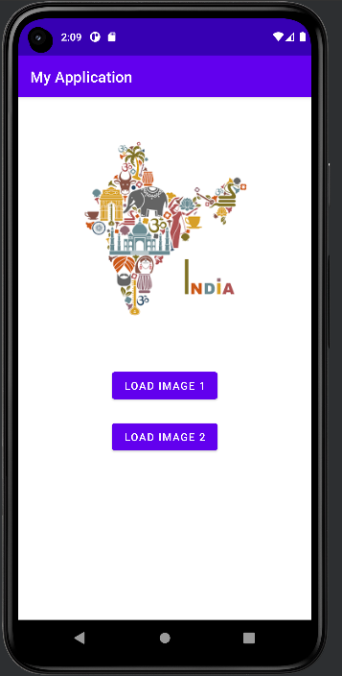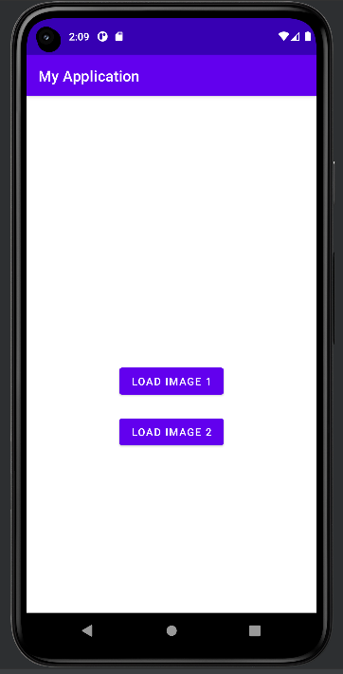**Output:**

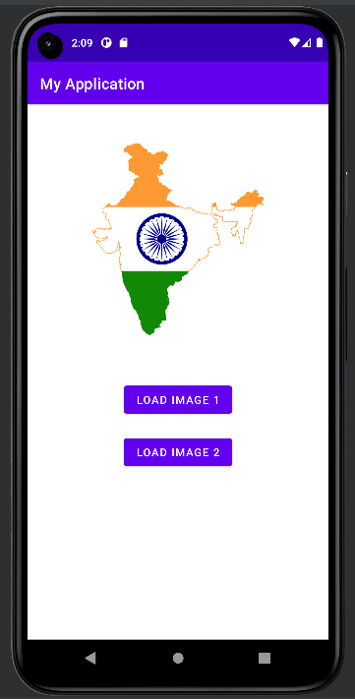

**Result:**

Thus, an application that implements multithreading has been implemented successfully.

**Ex.No: 08**

**DEVELOP A NATIVE APPLICATION THAT USES GPS LOCATION INFORMATION**

**Aim:**

To develop a native application that uses GPS location information.

**Procedure:**

* Open Android Studio and then click on File -> New -> New project
* Then type the Application name as “My Application″ and click Next.
* Then select the Minimum SDK as shown below and click Next.
* Then select the Empty Activity and click Next.
* Finally click Finish. It will take some time to build and load the project.
* Click on app -> res -> layout -> activity_main.xml
* Now click on Text as shown below. Delete the code which is there and type the code as given below.
* Click on app -> manifests -> AndroidManifest.xml
* Now include the INTERNET permissions in the AndroidManifest.xml file
* Click on app -> java -> com.example.myapplication -> MainActivity.
* Delete the code which is there and type the code as given below.
* Now run the application to see the output

**Code:**

**Main_Activity.java**

package com.example.myapplication;

import android.app.Activity;

import android.content.Context;

import android.location.Location;

import android.location.LocationListener;

import android.location.LocationManager;

import android.os.Bundle;

import android.view.View;

import android.view.View.OnClickListener;

import android.widget.Button;

import android.widget.Toast;

public class LbsGeocodingActivity extends Activity {

    private static final long MINIMUM_DISTANCE_CHANGE_FOR_UPDATES = 1; // in Meters

    private static final long MINIMUM_TIME_BETWEEN_UPDATES = 1000; // in Milliseconds

    protected LocationManager locationManager;

    protected Button retrieveLocationButton;

    @Override

    public void onCreate(Bundle savedInstanceState) {

        super.onCreate(savedInstanceState);

        setContentView(R.layout.main);

        retrieveLocationButton = (Button) findViewById(R.id.retrieve_location_button);

        locationManager = (LocationManager) getSystemService(Context.LOCATION_SERVICE);

        locationManager.requestLocationUpdates(

                LocationManager.GPS_PROVIDER,

                MINIMUM_TIME_BETWEEN_UPDATES,

                MINIMUM_DISTANCE_CHANGE_FOR_UPDATES,

                new MyLocationListener()

        );

    retrieveLocationButton.setOnClickListener(new OnClickListener() {

            @Override

            public void onClick(View v) {

                showCurrentLocation();

            }

    });

    }

    protected void showCurrentLocation() {

        Location location = locationManager.getLastKnownLocation(LocationManager.GPS_PROVIDER);

        if (location != null) {

            String message = String.format(

                    "Current Location \n Longitude: %1$s \n Latitude: %2$s",

                    location.getLongitude(), location.getLatitude()

            );

            Toast.makeText(LbsGeocodingActivity.this, message,

                    Toast.LENGTH_LONG).show();

        }

    }

    private class MyLocationListener implements LocationListener {

        public void onLocationChanged(Location location) {

            String message = String.format(

                    "New Location \n Longitude: %1$s \n Latitude: %2$s",

                    location.getLongitude(), location.getLatitude()

            );

            Toast.makeText(LbsGeocodingActivity.this, message, Toast.LENGTH_LONG).show();

        }

        public void onStatusChanged(String s, int i, Bundle b) {

            Toast.makeText(LbsGeocodingActivity.this, "Provider status changed",

                    Toast.LENGTH_LONG).show();

        }

        public void onProviderDisabled(String s) {

            Toast.makeText(LbsGeocodingActivity.this,

                    "Provider disabled by the user. GPS turned off",

                    Toast.LENGTH_LONG).show();

        }

        public void onProviderEnabled(String s) {

            Toast.makeText(LbsGeocodingActivity.this,

                    "Provider enabled by the user. GPS turned on",

                    Toast.LENGTH_LONG).show();

        }

    }

}

**activity_main.xml**

<?xml version="1.0" encoding="utf-8"?>

<LinearLayout xmlns:android="http://schemas.android.com/apk/res/android"

android:orientation="vertical"

android:layout_width="fill_parent"

android:layout_height="fill_parent">

<Button

android:id="@+id/retrieve_location_button"

android:text="Retrieve Location"

android:layout_width="wrap_content"

android:layout_height="wrap_content"/>

</LinearLayout>

**AndroidManifest.xml**

<?xml version="1.0" encoding="utf-8"?>

<manifest xmlns:android="http://schemas.android.com/apk/res/android"

package="com.javacodegeeks.android.lbs"

android:versionCode="1"

android:versionName="1.0">

<application android:icon="@drawable/icon" android:label="@string/app_name">

<activity android:name=".LbsGeocodingActivity"

android:label="@string/app_name">

<intent-filter>

<action android:name="android.intent.action.MAIN" />

<category android:name="android.intent.category.LAUNCHER" />

</intent-filter>

</activity>

</application>

<uses-permission android:name="android.permission.ACCESS_FINE_LOCATION" />

<uses-permission android:name="android.permission.ACCESS_MOCK_LOCATION" />

<uses-permission android:name="android.permission.ACCESS_COARSE_LOCATION" />

<uses-sdk android:minSdkVersion="3" />

</manifest>

**Output:**

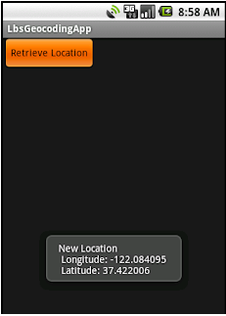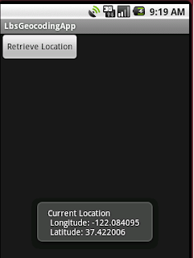

**Result:**

Thus, a native application that uses GPS location information has been implemented successfully.

**Ex.No: 9**

**IMPLEMENT AN APPLICATION THAT WRITES DATA TO THE SD CARD**

**Aim:**

To implement an application that writes data to the SD card

**Procedure:**

* Open Android Studio and then click on **File -> New -> New project.**
* Then type the Application name as “My Application″ and click Next.
* Then select the Minimum SDK as shown below and click Next
* Then select the Empty Activity and click Next.
* Finally click Finish. It will take some time to build and load the project.
* Click on app -> res -> layout -> activity_main.xml.
* Now click on Text as shown below. Then delete the code which is there and type the code as given below.
* Click on app -> manifests -> AndroidManifest.xml
* Now include the WRITE_EXTERNAL_STORAGE permissions in the AndroidManifest.xml file as shown below
* Click on app -> java -> com.example.myapplication -> MainActivity.
* Then delete the code which is there and type the code as given below.
* Now run the application to see the output

**Code:**

**MainActivity.java**

package com.example.myapplication;

import android.os.Bundle;

import androidx.appcomapt.app.AppCompatActivity;

import android.view.View;

import android.widget.Button;

import android.widget.EditText;

import android.widget.Toast;

import java.io.BufferedReader;

import java.io.File;

import java.io.FileInputStream;

import java.io.FileOutputStream;

import java.io.InputStreamReader;

public class MainActivity extends AppCompatActivity

{

EditText e1;

Button write,read,clear;

@Override

protected void onCreate(Bundle savedInstanceState)

{

super.onCreate(savedInstanceState);

setContentView(R.layout.activity_main);

e1= (EditText) findViewById(R.id.editText);

write= (Button) findViewById(R.id.button);

read= (Button) findViewById(R.id.button2);

clear= (Button) findViewById(R.id.button3);

write.setOnClickListener(new View.OnClickListener()

{

@Override

public void onClick(View v)

{

String message=e1.getText().toString();

try

{

File f=new File("/sdcard/myfile.txt");

f.createNewFile();

FileOutputStream fout=new FileOutputStream(f);

fout.write(message.getBytes());

fout.close();

Toast.makeText(getBaseContext(),"Data Written in SDCARD",Toast.LENGTH_LONG).show();

}

catch (Exception e)

{

Toast.makeText(getBaseContext(),e.getMessage(),Toast.LENGTH_LONG).show();

}

}

});

read.setOnClickListener(new View.OnClickListener()

{

@Override

public void onClick(View v)

{

String message;

String buf = "";

try

{

File f = new File("/sdcard/myfile.txt");

FileInputStream fin = new FileInputStream(f);

BufferedReader br = new BufferedReader(new InputStreamReader(fin));

while ((message = br.readLine()) != null)

{

buf += message;

}

e1.setText(buf);

br.close();

fin.close();

Toast.makeText(getBaseContext(),"Data Recived from SDCARD",Toast.LENGTH_LONG).show();

}

catch (Exception e)

{

Toast.makeText(getBaseContext(), e.getMessage(), Toast.LENGTH_LONG).show();

}

}

});

clear.setOnClickListener(new View.OnClickListener()

{

@Override

public void onClick(View v)

{

e1.setText("");

}

});

}

}

**activity_main.xml**

<?xml version="1.0" encoding="utf-8"?>

<LinearLayout xmlns:android="http://schemas.android.com/apk/res/android"

    android:layout_width="match_parent"

    android:layout_height="match_parent"

    android:layout_margin="20dp"

    android:orientation="vertical">

    <EditText

        android:id="@+id/editText"

        android:layout_width="match_parent"

        android:layout_height="wrap_content"

        android:singleLine="true"

        android:textSize="30dp" />

    <Button

        android:id="@+id/button"

        android:layout_width="match_parent"

        android:layout_height="wrap_content"

        android:layout_margin="10dp"

        android:text="Write Data"

        android:textSize="30dp" />

    <Button

        android:id="@+id/button2"

        android:layout_width="match_parent"

        android:layout_height="wrap_content"

        android:layout_margin="10dp"

        android:text="Read data"

        android:textSize="30dp" />

    <Button

        android:id="@+id/button3"

        android:layout_width="match_parent"

        android:layout_height="wrap_content"

        android:layout_margin="10dp"

        android:text="Clear"

        android:textSize="30dp" />

</LinearLayout>

**AndroidManifest.xml**

<?xml version="1.0" encoding="utf-8"?>

<manifest xmlns:android="http://schemas.android.com/apk/res/android"

    package="com.example.exno9" >

    <uses-permission android:name="android.permission.WRITE_EXTERNAL_STORAGE"></uses-permission>

    <application

        android:allowBackup="true"

        android:icon="@mipmap/ic_launcher"

        android:label="@string/app_name"

        android:supportsRtl="true"

        android:theme="@style/AppTheme" >

        <activity android:name=".MainActivity" >

            <intent-filter>

                <action android:name="android.intent.action.MAIN" />

                <category android:name="android.intent.category.LAUNCHER" />

            </intent-filter>

        </activity>

    </application>

</manifest>

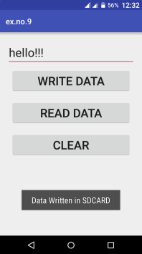**Output:**

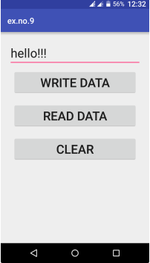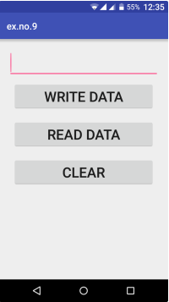

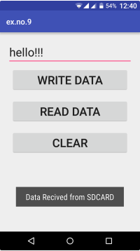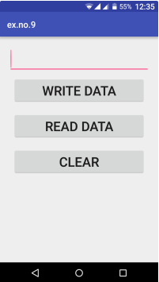

**Result:**

Thus, an android application that writes data to the SD card has been implemented successfully.

**Ex.No: 10**

**IMPLEMENT AN APPLICATION THAT CREATES AN ALERT UPON RECEIVING A MESSAGE**

**Aim:**

To implement an application that creates an alert upon receiving a message.

**Procedure:**

* Open Android Studio and then click on File -> New -> New project.
* Then type the Application name as “My Application″ and click Next.
* Then select the Minimum SDK as shown below and click Next.
* Then select the Empty Activity and click Next.
* Finally click Finish. It will take some time to build and load the project.
* Click on File -> New -> Activity -> Empty Activity.
* Type the Activity Name as SecondActivity and click Finish button. Thus Second Activity For the application is created.
* Click on app -> res -> layout -> activity_main.xml.
* Now click on Text as shown below. Then delete the code which is there and type the code as given below.
* Click on app -> java -> com.example.myapplication -> MainActivity.
* Now run the application to see the output.

**Code:**

**MainActivity.java**

package com.example.myapplication;

import android.app.Notification;

import android.app.NotificationManager;

import android.app.PendingIntent;

import android.content.Intent;

import android.os.Bundle;

import androidx.appcompat.app.AppCompatActivity;

import android.view.View;

import android.widget.Button;

import android.widget.EditText;

public class MainActivity extends AppCompatActivity

{

Button notify;

EditText e;

@Override

protected void onCreate(Bundle savedInstanceState)

{

super.onCreate(savedInstanceState);

setContentView(R.layout.activity_main);

notify= (Button) findViewById(R.id.button);

e= (EditText) findViewById(R.id.editText);

notify.setOnClickListener(new View.OnClickListener()

{

@Override

public void onClick(View v)

{

Intent intent = new Intent(MainActivity.this, SecondActivity.class);

PendingIntent pending = PendingIntent.getActivity(MainActivity.this, 0, intent, 0);

Notification noti = new Notification.Builder(MainActivity.this).setContentTitle("New Message").setContentText(e.getText().toString()).setSmallIcon(R.mipmap.ic_launcher).setContentIntent(pending).build();

NotificationManager manager = (NotificationManager) getSystemService(NOTIFICATION_SERVICE);

noti.flags |= Notification.FLAG_AUTO_CANCEL;

manager.notify(0, noti);

}

});

}

}

**activity_main.xml**

<?xml version="1.0" encoding="utf-8"?>

<LinearLayout xmlns:android="http://schemas.android.com/apk/res/android"

android:layout_width="match_parent"

android:layout_height="match_parent"

android:layout_margin="10dp"

android:orientation="vertical">

<TextView

android:layout_width="wrap_content"

android:layout_height="wrap_content"

android:text="Message"

android:textSize="30sp" />

<EditText

android:id="@+id/editText"

android:layout_width="match_parent"

android:layout_height="wrap_content"

android:singleLine="true"

android:textSize="30sp" />

<Button

android:id="@+id/button"

android:layout_width="wrap_content"

android:layout_height="wrap_content"

android:layout_margin="30dp"

android:layout_gravity="center"

android:text="Notify"

android:textSize="30sp"/>

</LinearLayout>

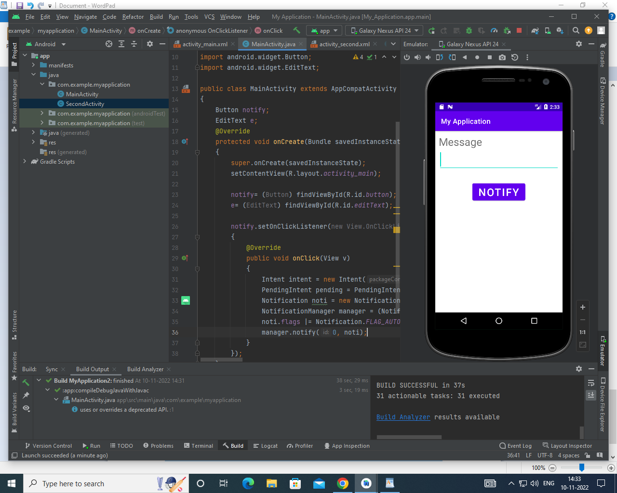**Output:**

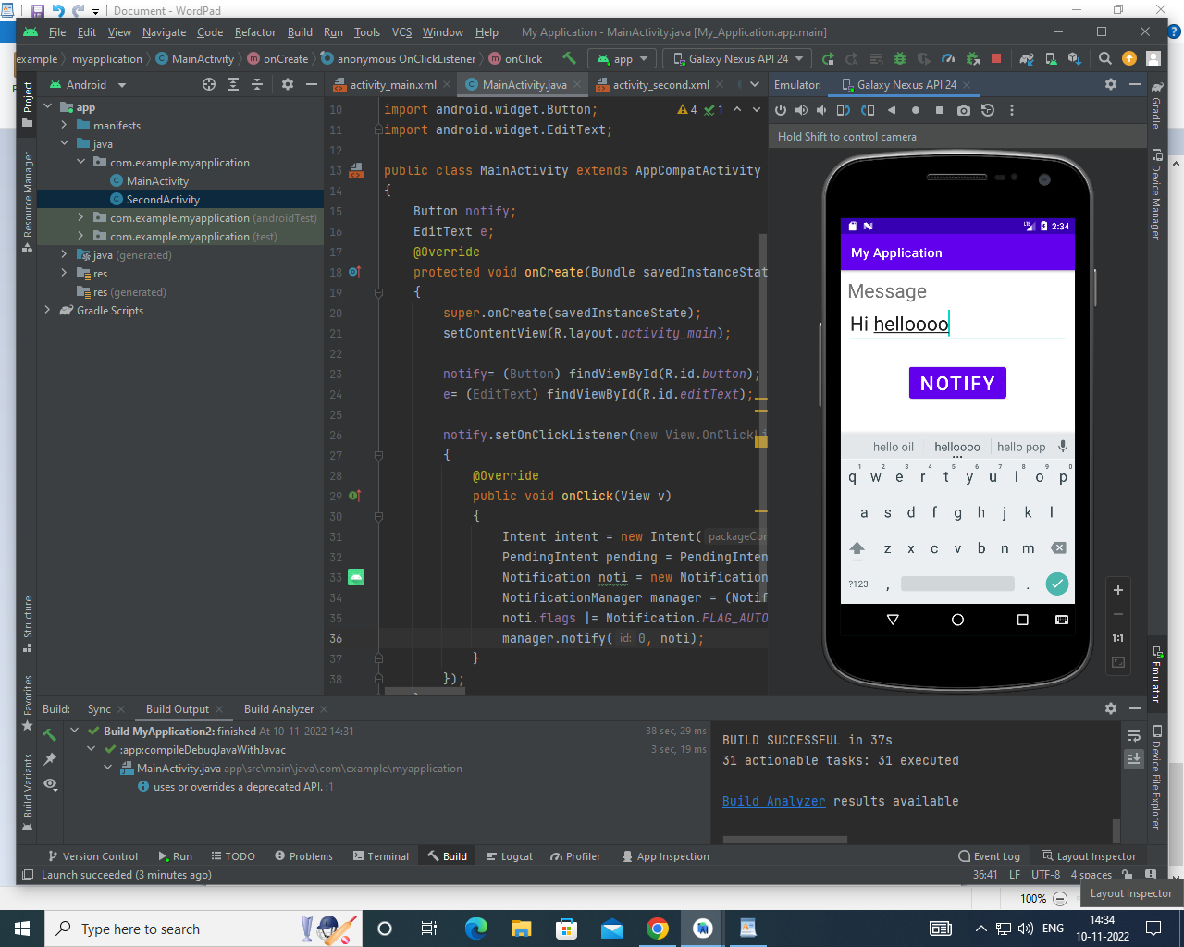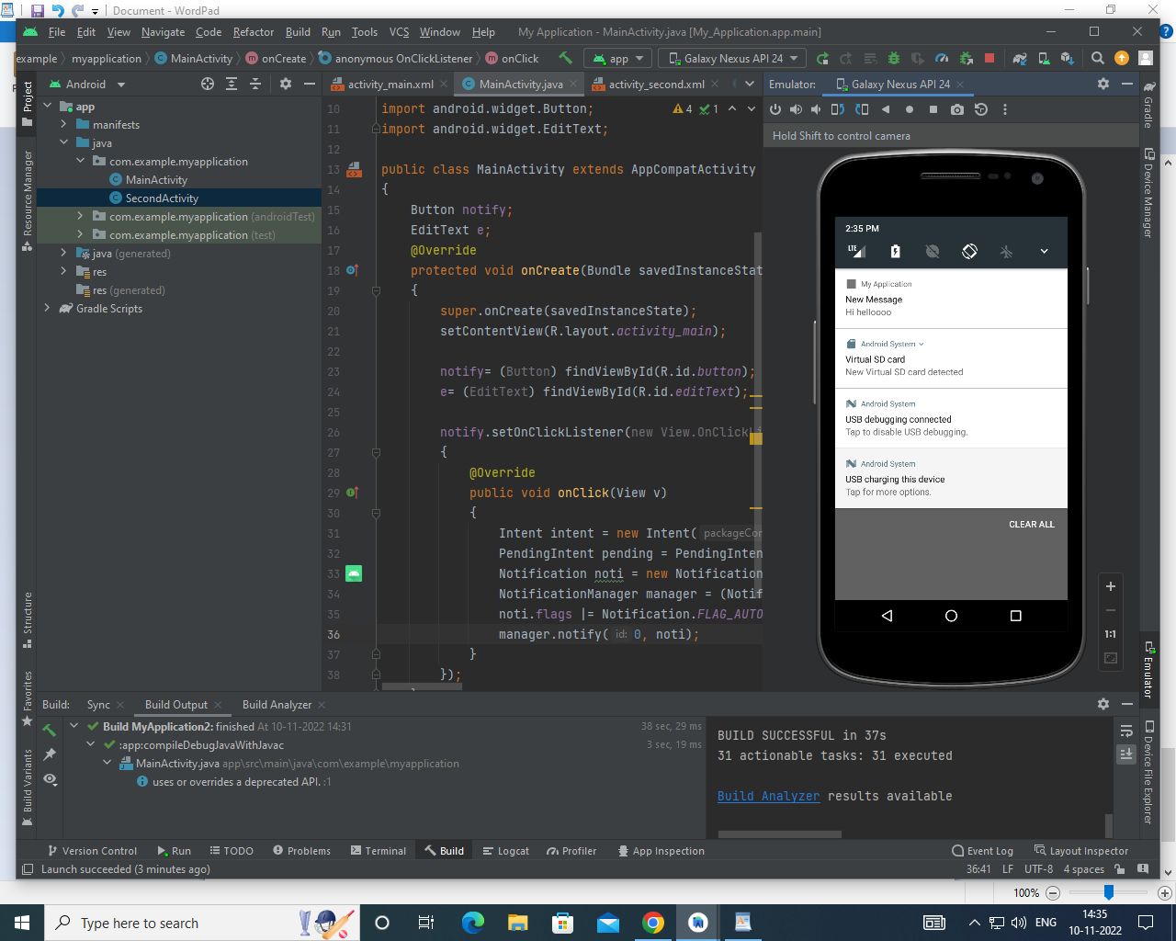

**Result:**

     Thus Android Application that creates an alert upon receiving a message is developed and executed successfully.

**Ex.No: 11**

**DEVELOP A MOBILE APPLICATION TO SEND EMAIL**

**Aim:**

To develop an Android Application to send an Email.

**Procedure:**

* Open Android Studio and then click on File -> New -> New project.
* Then type the Application name as “My Application″ and click Next.
* Then select the Minimum SDK as shown below and click Next.
* Then select the Empty Activity and click Next.
* Finally click Finish.It will take some time to build and load the project.
* Click on app -> res -> layout -> activity_main.xml.
* Now click on Text as shown below.Then delete the code which is there and type the code as given below.
* Click on app -> manifests -> AndroidManifest.xml.
* Now include the INTERNET permissions in the AndroidManifest.xml file.
* Click on app -> java -> com.example.myapplication -> MainActivity.
* Then delete the code which is there and type the code as given below.

**Code:**

**MainActivity.java**

package com.example.myapplication;

import android.content.Intent;

import android.os.Bundle;

import android.view.View;

import android.widget.Button;

import android.widget.EditText;

import androidx.appcompat.app.AppCompatActivity;

public class MainActivity extends AppCompatActivity {

private EditText eTo;

private EditText eSubject;

private EditText eMsg;

private Button btn;

@Override

protected void onCreate(Bundle savedInstanceState) { super.onCreate(savedInstanceState);

setContentView(R.layout.activity_main);

eTo = (EditText)findViewById(R.id.txtTo);

eSubject = (EditText)findViewById(R.id.txtSub);

eMsg = (EditText)findViewById(R.id.txtMsg);

btn = (Button)findViewById(R.id.btnSend);

btn.setOnClickListener(new View.OnClickListener() {

@Override

public void onClick(View v) {

Intent it = new Intent(Intent.ACTION_SEND); it.putExtra(Intent.EXTRA_EMAIL, new String[]{eTo.getText().toString()}); it.putExtra(Intent.EXTRA_SUBJECT,eSubject.getText().toString()); it.putExtra(Intent.EXTRA_TEXT,eMsg.getText()); it.setType("message/rfc822"); startActivity(Intent.createChooser(it,"Choose Mail App"));

}});

}

}

**activity_main.xml:**

<?xml version="1.0" encoding="utf-8"?>

<LinearLayout xmlns:android="http://schemas.android.com/apk/res/android" android:layout_width="match_parent"

android:layout_height="match_parent"

android:paddingLeft="20dp"

android:paddingRight="20dp"

android:orientation="vertical" >

<EditText android:id="@+id/txtTo"

android:layout_width="match_parent"

android:layout_height="wrap_content"

android:hint="To"/>

<EditText android:id="@+id/txtSub"

android:layout_width="match_parent"

android:layout_height="wrap_content"

android:hint="Subject"/>

<EditText

android:id="@+id/txtMsg"

android:layout_width="match_parent"

android:layout_height="0dp"

android:layout_weight="1"

android:gravity="top"

android:hint="Message"/>

<Button android:layout_width="100dp"

android:layout_height="wrap_content"

android:layout_gravity="right"

android:text="Send"

android:id="@+id/btnSend"/>

</LinearLayout>

**AndroidManifest.xml**

<?xml version="1.0" encoding="utf-8"?>

<manifest xmlns:android="http://schemas.android.com/apk/res/android" xmlns:tools="http://schemas.android.com/tools" package="com.example.exno11" >

<uses-permission android:name="android.permission.INTERNET" />

<application android:allowBackup="true" android:icon="@mipmap/ic_launcher"

android:label="@string/app_name"

android:theme="@style/AppTheme"

tools:ignore="GoogleAppIndexingWarning">

<activity android:name="com.example.myapplication.MainActivity" android:label="@string/app_name">

<intent-filter>

<action android:name="android.intent.action.MAIN" />

<category android:name="android.intent.category.LAUNCHER" />

<action android:name="android.intent.action.SEND"/>

<category android:name="android.intent.category.DEFAULT"/>

<data android:mimeType="message/rfc822"/>

</intent-filter>

</activity>

</application>

</manifest>

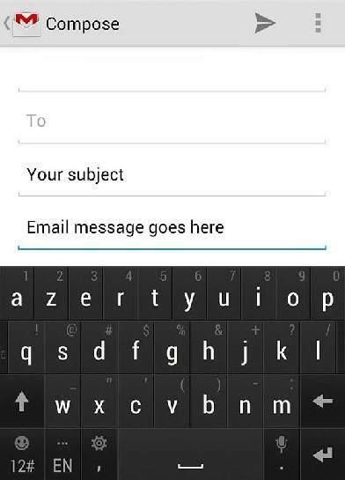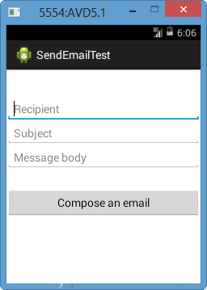**Output:**

**Result:**

Thus Android Application for sending an email is developed and executed successfully.

**Ex. No: 12**

**WRITE A MOBILE APPLICATION THAT CREATES ALARM CLOCK**

**Aim:**

To write a mobile application that creates an alarm clock.

**Procedure:**

* Open Android Studio and then click on File -> New -> New project.
* Then type the Application name as “My Application″ and click Next.
* Then select the Minimum SDK as shown below and click Next.
* Then select the Empty Activity and click Next.
* Finally click Finish. It will take some time to build and load the project.
* Click on File -> New -> Activity -> Empty Activity.
* Type the Activity Name as AlarmReceiver and click Finish button. Thus Second Activity For the application is created.
* Click on app -> res -> layout -> activity_main.xml. Then delete the code which is there and type the code as given below.
* Click on app -> manifests -> AndroidManifest.xml
* Now change the activity tag to receiver tag in the AndroidManifest.xml file as shown below
* Click on app -> java -> com.example.myapplication -> MainActivity. Then delete the code which is there and type the code as given below.
* Click on app -> java -> com.example.myapplication -> AlarmReceiver. Then delete the code which is there and type the code as given below.
* Now run the application to see the output.

**Code:**

**MainActivity.java**

package com.example.myapplication;

import android.app.AlarmManager;

import android.app.PendingIntent;

import android.content.Intent;

import android.os.Bundle;

import androidx.appcompat.app.AppCompatActivity;

import android.view.View;

import android.widget.TimePicker;

import android.widget.Toast;

import android.widget.ToggleButton;

import java.util.Calendar;

public class MainActivity extends AppCompatActivity

{

TimePicker alarmTimePicker;

PendingIntent pendingIntent;

AlarmManager alarmManager;

@Override

protected void onCreate(Bundle savedInstanceState)

{

super.onCreate(savedInstanceState);

setContentView(R.layout.activity_main);

alarmTimePicker = (TimePicker) findViewById(R.id.timePicker);

alarmManager = (AlarmManager) getSystemService(ALARM_SERVICE);

}

public void OnToggleClicked(View view)

{

long time;

if (((ToggleButton) view).isChecked())

{

Toast.makeText(MainActivity.this, "ALARM ON", Toast.LENGTH_SHORT).show();

Calendar calendar = Calendar.getInstance();

calendar.set(Calendar.HOUR_OF_DAY, alarmTimePicker.getCurrentHour());

calendar.set(Calendar.MINUTE, alarmTimePicker.getCurrentMinute());

Intent intent = new Intent(this, AlarmReceiver.class);

pendingIntent = PendingIntent.getBroadcast(this, 0, intent, 0);

time=(calendar.getTimeInMillis()-(calendar.getTimeInMillis()%60000));

if(System.currentTimeMillis()>time)

{

if (calendar.AM_PM == 0)

time = time + (1000*60*60*12);

else

time = time + (1000*60*60*24);

}

alarmManager.setRepeating(AlarmManager.RTC_WAKEUP, time, 10000, pendingIntent);

}

else

{

alarmManager.cancel(pendingIntent);

Toast.makeText(MainActivity.this, "ALARM OFF", Toast.LENGTH_SHORT).show();

}

}

}

**AndroidManifest.xml**

<?xml version="1.0" encoding="utf-8"?>

<manifest xmlns:android="http://schemas.android.com/apk/res/android"

xmlns:tools="http://schemas.android.com/tools"

package="com.example.myapplication">

<application

android:allowBackup="true"

android:dataExtractionRules="@xml/data_extraction_rules"

android:fullBackupContent="@xml/backup_rules"

android:icon="@mipmap/ic_launcher"

android:label="@string/app_name"

android:roundIcon="@mipmap/ic_launcher_round"

android:supportsRtl="true"

android:theme="@style/Theme.MyApplication"

tools:targetApi="31">

<activity

android:name=".MainActivity"

android:exported="true">

<intent-filter>

<action android:name="android.intent.action.MAIN" />

<category android:name="android.intent.category.LAUNCHER" />

</intent-filter>

</activity>

<receiver android:name=".AlarmReceiver" >

</receiver>

</application>

</manifest>

**AlarmReceiver.java**

package com.example.myapplication;

import android.content.BroadcastReceiver;

import android.content.Context;

import android.content.Intent;

import android.media.Ringtone;

import android.media.RingtoneManager;

import android.net.Uri;

import android.widget.Toast;

public class AlarmReceiver extends BroadcastReceiver

{

@Override

public void onReceive(Context context, Intent intent)

{

Toast.makeText(context, "Alarm! Wake up! Wake up!", Toast.LENGTH_LONG).show();

Uri alarmUri = RingtoneManager.getDefaultUri(RingtoneManager.TYPE_ALARM);

if (alarmUri == null)

{

alarmUri = RingtoneManager.getDefaultUri(RingtoneManager.TYPE_NOTIFICATION);

}

Ringtone ringtone = RingtoneManager.getRingtone(context, alarmUri);

ringtone.play();

}

}

**Output:**

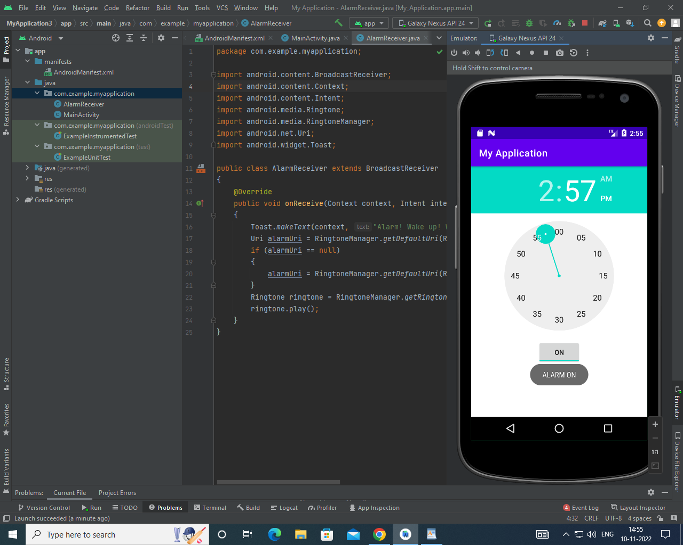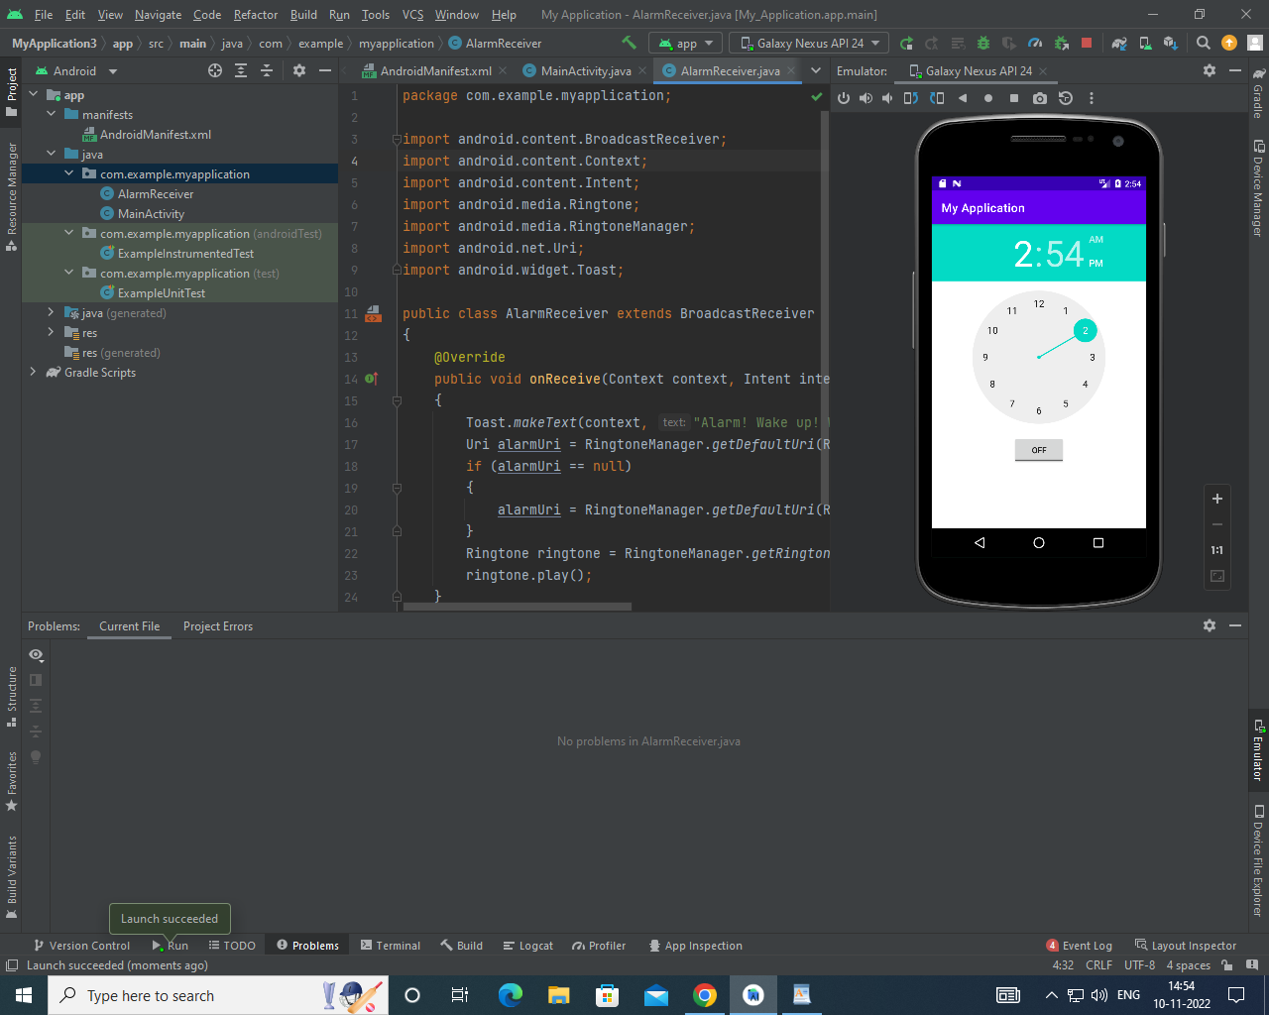

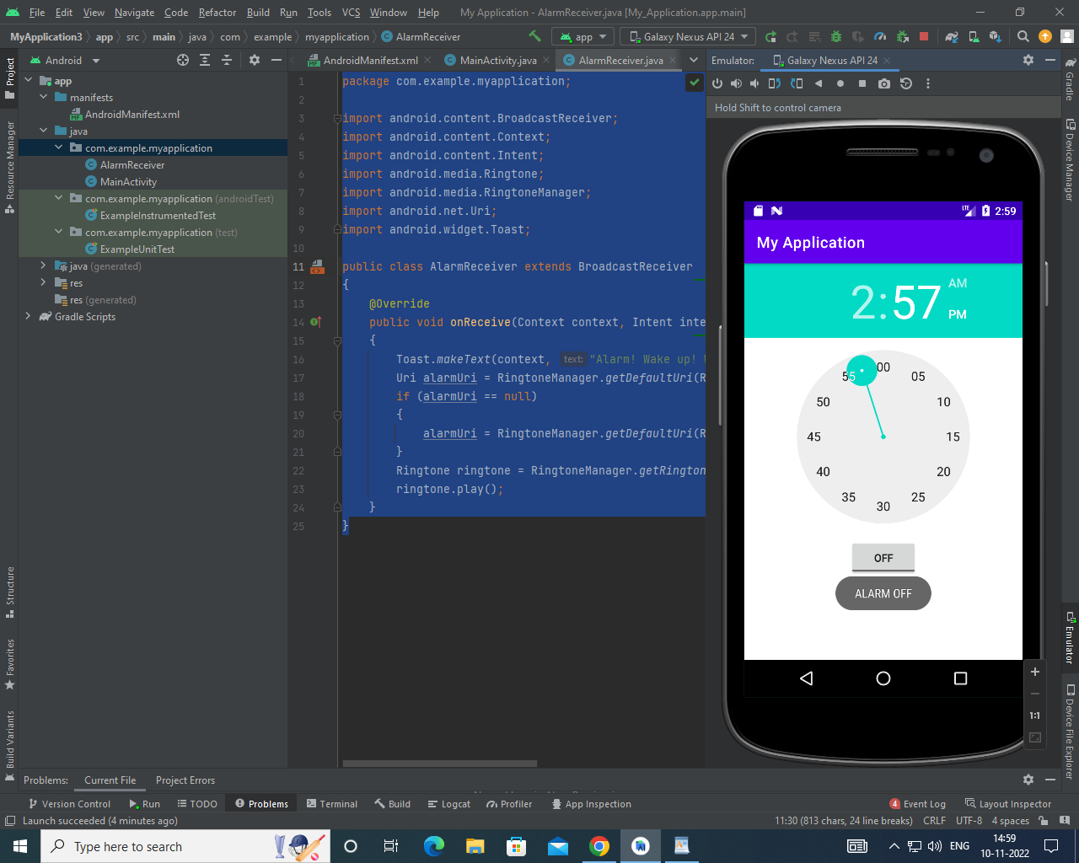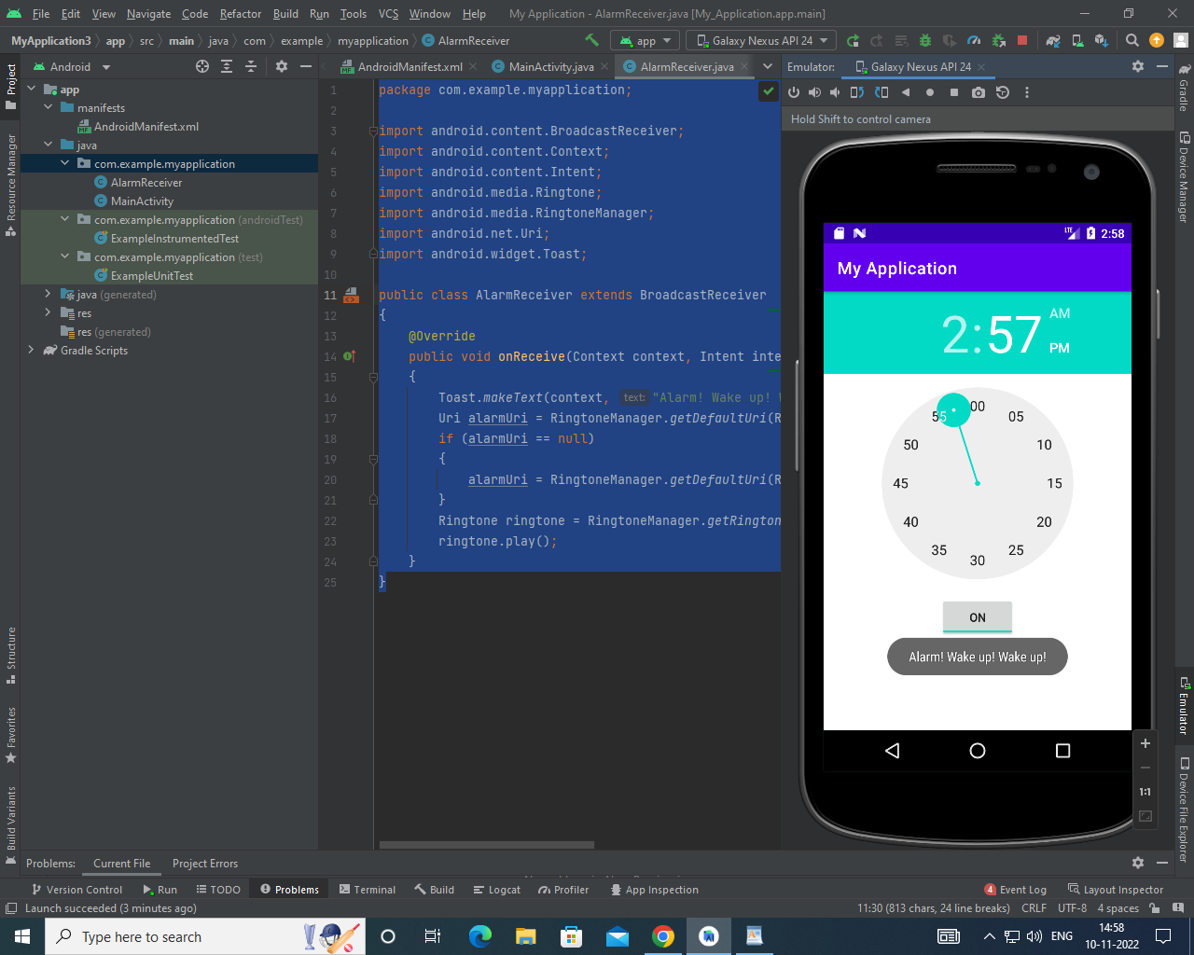

**Result:**

Thus**,** Android Application that creates Alarm Clock is developed and executed successfully.