DIGITAL CERTIFICATE GENERATION
& VERIFICATION SYSTEM

SAP ABAP Based E-Governance Internship Project
Internship Project Documentation

Developed by
Nandini Borade
SAP ABAP Developer (S/4HANA)

Technology: SAP ABAP | SAP S/4HANA | ABAP Objects | DDIC | Open SQL | Dynpro / Module Pool Programming

Table of Contents

1. Project Overview
This project is a modular SAP ABAP based e-Governance application designed to manage citizen registration, certificate applications, data validation, document verification, application processing, approval/rejection, digital certificate generation and certificate verification.

1.1 Project Objectives
- Citizen registration
- Application creation
- Data validation
- Document verification
- Application processing
- Application approval/rejection
- Digital certificate generation
- Certificate verification
- Modular and reusable ABAP programming
- Error handling and database operations

1.2 Skills Demonstrated
- SAP ABAP
- ABAP Objects
- DDIC
- Open SQL
- Dynpro Programming
- Module Pool Programming
- Database Operations
- Validation
- Error Handling
- Modular Programming
- Object-Oriented Programming
- e-Governance Application Development

2. System Architecture
The system follows a layered architecture separating the presentation logic (Dynpro screen), business logic (ABAP Objects classes) and data layer (DDIC objects and the custom database table), accessed through Open SQL.
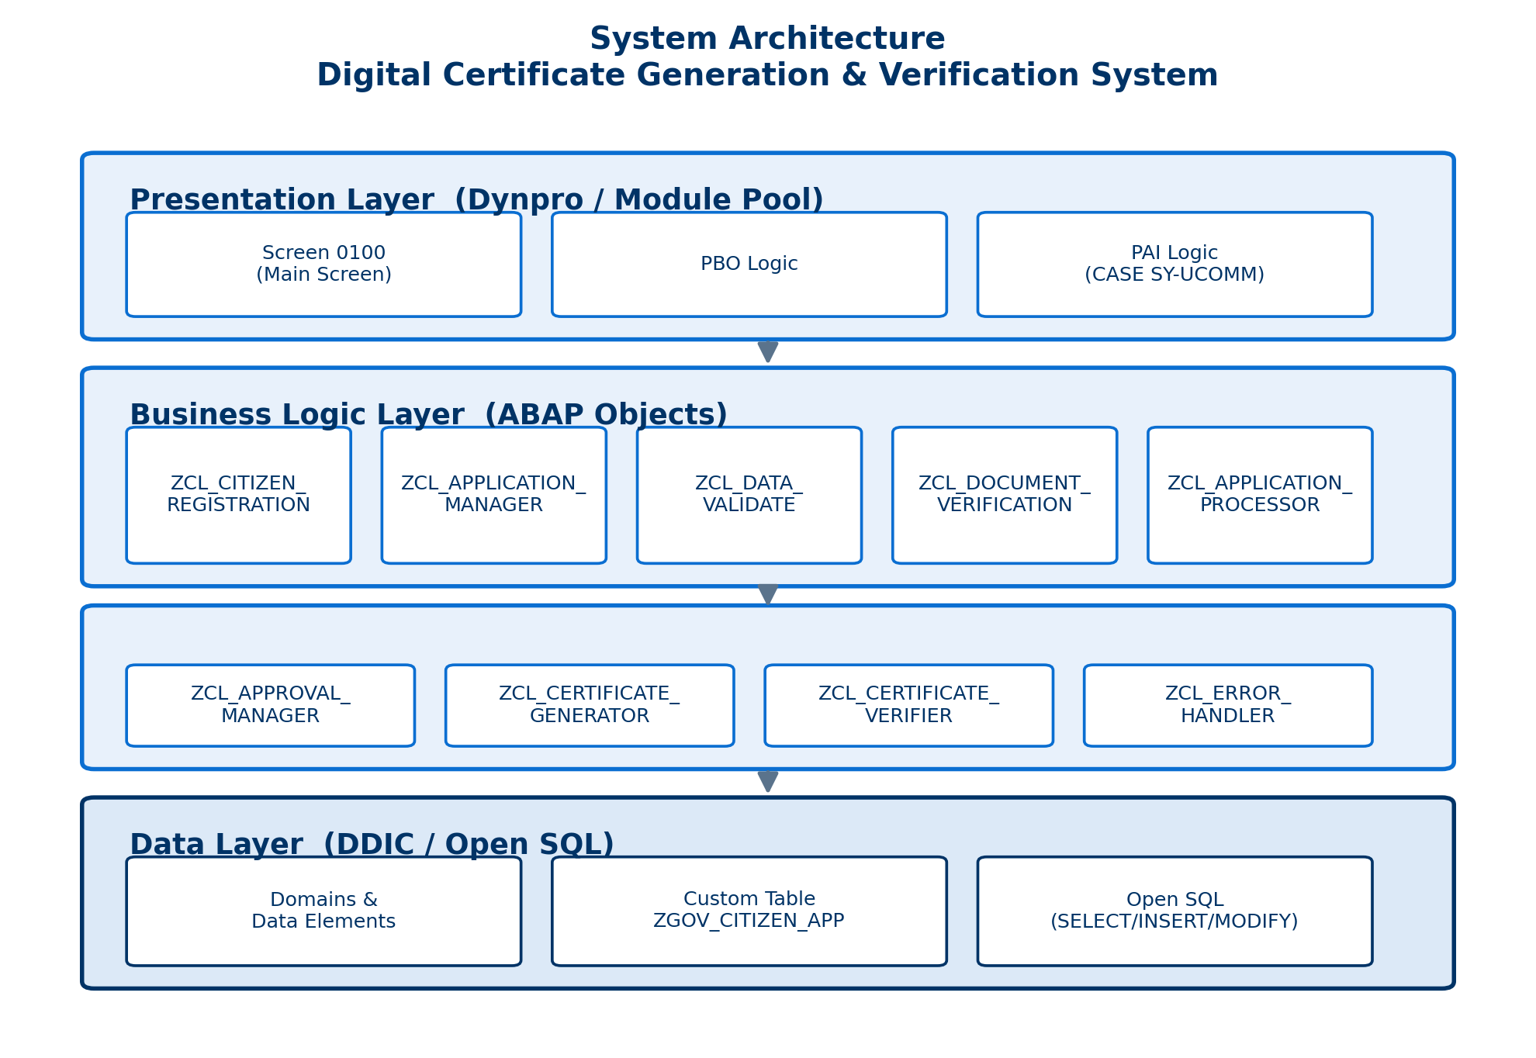
Figure 1: System Architecture — Digital Certificate Generation & Verification System

3. DDIC Objects

3.1 Domains
Domain | Data Type
ZEGOV_D_CITIZEN_ID | CHAR12
ZEGOV_D_APPLICATION_ID | CHAR15
ZEGOV_D_DOCUMENT_ID | CHAR15
ZEGOV_D_CERTIFICATE_ID | CHAR15
ZEGOV_D_STATUS | CHAR25
ZEGOV_D_CERT_TYPE | CHAR30

3.2 Status Fixed Values (ZEGOV_D_STATUS)
- SUBMITTED
- VALIDATED
- DOC_VERIFIED
- PROCESSING
- APPROVED
- REJECTED
- CERT_GENERATED

3.3 Certificate Types (ZEGOV_D_CERT_TYPE)
- BIRTH
- INCOME
- RESIDENCE
- CASTE

3.4 Data Elements
- ZEGOV_E_CITIZEN_ID
- ZEGOV_E_APPLICATION_ID
- ZEGOV_E_DOCUMENT_ID
- ZEGOV_E_CERTIFICATE_ID
- ZEGOV_E_STATUS
- ZEGOV_E_CERT_TYPE

4. Custom Database Table
Technical Name: ZGOV_CITIZEN_APP
Primary Key: MANDT + CITIZEN_ID

4.1 Key Fields
Field | Description
MANDT | Client
CITIZEN_ID | Citizen ID (Primary Key)
CITIZEN_NAME | Citizen Name
DOB | Date of Birth
GENDER | Gender
ADDRESS | Address
MOBILE_NO | Mobile Number
EMAIL | Email
AAPLICATION_ID | Application ID
CERTIFICATE_TYPE | Certificate Type
APPLICATION_DATE | Application Date
STATUS | Application Status
REJECTION_REASON | Rejection Reason
DOCUMENT_ID | Document ID
DOCUMENT_TYPE | Document Type
DOCUMENT_NUMBER | Document Number
VERIFICATION_STATUS | Verification Status
VERIFICATION_REMARK | Verification Remark
CERTIFICATE_ID | Certificate ID
ISSUE_DATE | Issue Date
VALID_FROM | Valid From
VALID_TO | Valid To
CERT_STATUS | Certificate Status
CREATED_ON | Created On
CREATED_BY | Created By

5. Main Program & Screen
Attribute | Value
Main Program | ZGOV_MODULAR_EGOV
Screen | 0100
Screen Title | DIGITAL CERTIFICATE GENERATION & VERIFICATION SYSTEM

5.1 Function Codes / Buttons
- REGISTER
- CREATE_APP
- VALIDATE
- VERIFY_DOC
- PROCESS
- APPROVE
- GENERATE_CERT
- VERIFY_CERT
- CLEAR
- EXIT

5.2 Main Program Structure
The main report uses CALL SCREEN 0100. User commands are handled through PAI and CASE SY-UCOMM. Each button calls a separate PERFORM routine. The PERFORM routines instantiate the appropriate ABAP class and call its method.

6. ABAP Classes Implemented
Class | Method | Purpose
ZCL_CITIZEN_REGISTRATION | REGISTER_CITIZEN | Register citizen information and save it into the database.
ZCL_APPLICATION_MANAGER | CREATE_APPLICATION | Create a certificate application and generate an application ID.
ZCL_DATA_VALIDATE | VALIDATE_APPLICATION | Validate citizen/application data and mandatory fields.
ZCL_DOCUMENT_VERIFICATION | VERIFY_DOCUMENT | Verify document information and update verification status.
ZCL_APPLICATION_PROCESSOR | PROCESS_APPLICATION | Process the application after successful validation and document verification.
ZCL_APPROVAL_MANAGER | APPROVE_APPLICATION | Approve or reject the processed application.
ZCL_CERTIFICATE_GENERATOR | GENERATE_CERTIFICATE | Generate a certificate ID and update certificate details.
ZCL_CERTIFICATE_VERIFIER | VERIFY_CERTIFICATE | Verify whether the certificate exists and has CERT_GENERATED status.
ZCL_ERROR_HANDLER | HANDLE_ERROR | Provide centralized and modular error message handling.

7. Application Flow
The application follows a sequential flow from citizen registration through to certificate verification, as illustrated below.
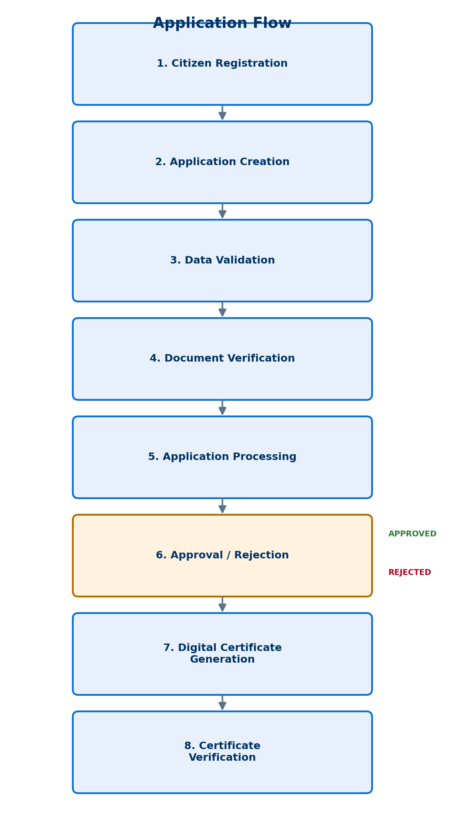
Figure 2: Application Flow — Digital Certificate Generation & Verification System

8. Programming Concepts Used
- ABAP Objects
- Classes and Methods
- Modular Programming
- PERFORM routines
- Dynpro / Module Pool Programming
- PBO and PAI
- Screen 0100
- DDIC
- Custom Database Table
- Open SQL
- SELECT SINGLE
- INSERT
- MODIFY
- COMMIT WORK
- ROLLBACK WORK
- Input validation
- Error handling

9. Error Handling
The project includes validation checks, mandatory field validation, database operation checks, approval checks and certificate verification checks. A separate ZCL_ERROR_HANDLER class is used for modular error message handling.

10. Performance Considerations
- Use SELECT SINGLE where only one record is required.
- Avoid unnecessary database access.
- Use appropriate database keys.
- Keep business logic inside reusable classes.
- Separate UI logic and business logic.
- Use modular programming for maintainability.

11. Project Status
The ABAP classes, DDIC objects, custom database table, main program and Dynpro screen were developed as part of the project. The project source code was also uploaded to GitHub.
GitHub Repository: https://github.com/NandiniBorade/Digital-Certificate-Generation-Verification-System

12. Resume-Ready Project Summary
Developed a modular SAP ABAP based e-Governance application for citizen registration, certificate application processing, document verification, approval and digital certificate generation. Implemented reusable ABAP Objects classes, DDIC objects, custom database table operations, Dynpro screen programming, validation, Open SQL and transaction handling. Added certificate verification and modular error handling to demonstrate an end-to-end business workflow.

