Revolutionizing neurodegenerative disease treatment with deep learning models

ABSTRACT:
This research explores the application of deep learning models, particularly Convolutional Neural Networks (CNNs) and hybrid algorithms, in revolutionizing the treatment and diagnosis of neurodegenerative diseases. The study utilizes a dataset from Kaggle, which contains comprehensive data related to neurodegenerative conditions, to train and evaluate various machine learning models. The models aim to classify different stages or types of neurodegenerative diseases, facilitating early diagnosis and personalized treatment. Advanced architectures, such as MobileNet, are also implemented to enhance the performance and efficiency of the model, particularly for mobile and edge computing environments. The frontend of the system is developed using HTML, CSS, and JavaScript, while Python is employed for the backend model training and deployment. This approach seeks to improve the accuracy, speed, and accessibility of neurodegenerative disease diagnosis, offering significant potential for healthcare innovation.
Keywords: Neurodegenerative diseases, deep learning, Convolutional Neural Networks (CNN), hybrid algorithms, MobileNet, classification, dataset, diagnosis, healthcare, machine learning.

Motivation:

Neurodegenerative diseases, such as Alzheimer's and Parkinson's, represent a significant burden on healthcare systems worldwide. Early diagnosis and personalized treatment are crucial in managing these conditions effectively, yet traditional diagnostic methods can be slow and often require invasive procedures. The rise of deep learning models, particularly Convolutional Neural Networks (CNNs), presents an opportunity to automate and enhance the accuracy of neurodegenerative disease diagnosis. This research is motivated by the need to accelerate and improve diagnostic processes, leveraging AI to identify disease patterns in medical data that are not immediately apparent to human clinicians. By integrating cutting-edge technologies into both mobile and healthcare environments, the study aims to create a more accessible, efficient, and accurate solution for neurodegenerative disease diagnosis.

1.2 Problem Statement:

Neurodegenerative diseases are complex, with symptoms that develop slowly over time, making early diagnosis and effective monitoring challenging. Current diagnostic methods often require subjective judgment, lengthy testing procedures, and high resource consumption, leading to delays in identifying the condition or its stage. These challenges hinder timely interventions, which are crucial for improving patient outcomes. Traditional methods also struggle to scale, particularly in resource-limited settings. With the increasing availability of health data, there is a need for advanced AI-driven models capable of automating disease detection and classification, providing faster and more accurate diagnoses. This study aims to address these challenges using deep learning techniques to enhance neurodegenerative disease diagnosis.

Objective of the Project:

The primary objective of this research is to develop and evaluate deep learning models, particularly Convolutional Neural Networks (CNNs) and hybrid algorithms, to classify different stages or types of neurodegenerative diseases based on available medical datasets. The study also aims to implement advanced architectures, such as MobileNet, to optimize the performance and efficiency of these models, especially for deployment in mobile and edge computing environments. Furthermore, the research seeks to explore the potential of integrating AI-based models with healthcare systems, aiming to improve diagnostic accuracy, speed, and accessibility. The ultimate goal is to create an automated system that can assist healthcare professionals in early diagnosis and personalized treatment planning for neurodegenerative diseases.

  - Scope:
The scope of this research includes the development and evaluation of deep learning models, particularly CNNs and hybrid algorithms, for diagnosing neurodegenerative diseases using a Kaggle dataset. The models will be designed to classify various stages or types of neurodegenerative diseases, facilitating early detection and intervention. The study also explores the use of advanced model architectures, like MobileNet, to improve performance in mobile and edge computing environments. While focusing on backend model development with Python, the research also includes the design of a frontend interface using HTML, CSS, and JavaScript to enable user interaction. The scope extends to enhancing the accuracy, speed, and scalability of disease diagnosis, contributing to healthcare innovation.

Project Introduction

Neurodegenerative diseases, such as Alzheimer's, Parkinson's, and Huntington's, are a growing global health concern, affecting millions of individuals worldwide. These diseases are characterized by the gradual degeneration of nerve cells, leading to cognitive, motor, and behavioral impairments. Early and accurate diagnosis is critical to managing these conditions, as early intervention can significantly improve the quality of life for patients and provide opportunities for personalized treatment strategies. However, traditional diagnostic methods, including clinical assessments and imaging techniques, are often time-consuming, expensive, and can be subject to human error.
Recent advancements in artificial intelligence, particularly deep learning, have opened up new possibilities for automating and enhancing the diagnosis of neurodegenerative diseases. medical data related to these diseases. Convolutional Neural Networks (CNNs), a class of deep learning models, have shown remarkable success in image and pattern recognition tasks, making them ideal for analyzing.
This research investigates the application of CNNs and hybrid machine learning algorithms to classify various stages and types of neurodegenerative diseases, using a dataset from Kaggle containing comprehensive medical data. The study also explores the integration of advanced architectures like MobileNet to optimize model performance, particularly for mobile and edge computing environments, ensuring accessibility and efficiency. By combining these technologies with an intuitive frontend, the aim is to revolutionize neurodegenerative disease diagnosis, enhancing both accuracy and speed for healthcare professionals.
EXISTING METHOD
The existing systems for diagnosing neurodegenerative diseases rely heavily on traditional methods, such as manual assessments, neuroimaging, and clinical evaluations. These processes often involve subjective interpretations by healthcare professionals, leading to variability in diagnoses. Furthermore, they are time-consuming, require extensive resources, and may lack precision in identifying early stages of diseases. Although some machine learning models have been used, they are often not optimized for efficiency or scalability, especially in mobile and edge computing environments. Traditional systems also struggle with handling large, complex datasets efficiently, limiting their ability to provide real-time, personalized diagnostic solutions. As a result, these systems may delay early diagnosis, impacting patient care and outcomes.

3.2 Disadvantages
- Increased Accuracy: Deep learning models like CNNs offer more accurate diagnoses by detecting patterns in data that may be missed by human clinicians.
- Faster Diagnosis: The system can provide near-instantaneous results, reducing the time required for diagnosis compared to traditional methods.
- Personalized Treatment: Early and precise classification of neurodegenerative diseases allows for tailored treatment plans for patients.
- Scalability: The system is optimized for mobile and edge environments, making it easily accessible and scalable in various healthcare settings.
- Automated Process: Reduces the reliance on human intervention, minimizing the risk of errors and ensuring consistent diagnoses.
PROPOSED SYSTEM:
The proposed system utilizes deep learning models, particularly Convolutional Neural Networks (CNNs), to automate and enhance the diagnosis of neurodegenerative diseases. By leveraging a dataset from Kaggle, it aims to classify various stages and types of these diseases with high accuracy. Hybrid algorithms are employed to improve model performance, and MobileNet architecture is implemented to optimize the system for mobile and edge computing environments, enhancing both speed and efficiency. The frontend is developed using HTML, CSS, and JavaScript, while the backend utilizes Python for model training and deployment. This approach aims to improve diagnostic accuracy, speed, and accessibility, offering significant potential for healthcare innovation, particularly in real-time and remote diagnostics.

3.4 Advantages:
Increased Accuracy: Deep learning models like CNNs offer more accurate diagnoses by detecting patterns in data that may be missed by human clinicians.
Faster Diagnosis: The system can provide near-instantaneous results, reducing the time required for diagnosis compared to traditional methods.
Personalized Treatment: Early and precise classification of neurodegenerative diseases allows for tailored treatment plans for patients.
Scalability: The system is optimized for mobile and edge environments, making it easily accessible and scalable in various healthcare settings.
Automated Process: Reduces the reliance on human intervention, minimizing the risk of errors and ensuring consistent diagnoses.

PROJECT FLOW:
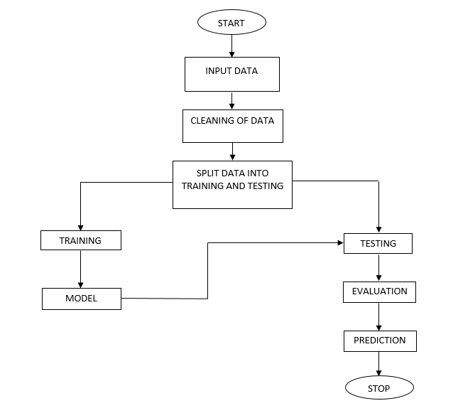
SOFTWARE FRONT END REQUIREMENTS

H/W CONFIGURATION:
- Operating system : Windows 7 or 7+
- RAM : 8 GB
- Hard disc or SSD : More than 500 GB
- Processor : Intel 3rd generation or high or Ryzen with 8 GB Ram
S/W CONFIGURATION:
- Software’s : Python 3.6 or high version
- IDE : PyCharm are VS code.
- Framework : Django, pandas, numpy and Scikit-Learn

4.4Architecture



