**Test Plan**

**Project “Google Mortgage Calculator”**

Document Revision History

|  |  |  |  |  |  |
| --- | --- | --- | --- | --- | --- |
| Date | Version | Description | Author | Reviewer | Approver |
| 02/11 | 0.1 | Test plan was created | Vidya |  |  |
|  |  |  |  |  |  |

**1 INTRODUCTION**Customer wants to verify the functionality and stability of “Google mortgage calculator” using Automation testing techniques.

The Test Plan document has been created to facilitate communication between QA team members and other teams within the project.

**1.2 PURPOSE**Purpose of the Automation Test Plan is to:

* Provide a highly structured and disciplined automation testing approach that would enable automation testing of “Google Mortgage Calculator” in an highly effective and efficient manner to meet Business objectives and expectations
* This document will also enable the automation test team to govern and direct their detailed automation testing work.
* Communicate the Objectives, Scope, Roles, Responsibilities, Assumptions, Timelines and Tools that govern the automation testing life cycle.
* Confirm to stakeholders that adequate consideration has been given to various aspects governing the automation testing effort, and where appropriate, to have those stakeholders approve the strategy.
* Increased focus on functional decomposition and help delivering quality automated regression suite
* Implement automation testing best practices processes to enable return on investment (ROI)

Testing is a living process and the testing approach may need to be adjusted after certain realizations or discoveries are made. When this is the case, both the Automation Test Strategy and the automation testing approach will be adjusted, the test strategy will be revised and shared for required approval.

**2 SCOPE**

This document will be in effect from the time of its approval until the end of UAT phase of the Project. Out of the test phases defined in the test strategy, the following test phase(s) are in scope for the Automation Test strategy.

|  |  |
| --- | --- |
| **Test Phase** | **Responsible Resource** |
| Sprint Functional/Regression Testing | Test Automation Team |
| Build Verification (Smoke) Testing | Test Automation Team |
| End to End Testing (E2E) | Test Automation Team |
| Test data creation support for UAT | Test Automation Team |

NOTE: This test strategy will be revisited and updated as needed based on any program scope/schedule changes

The scope of Automation includes the functional testing of “Google Mortgage Calculator” on different browsers

Feasibility Analysis of Requirements

Design Automation Scripts Automation Feasible

Scenario Identification

SetUp & Configure

Automation Framework

**3 AUTOMATION TESTING SPRINT ACTIVITIES & APPROACH**

The automation testing timeline will mimic the agile development approach. As configurations are completed, pieces of the system will be migrated to the testing environments, where automation testing will then take place. As Sprints development continues and automation test scripting and execution continues.

Given below are automation testing activities to be performed in each sprint –

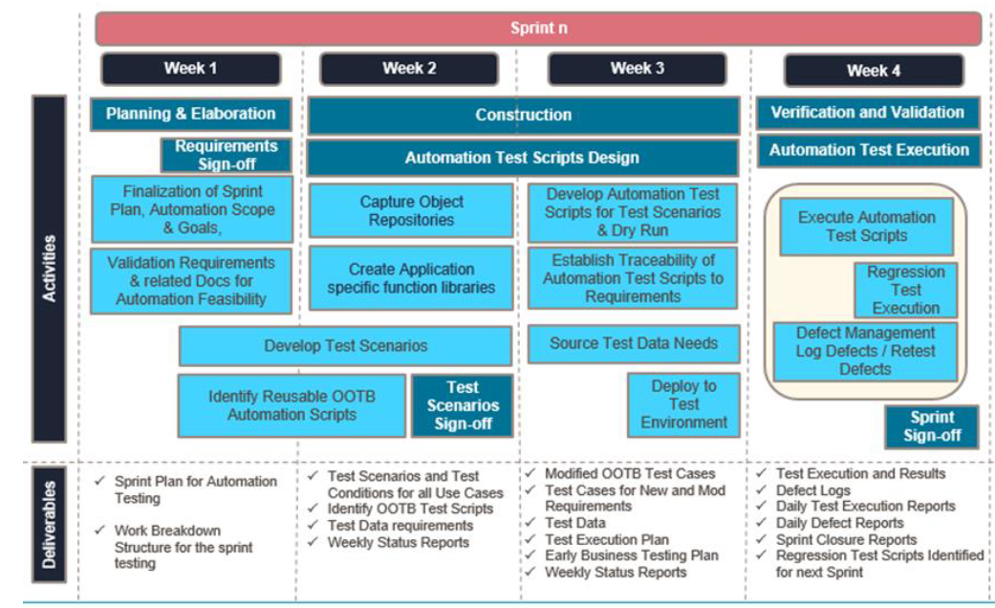

**4 TEST AUTOMATION APPROACH**

The table below depicts various phases of automation.

|  |  |  |
| --- | --- | --- |
| **Phase** | **Activities/Inputs** | **Outputs** |
| **Analysis phase** | * Automation Test strategy is finalized * Test scenarios developed for regression reviewed and approved business SMEs - will be base-lined to a version and are available for automation. | * Automation feasible test scenarios are identified * Automation tool is installed and ready for use on virtual machines |
| **Planning phase** | * Approved automation scope document is available in every sprint | * Functionality detailed schedule is ready |
| **Design & development phase** | * Test environment for automation is identified and appropriate access is obtained * Test data requirements are documented * Stable and running build is available * Direct access to test database is provided * Virtual Machines are available | * Automation scripts are developed * Test Data sheets * Virtual machines with automation needs are configured |
| **Stabilization phase (Dry Run)** | * Automation scripts are available * Environment is identified and access is made available to the automation resources | * Defects if any found are reported in Defect tracking tool after confirmation from SMEs |
| **Execution Phase** | * Automation scripts are available which are dry run completed * Environment is up and running * Application Test data is available | * Automation scripts are executed and results are available. * Test summary report is prepared * Issues if any found are reported in Defect tracking tool after confirmation from SMEs |
| **Signoff Phase** | * Stabilized test automation suite and execution summary | * Automation suite is base-lined for future deployments * Deliverables and Execution reports are signed off. |

**4.1 REVIEW PROCESS**

All testing scenarios and automation test scripts created by the automation QA team will undergo 3 levels of reviews:

**4.1.1 PEER REVIEW**

All test scenarios & automation test scripts created by the QA team need to be reviewed by at least one peer from the automation testing team. Peer reviews will be identified as a task in the test scenario creation process. All peer review comments will be logged in a review log and any issues noted will be addressed and updated prior to the scenario’s first execution.

**4.1.2 AUTOMATION TEST LEAD REVIEW**

Automation Test leads are required to perform a thorough review of all test scenarios that have been created by their team. These reviews including the high-level scenarios, test data requirements and their traceability against the functional points.

**4.1.3 BA REVIEW of functionality**

All the test scenarios created for Automation has to be reviewed with QA/BA and get the sign off on the same. These reviews including the high level scenarios, test data requirements and their traceability against the functional points.

**5. AUTOMATION –BEST PRACTICES**

Best practices at TMNAS followed by three phases.

* Designing
  + Standardized folder Format
  + Modular framework
  + Shared repositories
  + Common Utility
* Coding
  + Naming Conventions
  + Documentation
  + Avoid too many loops
  + Use case statements
  + Keep it simple
  + Data drive the script for different states ( Equal Data Distribution)
  + Page sync
  + Code review/Peer review
  + Create automated tests that are resistant to changes in UI.
* Execution
  + Module Driver
  + Reports
  + Scheduled execution
  + Auto notification of results
  + Execution in Multiple environments.

**5 ROLES AND RESPONSIBILITIES**

page4image31476160page4image31476352page4image31476544

|  |  |  |
| --- | --- | --- |
| Roles |  | Responsibilities |
| Project Manager / Scrum Master |  | 1. Acts as a primary contact for development and QA team. 2. Responsible for Project schedule and the overall success of the project. |
| Automation  QA Lead |  | * Coordinate with different team members on the project to resolve the blockers Automation team * Plan & Manage the automation activities * Ensure on time deliveries * Automation lead to send daily/weekly status reporting * Manage the scope of test automation for every sprint * Coordinate with test data analyst on test data requirements * Assure appropriate test coverage |
| Automation QA |  | 1. Understand requirements 2. Writing and executing Test cases 3. Preparing RTM 4. Reviewing Test cases, RTM 5. Defect reporting and tracking 6. Retesting and regression testing 7. Bug Review meeting 8. Preparation of Test Data 9. Coordinate with QA Lead for any issues or problems encountered during test preparation/execution/defect handling. |

**ENTRY AND EXIT CRITERIA**

The Automation entry/exit criteria are the set of conditions that should be met prior to the start of and before the close of the automation test stage. In the situation where conditions specified in the Entry/Exit criteria cannot be met or is expected to be waived after the documented criteria has been signed off, a review and approval from the respective stakeholders is required.

**6.1 Entry Criteria**

 Automation test strategy has been approved.

* Integrated environment (infrastructure/application systems) for automation is ready
* Testing resources execute or support automation (development/business) are available/on-board
* Automation Tool server should be configured
* All tools licenses should be available to support testing.
* Automation Framework in place.
* Test data available
* Machine requirement, all Automation machine requires 16 GB RAM
* Note: 1 automation resource will require minimum of 1 machine for Development and Execution. More automation machines will have better productivity.

**6.2 Exit Criteria**

Automated test scripts are executed and has been passed/deferred

* Results has been documented and approved
* Outstanding defect report documented
* Severity 1 and 2 defects are closed
* Severity 3 and 4 defects have been reviewed, closed and/or deferred
* All testing artefacts are archived and handed over to Project Test manager
* Automation test summary report is created and signed off
* Automation suite is base-lined for future deployments

**7 SUSPENSION CRITERIA AND RESUMPTION REQUIREMENTS**

**7.1 Suspension criteria**

• The build contains many serious defects which seriously or limit testing progress. Significant change in requirements suggested by client  
• Software/Hardware problems  
• Assigned resources are not available when needed by test team.

**7.2 Resumption criteria**

Resumption will only occur when the problem(s) that caused the suspension have been resolved

**8 TEST STRATEGY**

**8.1 QA role in test process**

Understanding Requirements:  
• Requirement specifications will be sent by client.  
• Understanding of requirements will be done by QA

Preparing Test Cases:  
QA will be preparing test cases based on the exploratory testing. This will cover all scenarios for requirements.

Preparing Test Matrix:  
QA will be preparing test matrix which maps test cases to respective requirement. This will ensure the coverage for requirements.

Reviewing test cases and matrix:  
• Peer review will be conducted for test cases and test matrix by QA Lead

• Any comments or suggestions on test cases and test coverage will be provided by reviewer respective Author of Test Case and Test Matrix  
• Suggestions or improvements will be re-worked by author and will be send for approval  
• Re-worked improvements will be reviewed and approved by reviewer

Creating Test Data:  
Test data will be created by respective QA on client's developments/test site based on scenarios and Test cases.

-Executing Test Cases:  
• Test cases will be executed by respective QA on client's development/test site based on designed scenarios, test cases and Test data.  
• Test result (Actual Result, Pass/Fail) will updated in test case document Defect

Logging and Reporting Defects:  
QA will be logging the defect/bugs in Word document, found during execution of test cases. After this, QA will inform respective developer about the defect/bugs.

Retesting and Regression Testing:  
Retesting for fixed bugs will be done by respective QA once it is resolved by respective developer and bug/defect status will be updated accordingly. In certain cases, regression testing will be done if required.

Deployment/Delivery:  
• Once all bugs/defect reported after complete testing is fixed and no other bugs are found, report will be deployed to client’s test site by PM.  
• Once round of testing will be done by QA on client’s test site if required Report will be delivered along with sample output by email to respective lead and Report group.  
• QA will be submitting the filled hard copy of delivery slip to respective developer.  
• Once lead gets the hard copy of delivery slip filled by QA and developer, he will send the report delivery email to client.

**8.2 Outline of planned TestScenarios :**

* Test if user is able to launch "Google Mortgage Calculator" at the least
* Test if user is able to calculate the "Monthly Payment" with valid Mortgage amount & Valid interest rate
* Test if user provides Invalid Mortgage amount & Valid interest rate
* Test if user provides valid Mortgage amount with some unwanted characters & Valid interest rate
* Test if user provides boundary values as Mortgage amount & Valid interest rate
* Test if user provides valid Mortgage amount & Invalid interest rate
* Test if user provides valid Mortgage amount & valid interest rate with some unwanted characters
* Test if user provides valid Mortgage amount & boundary values for interest rate
* Test microphone functionality on the Search bar
* Test Google icon/image & the colors, lines, dots, curves etc., in it

**8.3 Defect life cycle:**

All the issues found while testing will be logged into Word document.

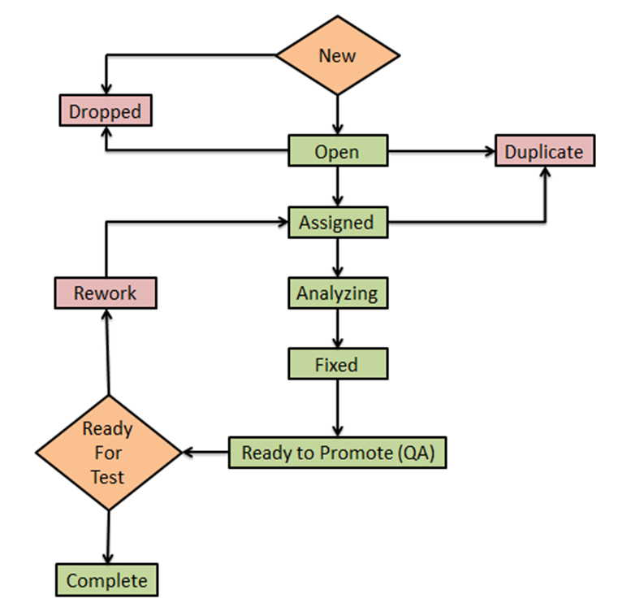

**8.4 Testing types**

Bug life cycle for this project is as follows:

**Smoke Testing:**  
This phase of testing includes checking the stability of the new functionality/build released

**Functional Testing:**  
This phase of testing includes the functionality & behavior testing of the application.

**Regression Testing:**  
This phase of testing includes the sprint level & release level regression testing of the application

**Performance Testing:**  
Out of scope

**User acceptance testing:**  
User acceptance testing (UAT) will be done at the Client.

**8.5 Bug Severity and Priority Definition**

Bug Severity and Priority fields are both very important for categorizing bugs and prioritizing if and when the bugs will be fixed. The bug Severity and Priority levels will be defined as outlined in the following tables below. Testing will assign a severity level to all bugs. The Test Lead will be responsible to see that a correct severity level is assigned to each bug.

The BA, QA Lead, Development Lead and Project Manager will participate in defect review meetings to assign the priority of all currently active bugs. This meeting will be known as “Defect Triage Meetings”. The QA Lead is responsible for setting up these meetings on a routine basis to address the current set of new and existing but unresolved bugs.

**Severity List**

The tester entering a bug into the defect tracking tool like Jira is also responsible for entering the bug Severity.

|  |  |  |
| --- | --- | --- |
| Severity ID | Severity | Severity Description |
| 1 | Critical Level | The module/product crashes or the bug causes non- recoverable conditions. System crashes, or database or file corruption, or potential data |
| 2 | High | Major system component unusable due to failure or incorrect functionality. Sev. 2 bugs cause serious problems such as a lack of functionality, or insufficient or unclear error messages that can have a major impact to the user, prevents other areas of the app from being tested, etc. Sev. 2 bugs can have a work around, but the work around is inconvenient or difficult. |
| 3 | Medium | Incorrect functionality of component or process. There is a simple work around for the bug if it is Sev. 3. |
| 4 | Minor | Documentation errors or signed off severity 3 bugs. |

**Priority List**

|  |  |  |
| --- | --- | --- |
| **Priority** | **Priority Level** | **Priority Description** |
| 1 | Must Fix | This bug must be fixed immediately; the product cannot ship with this bug. |
| **2** | Should Fix | These are important problems that should be fixed as soon as possible. It would be an embarrassment to the company if this bug shipped. |

|  |  |  |
| --- | --- | --- |
|  |  |  |

**9 RESOURCE AND ENVIRONMENT NEEDS**

**9.1 Testing Tools**

|  |  |
| --- | --- |
| **Process** | **Tool** |
| Test case creation | Microsoft Excel, Eclipse IDE |
| Test case tracking | Microsoft Excel, Git |
| Test case execution | Manual, Maven, Jenkins |
| Test case management | Microsoft Excel, Git |
| Defect Management | Jira |
| Test Reporting | TestNG/Cucumber |

**9.2 Configuration Management**

* Code CM: Git

**9.3 Test Environment**

Support level 1 (browsers):

* Windows : Edge, Chrome (latest), Firefox (latest), Safari (latest)
* Mac OS X: Chrome (latest), Firefox (latest), Safari (latest)
* Linux Ubuntu: Chrome (latest), Firefox (latest)
* Support level 1 (devices):
* iPhone 5 / 6, iPad 3, Nokia Lumia 910, Google Nexus 7, LG G3.

Support level 2:

* Windows 7: IE 9+, Chrome (latest), Firefox (latest), Safari (latest)
* Windows XP: IE 8, Chrome (latest), Firefox (latest), Safari (latest)

Support level 3:

* anything else

**10. Test Schedule**

|  |  |  |  |  |
| --- | --- | --- | --- | --- |
| **Task Name** | **Start** | **Finish** | **Effort** | **Comments** |
| Test Planning | 01/28 | 02/03 |  |  |
| Review Requirement documents |  |  |  |  |
| Create test basis |  |  |  |  |
| Staff and train new test resources |  |  |  |  |
| First deploy to QA test environment- Iteration 1 |  |  |  |  |
| Functional Testing – Iteration 1 |  |  |  |  |
| Iteration 2-Deploy to QA environment |  |  |  |  |
| Functional Testing – Iteration2 |  |  |  |  |
| System Testing |  |  |  |  |
| Regression Testing |  |  |  |  |
| UAT |  |  |  |  |
| Resolution of final defects and final build testing |  |  |  |  |
| Deploy to staging environment |  |  |  |  |
| Performance Testing |  |  |  |  |
| Release to Production |  |  |  |  |

**Approvals:**

|  |  |  |  |
| --- | --- | --- | --- |
| I have reviewed and agree with the information contained in this QA Test Plan.  **Note:** Signatures are allowed electronically. | | | |
| **Name** | **Role/Area** | **Signature**  (e-signature via email acceptable) | **Date**  (MM/DD/YYYY) |
|  | Business Analyst |  |  |
|  | Development Lead |  |  |
|  | Scrum Master / Project Manager |  |  |
|  | QA Manager |  |  |