1) Open a terminal and go to the folder containing your `docker-compose.yml`.

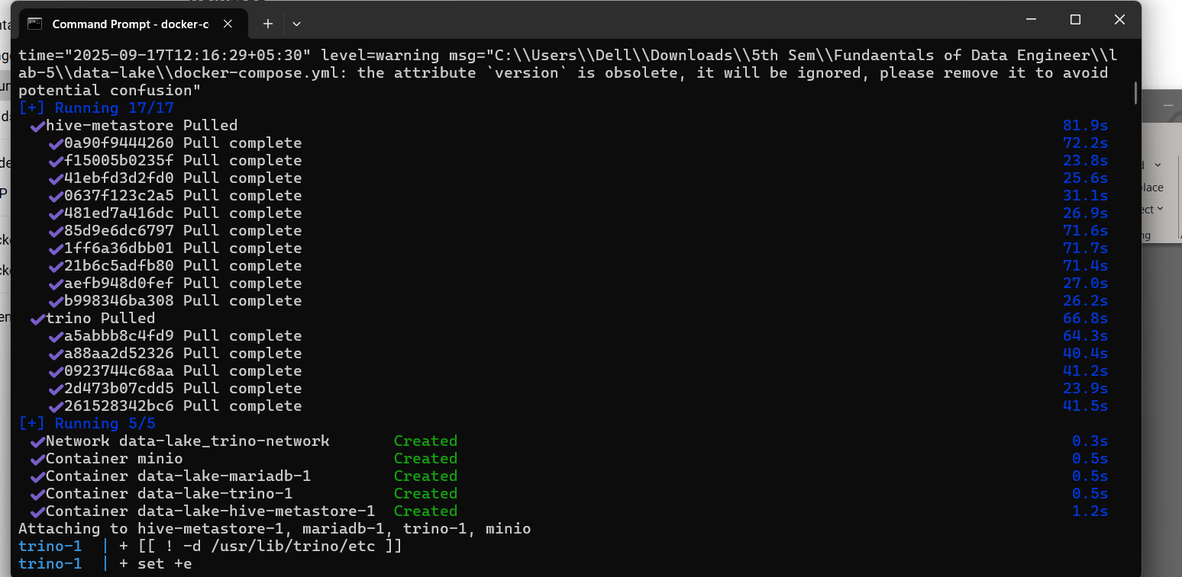 Execute the command**: docker-compose up**

2) Created volume in Docker:

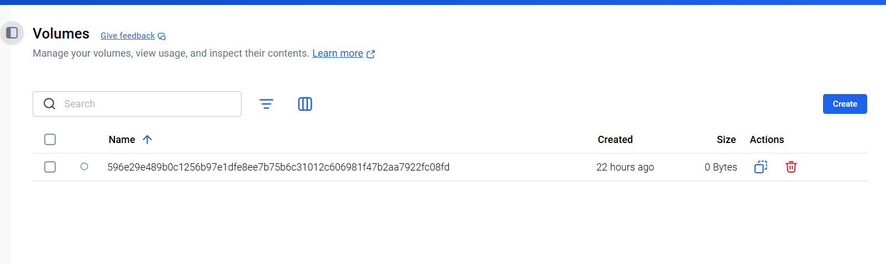

3)MinIO Dashboard:

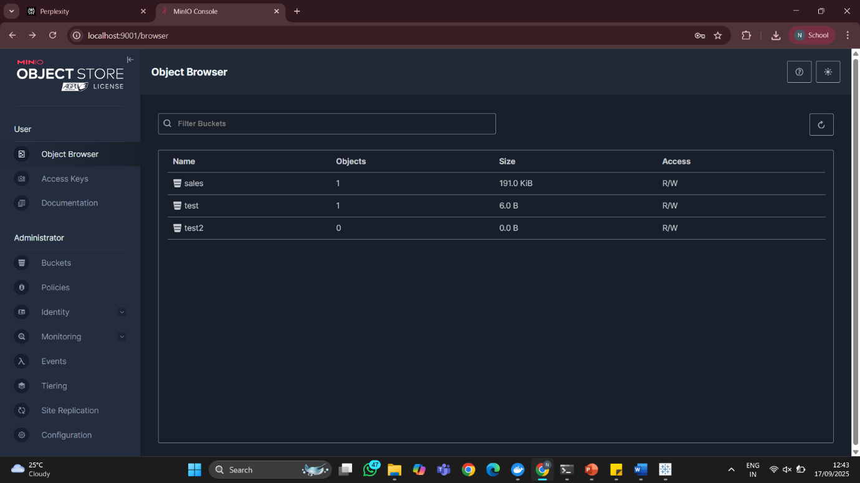

4) Trino:

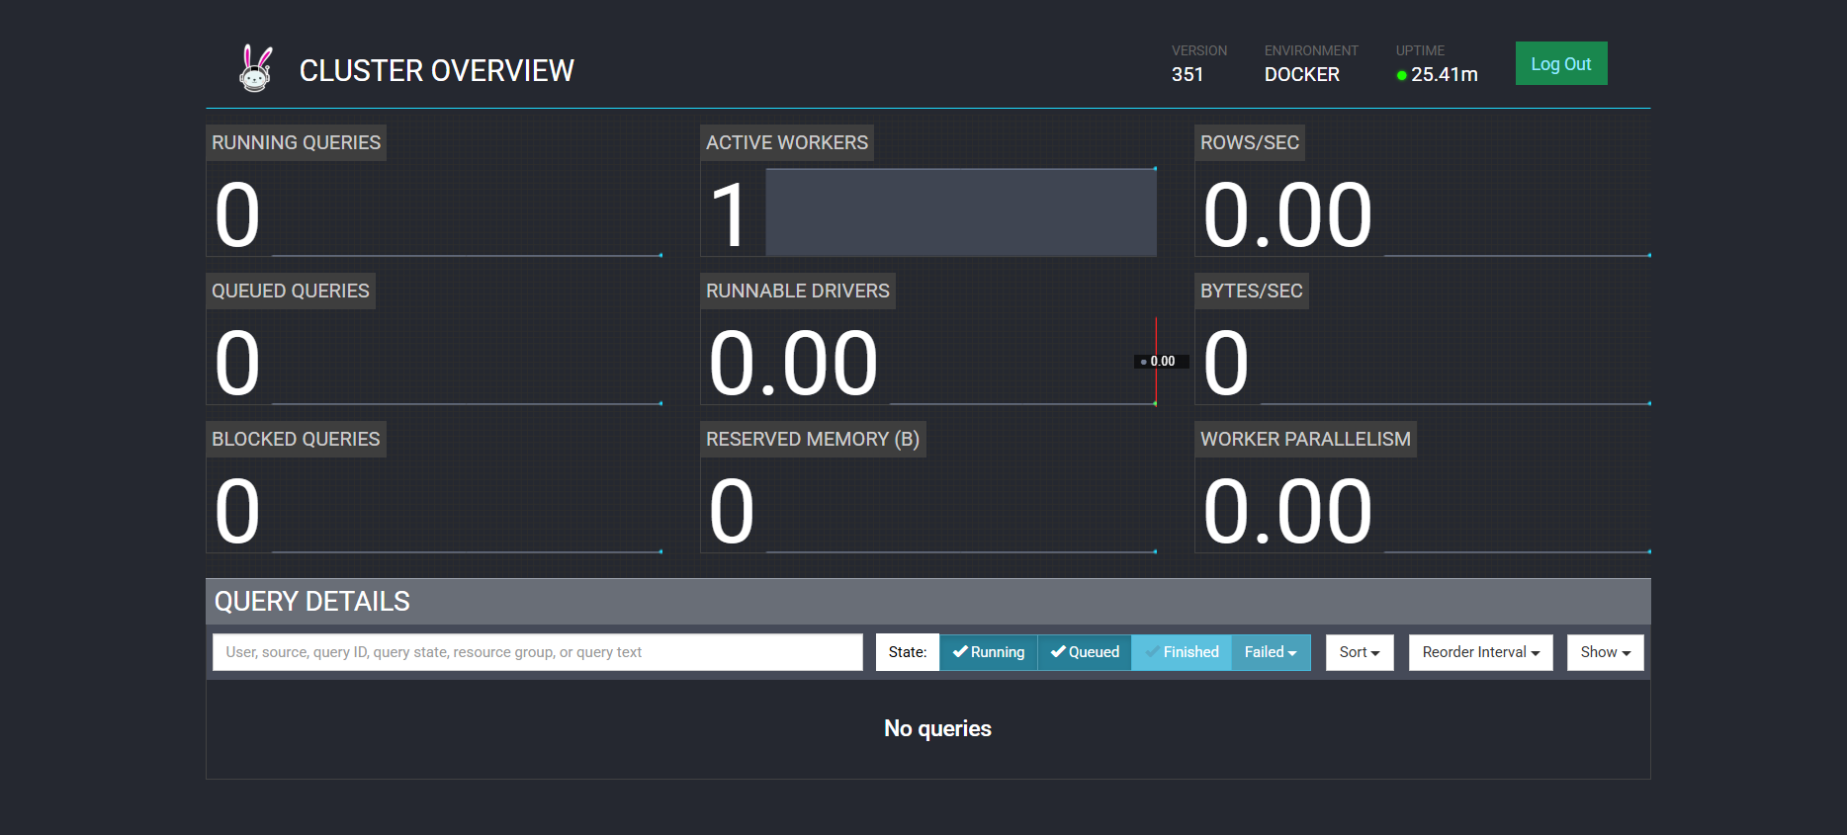

5)DBeaver:

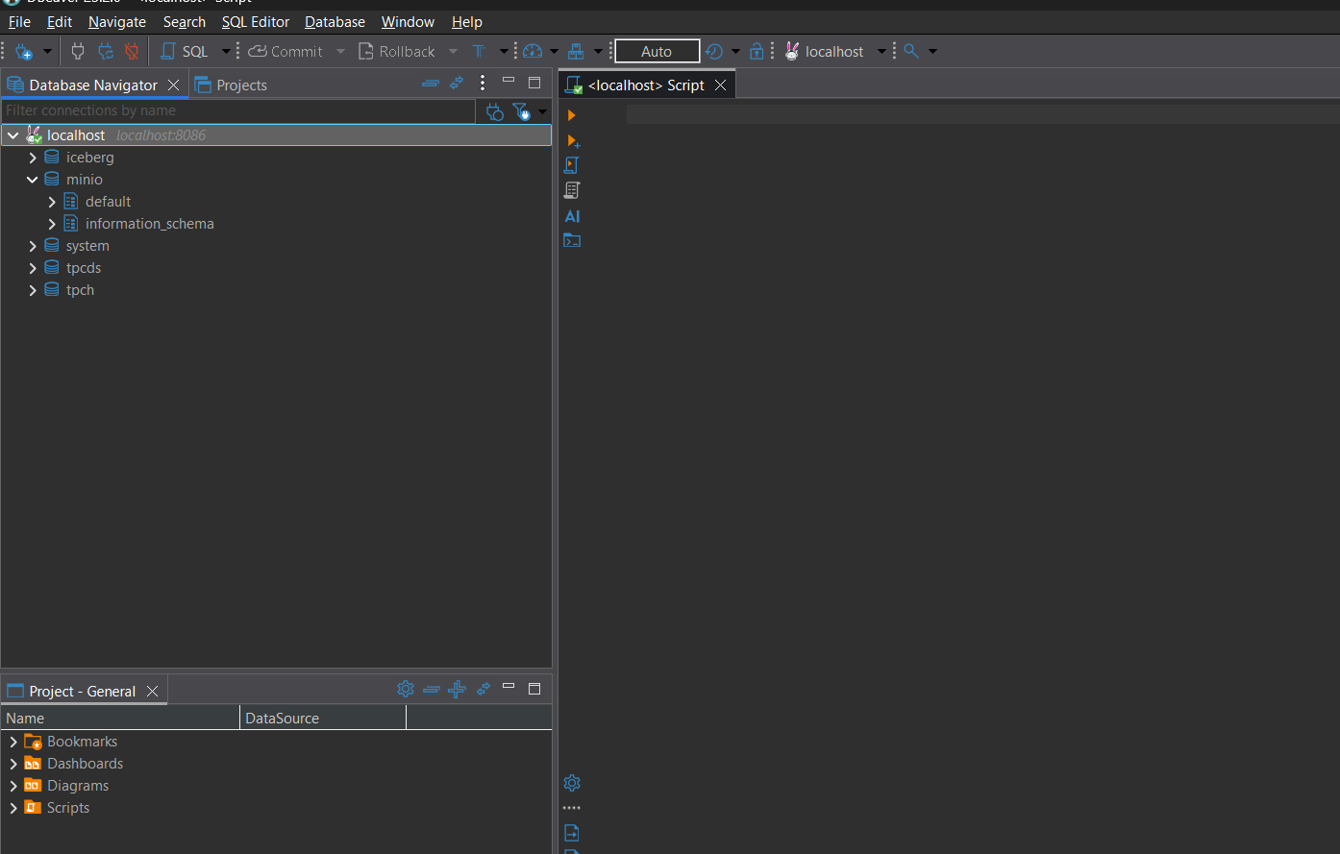

6)Create Schema

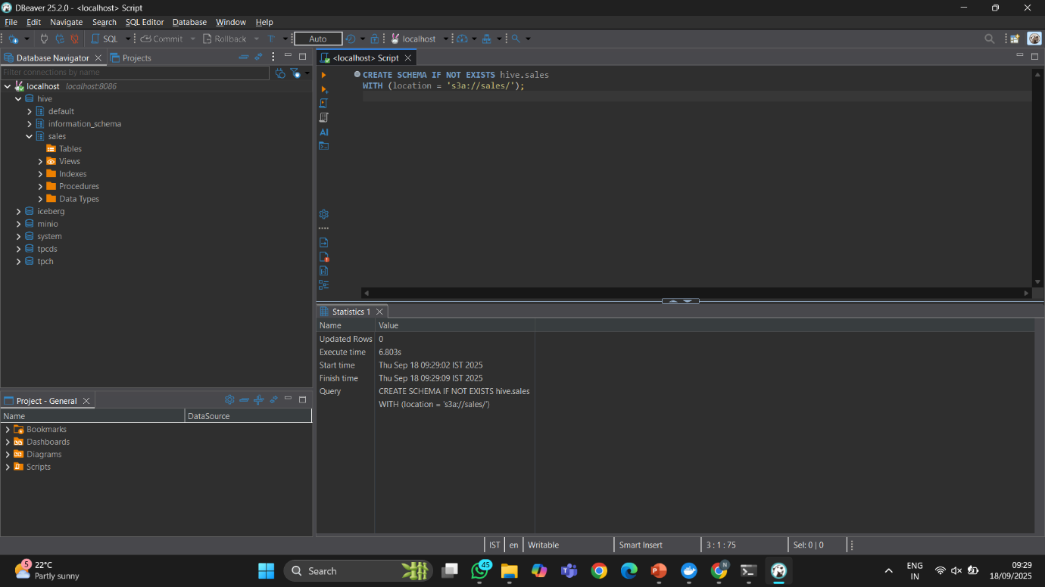

8) Table of sales_tz:

