Step 1: Set up Microsoft SQL Server
- Download the lightweight edition: SQL Server Express (from Microsoft’s official site).
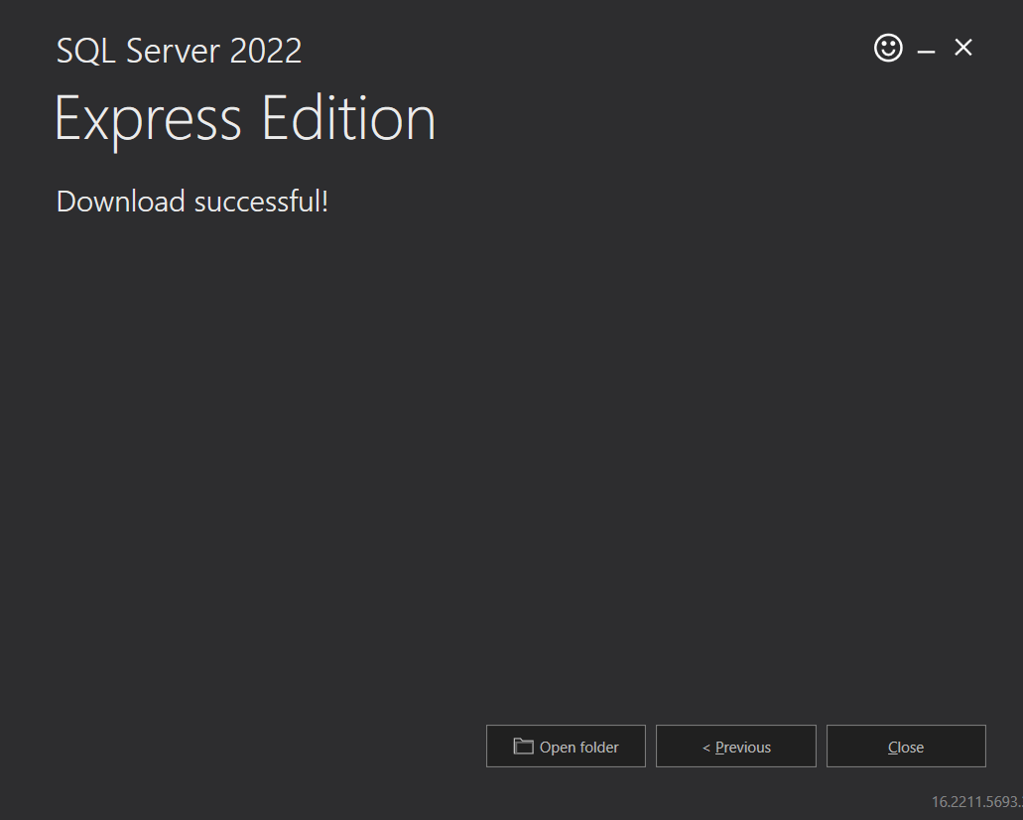
- Proceed with the installation using the default configuration.
- Next, install SQL Server Management Studio (SSMS) – this will serve as your graphical tool for interacting with the SQL Server.
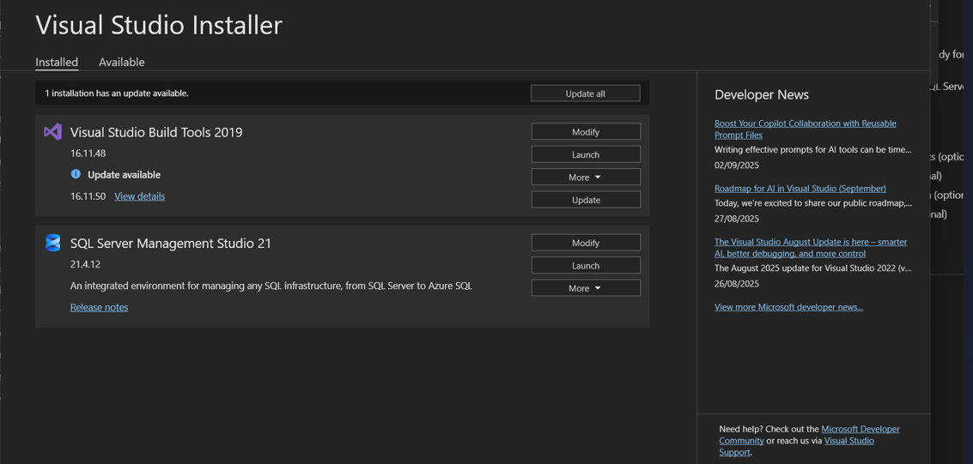

Step 2: Add a Sample Database
- Bring in the AdventureWorks sample database.
- Follow the installation instructions provided in Microsoft’s AdventureWorks setup guide.
- Verify that the database is available in your SQL Server instance.
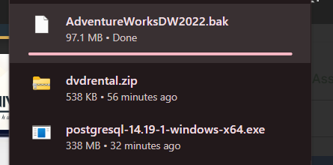
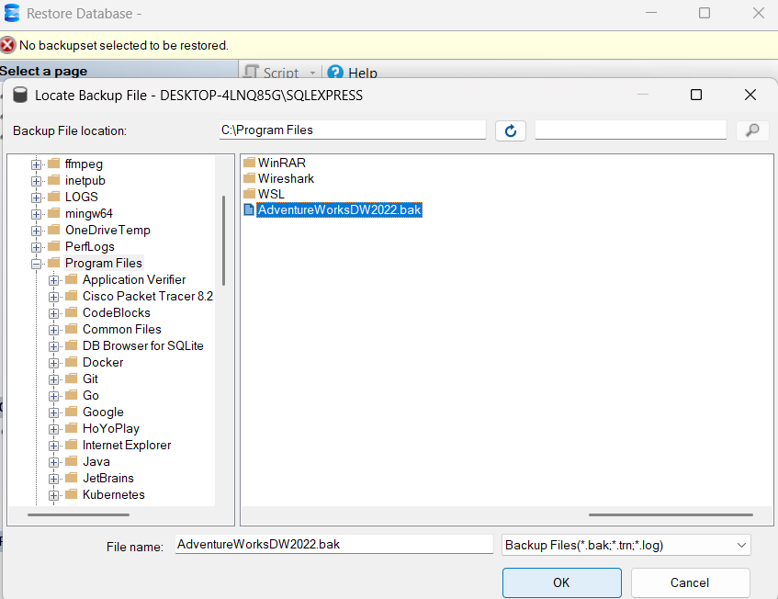

Step 3: Install PostgreSQL
- Grab the installer from the official PostgreSQL downloads page.
- While setting up, assign a password.
- For easier database visualization and management, consider installing pgAdmin4 alongside PostgreSQL
- 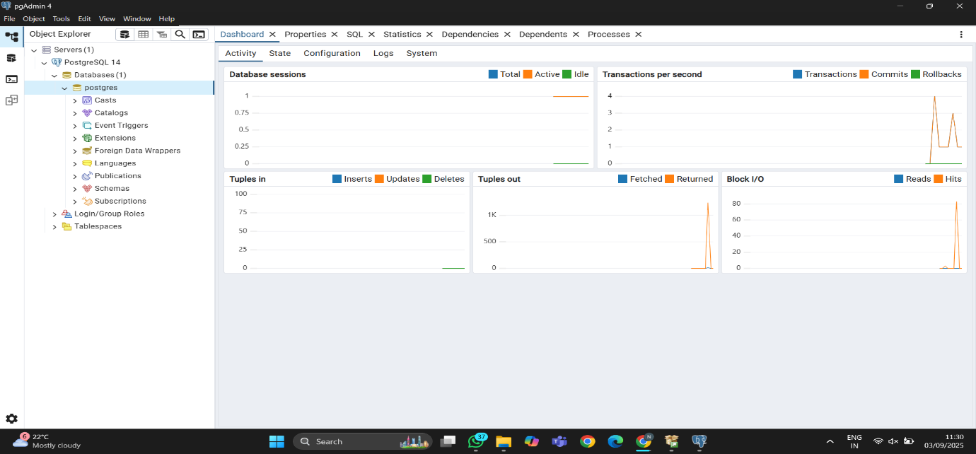

Step 5: Enable Connectivity
- Download and install the ODBC Driver 17 for SQL Server.
- This driver acts as a bridge, allowing applications (like Python or ETL tools) to connect seamlessly with SQL Server.

Step 6: Configure PostgreSQL in pgAdmin 4
- Launch pgAdmin 4.
- Go to Databases → Create → Database, enter the name adventureworks, and save.
- Open the Query Tool and execute the following SQL to create a role and assign privileges:

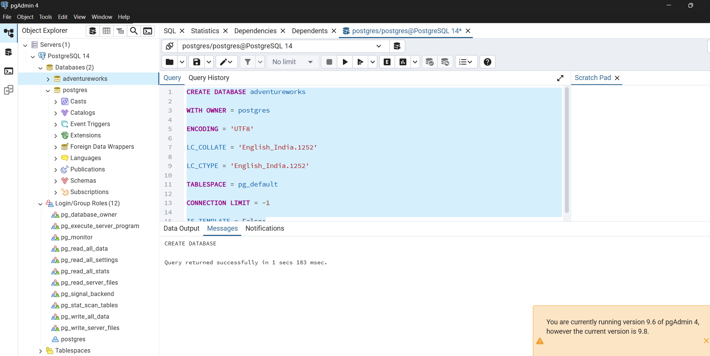

Step 7: Verify Data in PostgreSQL
- Open pgAdmin → Databases → adventureworks → Schemas → public → Tables.
- Right-click on one of the staging tables (e.g., stg_dimproduct, stg_dimproductcategory, stg_factinternetsales).
- Select View/Edit Data to confirm that records have been loaded.
- Capture a screenshot of the data preview and submit as required.
