# Python Assignment== > 3-09-25

Submitted by : NANDINI PALAGIRI

Roll no : 22KQ1A0216

1. Python program to find given number is prime or not:

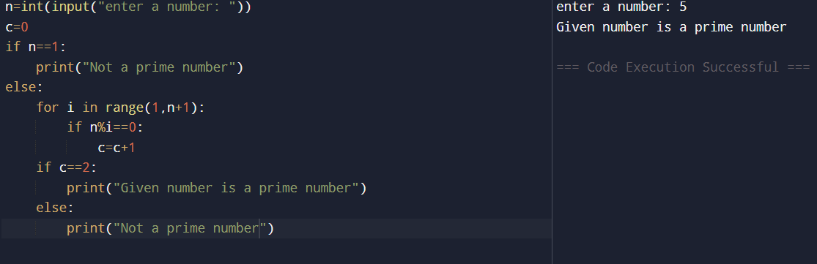

1. Python program to check a number is palindrome or not:

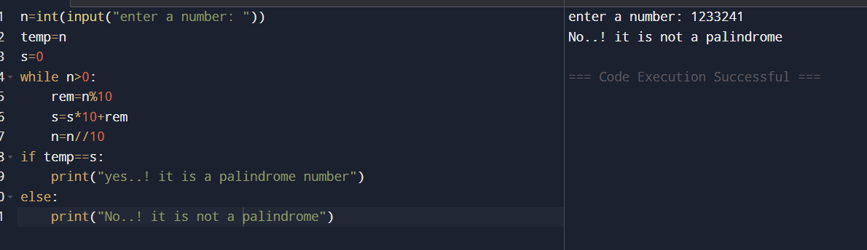

1. Python program to check whether the number is Armstrong or not:

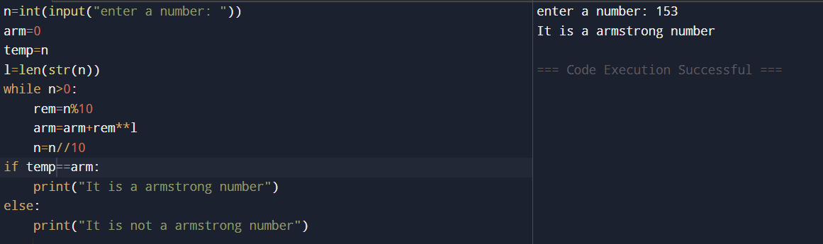

1. Python program to print Fibonacci series:

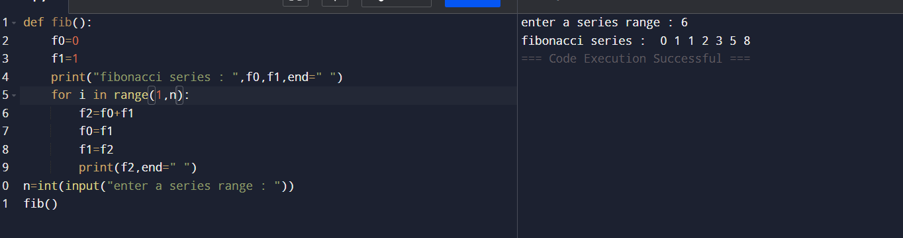

1. Python program to check a number whether strong number or not:

