# Python Assignment == > 04-09-25

Submitted by : NANDINI PALAGIRI

Roll no : 22KQ1A0216

1. Python program to print factorial of a number:

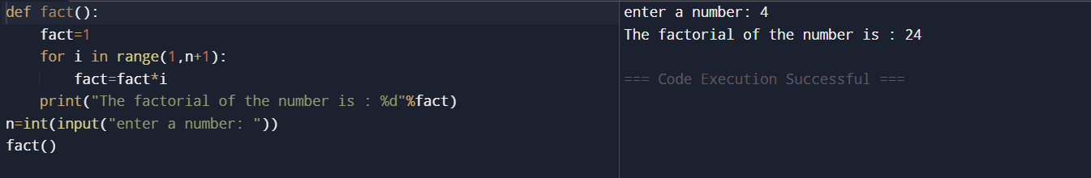

1. Program to print the factors of a number :

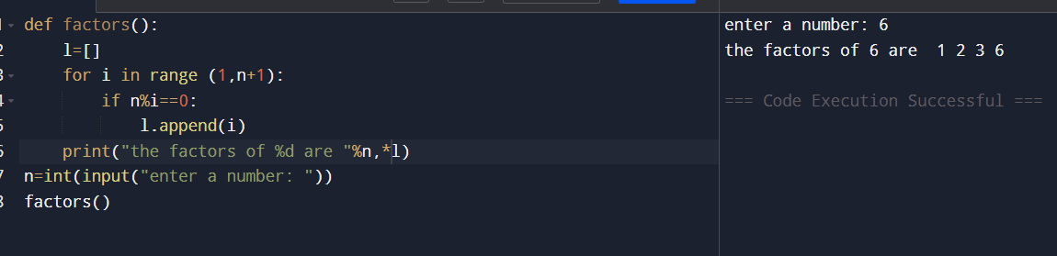

1. Python program to print perfect number:

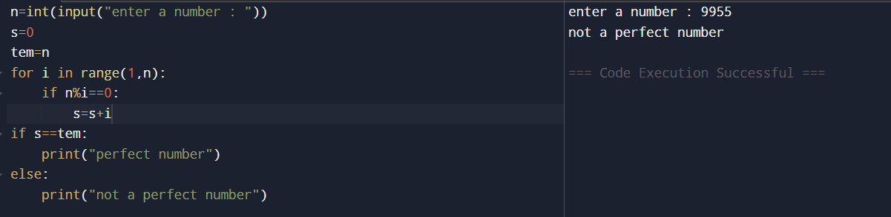

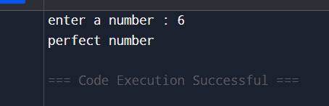

1. Program to print perfect square:

