# Python Assignment ==> 5-09-25

Submitted by : Nandini palagiri

Roll no : 22KQ1A0216

1. Program to check given is harshad number or not:

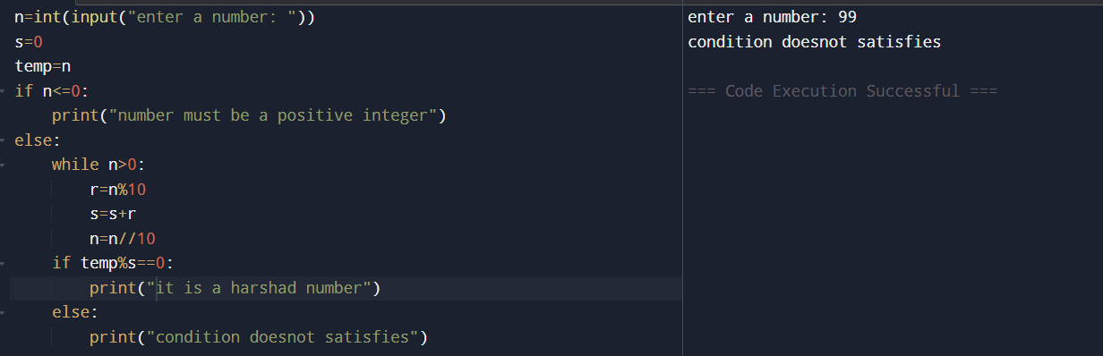

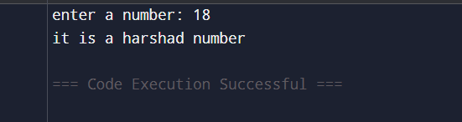

1. Program to print friendly pair:

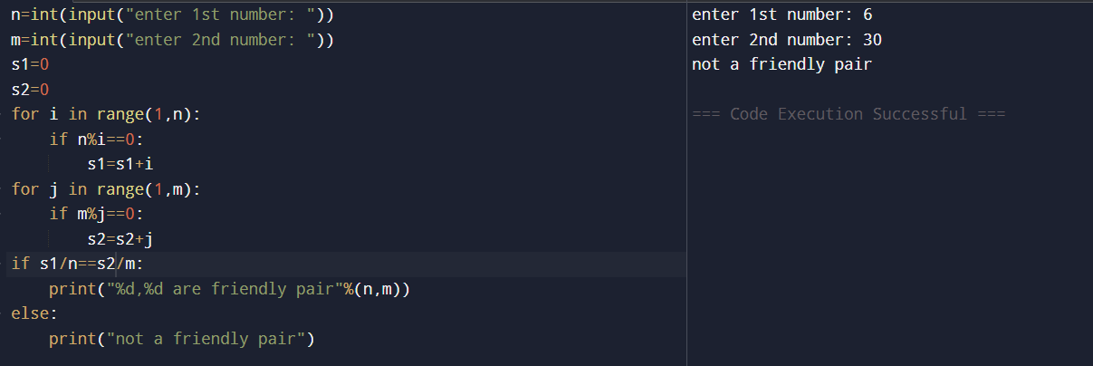

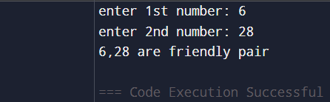

1. Program to check the number is abundant or not:

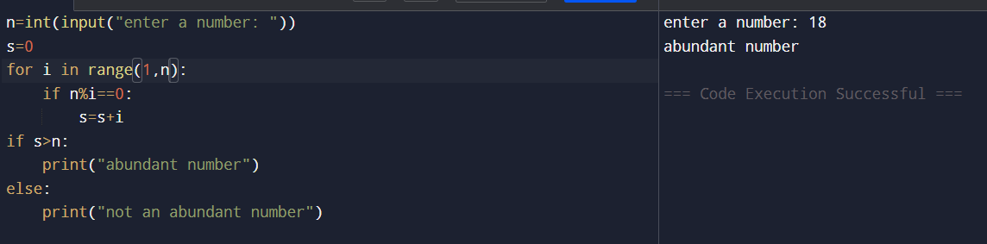

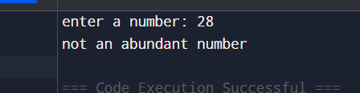

1. Program to check strong number or not:

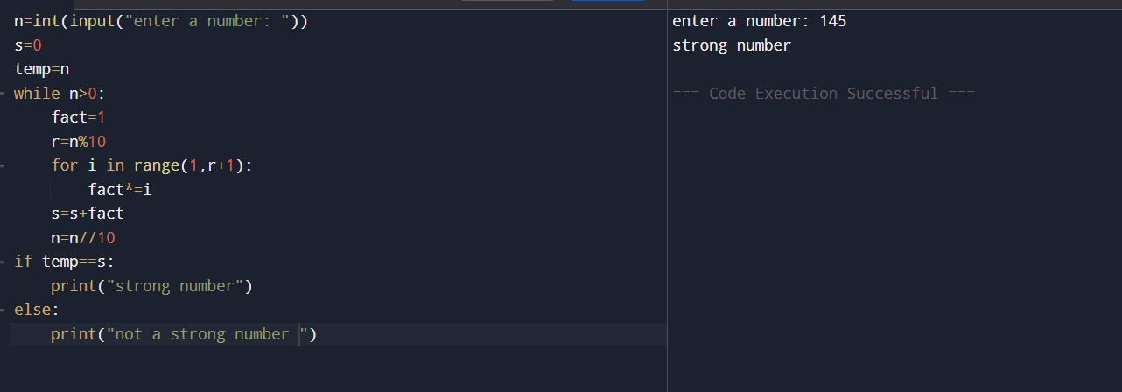

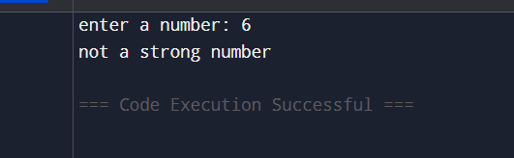

1. Program to check automorphic number or not:

