# Python Assignment == > 1-09-2025

Submitted by : Nandini Palagiri

Roll no : 22KQ1A0216

1. A pattern to print “*” in square format:

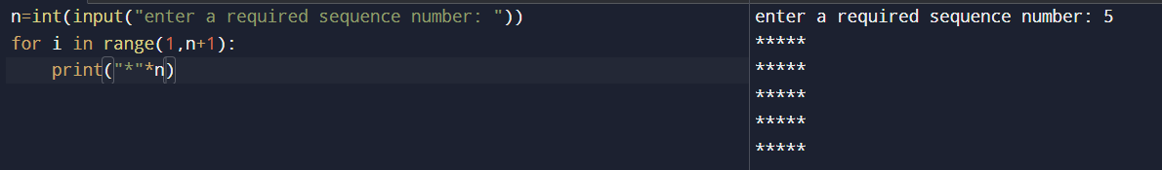

1. A pattern to print “*” in rectangular format:

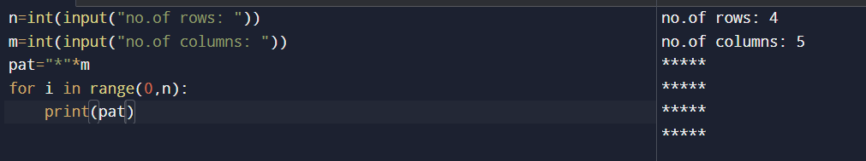

1. A pattern to print ‘*’ in hallow square:

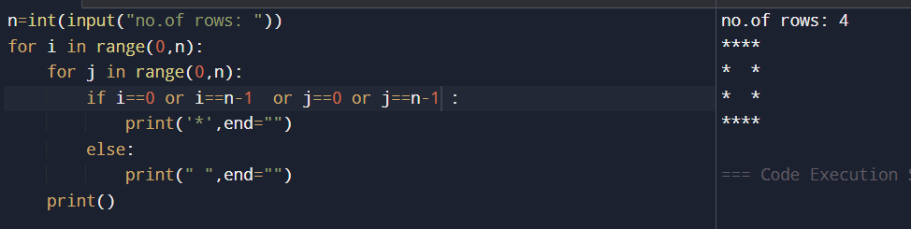

1. A pattern to print “*” in hallow rectangle:

