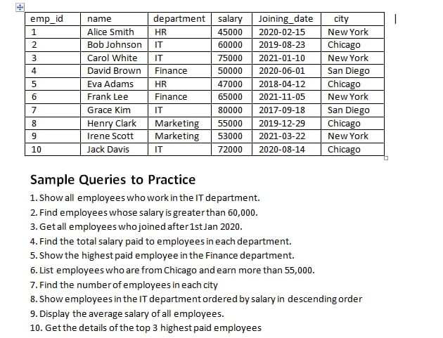

# **ANSWERS:**

1. **To show all the employees who work in IT department:**

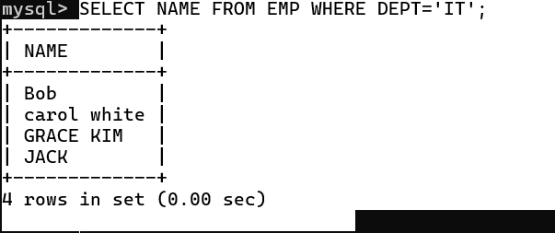

1. **To find employees whose salary s greater than 60,000**

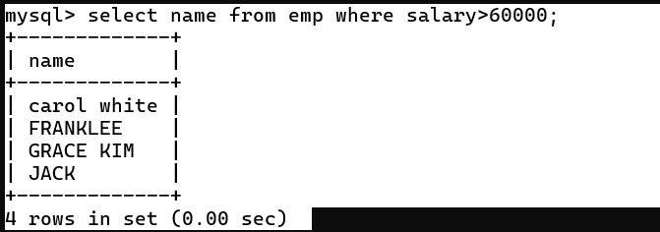

1. **To get all employees who joined after 1st jan 2020:**

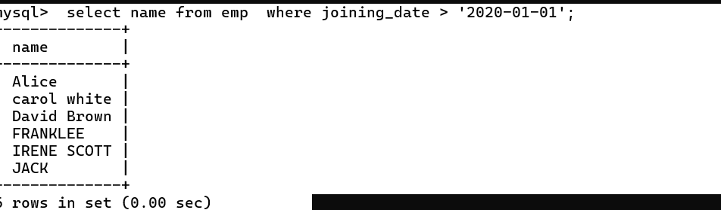

1. **To find total salary paid to employees in each department:**

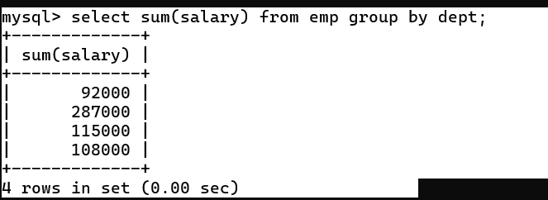

1. **To show the highest paid employee in finance department:**

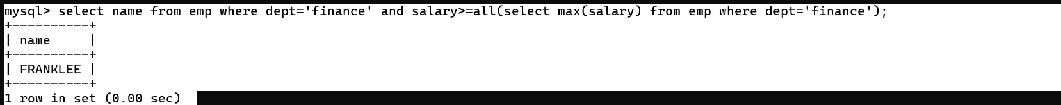

1. **To list employess who are from chicago and earn more than 55000:**

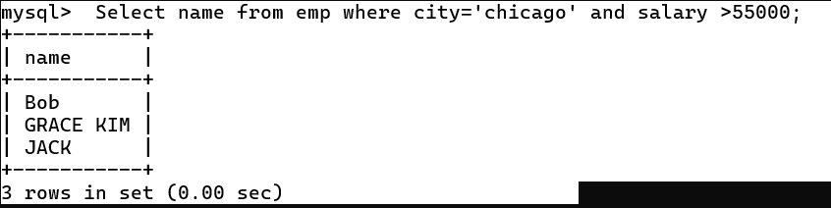

1. **To find the number of employees in each city:**

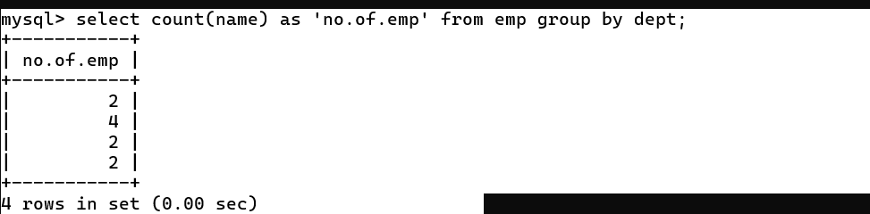

1. **To show employees in the IT department ordered by salary in descending order:**

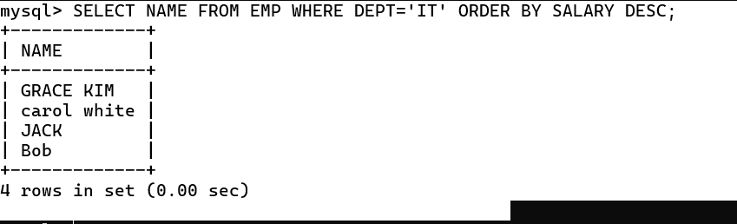

1. **To display average salaries of all employees:**

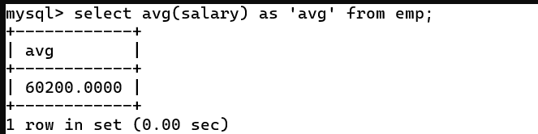

1. **To get the details of top 3 highest paid employees:**

