15-08-25

1. A python program to reverse a given string without using built-in reverse functions:

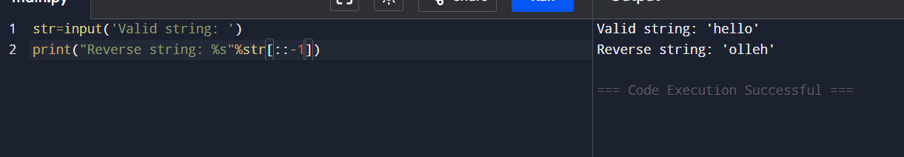

1. To check if a string is palindrome:

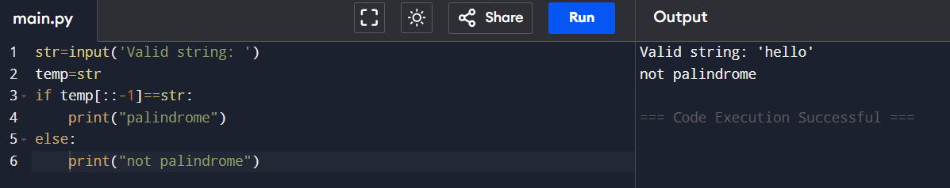

1. To count no.of vowels and consonants in a string:

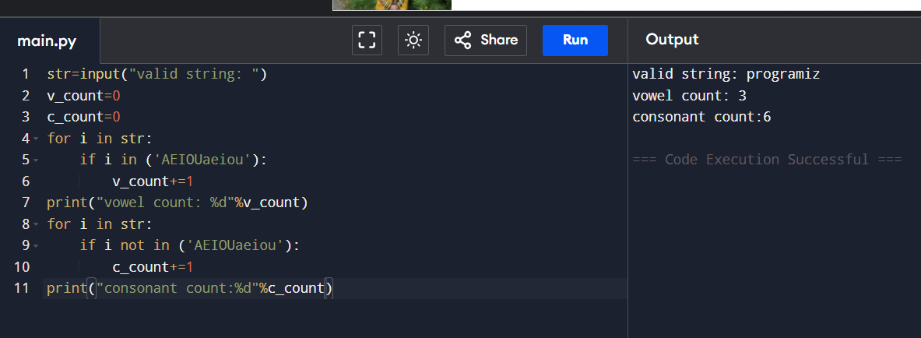

1. To remove all spaces from given string:

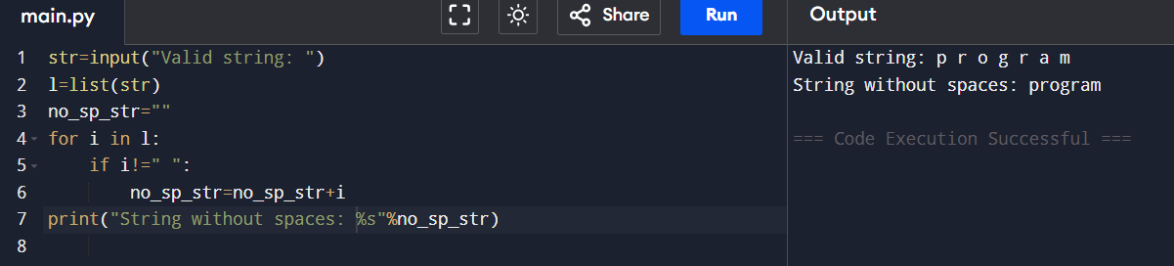

1. To find the frequency of each character in a string:

