# Python Assignment ==> 19-08-25

Submitted by: Nandini Palagiri

Roll no: 22KQ1A0216

1)Python program to find the largest number in given two numbers:

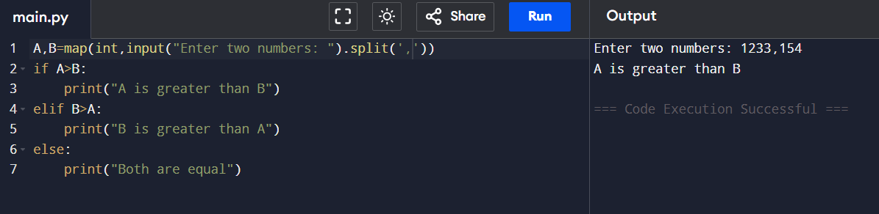

2) Python program to find the largest number in given three numbers:

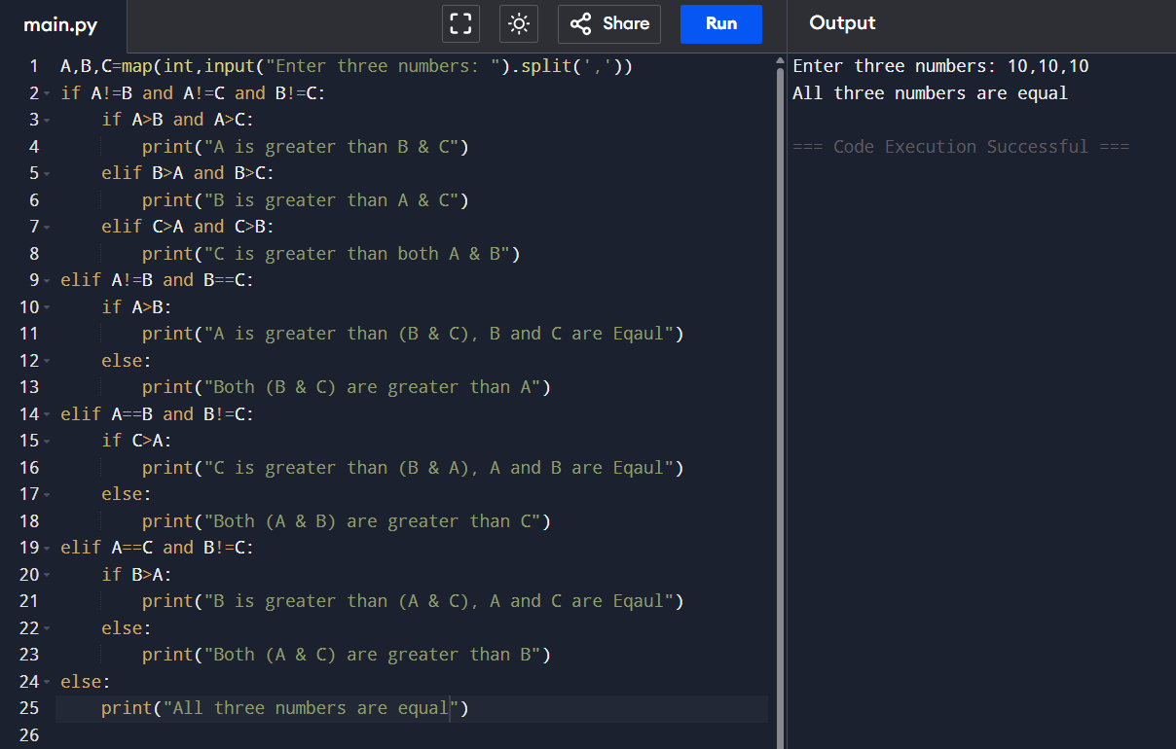

i) 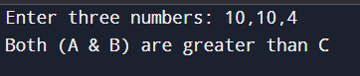 ii) 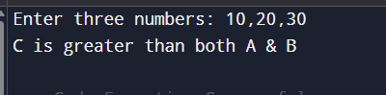 iii) 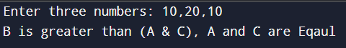

3) Python program to find the number is prime or not:

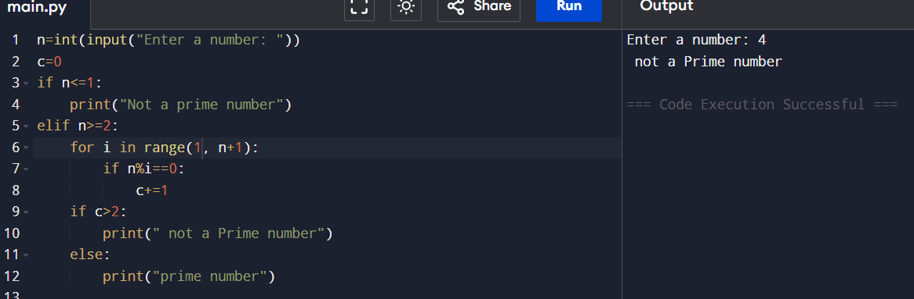

4) Python program to print list of prime numbers in a given range:

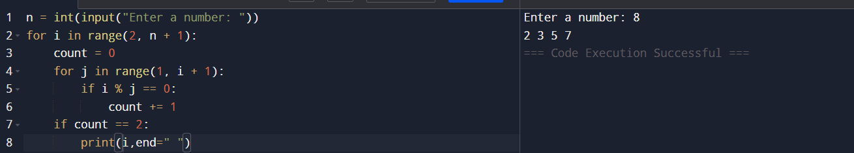

5) Python program to check leap year or not:

