# Python Assignment== > 2-09-25

Submitted by: NANDINI PALAGIRI

Roll no: 22KQ1A0216

1. String functions:

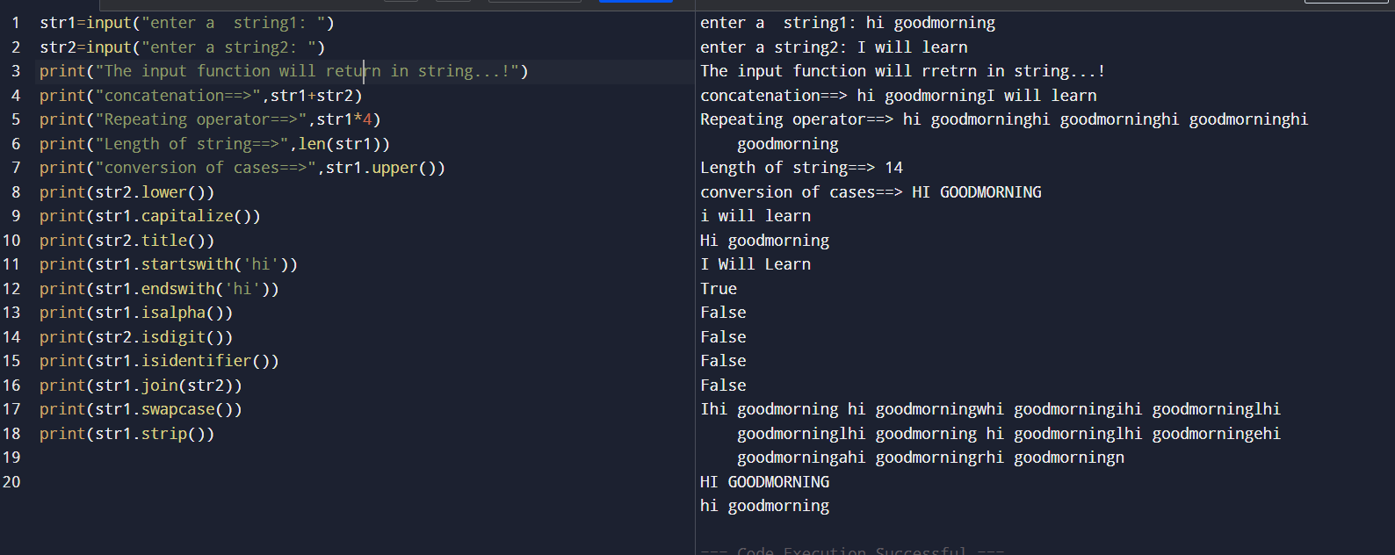

1. Python program to print a rhombus pattern:

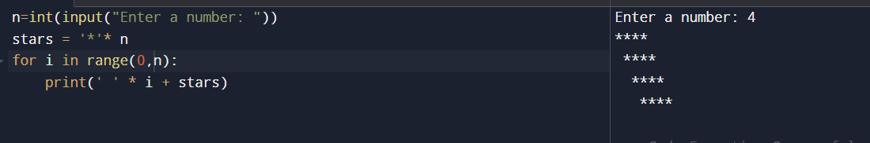

1. Python program to print parallelogram pattern:

