## Python Assignment == > 20-08-25

Submitted by: Nandini Palagiri

Roll no: 22KQ1A0216

1)Python program to find the count of digits in a given number:

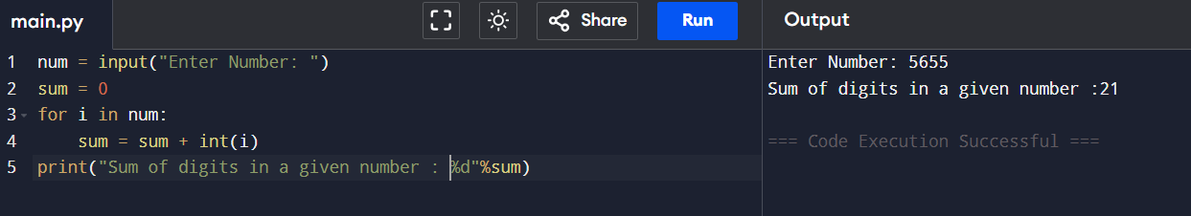

2) Python program to reverse a given number: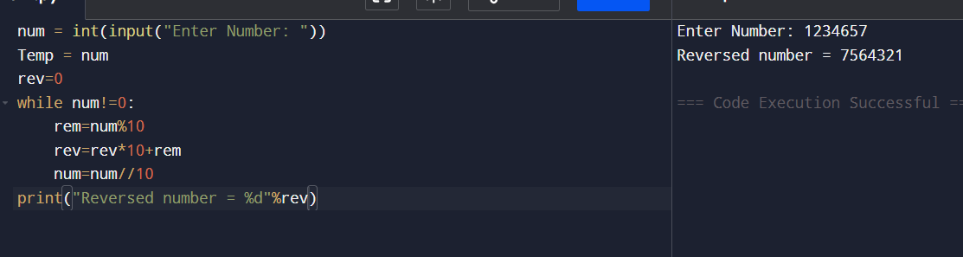

3)Python program to find the number is palindrome or not:

