## Python Assignment == > 21-08-25

Submitted by: Nandini palagiri

Roll no: 22KQ1A0216

1. Python program to find given number is Armstrong or not:

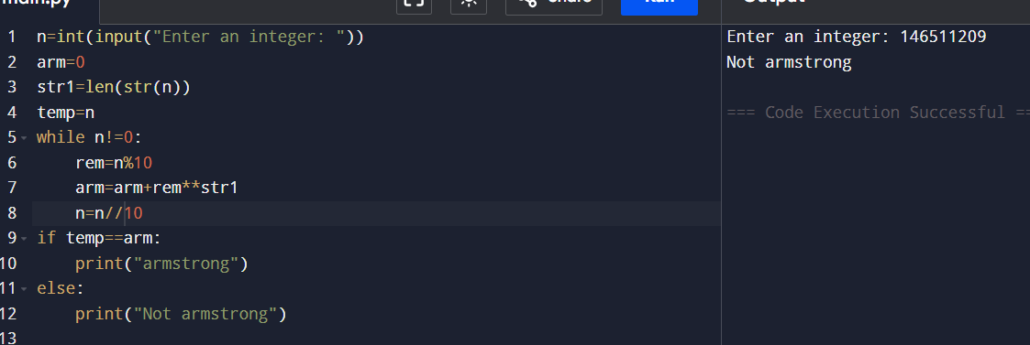

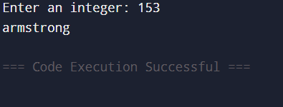

1. Python program to list out the Armstrong numbers in a given range:

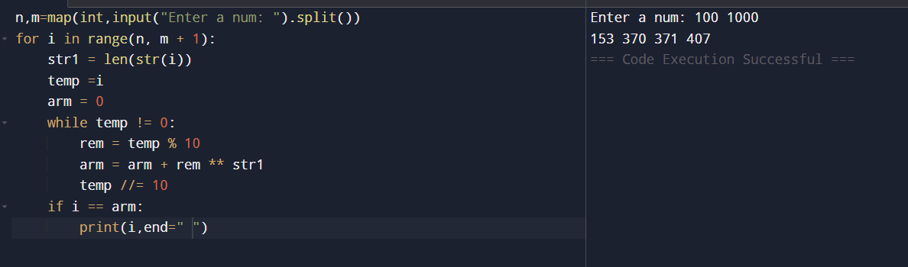

1. Python program to print Fibonacci series upto given input:

