# Python Assignment == > 22-08-25

Submitted by : Nandini Palagiri

Roll No : 22KQ1A0216

1. Python program to find the factorial of a given number:

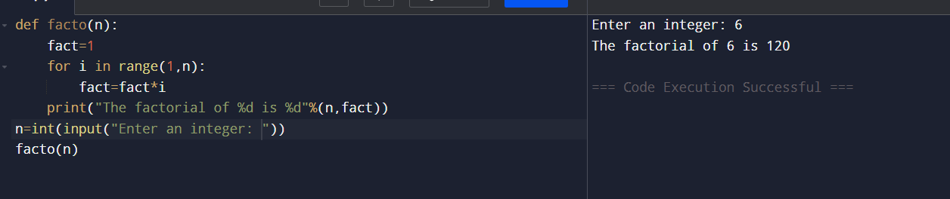

1. Python Program to find the power a number:

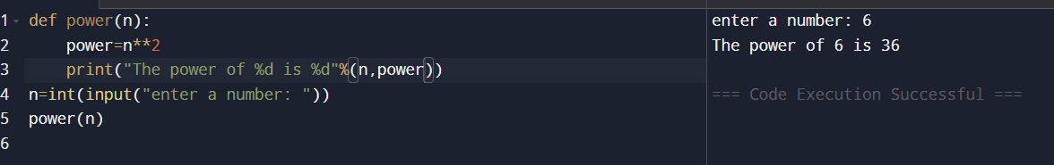

1. Python program to find the factors of a given number:

