SARDAR VALLABHBHAI GLOBAL UNIVERSITY
Faculty of Computer Applications
A PROJECT REPORT ON
NGOConnect
A Web-Based Platform Connecting Verified NGOs,
Donors and Volunteers
Submitted in partial fulfilment of the requirements
for the award of the degree of
BACHELOR OF COMPUTER APPLICATIONS
Semester III | Academic Year 2026–27
SUBMITTED BY
[Student Name] – [Enrolment Number]
[Student Name] – [Enrolment Number]
UNDER THE GUIDANCE OF
Dr./Prof. [Faculty Guide Name]

CERTIFICATE
This is to certify that the project work entitled “NGOConnect – A Web-Based Platform Connecting Verified NGOs, Donors and Volunteers” is a bonafide record of the work carried out by the student(s) named below, in partial fulfilment of the requirements for the award of the degree of Bachelor of Computer Applications at Sardar Vallabhbhai Global University during the academic year 2026–27.
The work presented in this report is original and has been carried out under my supervision. To the best of my knowledge, this project has not been submitted elsewhere for the award of any other degree or diploma.
[Student Name] – [Enrolment Number]
[Student Name] – [Enrolment Number]
_______________________ | _______________________
Internal Guide | Head of Department

Date: __________________ Place: __________________

PROJECT DETAILS
Project Title | NGOConnect – A Web-Based Platform Connecting Verified NGOs, Donors and Volunteers
Purpose | To provide a single trustworthy platform where government-registered NGOs are verified before they become publicly visible, donors may contribute either through a payment gateway or from a wallet held within the platform and receive an 80G tax receipt automatically, and volunteers can discover and enrol in events.
Front End | React 19, Vite 8, React Router 7, Axios, CSS3
Back End | Java 17, Spring Boot 4.1.1, Spring Security, Spring Data MongoDB, Spring Mail
Database | MongoDB Atlas (document-oriented NoSQL)
Other Tools and Libraries | Razorpay Java SDK 1.4.8 (payment gateway), Cloudinary (media storage and delivery), Apache PDFBox 2.0.31 (receipt generation and document text extraction), Tess4J 5.16.0 with Tesseract OCR (scanned document reading), Apache Maven (build), PlantUML (design diagrams), Git and GitHub (version control)
Submitted To | Sardar Vallabhbhai Global University
Academic Term | Semester III (2026–2027)
Faculty Guide | Dr./Prof. [Faculty Guide Name]
Submitted By | [Student 1 Name] – [Enrolment Number]  [Student 2 Name] – [Enrolment Number]

ACKNOWLEDGEMENT
The completion of this project has depended on the guidance, encouragement and support of several people, and it is a pleasure to record our gratitude to them here.
We express our sincere gratitude to our internal guide, Dr./Prof. [Faculty Guide Name], for continuous guidance, constructive criticism and patience throughout the development of this project. The questions raised at every review shaped not only the final system but our understanding of how software is designed, tested and judged.
We are thankful to the Head of the Department and to all faculty members of the Faculty of Computer Applications, Sardar Vallabhbhai Global University, for providing the academic environment and laboratory facilities that made this work possible.
We gratefully acknowledge the open-source community whose work this project is built upon: the Spring Framework and React teams, the MongoDB project, Apache PDFBox, the Tesseract OCR project, and Razorpay, whose documentation and sandbox environment allowed a complete payment integration to be developed and tested without risk.
Finally, we thank our families and friends for their constant encouragement during the course of this work.

[Student Name]
[Student Name]

TABLE OF CONTENTS
Page numbers update automatically when this document is opened in Microsoft Word. To refresh them manually, select the table and press F9.
1. Introduction 7
1.1 Purpose 7
1.2 Scope 7
2. System Analysis 9
2.1 Existing System 9
2.1.1 Drawbacks of the Existing System 9
2.2 Need for the New System 10
2.3 Objective of the New System 10
2.4 Problem Definition 11
2.5 Core Components 11
3. Advantages and Limitations of the Proposed System 13
3.1 Advantages 13
3.2 Limitations 14
4. Requirement Determination 15
4.1 Functional Requirements 15
4.1.1 Non-Functional Requirements 16
4.1.2 Hardware and Software Requirements 17
4.2 Targeted Users 17
5. System Design 19
5.1 Use Case Diagram 19
5.2 Activity Diagram 24
5.2.1 Donation Process 25
5.2.2 NGO Registration and Document Verification 27
5.3 Interaction Diagram 29
5.4 Class Diagram 32
5.5 Data Dictionary 33
5.5.1 accounts 33
5.5.2 ngos 33
5.5.3 NgoDocument (embedded) 34
5.5.4 donations 34
5.5.5 wallets 35
5.5.6 wallet_transactions 35
5.5.7 ngo_balances 36
5.5.8 ngo_ledger_entries 36
5.5.9 ngo_payout_methods 36
5.5.10 withdrawal_requests 37
5.5.11 events and event_enrollments 37
5.5.12 Supporting collections 38
5.6 System Architecture 39
6. Development 40
6.1 Coding Standards 40
6.1.1 Naming and Structure 40
6.1.2 Layering Rules 40
6.1.3 Handling Money 40
6.1.4 Idempotency 41
6.1.5 Comments and Documentation 41
6.1.6 Error Handling 42
6.1.7 Testing 42
6.2 Screenshots 43
7. Proposed Enhancements 44
8. Conclusion 45
9. Bibliography 46

1. Introduction

1.1 Purpose
NGOConnect is a web-based platform that connects verified non-governmental organisations with the donors who fund them and the volunteers who work alongside them. The purpose of the system is to remove the single largest obstacle to online charitable giving in India, which is not a shortage of willing donors but the absence of a dependable way to know that an organisation asking for money is genuine, and that the money actually reaches it.
The platform addresses this in three ways. First, no organisation becomes publicly visible until its statutory documents have been uploaded, checked automatically for authenticity and approved by a platform administrator. Second, every rupee that moves through the system is recorded in an append-only ledger, so the balance shown to any user or organisation can always be reconstructed from the transactions that produced it. Third, money donated to an organisation is not immediately withdrawable: it passes through a settlement window that mirrors the payment gateway's own settlement delay, so the platform never disburses funds it does not yet hold.
Alongside the financial function, the system provides the features that make a donation platform usable in practice — organisation profiles carrying photographs and videos, published requirements for material goods and volunteer help, event listings with enrolment and attendance tracking, direct messaging between donors and organisations, and the automatic issue of receipts valid for tax deduction under Section 80G of the Income Tax Act, 1961.

1.2 Scope
The system boundary encloses everything from the registration of an organisation through to the payout of funds into its bank account, together with the engagement features surrounding that flow. The following functionality lies within scope.
- Account management — registration and authentication for donors and volunteers, password recovery by time-limited email token, and profile picture management with uploaded images or bundled illustrated avatars.
- NGO onboarding — self-registration with upload of registration certificate, PAN card and NGO Darpan certificate; automatic text extraction and keyword verification of those documents; and an administrative approval queue.
- Donation processing — donations funded either through the Razorpay payment gateway or from a wallet balance held within the platform, with cryptographic verification of every gateway payment and server-to-server recovery of payments the browser fails to report.
- Digital wallet — top-up through the payment gateway, an immutable transaction passbook, and single-request donations funded directly from the balance.
- Tax receipts — automatic generation of a sequentially numbered 80G receipt as a PDF for every paid donation, emailed to the donor and downloadable thereafter.
- NGO finance — a three-bucket balance model of clearing, available and reserved funds; a scheduled job promoting funds once the settlement window elapses; payout destination management with a security cooling-off period; and withdrawal requests subject to administrative approval.
- Engagement — publication of material needs and volunteering calls, event creation with capacity limits, volunteer enrolment, attendance marking, absence notification, and one-to-one chat between a donor and an organisation.
- Administration — review and approval of NGO applications, management of user accounts, oversight of donations and events, and approval or rejection of withdrawal requests.
The following are deliberately outside the present scope and are revisited as proposed enhancements in Section 7: recurring or scheduled donations; campaign-level fundraising with individual targets; a native mobile application; multi-currency and international payments; and automated bank transfer of approved withdrawals, which at present are executed manually by an administrator and then recorded in the system.

2. System Analysis

2.1 Existing System
Charitable giving in India is presently spread across several mechanisms, none of which offers the combination of verification, traceability and convenience that people now expect from any other online transaction.
- Direct bank transfer — a donor takes an account number from an organisation's website or a social media post and transfers funds by UPI or NEFT. Nothing in this process establishes that the organisation is registered, that the account belongs to it, or that the money will be used as described. No receipt is guaranteed.
- Individual NGO websites — larger organisations run their own donation pages. These work, but each is a separate registration, a separate payment flow and a separate receipt process, and a donor comparing several causes has no common basis on which to do so.
- Social media appeals — appeals circulated through messaging applications reach large audiences quickly but carry no verification whatsoever, and are a well-documented vector for fraud, particularly during disasters when urgency suppresses scrutiny.
- General crowdfunding platforms — these supply payment infrastructure and some campaign vetting, but are oriented towards individual fundraisers rather than registered organisations, and typically do not issue receipts valid under Section 80G.

2.1.1 Drawbacks of the Existing System
ID | Drawback | Consequence
D-1 | No verification of legitimacy | A donor cannot confirm that an organisation holds valid registration, a PAN or an NGO Darpan identity.
D-2 | No audit trail | Once funds leave the donor's account, no system records the payment against a specific organisation and purpose.
D-3 | Manual or absent tax receipts | A donor entitled to an 80G deduction must request a receipt by hand; many never receive one and the deduction goes unclaimed.
D-4 | Payment friction on every donation | Card or UPI details must be re-entered each time, which measurably suppresses small and repeat giving.
D-5 | No unified discovery | There is no single searchable catalogue of verified organisations by city or by cause.
D-6 | Volunteering disconnected from giving | Organisations needing goods or volunteers rather than money have no structured channel for publishing those needs.
D-7 | No protection against premature payout | A direct transfer is irreversible immediately, with no settlement period in which an error or dispute can be addressed.
Table 1: Drawbacks of the existing mechanisms

2.2 Need for the New System
The need for the proposed system follows directly from the drawbacks above, and is reinforced by the structure of the Indian regulatory environment, which already supplies the raw material for verification but no platform that makes use of it.
Every legitimate Indian NGO holds a registration number under the Societies Registration Act, the Indian Trusts Act or Section 8 of the Companies Act; a Permanent Account Number issued by the Income Tax Department; and in most cases a unique identity on the NGO Darpan portal maintained by NITI Aayog. These identifiers exist and are documented on paper, but a donor has no practical way of checking them at the moment of giving. A platform that collects these documents at registration, verifies them and withholds publication until an administrator has approved the organisation converts a paper formality into a usable signal of trust.
Section 80G of the Income Tax Act likewise permits a taxpayer to deduct donations made to eligible institutions, but the deduction can only be claimed against a receipt carrying the organisation's registration details, the amount and a receipt number. Producing that document automatically at the moment a payment succeeds removes an administrative burden from the organisation and a source of loss from the donor.
Finally, the technical means to do all of this safely are now routine. Payment gateways return cryptographically signed confirmation of every transaction; document databases support atomic conditional updates that make concurrent financial operations correct without distributed transactions; and optical character recognition is accurate enough to read a scanned certificate and check it for expected keywords. The proposed system assembles these into a single coherent workflow.

2.3 Objective of the New System
The system is designed to meet the following objectives.
- To ensure that only verified, government-registered organisations can receive donations through the platform, by requiring statutory documents at registration and subjecting every application to automated document checking followed by administrative approval.
- To guarantee financial correctness under concurrent use, so that a balance can never become negative, money can never be credited twice for one payment, and the sum of recorded transactions always reconstructs the current balance exactly.
- To reduce the friction of repeat giving by providing an internal wallet, allowing a donor to add funds once and thereafter donate in a single request with no gateway interaction.
- To issue a valid, sequentially numbered 80G tax receipt automatically for every completed donation, delivered by email and available for download at any time afterwards.
- To protect the platform against paying out funds it has not yet received, by holding donated money in a clearing state for a configurable settlement window before it becomes withdrawable.
- To ensure that no payment is lost through a browser failure, by accepting server-to-server confirmation from the payment gateway as an independent path to crediting a transaction.
- To give organisations a complete financial view — balance, ledger, payout destination and withdrawal history — so that their own reporting obligations become easier to meet.
- To extend the platform beyond monetary donation, supporting requests for material goods and volunteer time, event management with attendance tracking, and direct communication between donors and organisations.

2.4 Problem Definition
A donor wishing to contribute to a charitable cause in India cannot readily establish whether a given organisation is genuine, cannot trace what becomes of the money once it leaves their account, and frequently does not receive the tax receipt to which they are entitled. An organisation, correspondingly, must build and maintain its own payment infrastructure, prepare receipts by hand, and has no structured channel through which to publish needs for goods or volunteers.
The problem is therefore twofold. On the donor's side it is a problem of trust and convenience; on the organisation's side it is one of infrastructure and administrative burden. Both parties are further exposed to a class of technical failure specific to financial software: if the system moving the money is not correct under concurrent access, balances drift, payments are double-counted, and the resulting records cannot be audited.
The system must accordingly solve three problems at once — verification of organisations, correctness of money movement under concurrency, and automation of compliance documentation — while remaining simple enough that a donor completes a donation in a few seconds.

2.5 Core Components
The system is organised into ten functional modules. Figure 6 in Section 5.6 shows how these are distributed across the architectural layers.
Module | Responsibility
Account Management | Registration and authentication of donors and volunteers; password reset by time-limited email token; profile picture upload and preset avatar selection.
NGO Onboarding | Self-registration with mandatory document upload; automatic text extraction and keyword verification; generation of a unique organisation identifier; administrative approval.
Document Verification | Text extraction from uploaded PDFs using Apache PDFBox, falling back to Tesseract OCR for scanned images; keyword matching against the declared document type; cross-checking of the PAN and registration number declared at registration.
Donation Processing | Two-step gateway donation with HMAC-SHA256 signature verification; one-step wallet donation; atomic claim of each donation record to guarantee single crediting; automatic refund where a wallet-funded donation cannot be completed.
Digital Wallet | Per-user balance held in paise as an integer; conditional atomic debit that cannot overdraw; immutable ledger recording every top-up, donation and refund.
Receipt Generation | Financial-year-scoped sequential receipt numbering from an atomic counter; PDF rendering with Apache PDFBox including the amount in words using Indian place values; delivery by email as a MIME attachment.
Payment Recovery | A public webhook endpoint receiving server-to-server payment confirmation from the gateway, authenticated by HMAC signature over the raw request body, providing an independent path to crediting when the browser does not return.
NGO Finance | Three-bucket balance of clearing, available and reserved funds; a scheduled job promoting cleared funds; an append-only ledger of every movement.
Payouts and Withdrawals | Payout destination management with masking of account numbers and a cooling-off period after any change; withdrawal requests reserving funds; administrative approval, rejection and settlement recording.
Engagement | Publication of material needs and volunteering calls; event creation with capacity limits; volunteer enrolment and attendance marking; absence notification; one-to-one chat.
Table 2: Core functional modules of the system

3. Advantages and Limitations of the Proposed System

3.1 Advantages
The proposed system offers the following benefits over the mechanisms described in Section 2.1.
- Verified organisations only — an organisation is invisible to donors until its documents have passed automated checking and an administrator has approved it. The trust decision is taken once, by a reviewer with the documents in front of them, rather than repeatedly by every individual donor.
- Automated document checking — text is extracted from every uploaded document and matched against keywords expected for its declared type, with the declared PAN and registration number cross-checked against the document contents. A mismatch is flagged to the reviewer before approval, so obvious forgeries and misplaced uploads are caught immediately.
- Guaranteed financial correctness — every balance change is expressed as a single conditional atomic database operation rather than a read followed by a write. A debit carries its own sufficiency condition, so two simultaneous requests cannot both succeed against the same funds and a balance cannot become negative under any interleaving.
- Payments credited exactly once — each payment record must be atomically claimed before any money moves. Duplicate submissions, page refreshes, browser retries and repeated webhook deliveries all converge on the same record, and only the first claim credits it.
- No payment can be lost — the gateway confirms every captured payment server-to-server in addition to the browser callback, so a donor who closes the tab, loses connectivity, or is not returned cleanly by a UPI application is still credited.
- Automatic tax receipts — a sequentially numbered 80G receipt is generated and emailed the moment a donation completes and remains downloadable afterwards. The number is drawn from an atomic counter scoped to the Indian financial year, so the sequence is unbroken and never repeats.
- Reduced friction for repeat giving — once a wallet holds a balance, a donation is a single request completing in milliseconds with no gateway interaction at all.
- Protection against premature payout — donated funds are held in a clearing state for a configurable window mirroring the gateway's settlement delay, so the platform never disburses money it does not yet hold.
- Payout security — bank account numbers and UPI identifiers are never returned to any client; only a masked form is exposed. Withdrawals are frozen for a cooling-off period after any change of payout destination, so a compromised login cannot redirect and drain a balance before the change is noticed.
- Complete auditability — both the donor wallet and the NGO balance maintain append-only ledgers. Corrections are recorded as new compensating entries rather than by editing history, so the record of what happened is never altered.
- Engagement beyond money — organisations may request material goods and volunteer time, run events with capacity limits and attendance tracking, and communicate directly with donors.

3.2 Limitations
The following constraints apply to the present implementation. Each is a deliberate boundary rather than an oversight, and most are addressed in Section 7.
ID | Limitation | Reason and mitigation
L-1 | Manual payout execution | An approved withdrawal is transferred by an administrator outside the system and the reference recorded afterwards. Automated disbursement needs a payout API and further compliance.
L-2 | Document verification is advisory | The automated check reads text and matches keywords; it does not contact any government registry. Final approval therefore remains a human decision.
L-3 | Stateless HTTP Basic authentication | Simple and adequate at this scope, but it requires the client to retain credentials. Token-based authentication is identified as the priority enhancement.
L-4 | Single currency | All amounts are Indian Rupees stored as integer paise. International donation would require currency conversion and different compliance treatment.
L-5 | No recurring donations | Each donation is a discrete transaction; standing instructions are not supported.
L-6 | No campaign-level fundraising | Donations are made to an organisation rather than to a campaign with its own target.
L-7 | Email delivery is best-effort | Receipt and notification email is dispatched without blocking the operation that triggered it. A failure is logged and the receipt remains downloadable, but no retry queue is maintained.
L-8 | Chat is not real-time | Messages are exchanged by polling rather than a persistent connection, so delivery is not instant.
L-9 | No mobile application | The interface is a responsive web application; no native application is provided.
L-10 | Single-instance scheduling | The clearing job is safe on multiple instances because each ledger row is atomically claimed, but no distributed scheduler is configured.
Table 3: Limitations of the proposed system

4. Requirement Determination

4.1 Functional Requirements
Functional requirements are grouped by module and numbered for reference. Each states an observable behaviour of the system.
ID | Requirement
FR-1 | The system shall allow a donor to register with a full name, email address and a password of at least eight characters, rejecting an email that is already registered.
FR-2 | The system shall authenticate users by email and password, storing passwords only as BCrypt hashes, and shall refuse access to a deactivated account.
FR-3 | The system shall allow a user to request a password reset, issuing a single-use token valid for fifteen minutes delivered by email, and shall respond identically whether or not the email is registered.
FR-4 | The system shall allow any authenticated user to upload a profile picture of up to 5 MB, select one of eight bundled illustrated avatars, or remove their picture entirely.
FR-5 | The system shall allow an organisation to register by submitting its statutory details together with a registration certificate and PAN card as mandatory documents, and a Darpan certificate and further supporting document as optional ones.
FR-6 | The system shall extract text from each uploaded document, using OCR where the document contains no text layer, and shall classify it as valid, suspicious or unreadable against keywords expected for its declared type.
FR-7 | The system shall cross-check the PAN and registration number declared at registration against the text found in the corresponding documents and flag any mismatch to the reviewing administrator.
FR-8 | The system shall withhold a newly registered organisation from all public listings until an administrator has approved it, and shall assign a unique organisation identifier upon approval.
FR-9 | The system shall allow an administrator to approve or reject an organisation with a recorded note, and to view any uploaded document through a time-limited signed URL.
FR-10 | The system shall allow a donor to donate to an approved organisation through the payment gateway, creating a pending record before contacting the gateway.
FR-11 | The system shall verify the HMAC-SHA256 signature of every gateway payment before crediting it, and reject any payment whose signature does not match.
FR-12 | The system shall atomically claim a donation record before crediting it, such that repeated verification of the same payment credits the organisation exactly once.
FR-13 | The system shall accept server-to-server payment confirmation at a public webhook endpoint, authenticated by HMAC signature over the unmodified request body, and credit the payment if the browser has not already done so.
FR-14 | The system shall refuse to credit any webhook-reported payment whose amount differs from the amount recorded against the order.
FR-15 | The system shall maintain a wallet for each donor, holding the balance as an integer number of paise.
FR-16 | The system shall allow a donor to add between ₹1 and ₹1,00,000 to their wallet in a single top-up through the payment gateway.
FR-17 | The system shall debit a wallet only by a conditional atomic operation that succeeds solely when the balance is sufficient, so the balance can never become negative.
FR-18 | The system shall record every wallet movement as an immutable ledger entry carrying its type, amount, resulting balance and the donation it relates to.
FR-19 | The system shall reverse a wallet debit by writing a compensating refund entry rather than deleting the original entry.
FR-20 | The system shall generate a sequentially numbered 80G receipt for every paid donation, scoped to the Indian financial year and drawn from an atomic counter.
FR-21 | The system shall render each receipt as a PDF carrying the organisation's registration number, PAN and Darpan identity, the donor's name and email, the amount in both figures and words, and the payment reference.
FR-22 | The system shall email each receipt to the donor as a PDF attachment and make it downloadable thereafter only to the donor who made that donation.
FR-23 | The system shall credit a paid donation to the receiving organisation's clearing balance, not to its available balance.
FR-24 | The system shall promote cleared funds from clearing to available once the configured settlement window has elapsed, by a scheduled job that claims each ledger entry atomically.
FR-25 | The system shall allow an organisation to record a bank account or UPI payout destination, storing the identifier such that only a masked form is ever returned to a client.
FR-26 | The system shall prevent withdrawal for a configured cooling-off period following any change of payout destination.
FR-27 | The system shall allow an organisation to request a withdrawal of at least the configured minimum amount, reserving the funds from its available balance at the moment of request.
FR-28 | The system shall allow an administrator to approve, reject, or mark as paid or failed any withdrawal request, releasing reserved funds back to available on rejection or failure.
FR-29 | The system shall allow an organisation to publish photographs, external video links, material needs and volunteering calls on its public profile.
FR-30 | The system shall allow an organisation to create events with a capacity limit and shall prevent enrolment once that capacity is reached.
FR-31 | The system shall allow a volunteer to enrol in an event, view their enrolments, and shall allow the organising body to mark attendance.
FR-32 | The system shall notify a volunteer who was marked absent from an event for which they had enrolled.
FR-33 | The system shall provide one-to-one messaging between a donor and an organisation, with unread message counts.
FR-34 | The system shall restrict every endpoint by role, such that wallet operations are available only to donors, finance operations only to the owning organisation, and approval operations only to an administrator.
Table 4: Functional requirements

4.1.1 Non-Functional Requirements
ID | Category | Requirement
NFR-1 | Correctness | No sequence of concurrent operations shall produce a negative balance, a doubly credited payment, or a ledger whose sum differs from the recorded balance.
NFR-2 | Security | Passwords shall be stored only as BCrypt hashes. Payment secrets and bank identifiers shall never be transmitted to any client.
NFR-3 | Security | Every state-changing endpoint shall verify not only that the caller is authenticated but that the resource being modified belongs to them.
NFR-4 | Reliability | No payment accepted by the gateway shall be lost because of a client-side failure.
NFR-5 | Reliability | Failure of a non-essential subsystem such as email shall not fail the financial operation that triggered it.
NFR-6 | Performance | A wallet-funded donation shall complete within a single request-response cycle.
NFR-7 | Usability | The interface shall be responsive and usable at a viewport width of 400 pixels and above.
NFR-8 | Maintainability | All balance arithmetic shall reside in a single service class per balance type, so the correctness argument is confined to one file.
NFR-9 | Auditability | Financial records shall be append-only; corrections shall be expressed as compensating entries.
NFR-10 | Configurability | Settlement window, cooling-off period, minimum withdrawal, token lifetime and all credentials shall be externally configurable without code change.
NFR-11 | Portability | The application shall run on any platform providing a Java 17 runtime and shall depend on no operating-system-specific service.
Table 5: Non-functional requirements

4.1.2 Hardware and Software Requirements
Category | Requirement
Processor | Intel Core i3 or equivalent, 2.0 GHz or higher
Memory | 4 GB RAM minimum; 8 GB recommended for development
Storage | 2 GB free disk space for the application and its dependencies
Operating System | Windows 10/11, Linux or macOS — any platform with a Java 17 runtime
Java Runtime | JDK 17 or later
Build Tool | Apache Maven 3.8 or later (a wrapper is included)
Node Runtime | Node.js 18 or later with npm, for the frontend build
Database | MongoDB Atlas cluster, or MongoDB 6.0 or later running locally
Browser | Any modern browser supporting ES2020 (Chrome, Edge, Firefox, Safari)
Network | Internet connectivity for payment gateway, media storage and mail delivery
Table 6: Hardware and software requirements

4.2 Targeted Users
The system recognises four categories of user. The first three hold authorisation roles enforced by the security layer; the fourth is an unauthenticated visitor.
User Category | Description and Capabilities
Donor / Volunteer  (ROLE_USER) | Any individual wishing to contribute money or time. Browses verified organisations, donates by gateway or wallet, maintains a wallet balance and passbook, downloads 80G receipts, enrols in events, responds to published needs and messages organisations directly. This is the largest user group and the primary consumer of the platform.
NGO Representative  (ROLE_NGO) | An authorised person acting for a registered organisation. Registers the organisation with its statutory documents, maintains its public profile with photographs and videos, publishes material needs and volunteering calls, creates events and marks attendance, monitors the organisation's balance and ledger, records a payout destination and requests withdrawals.
Administrator  (ROLE_ADMIN) | Platform operator responsible for trust and financial oversight. Reviews NGO applications alongside the automated verification results, approves or rejects them with a recorded reason, manages user accounts, oversees donations and events, and approves, rejects or settles withdrawal requests.
Guest Visitor  (unauthenticated) | Any visitor who has not signed in. May browse the catalogue of verified organisations, view profiles and see published events and needs, but cannot donate, enrol or communicate until registered.
Table 7: Targeted user categories

5. System Design
This section presents the design of the system through standard UML models. Section 5.1 establishes what each class of user may do; 5.2 traces the two most significant workflows as activity diagrams; 5.3 examines the donation interaction in detail; 5.4 gives the static structure; 5.5 documents every stored collection and field; and 5.6 places the components in their architectural layers.

5.1 Use Case Diagram
The use case model is presented as two diagrams so that each remains legible. Figure 1 covers the donor and volunteer; Figure 2 covers the NGO representative and the administrator. Both share the same system boundary — it is drawn twice only for clarity of presentation.
Two UML dependency stereotypes appear in these diagrams. An «include» dependency means the included behaviour always occurs as part of the base use case: verifying a payment signature is not optional when donating through the gateway. An «extend» dependency means the extending behaviour occurs only in certain circumstances: a donor paying from wallet balance may first need to top that balance up, but usually will not.
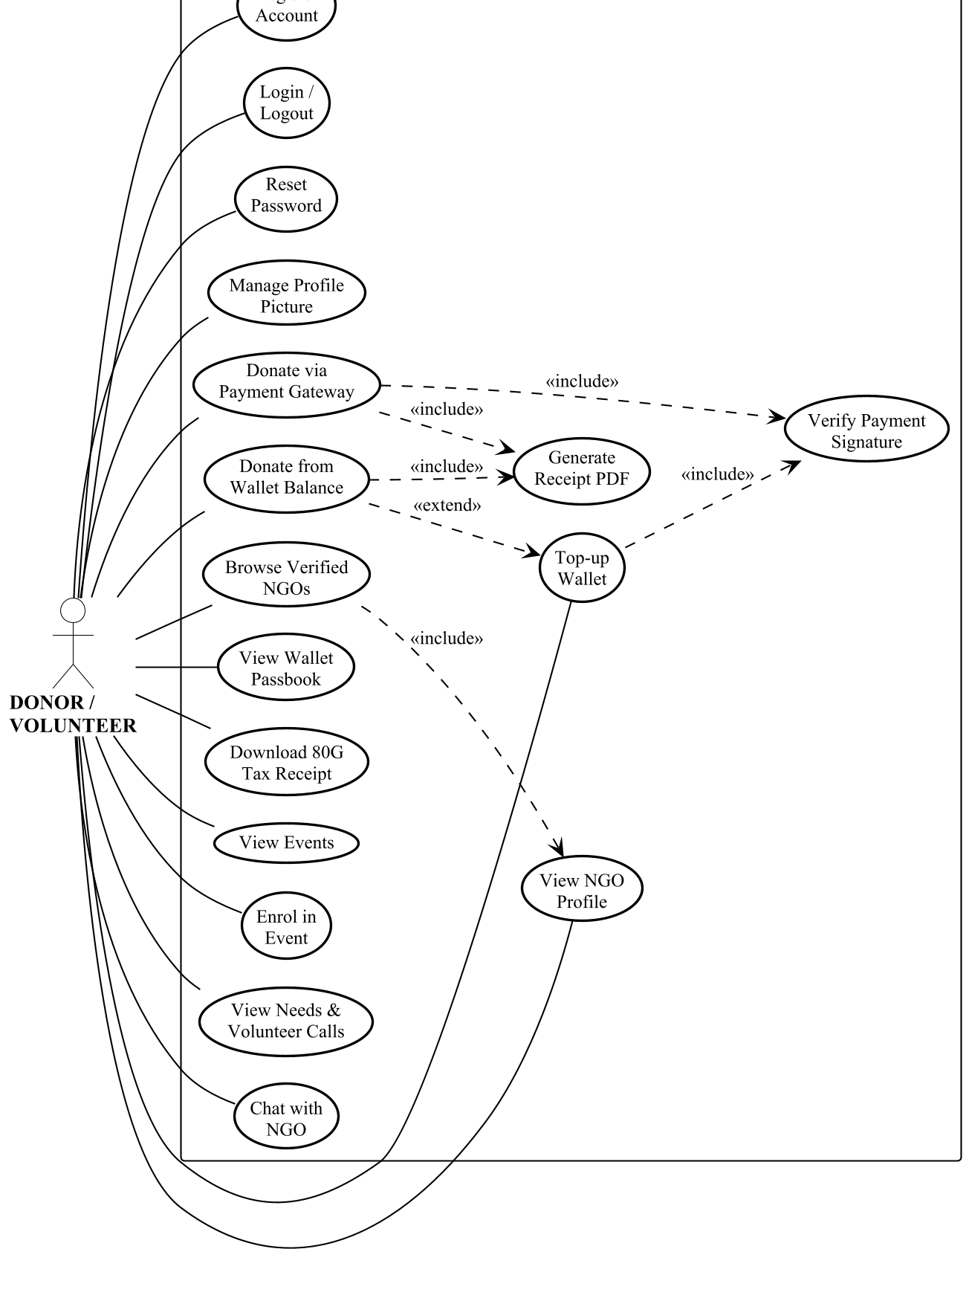
Figure 1: Use Case Diagram – Donor and Volunteer
The donor's use cases fall into three groups. Account management covers registration, authentication, password recovery and profile pictures. The donation group is the centre of the system: browsing verified organisations, donating by either funding route, maintaining a wallet and retrieving tax receipts. The engagement group covers events, published needs and direct messaging.
Note that “Verify Payment Signature” and “Generate Receipt PDF” are drawn as use cases although the donor never invokes them directly. They are included behaviours of the two donation use cases, and showing them makes explicit that no donation completes without both.
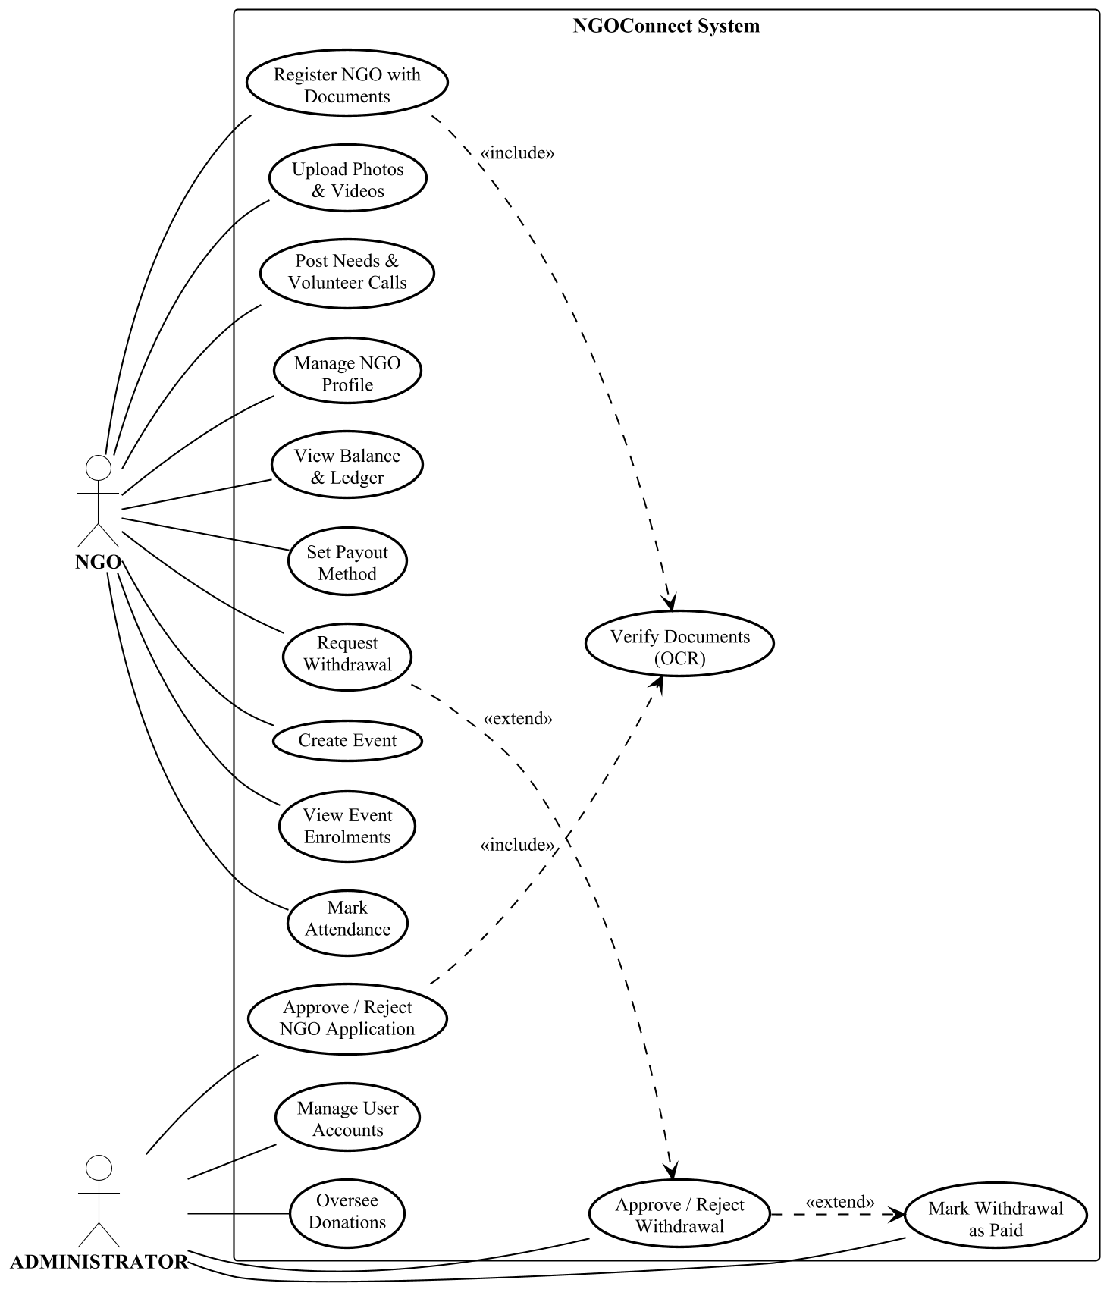
Figure 2: Use Case Diagram – NGO and Administrator
The NGO representative manages onboarding, public content, finance and events. The administrator holds only five use cases, but they are the ones on which the platform's integrity depends: admitting an organisation to the platform, and releasing money from it. Separating these from the NGO's own capabilities is a deliberate design decision — an organisation can request a withdrawal but cannot approve its own.

5.2 Activity Diagram
Two workflows are modelled: the donation process, which is the system's principal transaction, and NGO registration with document verification, which is the process the platform's trustworthiness rests upon. Both diagrams use swimlane partitions so that responsibility for each action is visible without reading the labels.

5.2.1 Donation Process
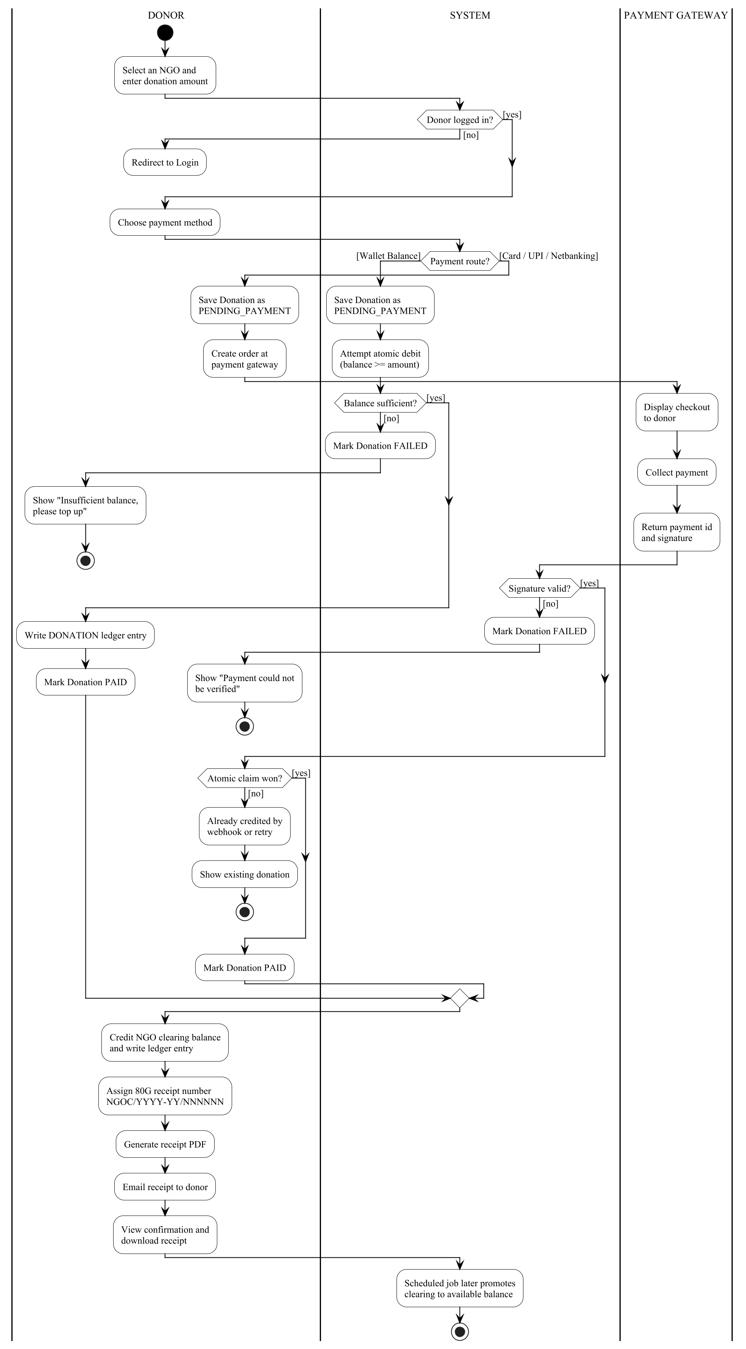
Figure 3: Activity Diagram – Donation Process
The flow divides at the payment-route decision into two materially different paths. The wallet route completes within a single request: the donation record is written, an atomic conditional debit is attempted, and if the balance is sufficient the donation is marked paid immediately. No external party is involved, which is why paying from balance is instantaneous.
The gateway route requires two separate requests with the donor's interaction between them. The first creates a pending donation and an order at the gateway; the donor then pays inside the gateway's own interface; the second verifies the returned signature and only then credits anything. Two guards protect this path. The signature check establishes that the payment is genuine, since everything reported by the browser is untrusted. The atomic claim establishes that it is credited once and only once, because the same payment may legitimately be reported more than once — by a page refresh, by a retry, or by the gateway's own webhook.
Both routes converge on the same three closing actions: the receiving organisation's clearing balance is credited and a ledger entry written, an 80G receipt number is assigned and the PDF rendered and emailed, and the donor is shown confirmation. A scheduled job later promotes the funds from clearing to available once the settlement window has elapsed.

5.2.2 NGO Registration and Document Verification
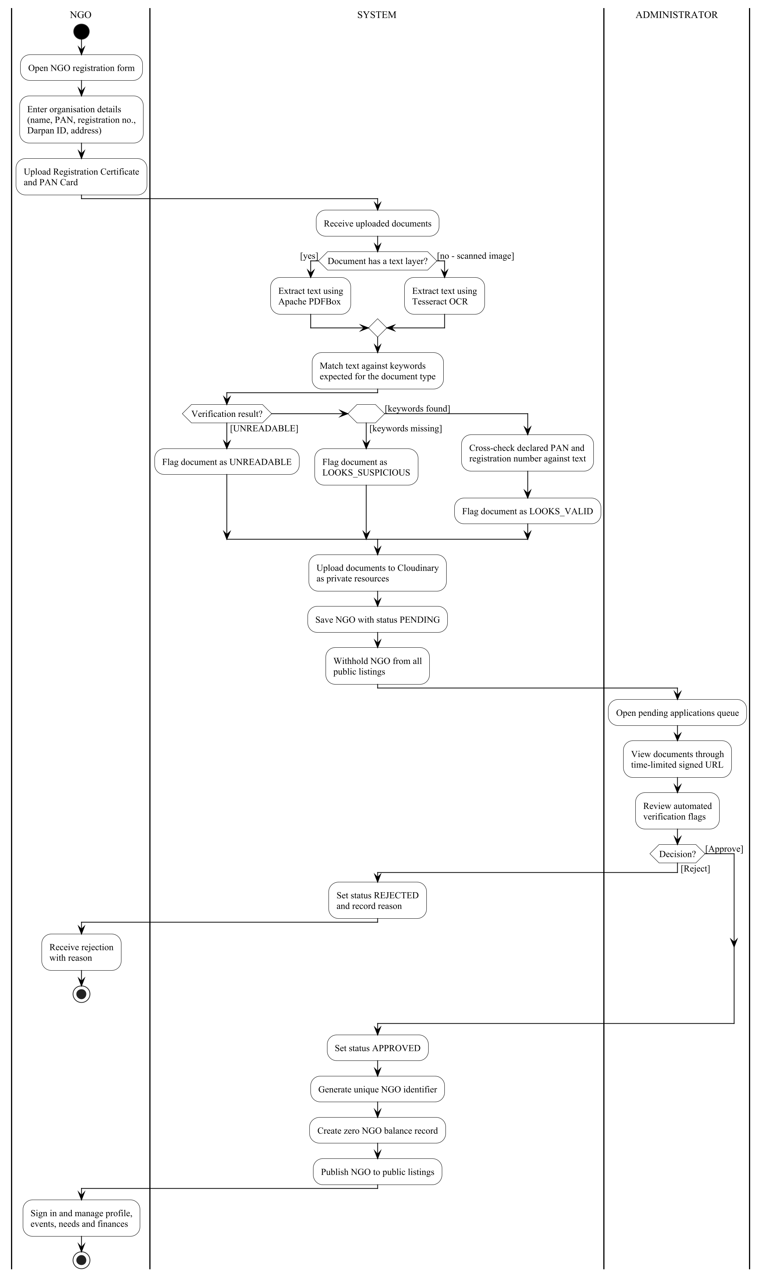
Figure 4: Activity Diagram – NGO Registration and Verification
This workflow determines whether an organisation is ever seen by a donor. After the representative submits the statutory details and documents, the system attempts to read each document. The branch at the top reflects a practical reality: a PDF exported from a computer carries a text layer that Apache PDFBox can read directly, whereas a photographed or scanned certificate carries none and must be passed through Tesseract OCR. Handling both means the check works on the documents organisations actually possess rather than only on ideal ones.
The extracted text is matched against keywords expected for the declared document type, producing one of three outcomes, and where keywords are found the declared PAN and registration number are additionally cross-checked against the document contents. The result is advisory: it is shown to the administrator rather than used to accept or reject automatically. This is deliberate, since the check can prove a document is wrong but cannot prove that it is genuine.
Throughout this process the organisation is withheld from every public listing. Only after an administrator approves it does the system assign a unique identifier, create a zero balance record and publish the organisation. Rejection records a reason, which is returned to the applicant so the application can be corrected and resubmitted.

5.3 Interaction Diagram
The sequence diagram below traces a single gateway-funded donation from the donor's first action to the confirmation shown on screen. It uses the analysis stereotypes conventional in UML interaction modelling: a boundary object for the screen the donor interacts with, a control object coordinating the operation, and entity objects for the persistent store and the external gateway.
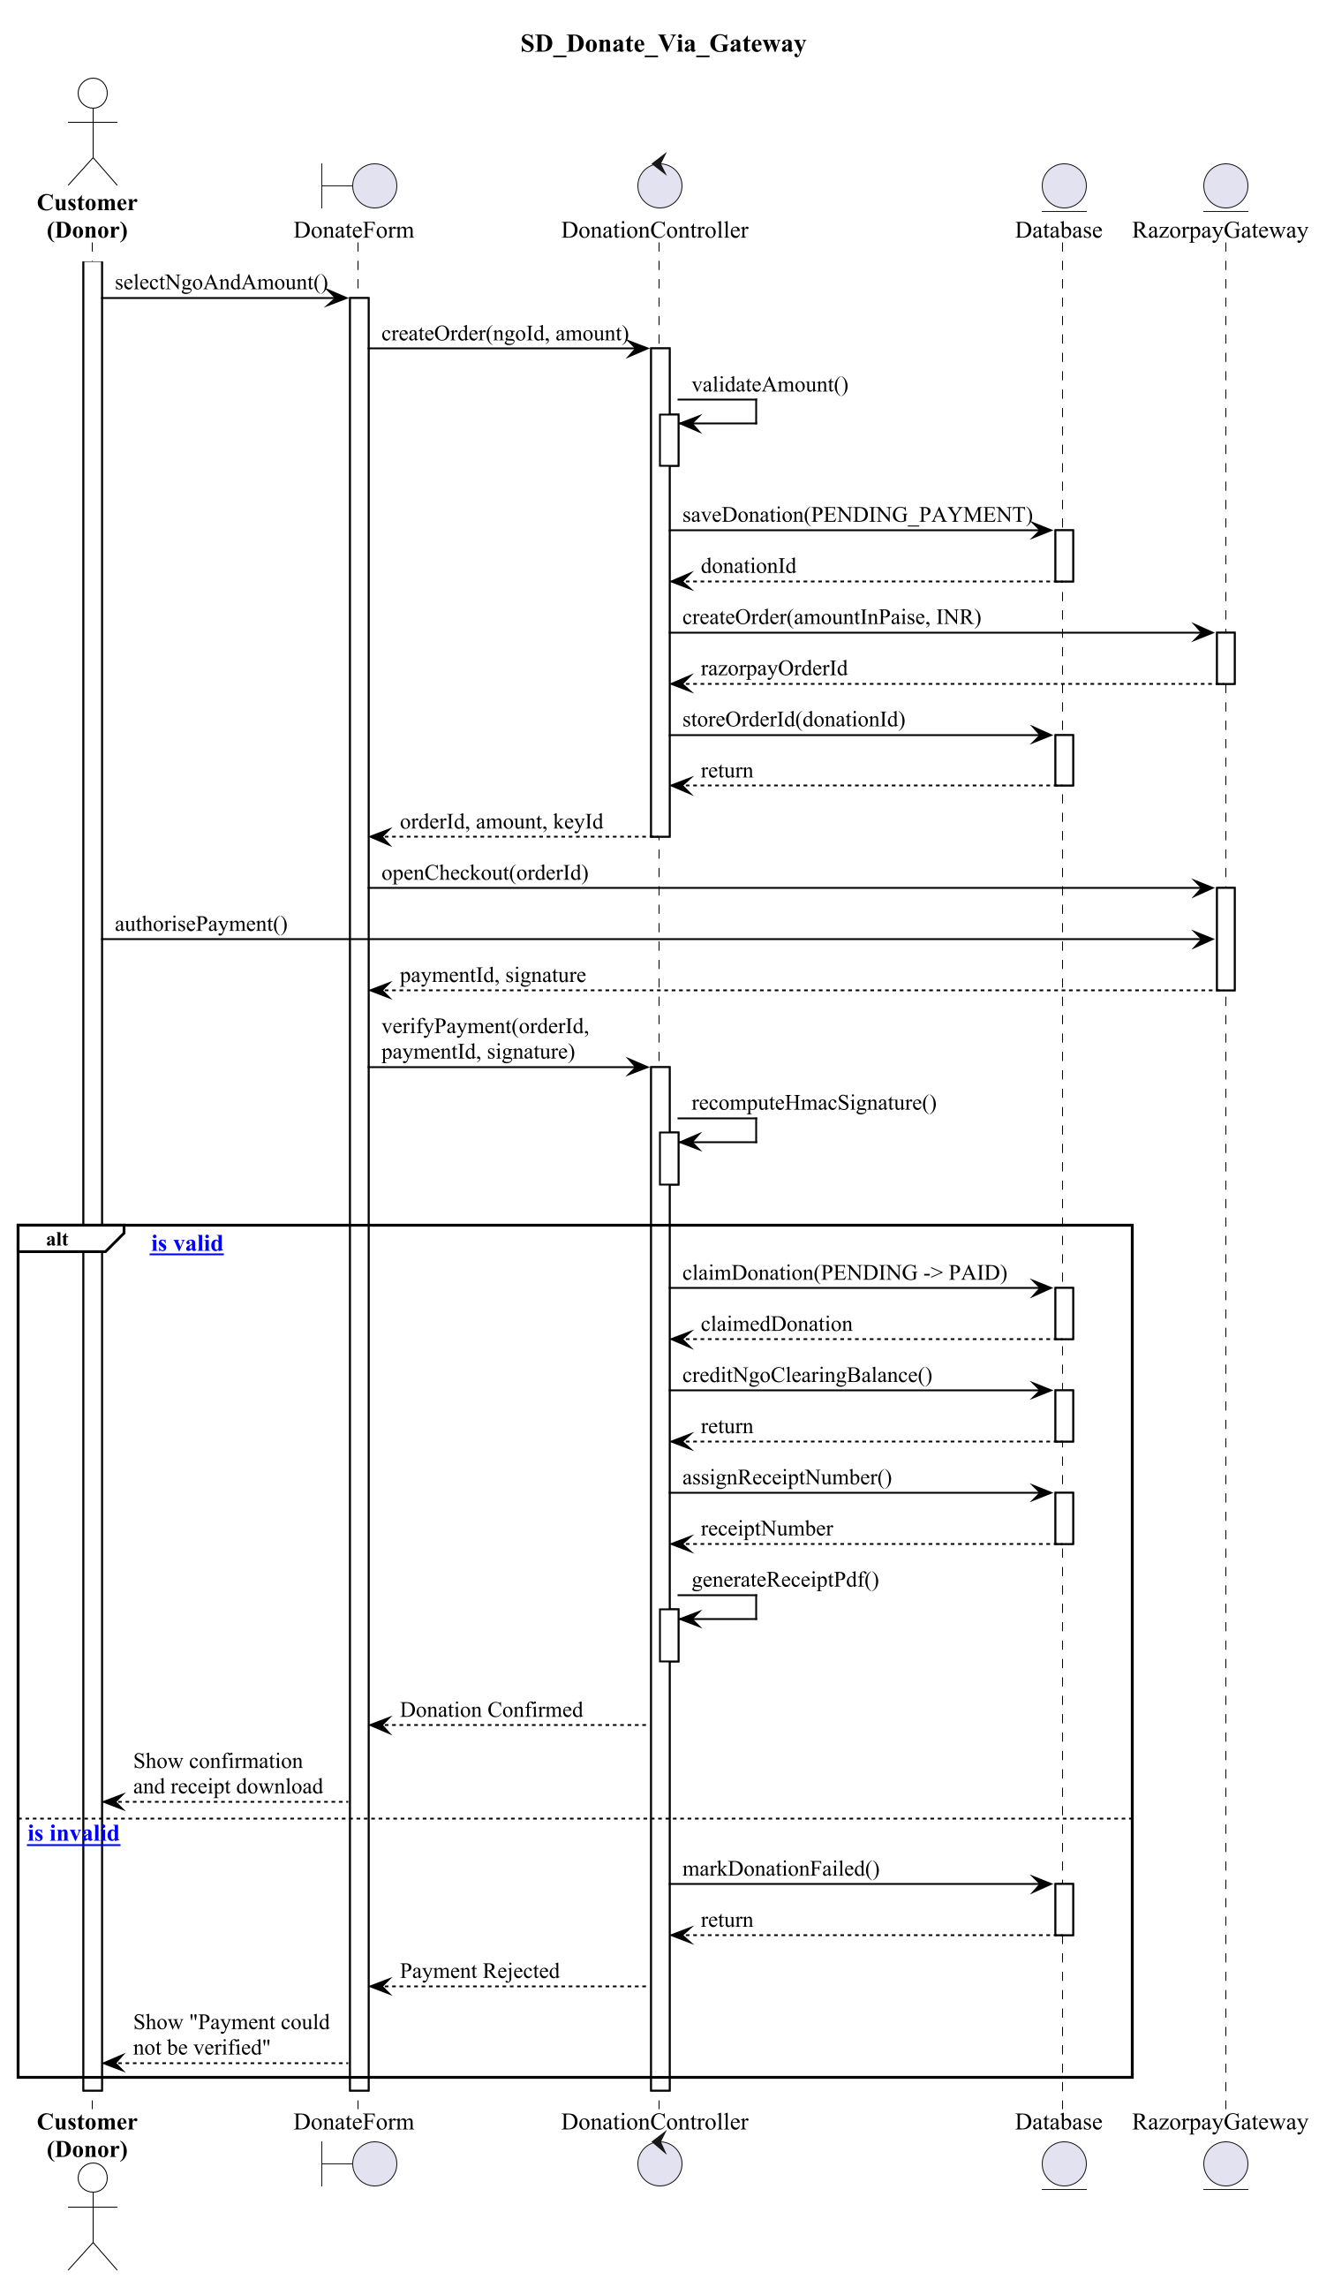
Figure 5: Sequence Diagram – Donate via Payment Gateway
Three features of the diagram are worth drawing attention to.
- Activation bars — the narrow rectangles on each lifeline show when that object is actively processing. The control object's bar spans almost the whole interaction because it coordinates every step; the gateway's appears twice, once to create the order and once to take the payment.
- The order of the first two writes — the donation record is saved as pending BEFORE the gateway is contacted. Were the order reversed and the system to fail in between, there would exist a live order at the gateway that the database knew nothing about, and a donor who had paid with no record to credit.
- The alt fragment — the combined fragment at the foot of the diagram shows the two mutually exclusive outcomes of signature verification. Only the valid branch reaches the claim, the credit and the receipt; the invalid branch marks the donation failed and nothing moves.
The wallet-funded donation is not drawn separately because it is a strict simplification of this one: the gateway lifeline disappears entirely, and the interaction reduces to the donor, the boundary, the control object and the database.

5.4 Class Diagram
The class diagram gives the static structure of the system: the entities that are stored, the attributes each carries, the operations defined on them and the associations between them. Attributes are marked – for private and operations + for public, following standard UML visibility notation, and every association carries a name and multiplicities at both ends.
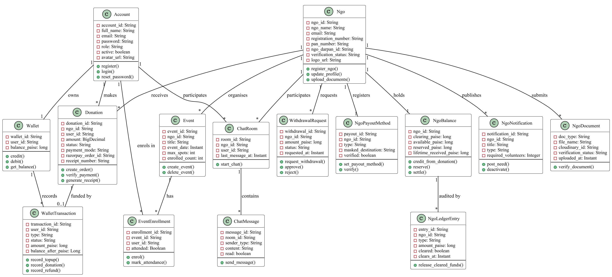
Figure 6: Class Diagram – Entities and Associations
Several design decisions are visible in the structure itself.
- Balances are integers of paise, not decimals of rupees — Wallet.balance_paise and the four NgoBalance fields are all declared long. Money held as a fractional type is a classic source of rounding error, and the atomic increment operator the system depends upon works reliably only on whole numbers.
- Every balance has a ledger beside it — Wallet is paired with WalletTransaction and NgoBalance with NgoLedgerEntry. The balance records the current figure; the ledger records why it is that figure. Summing the ledger must always reproduce the balance, and that property is what makes the system auditable.
- An NGO has exactly one balance and one payout method — both are 1 : 1 associations enforced by a unique index. Two balance records for one organisation would make it impossible to say what that organisation is owed.
- A donation optionally references a wallet transaction — the 1 : 0..1 association records how the donation was funded. A gateway-funded donation has none; a wallet-funded one points at the ledger entry that paid for it.

5.5 Data Dictionary
MongoDB is a document database, so the structures below are collections of documents rather than relational tables. Each document carries a generated _id as its primary key, mapped to the id field of the corresponding model class. Fields marked unique are backed by a unique index created at application start-up; fields marked indexed carry a non-unique index supporting the queries the application performs most often.
Two conventions run through every collection. Monetary values are stored as a whole number of paise in a 64-bit integer field whose name ends in Paise, never as a decimal; and timestamps are stored as UTC instants, converted to Indian Standard Time only where a figure is presented to a person.

5.5.1 accounts
One document per donor, volunteer or administrator account.
Field | Type | Description and constraints
id | String | Primary key, generated by MongoDB.
fullName | String | Display name, required, trimmed at registration.
email | String | Login identifier. Stored lower-case; registration rejects a duplicate.
password | String | BCrypt hash. The plaintext password is never stored.
role | String | USER or ADMIN. Determines authorisation.
active | boolean | False disables sign-in without deleting the account. Defaults true.
avatarUrl | String | Profile picture: an https URL for an uploaded image, "preset:<name>" for a bundled avatar, or null for initials.
avatarCloudinaryId | String | Cloudinary handle for an uploaded image, so the old file can be deleted when replaced. Null for presets.
resetToken | String | Single-use password-reset token (UUID). Cleared the moment it is used.
resetTokenExpiry | Instant | Moment the reset token stops being accepted — fifteen minutes after issue.
Table 8: Data dictionary – accounts collection

5.5.2 ngos
One document per registered organisation, including those awaiting approval.
Field | Type | Description and constraints
id | String | Primary key.
ngoName | String | Registered name of the organisation.
email | String | Login identifier for the organisation's representative.
password | String | BCrypt hash.
ngoType | String | Sector, e.g. Education, Health, Environment.
legalStructure | String | Trust, Society or Section 8 Company.
registrationNumber | String | Statutory registration number. Cross-checked against the uploaded certificate.
panNumber | String | Permanent Account Number. Cross-checked against the uploaded PAN card.
ngoDarpanId | String | NITI Aayog NGO Darpan identity, where held.
authorizedPersonName | String | Person authorised to act for the organisation.
authorizedPersonDesignation | String | That person's role within the organisation.
description | String | Public description shown on the organisation's profile.
location | String | City or district, used for browsing and filtering.
address | String | Full postal address; also the default delivery address for material needs.
contactPhone | String | Public contact number.
uniqueNgoId | String | Platform identifier assigned on approval.
verificationStatus | Enum | PENDING, APPROVED or REJECTED. Only APPROVED organisations are publicly visible.
active | boolean | False suspends the organisation without deleting it.
registeredAt / reviewedAt | Instant | Submission and review timestamps.
reviewNote | String | Administrator's recorded reason for the decision.
logoUrl | String | Organisation logo. Same three-way meaning as Account.avatarUrl.
logoCloudinaryId | String | Cloudinary handle for an uploaded logo.
documents | List | Embedded NgoDocument subdocuments — see 5.5.3.
websiteUrl, facebookUrl,  instagramUrl, linkedinUrl | String | Optional public links.
Table 9: Data dictionary – ngos collection

5.5.3 NgoDocument (embedded)
Embedded inside the ngos document rather than stored separately, because a document has no meaning apart from the organisation that submitted it and is always read together with it.
Field | Type | Description and constraints
docType | String | REGISTRATION_CERT, PAN_CARD, DARPAN_CERT or OTHER.
fileName | String | Original filename, shown to the reviewing administrator.
cloudinaryId | String | Cloudinary public_id, used to generate a time-limited signed URL.
resourceType | String | raw for a PDF, image for a JPG or PNG.
mimeType | String | application/pdf, image/jpeg or image/png.
uploadedAt | Instant | Upload timestamp.
verificationStatus | String | LOOKS_VALID, LOOKS_SUSPICIOUS or UNREADABLE — result of the automatic keyword check.
verificationNote | String | Human-readable reason behind that status.
Table 10: Data dictionary – NgoDocument embedded structure

5.5.4 donations
Field | Type | Description and constraints
id | String | Primary key.
ngoId | String | Receiving organisation.
userId | String | Donating account.
amount | BigDecimal | Donation amount in rupees, as entered by the donor.
status | Enum | PENDING_PAYMENT, PAID or FAILED.
paymentMode | Enum | UPI, CARD, NET_BANKING, WALLET (a third-party wallet inside the gateway) or WALLET_BALANCE (the platform's own wallet).
razorpayOrderId | String | Indexed. Gateway order identifier; also how a webhook locates the record.
paymentReference | String | Gateway payment id, or the wallet ledger entry id for a wallet-funded donation.
receiptNumber | String | 80G receipt number, e.g. NGOC/2026-27/000042. Assigned once when the donation becomes PAID and never altered.
createdAt | Instant | Creation timestamp; also the date printed on the receipt.
Table 11: Data dictionary – donations collection

5.5.5 wallets
Field | Type | Description and constraints
id | String | Primary key.
userId | String | Unique index. Guarantees a user can never hold two wallets.
balancePaise | long | Spendable balance in paise; 50000 means ₹500.00. Never negative.
createdAt / updatedAt | Instant | Creation and last-modification timestamps.
Table 12: Data dictionary – wallets collection

5.5.6 wallet_transactions
The donor's passbook. Summing every COMPLETED entry must always reproduce the wallet balance.
Field | Type | Description and constraints
id | String | Primary key.
userId | String | Indexed. Owner of the wallet.
type | Enum | TOPUP (money in from outside), DONATION (money out to an NGO) or REFUND (money returned after a failed donation).
status | Enum | PENDING, COMPLETED or FAILED. Only a top-up is ever PENDING.
amountPaise | long | Always a positive magnitude; direction is carried by type, not by sign.
balanceAfterPaise | Long | Balance immediately after this entry. Null while a top-up is pending.
description | String | Human-readable label shown in the passbook.
razorpayOrderId | String | Indexed. Set on a top-up; how the verify call and the webhook find the row.
razorpayPaymentId | String | Gateway payment id, recorded when the top-up completes.
donationId | String | Set on DONATION and REFUND entries, linking back to the donation.
createdAt | Instant | Creation timestamp; the passbook orders by this descending.
Table 13: Data dictionary – wallet_transactions collection

5.5.7 ngo_balances
The organisation's money, divided into three buckets so that funds which have been received can be distinguished from funds which may actually be withdrawn.
Field | Type | Description and constraints
id | String | Primary key.
ngoId | String | Unique index. One balance record per organisation.
clearingPaise | long | Donated but not yet withdrawable, awaiting the settlement window.
availablePaise | long | Cleared and withdrawable.
reservedPaise | long | Locked against an open withdrawal request.
lifetimeReceivedPaise | long | Cumulative total ever received. Never decreases.
lifetimeWithdrawnPaise | long | Cumulative total ever paid out. Never decreases.
createdAt / updatedAt | Instant | Creation and last-modification timestamps.
Table 14: Data dictionary – ngo_balances collection

5.5.8 ngo_ledger_entries
Field | Type | Description and constraints
id | String | Primary key.
ngoId | String | Indexed. Owning organisation.
type | Enum | DONATION_RECEIVED, CLEARED, WITHDRAWAL_RESERVED, WITHDRAWAL_PAID or WITHDRAWAL_REVERSED.
amountPaise | long | Magnitude of the movement.
availableAfterPaise | Long | Available balance immediately after this entry.
description | String | Human-readable label.
donationId | String | Set where the entry originates from a donation.
withdrawalId | String | Set where the entry originates from a withdrawal.
clearsAt | Instant | Indexed. When this money becomes withdrawable. Drives the scheduled job.
cleared | boolean | Whether the money has been promoted. Claimed atomically so the job may run on several instances at once.
createdAt | Instant | Creation timestamp.
Table 15: Data dictionary – ngo_ledger_entries collection

5.5.9 ngo_payout_methods
Field | Type | Description and constraints
id | String | Primary key.
ngoId | String | Unique index. One payout destination per organisation.
type | Enum | BANK_ACCOUNT or UPI.
accountHolderName | String | Name the destination is held in.
accountNumber | String | Full bank account number. Annotated so it is never serialised to any client.
upiId | String | Full UPI identifier. Likewise never serialised to a client.
maskedDestination | String | The only form ever returned, e.g. “XXXXXX4321”.
ifsc / bankName | String | Bank routing details.
verified | boolean | Whether an administrator has confirmed the destination.
changedAt | Instant | Last change. Starts the cooling-off period during which withdrawal is frozen.
createdAt / updatedAt | Instant | Creation and last-modification timestamps.
Table 16: Data dictionary – ngo_payout_methods collection

5.5.10 withdrawal_requests
Field | Type | Description and constraints
id | String | Primary key.
ngoId | String | Indexed. Requesting organisation.
ngoName | String | Denormalised so the administrative queue needs no second lookup.
amountPaise | long | Requested amount, reserved from available balance at request time.
status | Enum | Indexed. PENDING, APPROVED, REJECTED, PAID or FAILED.
payoutType | Enum | Destination type captured at request time.
payoutMaskedDestination | String | Masked destination, safe to display.
payoutAccountNumber / payoutUpiId | String | Full destination, never serialised to a client.
requestedAt / reviewedAt / paidAt | Instant | Lifecycle timestamps.
reviewedBy | String | Administrator who decided the request.
ngoNote / adminNote | String | Reason supplied by the organisation, and by the administrator.
paymentReference | String | Bank or UPI reference of the completed transfer.
Table 17: Data dictionary – withdrawal_requests collection

5.5.11 events and event_enrollments
Field | Type | Description and constraints
id | String | Primary key of the event.
ngoId / ngoName | String | Organising body; the name is denormalised for listing.
title / description | String | Event details shown to volunteers.
location | String | Where the event takes place.
eventDate | Instant | Scheduled date and time.
maxSpots | int | Capacity. Enrolment is refused once reached.
enrolledCount | int | Current enrolments, incremented atomically.
category | String | Grouping label, e.g. Cleanliness, Teaching.
active | boolean | False hides the event without deleting its enrolments.
Table 18: Data dictionary – events collection
Field | Type | Description and constraints
id | String | Primary key of the enrolment.
eventId | String | Event enrolled in.
userId / userEmail / userName | String | Volunteer, with contact details denormalised for the attendance sheet.
enrolledAt | Instant | Enrolment timestamp.
attended | Boolean | Null until marked; true or false afterwards.
absenceNotificationSent | boolean | Prevents an absence notice being sent twice.
Table 19: Data dictionary – event_enrollments collection

5.5.12 Supporting collections
Collection | Purpose | Key fields
ngo_media | Photographs and video links on an organisation's public profile. | ngoId, mediaUrl, mediaType (IMAGE or VIDEO), caption, cloudinaryId, createdAt
ngo_notifications | Published material needs and volunteering calls. | ngoId, ngoName, title, description, type (NEED or VOLUNTEERING), resourceDetails, deliveryAddress, requiredVolunteers, deadline, active
user_notifications | Messages addressed to an individual donor or volunteer. | userId, ngoId, title, message, type (ABSENCE_ALERT or GENERAL), eventId, read, createdAt
chat_rooms | One conversation between a donor and an organisation. | ngoId, userId, ngoName, userName, lastMessageAt, lastMessagePreview
chat_messages | Individual messages within a room. | roomId, senderEmail, senderType (USER or NGO), content, sentAt, read
counters | Named sequences that only increase. Presently holds one document per financial year for 80G receipt numbering. | _id (e.g. “receipt:2026-27”), seq
Table 20: Data dictionary – supporting collections

5.6 System Architecture
The application is arranged in layers, each depending only on the layer beneath it. A request enters at the presentation layer, is authenticated and authorised, is routed to a controller, is executed by a service holding the business rules, and reaches the database through the persistence layer. Nothing skips a layer, and no layer reaches upward.
Layer | Responsibility | Principal components
Presentation | Renders the interface and collects user input. Holds no business rule; every decision it displays was made on the server. | React 19 with Vite; pages for donation, wallet, dashboards, NGO finance and administration
Security | Authenticates every request and enforces role-based authorisation before a controller is reached. | Spring Security; HTTP Basic authentication; BCrypt password hashing; CORS policy
Controller | Translates HTTP into service calls. Extracts the caller's identity from the security context rather than from the request body. | AccountController, NgoController, DonationController, WalletController, NgoFinanceController, AdminController, PaymentWebhookController
Service | Holds all business logic and is the only layer permitted to change state. | DonationService, WalletService, NgoBalanceService, WithdrawalService, ReceiptService, PaymentWebhookService, DocumentVerificationService, MailService
Persistence | Maps objects to documents. Repository interfaces serve ordinary queries; MongoTemplate serves the atomic conditional updates that money movement requires. | Spring Data MongoDB repositories; MongoTemplate findAndModify operations
Data | Stores documents durably and enforces unique indexes. | MongoDB Atlas — seventeen collections as catalogued in Section 5.5
External | Third-party services the platform depends upon. | Razorpay (payments), Cloudinary (media), Gmail SMTP (email), Tesseract OCR and Apache PDFBox (documents and receipts)
Table 21: Architectural layers and their responsibilities
One component sits outside this request-driven flow. The fund-clearing job runs on a timer rather than in response to any request, promoting donated money from an organisation's clearing balance to its available balance once the settlement window has elapsed. It enters at the service layer directly, and claims each ledger entry atomically so that it remains correct even if several application instances run it simultaneously.
The payment webhook is the one inbound path that originates outside the system. The gateway calls it server-to-server when a payment is captured, which is what allows a payment to be credited even when the donor's browser never returns from checkout. Because it cannot be authenticated by a login, it verifies an HMAC signature computed over the unmodified request body instead.

6. Development

6.1 Coding Standards
A consistent set of conventions was followed throughout, so that the codebase reads as though written by one hand and so that the reasoning behind unusual decisions survives in the source rather than only in this document.

6.1.1 Naming and Structure
Element | Convention | Example
Package | lower case, grouped by architectural role | app.service, app.controller, app.model
Class | PascalCase, named for what it owns | WalletService, NgoBalanceService
Method | camelCase, verb first | createTopUpOrder(), debitForDonation()
Constant | UPPER_SNAKE_CASE | MAX_TOPUP_PAISE, DEMO_ORDER_PREFIX
Monetary field | suffixed Paise, always an integer type | balancePaise, amountPaise
Boolean field | reads as an assertion | active, cleared, verified
REST endpoint | plural noun, hierarchical | /api/ngos/{ngoId}/finance/withdrawals
React component | PascalCase, one file per component | DemoCheckout.jsx, Avatar.jsx
CSS class | kebab-case, scoped by page | wallet-balance-card, demo-method
Table 22: Naming conventions

6.1.2 Layering Rules
- Controllers contain no business logic — each method extracts the caller's identity from the security context, calls one service method and returns the result.
- Identity is never taken from the request body — a user id supplied by the client would let anyone act as anyone else. It always comes from the authenticated session.
- One owner per balance — WalletService is the only class that may change a donor balance and NgoBalanceService the only one that may change an organisation's. Confining the arithmetic to one file per balance is what makes its correctness arguable at all.
- Dependencies point one way — donations know about wallets; wallets know nothing about donations. This keeps the dependency graph acyclic.
- Constructor injection throughout — dependencies are final fields set in the constructor, so an object cannot exist in a partly-initialised state.

6.1.3 Handling Money
Two rules govern every monetary operation, and the correctness of the system rests on them.
First, money is stored as an integer number of paise, never as a decimal of rupees. Fractional types accumulate rounding error, and the atomic increment operator the system relies on is dependable only on whole numbers. Rupees reappear only at the outermost edge, for display.
Second, a balance is never read into the application, altered there and written back. That sequence contains a gap in which a second request can read the same value, and both then write a figure computed from stale data. Instead the condition and the change are expressed as a single database operation, which the database applies indivisibly:
private Wallet debit(String userId, long amountPaise) {
return mongoTemplate.findAndModify(
Query.query(Criteria.where("userId").is(userId)
.and("balancePaise").gte(amountPaise)), // the condition
new Update().inc("balancePaise", -amountPaise) // the change
.set("updatedAt", Instant.now()),
FindAndModifyOptions.options().returnNew(true),
Wallet.class);
}
Because “balance is at least the amount” is part of the query rather than a preceding if-statement, two simultaneous debits are serialised by the database: the first succeeds and the second finds the condition no longer satisfied, matches nothing and returns null. The balance therefore cannot go below zero under any interleaving of requests.

6.1.4 Idempotency
A payment may legitimately be reported more than once — by a page refresh, a retry, or the gateway's webhook arriving alongside the browser callback. Every such path therefore claims the record before moving any money:
Donation claimed = mongoTemplate.findAndModify(
Query.query(Criteria.where("_id").is(donation.getId())
.and("status").is(DonationStatus.PENDING_PAYMENT.name())),
new Update().set("status", DonationStatus.PAID.name())
.set("paymentReference", razorpayPaymentId),
FindAndModifyOptions.options().returnNew(true),
Donation.class);
if (claimed == null) return null; // another request already credited this
The update matches only while the record is still pending. Whichever request arrives first flips the status and receives the document; every other receives null and stops. Exactly one caller proceeds to credit the organisation and issue the receipt.

6.1.5 Comments and Documentation
Comments explain why a decision was taken, not what the line does. Code that is unusual carries the reasoning that makes it necessary — for instance the note above the webhook handler explaining why the raw request body must be hashed before it is parsed, since re-serialising it would change the bytes and invalidate the signature. Configuration files are commented to the same standard, so that a setting's purpose and its safe default are visible at the point where it is defined.

6.1.6 Error Handling
- Meaningful status codes — 400 for invalid input, 401 unauthenticated, 403 not the owner, 404 absent, 409 conflicting state, 500 genuine server fault.
- Messages address the user — “Insufficient wallet balance. Please top up and try again.” rather than an exception class name.
- Non-essential failures never fail the operation — a mail server outage must not turn a completed donation into an error, so email is dispatched best-effort and logged on failure.
- Fail closed on security — an unconfigured webhook secret causes the endpoint to reject every call rather than accept unverified ones.

6.1.7 Testing
Automated tests concentrate on the logic whose failure would be silent — where a bug produces a plausible wrong answer rather than a visible error.
Test class | Covers
PaymentWebhookServiceTest | Signature verification against an independently computed HMAC, rejection of a forged body, routing to the correct flow, refusal when the secret is unconfigured, and that a failed-payment event settles nothing.
ReceiptServiceTest | That the generated PDF parses and carries every field an 80G claim requires, that non-Latin characters do not break generation, and that the amount in words uses Indian place values — lakh and crore, not million.
DocumentVerificationServiceTest | All three document-reading paths, including the OCR fallback, so a broken native OCR installation surfaces as a failing test rather than during a demonstration.
BackendApplicationTests | That the Spring context loads, which verifies every bean and its dependencies resolve.
Table 23: Automated test coverage
All tests pass; the suite runs with mvnw test.

6.2 Screenshots
This section illustrates the running application. Each screenshot should be captured at a browser width of at least 1280 pixels and inserted beneath the corresponding caption.
[Insert screenshots here. The suggested sequence below follows the narrative of the report: registration and verification first, then the donation flow, then finance and administration.]
No. | Screen | What it should show
1 | Home page | Landing page with featured verified organisations and impact figures.
2 | NGO catalogue | Browsable list of approved organisations with sector and location.
3 | NGO profile | A single organisation with its photographs, needs and events.
4 | NGO registration | The registration form with documents attached and the automatic verification result displayed.
5 | Administrator queue | Pending applications with the document-verification flags visible.
6 | Donation step 1 | Choosing an organisation and entering an amount.
7 | Donation step 2 | Payment method selection, showing both wallet and gateway options.
8 | Payment checkout | The gateway checkout, or the demo payment sheet.
9 | Donation confirmation | Success screen with the payment reference and receipt download.
10 | 80G receipt | The generated PDF opened, showing registration details and the amount in words.
11 | Wallet | Balance, top-up options and the transaction passbook.
12 | Donor dashboard | Donation history with receipt download buttons.
13 | NGO finance | Clearing, available and reserved balances with the ledger.
14 | Withdrawal request | Requesting a withdrawal and the resulting reservation.
15 | Events | Event listing, enrolment, and the attendance sheet.
Table 24: Suggested screenshot sequence

7. Proposed Enhancements
The following extensions were identified during development but fell outside the scope agreed for this project. They are listed in the order in which they would most sensibly be undertaken.
- Token-based authentication. The system presently uses HTTP Basic, which obliges the client to retain credentials for the duration of a session. Issuing a signed token at sign-in and presenting that thereafter would remove the stored password, allow sessions to expire independently, and permit a session to be revoked without a password change.
- Automated payout execution. Approved withdrawals are at present transferred by an administrator and the reference recorded afterwards. A payout API would complete the cycle, though it brings additional regulatory obligations.
- Campaign-level fundraising. Donations are currently made to an organisation. Allowing an organisation to run named campaigns with their own targets and progress would let donors give to a specific purpose and see how close it is to being met.
- Recurring donations. Standing monthly instructions, which for most charities represent the larger share of revenue, require a mandate flow and a scheduled collection job.
- Transparency reporting. Allowing an organisation to publish an outcome update — what was achieved with the money, with photographs — and notifying the donors who funded it would close the loop that currently ends at the receipt.
- Reconciliation dashboard. The design already guarantees that the sum of ledger entries equals the recorded balance. An administrative screen that verifies this continuously across every wallet and organisation would turn that property into visible evidence.
- Real-time chat. Messages are presently exchanged by polling. A persistent connection would make delivery immediate and reduce needless requests.
- Verification against government registries. The document check reads and matches text but cannot confirm that a registration number is genuine. Querying the NGO Darpan or Ministry of Corporate Affairs registries directly would strengthen this considerably.
- Native mobile application. The interface is responsive, but a native application would permit push notification for event reminders and donation confirmations.
- Analytics for organisations. Donation trends, donor retention and event attendance over time would help an organisation plan, using data the system already records.

8. Conclusion
NGOConnect set out to address a specific difficulty: that a person willing to donate to a charitable cause in India has no straightforward way of establishing that the organisation asking is genuine, no record of what becomes of the money afterwards, and frequently no receipt for the tax deduction to which they are entitled.
The completed system addresses each of these. An organisation becomes visible to donors only after its statutory documents have been read, checked against the details it declared, and approved by an administrator, so the judgement of legitimacy is made once by someone holding the evidence rather than repeatedly by every donor. Every movement of money is recorded in an append-only ledger from which the current balance can always be reconstructed. A numbered 80G receipt is produced and emailed automatically the moment a donation completes.
The most demanding part of the work was not any individual feature but the correctness of the money handling. Software that moves money is subject to a class of failure that ordinary applications tolerate: two requests arriving at the same instant, a browser that never returns from a payment page, a confirmation delivered twice. Each of these was addressed explicitly — by expressing every balance change as a single conditional atomic operation rather than a read followed by a write, by requiring each payment record to be claimed before any money moves, and by accepting server-to-server confirmation from the gateway as an independent path to crediting. The result is that a balance cannot become negative, a payment cannot be credited twice, and a payment cannot be lost because a browser closed.
Building the system also demonstrated how much of a real application lies outside its central feature. Reading a scanned certificate required a fallback to optical character recognition because organisations hold photographs of documents as often as digital originals. Producing a valid receipt required writing amounts in words using Indian place values, which group differently from English ones. Sending a single email required understanding why a provider refuses an ordinary account password. None of these is conceptually difficult, and all of them were necessary.
The system meets the objectives set out in Section 2.3, and the architecture leaves room for the enhancements described in Section 7 without redesign: campaigns attach to donations, recurring payments reuse the existing gateway integration, and automated payouts replace only the final manual step of a withdrawal cycle that is otherwise complete.

9. Bibliography
Books
- Walls, C. (2022). Spring in Action, 6th edition. Manning Publications.
- Bruce, B. and Pereira, N. (2019). MongoDB: The Definitive Guide, 3rd edition. O'Reilly Media.
- Banks, A. and Porcello, E. (2020). Learning React, 2nd edition. O'Reilly Media.
- Bloch, J. (2018). Effective Java, 3rd edition. Addison-Wesley.
- Fowler, M. (2002). Patterns of Enterprise Application Architecture. Addison-Wesley.
- Kleppmann, M. (2017). Designing Data-Intensive Applications. O'Reilly Media.
- Booch, G., Rumbaugh, J. and Jacobson, I. (2005). The Unified Modeling Language User Guide, 2nd edition. Addison-Wesley.
Official Documentation
- Spring Boot Reference Documentation. https://docs.spring.io/spring-boot/
- Spring Security Reference. https://docs.spring.io/spring-security/reference/
- Spring Data MongoDB Reference. https://docs.spring.io/spring-data/mongodb/reference/
- MongoDB Manual. https://www.mongodb.com/docs/manual/
- React Documentation. https://react.dev/
- Vite Guide. https://vite.dev/guide/
- Razorpay Payment Gateway Documentation. https://razorpay.com/docs/
- Cloudinary Java SDK Documentation. https://cloudinary.com/documentation/java_integration
- Apache PDFBox Documentation. https://pdfbox.apache.org/
- Tesseract OCR Documentation. https://tesseract-ocr.github.io/
- PlantUML Language Reference Guide. https://plantuml.com/guide
Statutory and Regulatory References
- Income Tax Act, 1961, Section 80G — Deduction in respect of donations to certain funds and charitable institutions. Income Tax Department, Government of India.
- NGO Darpan Portal, NITI Aayog, Government of India. https://ngodarpan.gov.in/
- Societies Registration Act, 1860. Government of India.
- Indian Trusts Act, 1882. Government of India.
- Companies Act, 2013, Section 8 — Formation of companies with charitable objects. Ministry of Corporate Affairs, Government of India.
Technical References
- RFC 2104 — HMAC: Keyed-Hashing for Message Authentication. Internet Engineering Task Force.
- RFC 6749 — The OAuth 2.0 Authorization Framework. Internet Engineering Task Force.
- Provos, N. and Mazières, D. (1999). A Future-Adaptable Password Scheme. USENIX. [The bcrypt algorithm used for password hashing.]
- MongoDB Documentation — findAndModify and atomic operations. https://www.mongodb.com/docs/manual/reference/command/findAndModify/

