KitchenGen AI: AI-Powered Personal Food Creator
& Kitchen Assistant

Project Description:
KitchenGen AI is a personal food-planning and recipe discovery application designed to help users decide what to cook using ingredients they already have at home. Users can enter available ingredients, maintain pantry information, and explore recipe suggestions that reflect their preferences. The application focuses on reducing the effort involved in meal planning by showing recipe matches, estimated preparation time, serving information, estimated cost, and missing ingredients.
The project is organized as a web application with a React and Vite frontend and a FastAPI backend. The backend uses SQLAlchemy for database interaction and SQLite for local data persistence. Its recipe experience includes Indian and regional dishes alongside other cuisines, ingredient matching, cooking filters, pantry-aware suggestions, recipe details, favorites, and shopping-list support where implemented. Gemini-powered generation is planned as an optional AI integration; the environment template includes GEMINI_API_KEY, which should remain empty until the integration is configured.

Scenarios
Scenario 1: A user enters ingredients such as rice, onion, tomato, and coconut milk. KitchenGen AI compares the pantry items against its recipe collection and displays a small ranked set of relevant dishes, along with match percentages and missing ingredients.

Scenario 2: A user wants breakfast in under 30 minutes. They choose the Breakfast category and a time limit, then review recipes that satisfy the selected filters.

Scenario 3: A user selects an Indian cuisine preference and chooses a serving size and budget. The application filters and presents suitable recipes with estimated cost and serving details where that data is available.

Scenario 4: A user opens a recipe and notices missing ingredients. They can review the missing-item list and use the shopping-list workflow if it is enabled in the current build.

Scenario 5: A registered user signs in to access personal pantry details, saved recipes, preferences, and shopping lists. Authentication must be connected to the backend and verified before the project is treated as production-ready.

Technical Architecture

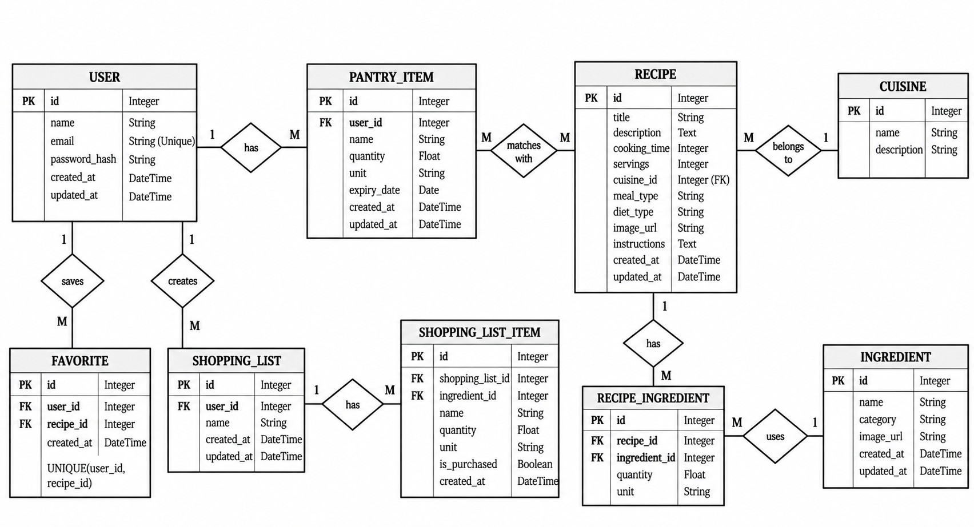

Pre-requisites:
Flask Framework Knowledge: Flask Documentation
Groq API Familiarity: Groq API Documentation
HTML, CSS, and JavaScript Skills: W3Schools HTML/CSS/JavaScript Tutorials
Python Programming Proficiency: Python Documentation
Version Control with Git: Git Documentation
Development Environment Setup: Flask Installation Guide
Ngrok for Public Deployment: Ngrok Documentation

Project Workflow

Activity 1: Project Analysis and Architecture
- Activity 1.1: Review the project requirements, including recipe discovery, Indian cuisines, meal categories, cooking time, budget, pantry management, and shopping lists.
- Activity 1.2: Analyze the existing frontend, backend, database, and services, and define the overall system architecture.
- Activity 1.3: Configure the development environment and verify that the frontend and backend run independently.

Activity 2: Backend and Database Development
- Activity 2.1: Develop and maintain database models for recipes, users, pantry items, favorites, and shopping lists.
- Activity 2.2: Implement backend APIs, request validation, error handling, and database operations while preserving existing recipe data.

Activity 3: Recipe Matching and AI Assistance
- Activity 3.1: Implement ingredient matching, match scores, and missing-ingredient identification.
- Activity 3.2: Add meal categories, cooking-time and budget filters, serving-size adjustments, and recipe limits.
- Activity 3.3: Integrate optional Gemini AI features for personalized recipe generation, ingredient substitutions, and cooking assistance.

Activity 4: Frontend Development
- Activity 4.1: Develop the recipe-matching interface, recipe cards, ingredient editor, filters, and recipe-detail pages with accurate recipe images.
- Activity 4.2: Implement responsive layouts, error messages, and login and registration functionality with secure backend authentication.
- Activity 4.3: Design user-friendly pantry, favorites, and shopping-list pages while maintaining a consistent interface and navigation.

Activity 5: Testing and Local Deployment
- Activity 5.1: Install dependencies, configure environment variables, and run the FastAPI backend and React frontend.
- Activity 5.2: Test recipe matching, filters, images, authentication, pantry management, shopping lists, and frontend-backend connectivity.

Activity 6: Conclusion

Milestone 1: Project Analysis and System Design

This milestone focuses on understanding the project requirements, identifying the main modules, and designing the architecture of the KitchenGen AI application.

Activity 1.1: Requirement Analysis
Identify the functional requirements of KitchenGen AI, including ingredient-based recipe recommendations, Indian cuisine categories, meal planning, cooking-time filters, budget estimation, pantry management, and shopping-list generation. Define the expected inputs and outputs for each module.

Activity 1.2: System Architecture and Database Design
Design the application architecture using React and Vite for the frontend, FastAPI for backend services, SQLAlchemy for database operations, and SQLite for local data storage. Identify the entities required to manage recipes, ingredients, users, pantry items, favorites, and shopping lists.

Activity 1.3: Development Environment Setup
Inspect the existing project structure, configure the Python virtual environment and frontend dependencies, prepare the environment variables, and verify that the frontend and backend can run independently.
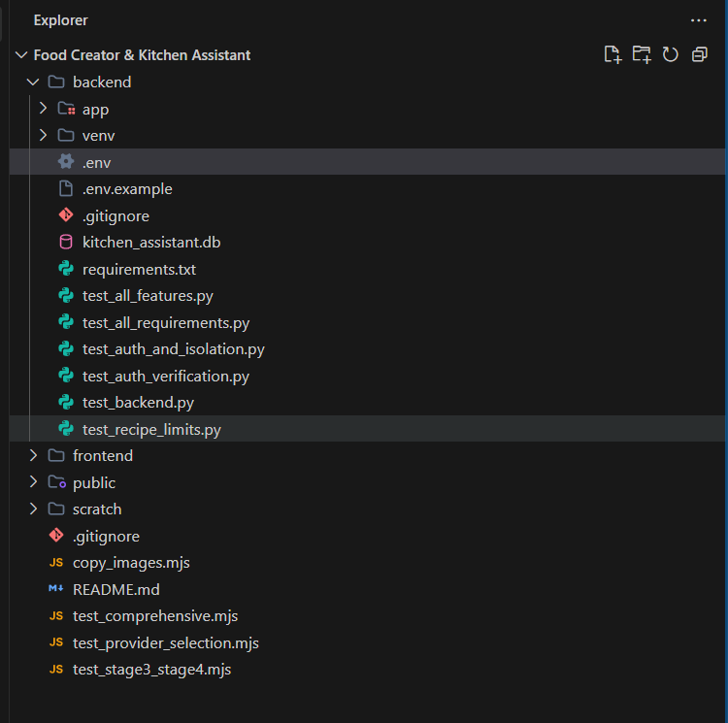

Milestone 2: Backend and Database Development
This milestone focuses on implementing backend services, managing recipe data, and establishing communication between the application modules.

Activity 2.1: Database and Model Implementation
Create or refine the database models for recipes, recipe ingredients, user accounts, pantry items, favorites, and shopping lists. Define the necessary relationships and ensure existing recipe data is preserved when updating the database.
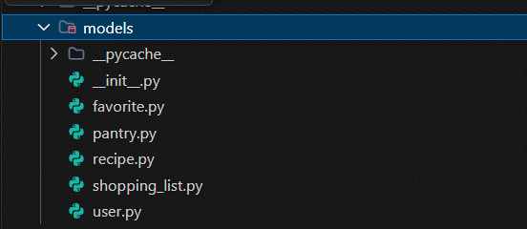

Activity 2.2: API Development
Implement and organize FastAPI endpoints for retrieving recipes, filtering recipes, viewing recipe details, managing pantry ingredients, and maintaining shopping lists. Add authentication endpoints if the account system is implemented.

Activity 2.3: Backend Validation and Integration
Validate incoming requests, handle invalid inputs and missing records, configure frontend-backend communication, and test database operations. Return consistent API responses so the frontend can display results and errors correctly.
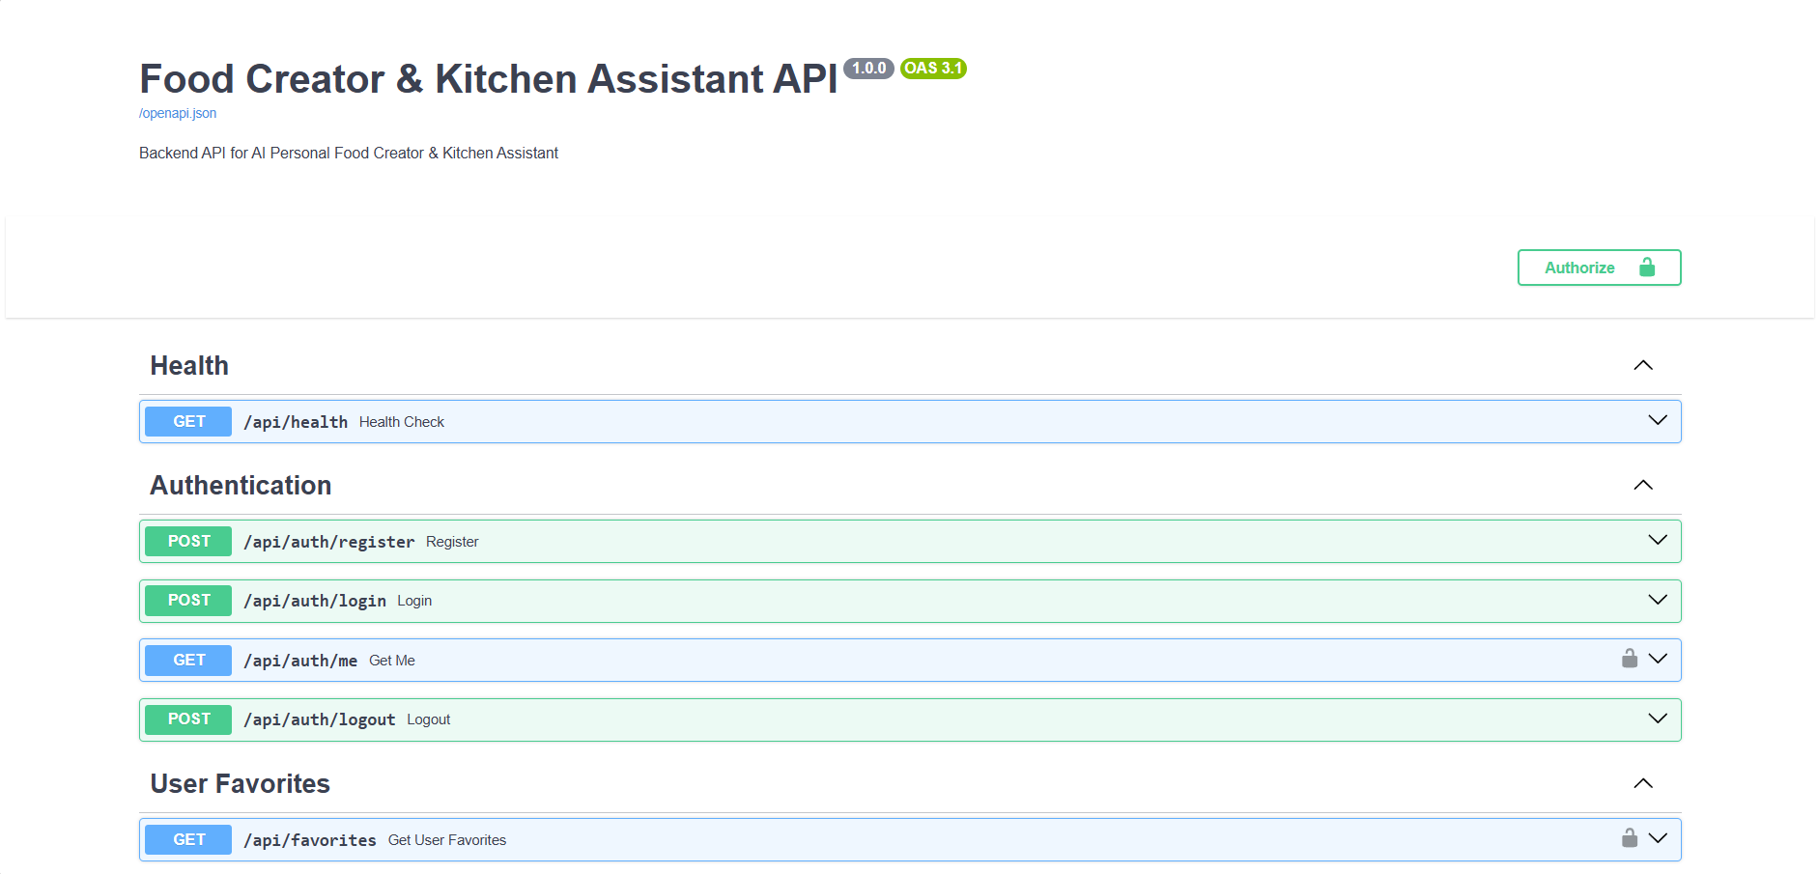

Milestone 3: Indian Recipe Management and Intelligent Matching
This milestone focuses on building a useful recipe collection and recommending dishes based on available ingredients and user preferences.

Activity 3.1: Indian Recipe Dataset Development
Create a structured collection of Indian recipes covering regional cuisines, including South Indian, North Indian, Andhra, Telangana, Punjabi, Gujarati, Maharashtrian, Bengali, and other regional dishes. Categorize recipes by breakfast, lunch, dinner, snacks, and desserts, and store their ingredients, cooking instructions, preparation time, total cooking time, serving size, and estimated cost.

Activity 3.2: Ingredient Matching and Recipe Filtering
Implement ingredient matching to compare the user's pantry items with recipe requirements. Calculate match percentages, identify missing ingredients, and rank suitable recipes. Apply filters for meal category, cuisine, cooking time, budget, serving size, and dietary preferences. Display eight recipes by default and no more than ten at a time.
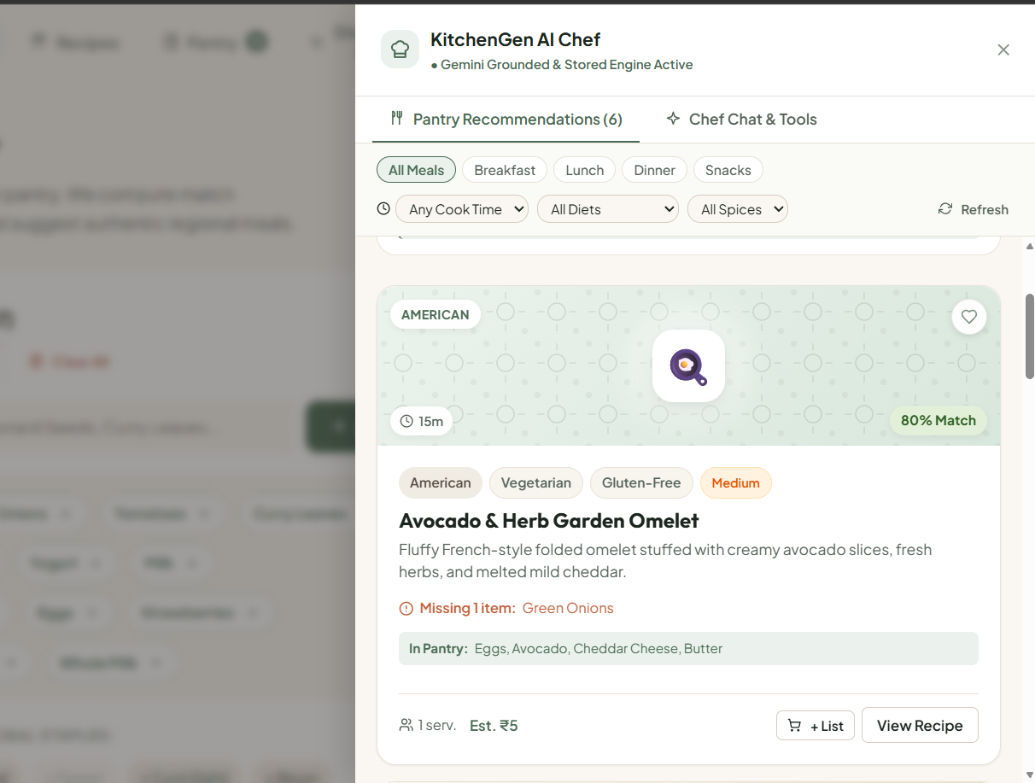

Activity 3.3: Recipe Personalization and AI Assistance
Support recipe customization through serving-size adjustments, suitable ingredient substitutions, and suggestions for using leftover ingredients. Integrate Gemini for AI-generated recipes and ingredient-photo analysis if these features are implemented and configured. Ensure existing recipe browsing and filtering remain available without Gemini.
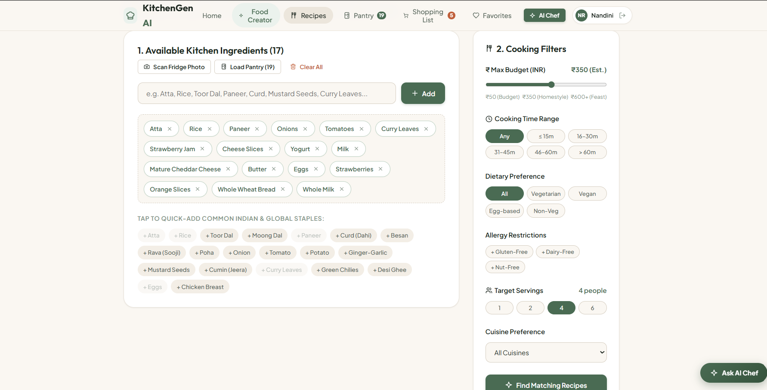

Milestone 4: Frontend Development and User Interface
This milestone focuses on creating an intuitive interface through which users can discover recipes, manage ingredients, and access personalized kitchen features.

Activity 4.1: Recipe Discovery Interface
Develop the recipe-matching page with recipe cards, ingredient input controls, cuisine selection, meal categories, cooking-time filters, and sorting options. Display the correct recipe image, match percentage, missing ingredients, estimated cost, and serving information for each dish.

Activity 4.2: User Authentication and Personalization
Implement login, registration, and logout functionality connected to the backend. Provide secure authentication and ensure that pantry data, saved recipes, and shopping lists are accessible only to the appropriate user.
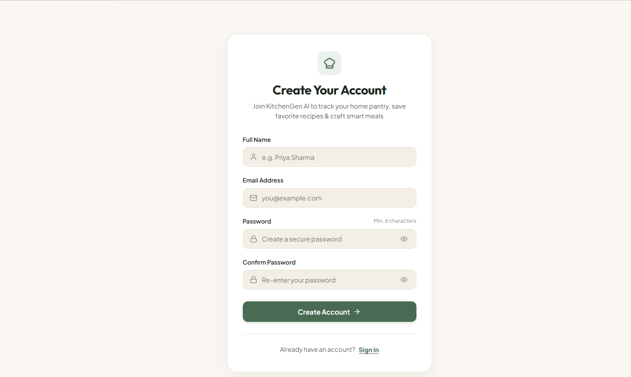

Activity 4.3: Pantry, Favorites, and Shopping List Interface
Develop the interfaces for managing pantry ingredients, saving favorite recipes, and preparing shopping lists from missing ingredients. Maintain consistent navigation, responsive layouts, and clear loading, success, and error messages across the application.

Milestone 5: Testing, Integration, and Deployment
This milestone focuses on verifying the application, resolving errors, and preparing the working system for local or online deployment.

Activity 5.1: Functional Testing
Test ingredient entry, recipe matching, Indian cuisine selection, meal categories, cooking-time limits, budget filters, serving-size adjustments, missing-ingredient detection, and recipe-image accuracy. Verify that no more than ten recipe cards appear simultaneously.

Activity 5.2: Integration and Authentication Testing
Verify frontend-backend communication, database operations, login, registration, logout, pantry updates, favorites, and shopping-list functionality where implemented. Test invalid inputs, incorrect credentials, API failures, and the application's non-AI features when the Gemini API key is unavailable.
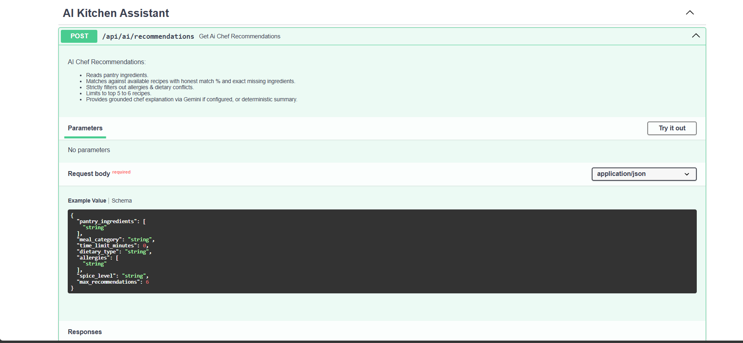

Activity 5.3: Deployment and Final Verification
Configure the frontend and backend for the target environment, set the required environment variables, and verify that the application starts correctly. Resolve remaining errors, protect credentials and user data, and document the tested functionality and outstanding limitations.

Exploring the Website's Web Pages

1. Login Page
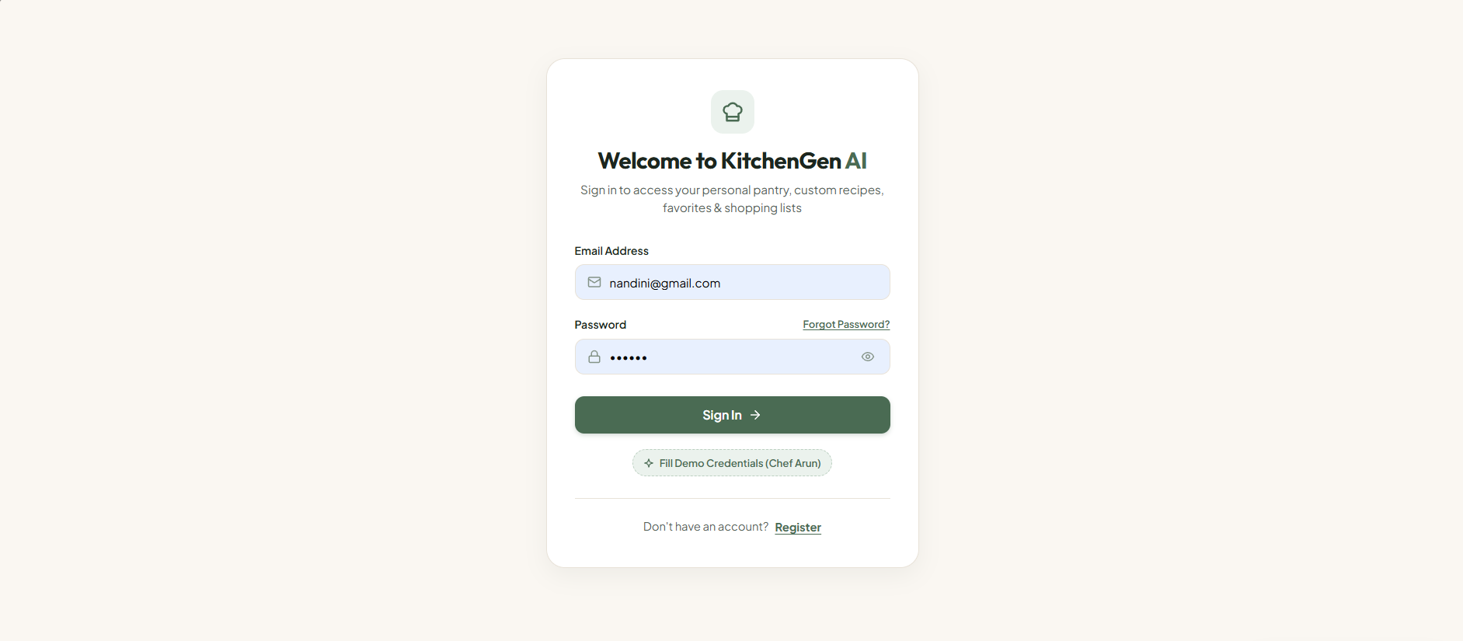
The login page welcomes users to KitchenGen AI and provides fields for email and password. The displayed controls include password visibility, a Sign In action, and links or options for account recovery, registration, or demo credentials if configured. The form should display meaningful feedback for incorrect credentials and only navigate to the application after backend authentication succeeds.

2. Registration Page
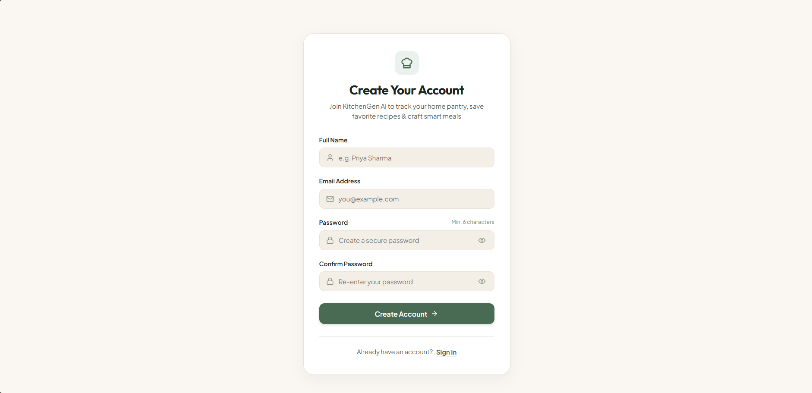
The registration page allows a new user to create an account using the required account fields. It should validate input, reject duplicate email addresses, and send the request to the backend. Passwords must be securely hashed on the server and must never be stored as plaintext.

3. Home or Dashboard Page
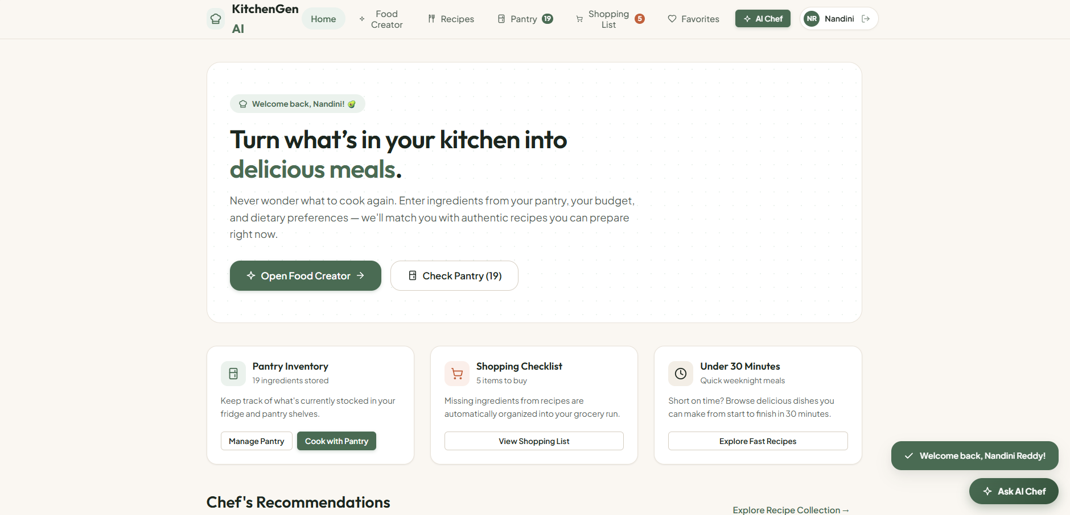
The home page acts as the starting point for recipe discovery. It can summarize the main actions—enter ingredients, explore recipe matches, manage the pantry, open favorites, and access shopping lists—based on the features present in the current build.

4. Recipe Creator / Ingredient Input Page
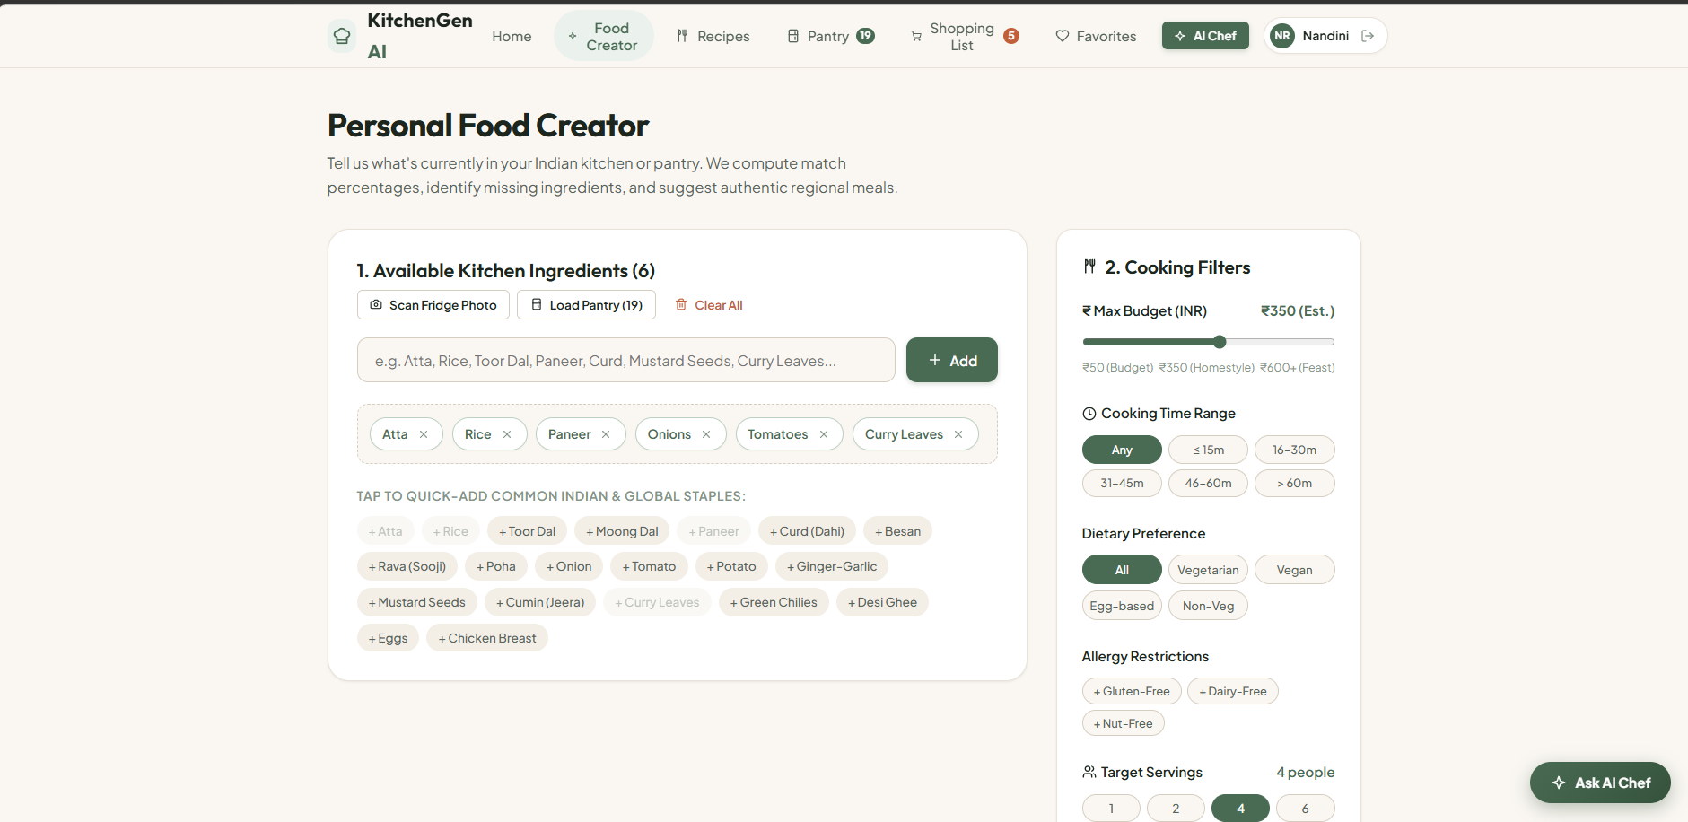
This page allows users to enter ingredients available at home. Quick-add controls can simplify adding common ingredients, while selected ingredients appear as removable chips. A clear-all action should reset the ingredient list without affecting unrelated user data.

5. Recipe Matches Page
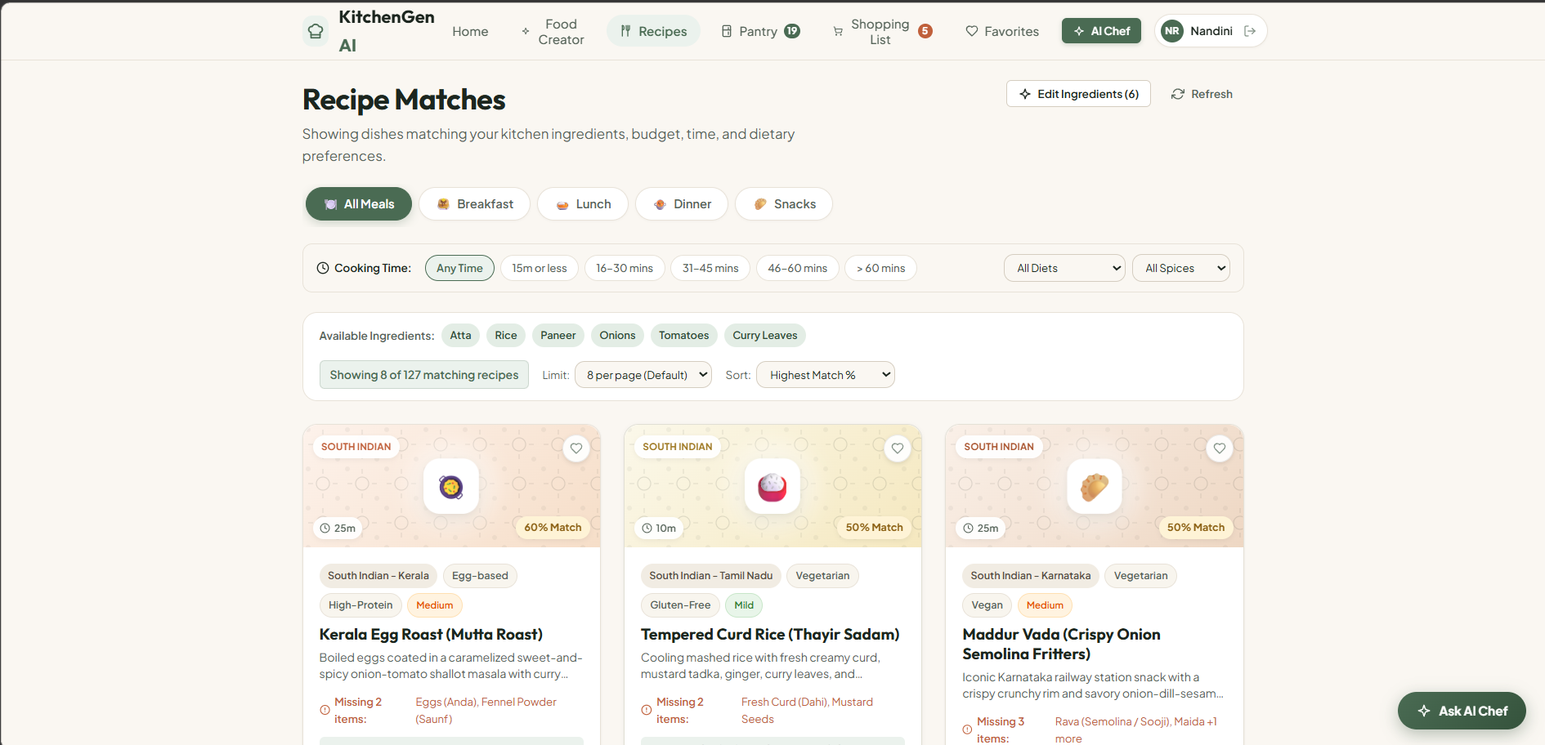
The Recipe Matches page presents candidate recipes based on the active pantry ingredients and selected filters. Cards display a dish image, cuisine and dietary labels, preparation time, match percentage, missing ingredients, ingredients already in the pantry, estimated servings, and estimated cost where data is available. The page should show a small ranked selection—eight by default and no more than ten at once.

6. Recipe Details Page
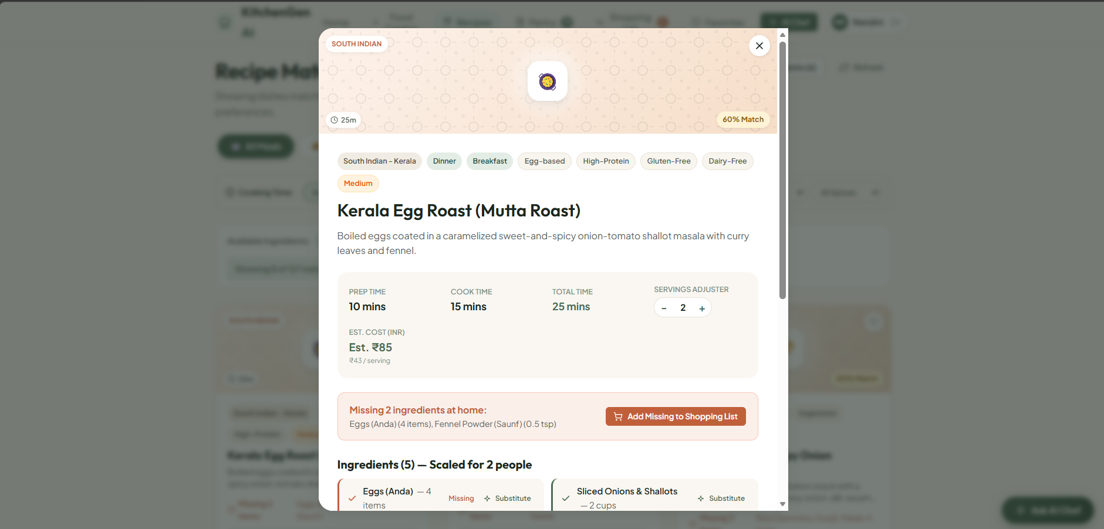
The recipe details page provides the complete recipe name, ingredient list, cooking instructions, preparation time, serving count, cuisine, and any available nutrition or cost estimates. Serving-size adjustment should scale quantities only when the underlying ingredient quantities support it.

7. Pantry Page
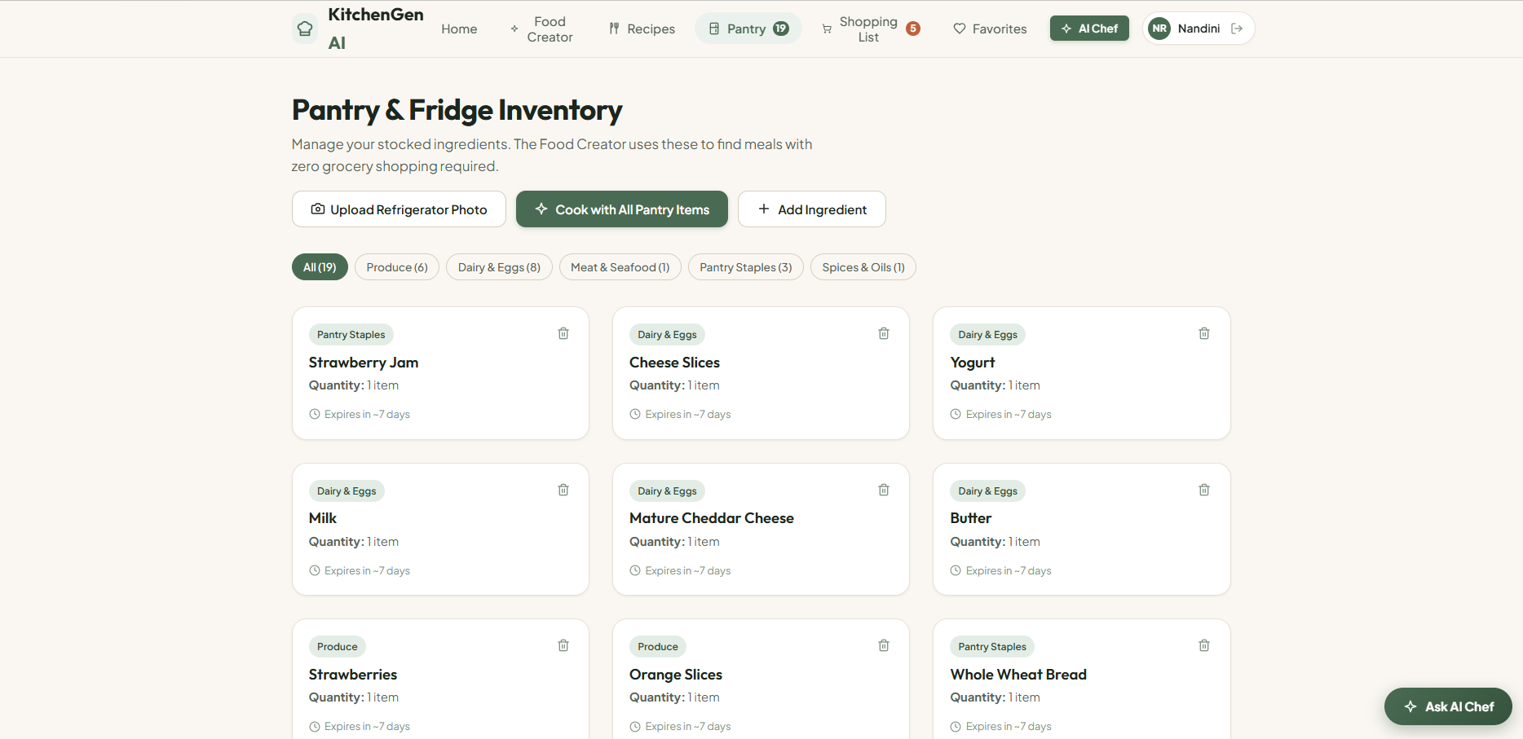
The pantry page allows users to review and update ingredients they currently have. Consistent ingredient naming helps the recipe matcher recognize pantry items. Expiry-date or use-soon prioritization should be described as available only if those fields and behaviors have been implemented.

8. Shopping List Page
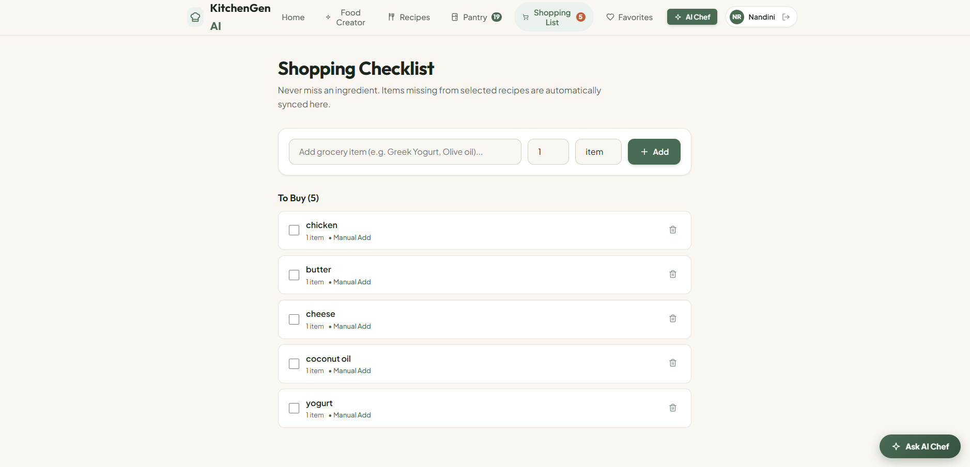
The shopping-list page collects ingredients missing from selected recipes. Users should be able to review and manage items, and duplicate ingredients should be consolidated where practical. The list should remain associated with the correct user account when authentication is enabled.

9. Favorites Page
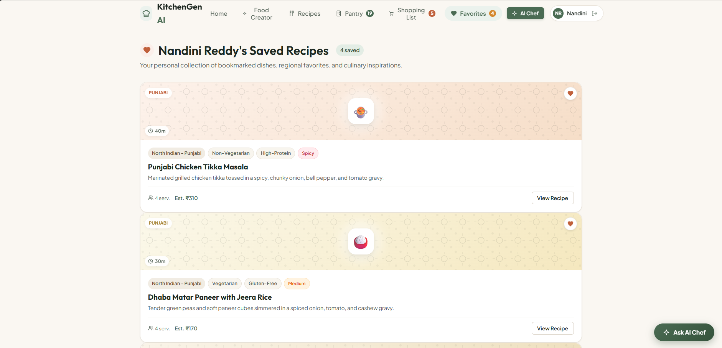
The favorites page provides a place to revisit saved recipes. Favorite actions should persist in the backend or the project's selected storage mechanism and should not leak between different users.

10. Ask AI Chef / AI Assistance

An AI assistant can help answer cooking questions, suggest substitutions, or adapt recipe ideas. If this feature uses Gemini, the backend must make the provider request securely and handle missing keys, API errors, and invalid responses. If it is not yet connected, present it as a planned or disabled feature rather than implying that AI generation is working.

Conclusion
KitchenGen AI aims to make everyday meal planning easier by helping users turn available ingredients into practical recipe options. The application combines recipe discovery with ingredient matching, meal categories, preparation-time and budget filters, pantry awareness, and shopping-list support. A reliable implementation depends on accurate recipe metadata and images, sensible limits on suggested recipes, responsive frontend behavior, robust FastAPI endpoints, and secure account handling. Gemini can provide an additional layer of AI-assisted recipe creation after it is integrated and tested.
Continued testing and incremental development will help make KitchenGen AI more useful, consistent, and ready for deployment. By bringing recipe discovery, ingredient management, and meal planning together in one platform, the system has the potential to reduce the time and effort required to decide what to cook. It can also help users make better use of ingredients already available at home, identify missing items before shopping, and plan meals according to their preferences, available time, and budget.
Future enhancements may include improved ingredient recognition from uploaded fridge images, more personalized recipe recommendations, regional Indian cuisine expansion, nutritional information, and smarter food-waste reduction suggestions. With further improvements in usability, accuracy, security, and AI integration, KitchenGen AI can evolve into a practical kitchen companion that supports convenient, efficient, and more organized everyday cooking.

