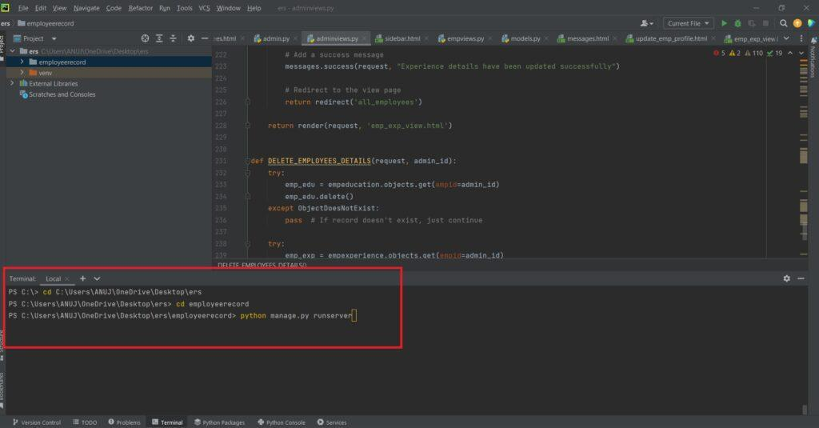

**Login Details:**

**\*\*\*\*\*Employee\*\*\*\*\***

**Username:** asdfg

**Password:** root

Or Register a New Employee.