### BookNest : Where Stories Nestle

**Using MERN stack**

**Project Documentation**

# Project Title: BookNest: Where Stories Nestle

**Team ID:** LTVIP2025TMID20320

**Team Size:** 4

**Team Leader:** Koppula Gowri Pranaya

**Team member:** Kondapalli Yoga Srivalli

**Team member:** Konatham Nandini

**Team member:** Kollubindu Priya

**Project Overview:**

BookNest is a web-based platform designed for book lovers and authors. It enables users to share, discover, and review books, as well as interact with the community. Authors can publish their works, and readers can follow, comment, and organize their reading experience in a user-friendly environment.

**Feature Description**

| **Feature** | **Description** |
| --- | --- |
| **Authentication** | Users can sign up or log in with roles (reader/author). |
| **Book Publishing** | Authors can upload books with details (title, genre, cover, synopsis, etc.). |
| **Book Browsing & Search** | Users can browse and search for books using filters like genre, author, or popularity. |
| **Review & Ratings** | Readers can write reviews and give star ratings for books. |
| **Reading Lists** | Users can add books to their personal reading lists (e.g., To Read, Currently Reading, Finished). |
| **Comment & Discussion** | Comment section on each book page for discussions. |
| **Admin Panel** | Admin can manage users, reported books/reviews, and platform moderation. |

**Tech Stack**

Layer: Technology

Frontend (future phase): React.js

Backend: Node.js, Express.js

Database: MongoDB

Authentication : JWT

Other Packages: Mongoose, bcryptjs, dotenv, cors, body-parser

**📈 Future Enhancements**

In-App Book Store – Monetize published books (sell eBooks or paperbacks).

Email Notifications – Notify users for comments, reviews, or updates.

Author Dashboard – Analytics on book views, downloads, and reader feedback.

Customizable Bookshelf – Users can customize their personal book display.

Reading Goals & Stats – Track reading habits, yearly goals, and progress.

Mobile-Friendly UI – Progressive Web App (PWA) for mobile users.

# Book-Store

# Introduction:

Introducing the Book Store App – your gateway to a world of literary wonders! Whether you're an avid reader, a casual browser, or someone on the hunt for the perfect gift, our app is designed to cater to all your bookish needs. With a vast collection of books spanning genres, authors, and languages, finding your next great read has never been easier. Explore recommendations, read reviews, and effortlessly purchase or reserve books for pickup at your convenience. Dive into the immersive world of books with the Book Store App – where every page turns into an adventure!

**Description:**

Welcome to the literary haven of the digital age—introducing our revolutionary Book-Store Application, a masterpiece crafted with precision using the powerful MERN (MongoDB, Express.js, React, Node.js) Stack. Immerse yourself in a world where the love for reading converges seamlessly with cutting-edge technology, redefining the way bibliophiles explore, discover, and indulge in their literary pursuits.

Tailored for the modern book enthusiast, our MERN-based Book-Store Application seamlessly blends robust functionality with an intuitive user interface. From the joy of discovering new releases to the nostalgia of revisiting timeless classics, our platform promises an immersive reading experience customized to cater to your literary preferences.

Fueling the backbone of our application is MongoDB, ensuring a scalable and efficient database infrastructure that facilitates swift access to an extensive collection of literary works. Express.js, with its streamlined web application framework, establishes a responsive and efficient server, while Node.js ensures high-performance, non-blocking I/O operations—resulting in a seamless and enjoyable user experience.

At the heart of our Book-Store Application lies React, a dynamic and feature-rich JavaScript library. Dive into a visually enchanting and interactive interface where every click, search, and book selection feels like a literary journey. Whether you're exploring on a desktop, tablet, or smartphone, our responsive design ensures a consistent and delightful experience across all devices.

Say farewell to the constraints of traditional bookstores and embrace a new era of possibilities with our MERN Stack Book-Store Application. Join us as we transform how you connect with literature, making the discovery of your next favorite read an effortless and enriching experience. Get ready to turn the digital pages of a new chapter in reading, where every book is just a click away, and the literary world is at your fingertips. It's time to open the door to a future where the love for books meets the convenience of modern technology.

**Scenario Based Case Study:**

Sarah is an avid reader with a passion for exploring new genres and authors. However, her busy schedule often leaves her with limited time to visit physical bookstores. Sarah is looking for a solution that allows her to discover and purchase books conveniently, without compromising her reading preferences or the joy of browsing through a bookstore.

**User Registration and Authentication:** Allow users to register accounts securely, log in, and authenticate their identity to access the book store platform.

**Book Listings:** Display a comprehensive list of available books with details such as title, author, genre, description, price, and availability status.

**Book Selection:** Provide users with options to select their preferred books based on factors like genre, author, ratings, and popularity.

**Purchase Process:** Allow users to add books to their cart, specify quantities, and complete purchases securely. Upon successful completion, an order is generated, and the inventory is updated accordingly.

**Order Confirmation:** Provide users with a confirmation page or notification containing details of their order, including book information, total price, and order ID.

**Order History:** Allow users to view their past and current orders, providing options to track shipments, review purchased books, and rate their shopping experience.

# Technical Architecture:

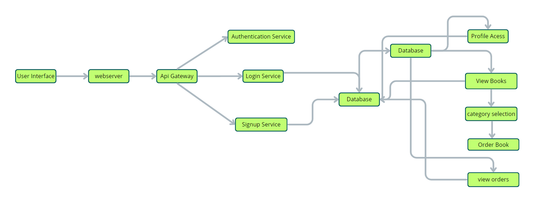

User Interface: The user interface will serve as the platform where customers can browse books, search for specific titles or authors, read book descriptions, and make purchases. It should be intuitive and user-friendly, enabling easy navigation and exploration of available books.

Web Server: The web server hosts the user interface of the book store app, serving dynamic web pages to users and ensuring a seamless browsing and shopping experience.

API Gateway: Similar to the original architecture, the API gateway will serve as the central entry point for client requests, directing them to the relevant services within the system. It will handle requests such as fetching book information, processing orders, and managing user accounts.

Authentication Service: The authentication service manages user authentication and authorization, ensuring secure access to the book store app and protecting sensitive user information during the browsing and purchasing process.

Database: The database stores persistent data related to books, including information such as titles, authors, genres, descriptions, prices, and availability. It also stores user profiles, purchase history, and other essential entities crucial to the book store app.

View Books: This feature allows users to browse through the available books. They can explore different categories and genres to discover books of interest.

Category Selection: Users can select specific categories or genres to filter and refine their book browsing experience, making it easier to find books tailored to their preferences.

Inventory Management Service: This service manages information about available books, including their availability, stock levels, and ratings. It ensures efficient management of the book inventory and seamless integration with the browsing and purchasing process.

Order Management Service: This service facilitates the ordering process, allowing users to add books to their cart, specify quantities, and complete purchases securely. It also handles order tracking and status updates in real-time.

**ER-Diagram:**

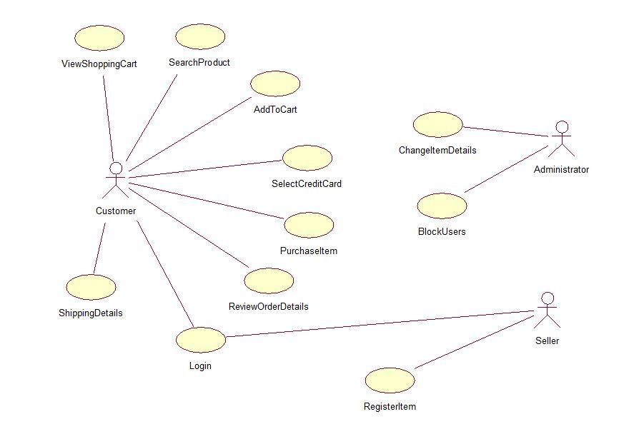

**User-Book Relationship:**

Type: Many-to-Many (M:M). A single user can read or interact with many books, and a single book can be accessed by many users.

Implementation: Introduce an intermediate entity, "Interaction", with foreign keys to both User and Book tables. This table could store additional information like reading progress, reviews, or ratings.

**Book-Inventory Relationship:**

Type: One-to-Many (1:M). Each book can have multiple copies in inventory, but each copy belongs to one book.

Implementation: Maintain a separate Inventory table with fields like BookID (foreign key), quantity, location, and condition.

**User-Order Relationship:**

Type: One-to-Many (1:M). A single user can place multiple orders, but each order belongs to one user.Implementation: Keep the UserID foreign key in the Order table to track user purchase history.

**Additional Relationships:**

Book-Author Relationship: Many-to-Many (M:M). A book can have multiple authors, and an author can write multiple books. (Similar to User-Book, use an intermediate "WrittenBy" table)

Book-Genre Relationship: Many-to-Many (M:M). A book can belong to multiple genres, and a genre can have many books. (Similar to User-Book, use an intermediate "CategorizedAs" table)

Review-User Relationship: Many-to-One (M:1). A review is written by one user, but a user can write many reviews. (Keep UserID as a foreign key in the Review table)

**Key Features:**

**User Registration and Authentication:** Allow users to register accounts securely, log in, and authenticate their identity to access the book store platform.

**Book Listings:** Display a comprehensive list of available books with details such as title, author, genre, description, price, and availability status.

**Book Selection:** Provide users with options to select their preferred books based on factors like genre, author, ratings, and popularity.

**Purchase Process:** Allow users to add books to their cart, specify quantities, and complete purchases securely. Upon successful completion, an order is generated, and the inventory is updated accordingly.

**Order Confirmation:** Provide users with a confirmation page or notification containing details of their order, including book information, total price, and order ID.

**Order History:** Allow users to view their past and current orders, providing options to track shipments, review purchased books, and rate their shopping experience.

**Organizer Dashboard:** Offer administrators an interface to manage book listings, inventory levels, user accounts, orders, and other platform-related activities.

**Create Item:** Organizer can create items and add new items and he can get the items and he can update items.

**Admin Dashboard:** Offer administrators an interface to manage book listings, inventory levels, user accounts, orders, and other platform-related activities. Manage the users and organizers.

**Reporting and Analytics:** Generate reports and analytics on book sales, popular genres, user demographics, and other relevant metrics to gain insights into platform usage and performance.

**Integration with External APIs:** Integrate with third-party APIs for services like payment processing, shipping logistics, and book recommendations to enhance the functionality and user experience of the book store platform.

## PRE REQUISITES:

To develop a full-stack Book Store App using React js, Node.js,Express js and MongoDB, there are several prerequisites you should consider. Here are the key prerequisites for developing such an application:

**Node.js and npm:** Install Node.js, which includes npm (Node Package Manager), on your development machine. Node.js is required to run JavaScript on the server side.

• Download: <https://nodejs.org/en/download/>

• Installation instructions:<https://nodejs.org/en/download/package-manager/>

**MongoDB:** Set up a MongoDB database to store hotel and booking information. Install MongoDB locally or use a cloud-based MongoDB service.

• Download:<https://www.mongodb.com/try/download/community>

• Installation instructions:<https://docs.mongodb.com/manual/installation/>

**Express.js:** Express.js is a web application framework for Node.js. Install Express.js to handle server-side routing, middleware, and API development.

• Installation: Open your command prompt or terminal and run the following

command: **npm install express**

**React js: React** is a JavaScript library for building client-side applications.

And Creating Single Page Web-Appliaction

**Getting Started**

Create React App is an officially supported way to create single-page React applications. It offers a modern build setup with no configuration.

**Quik Start**

npm create vite@latest

cd my-app

npm install

npm run dev

If you've previously installed create-react-app globally via npm install -g create-react-app, we recommend you uninstall the package using npm uninstall -g create-react-app or yarn global remove create-react-app to ensure that npx always uses the latest version.

**Create a new React project:**

• Choose or create a directory where you want to set up your React project.

• Open your terminal or command prompt.

• Navigate to the selected directory using the cd command.

• Create a new React project by running the following command: npx create-react-app your-app-name.Wait for the project to be created:

• This command will generate the basic project structure and install the necessary dependencies

**Navigate into the project directory:**

• After the project creation is complete, navigate into the project directory by running the following command**: cd your-app-name**

**Start the development server:**

• To launch the development server and see your React app in the browser, run the following command:  **npm run dev**

• The npm start will compile your app and start the development server.

• Open your web browser and navigate to <https://localhost:5173> to see your React app.

You have successfully set up React on your machine and created a new React project. You can now start building your app by modifying the generated project files in the src directory.

Please note that these instructions provide a basic setup for React. You can explore more ad- vanced configurations and features by referring to the official React documentation: <https://react.dev/>

**HTML, CSS, and JavaScript:** Basic knowledge of HTML for creating the structure of your app, CSS for styling, and JavaScript for client-side interactivity is essential.

**Database Connectivity:** Use a MongoDB driver or an Object-Document Mapping (ODM) library like Mongoose to connect your Node.js server with the MongoDB database and perform CRUD (Create, Read, Update, Delete) operations.

**Front-end Library:** Utilize React to build the user-facing part of the application, including products listings, booking forms, and user interfaces for the admin dashboard.

**Version Control**: Use Git for version control, enabling collaboration and tracking changes throughout the development process. Platforms like GitHub or Bitbucket can host your repository.

• Git: Download and installation instructions can be found at:<https://git-scm.com/downloads>

**Development Environment:** Choose a code editor or Integrated Development Environment (IDE) that suits your preferences, such as Visual Studio Code, Sublime Text, or WebStorm.

• Visual Studio Code: Download from <https://code.visualstudio.com/download>

• Sublime Text: Download from

<https://www.sublimetext.com/download>

• WebStorm: Download from <https://www.jetbrains.com/webstorm/download>

**Roles and Responsibility**

**User:**

• Registration: Users are responsible for registering an account on the BookEase book store app by providing essential details such as name, email, and password.

• Profile Management: Users have the capability to manage their profiles, allowing them to update information like email, name, and password.

• Book Browsing: Users can browse through the available books, explore different genres, and search for specific titles or authors.

• Purchase: Users can add books to their cart, specify quantities, and complete purchases securely.

• Feedback: Provide feedback and ratings for purchased books and sellers on the BookEase platform.

• Logout: Lastly, they can logout from the BookEase book store app.

**Seller:**

• Registration: Sellers register an account on the BookEase book store app by providing necessary details such as business name, email, and password.

• Profile Management: Sellers have the capability to manage their profiles, allowing them to update information like email, business name, and password.

• Book Listing: Sellers can add new books to the platform, including details such as title, author, genre, description, price, and quantity available.

• Inventory Management: Sellers can manage their book inventory, updating stock levels, removing inactive listings, and handling book ratings.

• Order Fulfillment: Sellers are responsible for fulfilling orders placed by users, including packaging and shipping books in a timely manner.

• Logout: Finally, they can logout from the BookEase book store app.

**Admin:**

• System Management: Admins have full control over all aspects of the book store system, overseeing functionalities, configurations, and security.

• User Management: Admins can manage user information, including creating, updating, and deleting accounts. They also have authority over user ratings.

• Book Management: Admins can manage book listings, including adding new books, updating details, and removing inactive listings from the platform.

• Seller Management: Admins have the authority to manage seller information, including approving new seller accounts, updating profiles, and handling seller ratings.

• Logout: Finally, they can logout from the BookEase book store app.

This adaptation aligns user, seller, and admin functionalities with those of a book store app, emphasizing actions and terminology relevant to book browsing, purchasing, and selling.

**User Flow:**

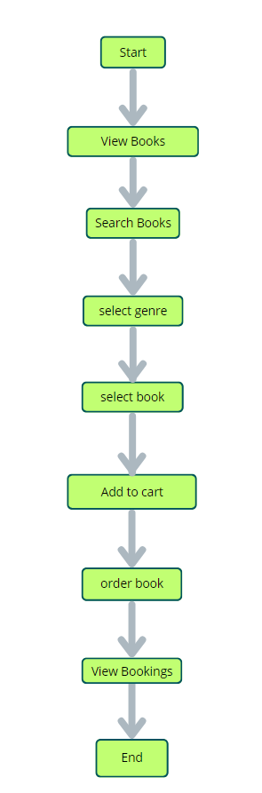

Start: Users open the BookEase app to explore a vast collection of books.

Home Page: Users land on the home page, which provides an overview of the book store's offerings. From here, they can navigate to various sections of the app.

Access Profile: Users have the option to access their profiles, allowing them to view or update personal information, preferences, and order history.

Book Selection: After accessing their profiles, users proceed to browse and select books to purchase. The app presents a list of available books, along with details such as title, author, genre, and price.

Book Purchase: Users navigate through the available book options and specify the quantity of each book they wish to purchase. They can also choose additional options such as e-book format or special editions.

View Orders: Users have the option to view their current and past orders. This section provides details about ordered books, order status, and payment history.

Order Confirmation: For new purchases, users can initiate the ordering process. This involves selecting books, specifying quantities, confirming the order, and receiving an order confirmation.

End: The flow concludes as users have completed their desired actions within the BookEase app.

**Project Structure:-**

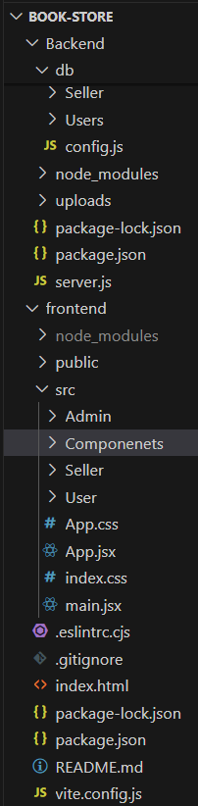

**PROJECT FLOW:-**

Before starting to work on this project, let’s see the demo.

Demo link:-

<https://drive.google.com/file/d/14zsjfT65GYyZdnw2v5StoNeRn5bApsxa/view?usp=drive_link>

Use the code in:-

[code](https://drive.google.com/drive/folders/1kC_gVVwZlHaZ6VuGvs71-4ynQXmiC2Kh)

or follow the videos below for better understanding.

**Milestone 1: Project Setup and Configuration:**

**1. Install required tools and software:**

* Node.js.
* MongoDB.
* Create-react-app.

**2. Create project folders and files:**

* Client folders.
* Server folders.

**3. Install Packages:**

**Frontend npm Packages**

* Axios.
* React-Router –dom.
* Bootstrap.
* React-Bootstrap.

**Backend npm Packages**

* Express.
* Mongoose.
* Cors.

**Milestone 2: Backend Development:**

* **Setup express server**

1. Create index.js file in the server (backend folder).
2. Create a .env file and define port number to access it globally.
3. Configure the server by adding cors, body-parser.

* **User Authentication:**
  + Create routes and middleware for user registration, login, and logout.
  + Set up authentication middleware to protect routes that require user authentication.
* **Define API Routes:**
  + Create separate route files for different API functionalities such as users orders, and authentication.
  + Define the necessary routes for listing products, handling user registration and  login,managing orders, etc.
  + Implement route handlers using Express.js to handle requests and interact with the database.
* **Implement Data Models:**
  + Define Mongoose schemas for the different data entities like products, users,  and orders.
  + Create corresponding Mongoose models to interact with the MongoDB database.
  + Implement CRUD operations (Create, Read, Update, Delete) for each model to perform database operations.
* **User Authentication:**
  + Create routes and middleware for user registration, login, and logout.
  + Set up authentication middleware to protect routes that require user authentication.
* **Error Handling:**

• Implement error handling middleware to catch and handle any errors that occur during the API requests.

• Return appropriate error responses with relevant error messages and HTTP status codes.

**Milestone 3: Database:**

**1. Configure MongoDB:**

* Install Mongoose.
* Create database connection.
* Create Schemas & Models.

**2. Connect database to backend:**

Now, make sure the database is connected before performing any of the actions through the backend. The connection code looks similar to the one provided below.

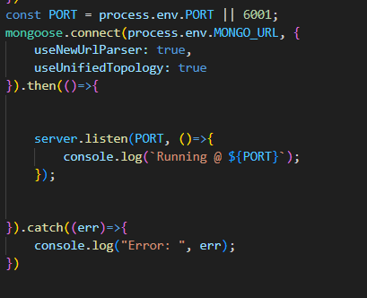

**3. Configure Schema:**

Firstly, configure the Schemas for MongoDB database, to store the data in such pattern. Use the data from the ER diagrams to create the schemas.

The Schemas for this application look alike to the one provided below.

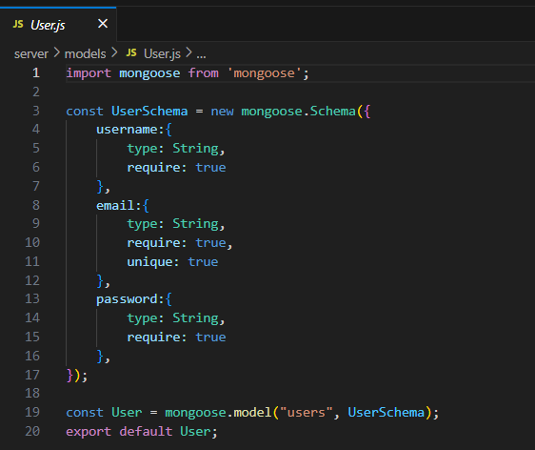

**Milestone 4: Frontend Development:**

**1. Setup React Application:**

• Create React application.

• Configure Routing.

• Install required libraries.

**2. Design UI components:**

• Create Components.

• Implement layout and styling.

• Add navigation.

**3. Implement frontend logic:**

• Integration with API endpoints.

• Implement data binding.

**Milestone 5: Project Implementation:**

Finally, after finishing coding the projects we run the whole project to test it’s working process and look for bugs. Now, let’s have a final look at the working of our Cab Booking application.

Landing page:-

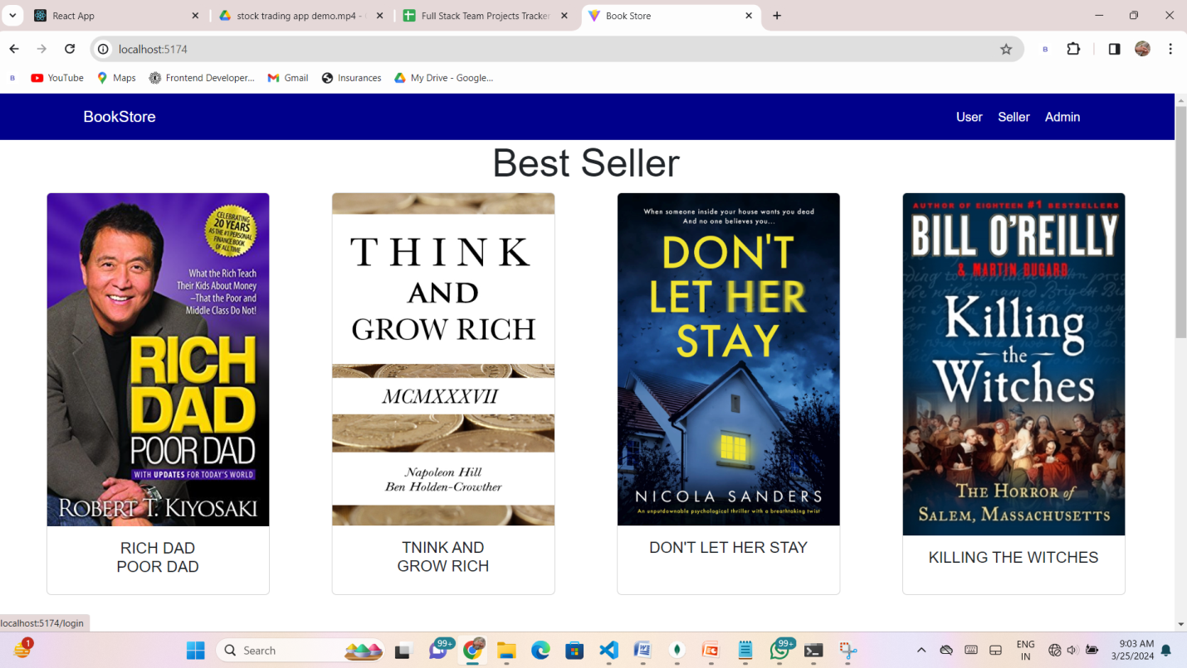

Login Page:-

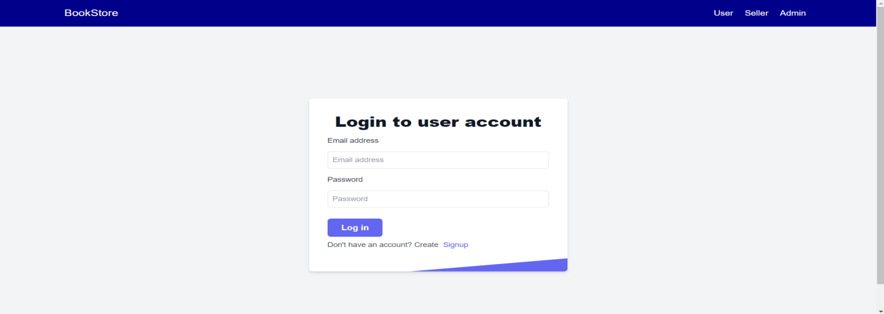

Home Page:-

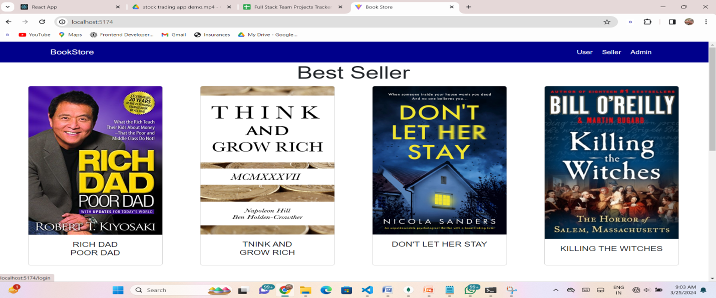

Books Page:-

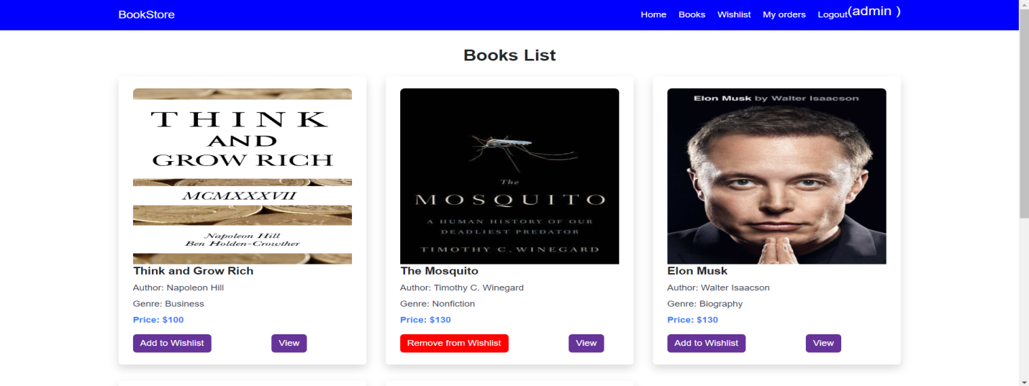

Wishlist Page:-

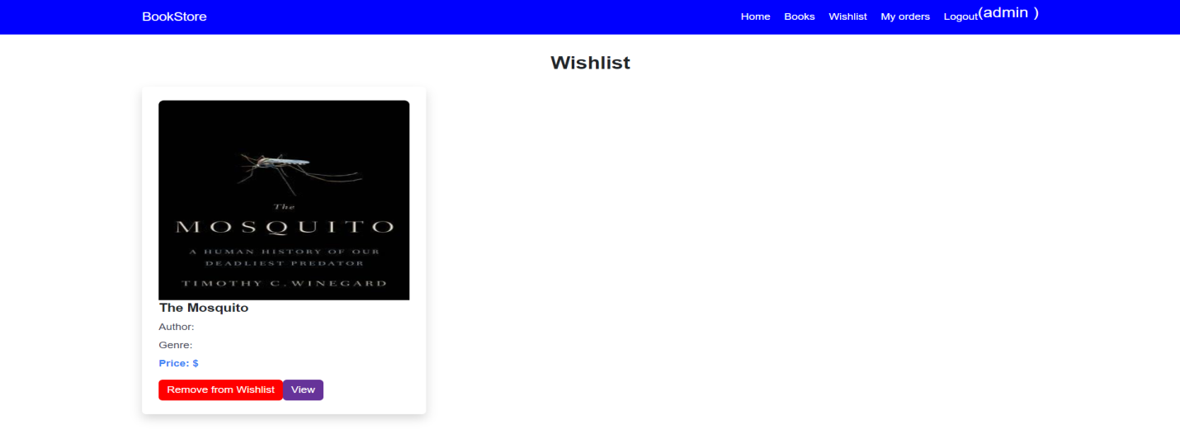

My Bookings Page :-

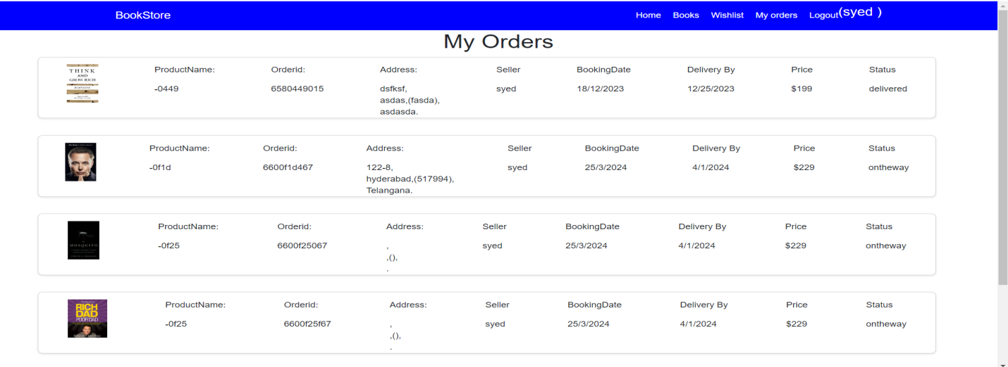

Seller Dashboard:-

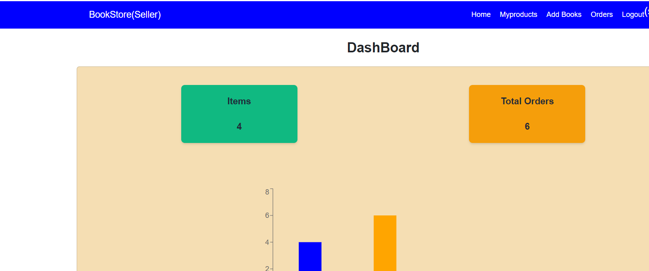

Seller Items:

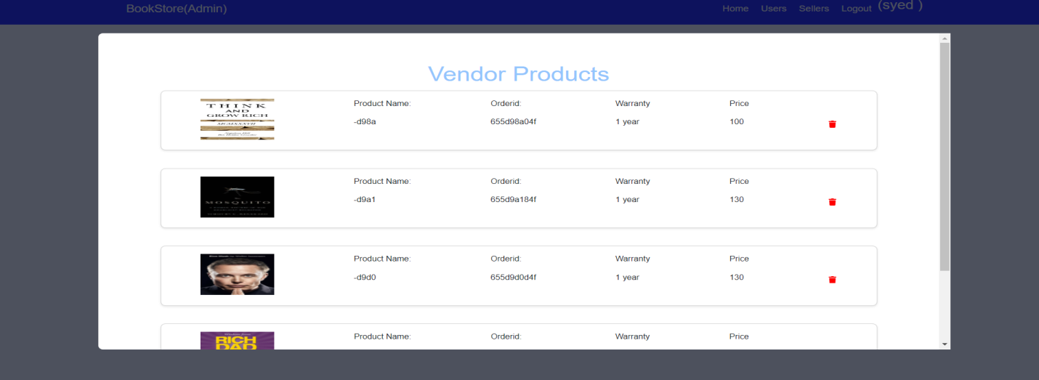

Admin Dashboard:-

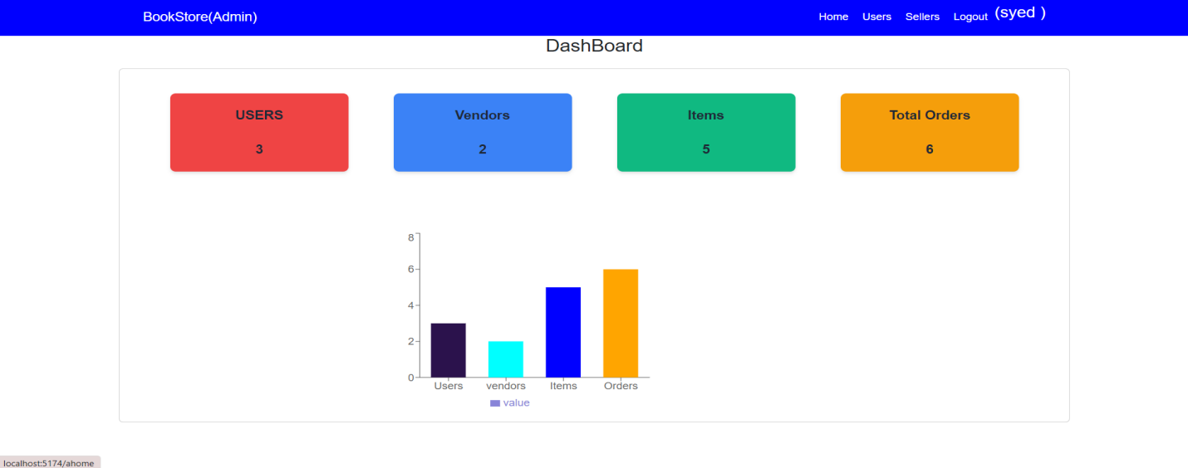

Users Page:

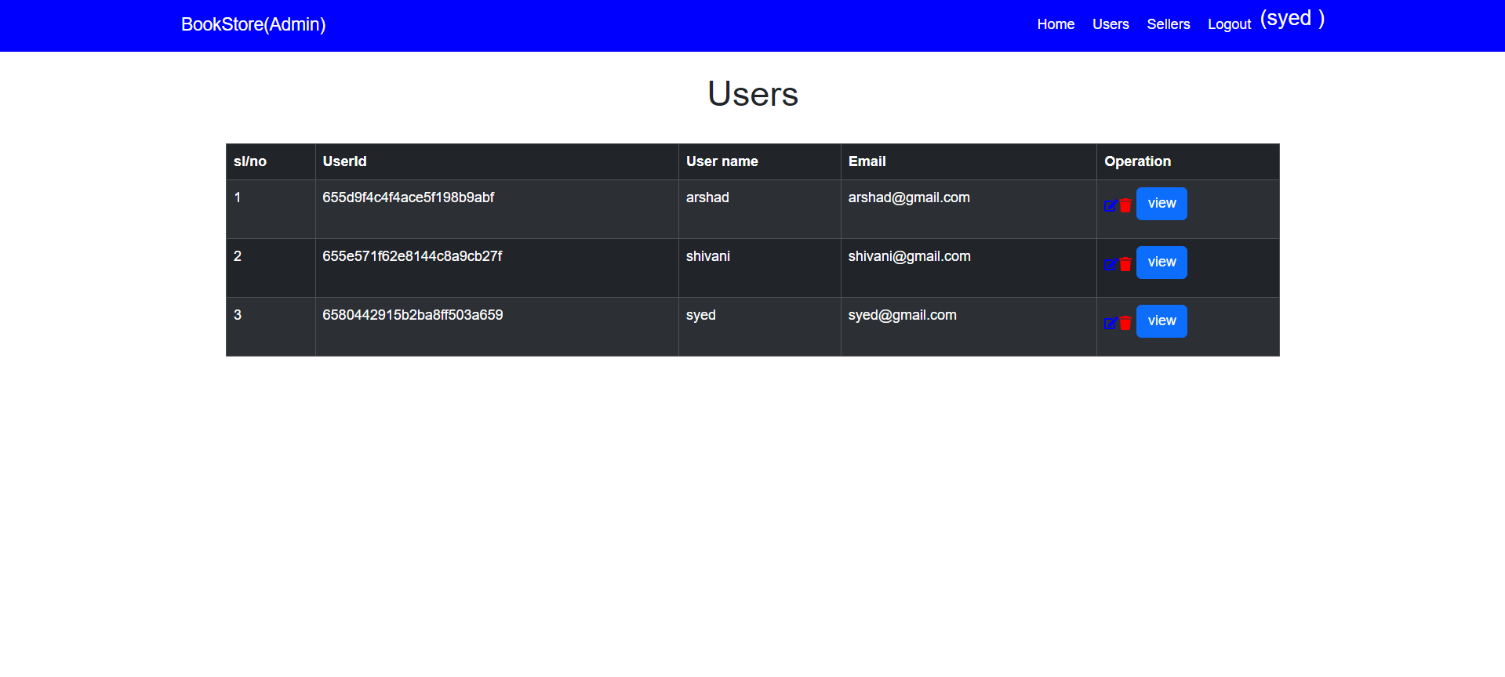

User Orders:

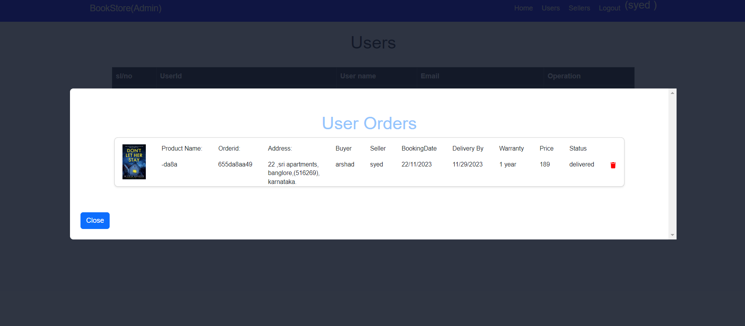

Sellers Page:

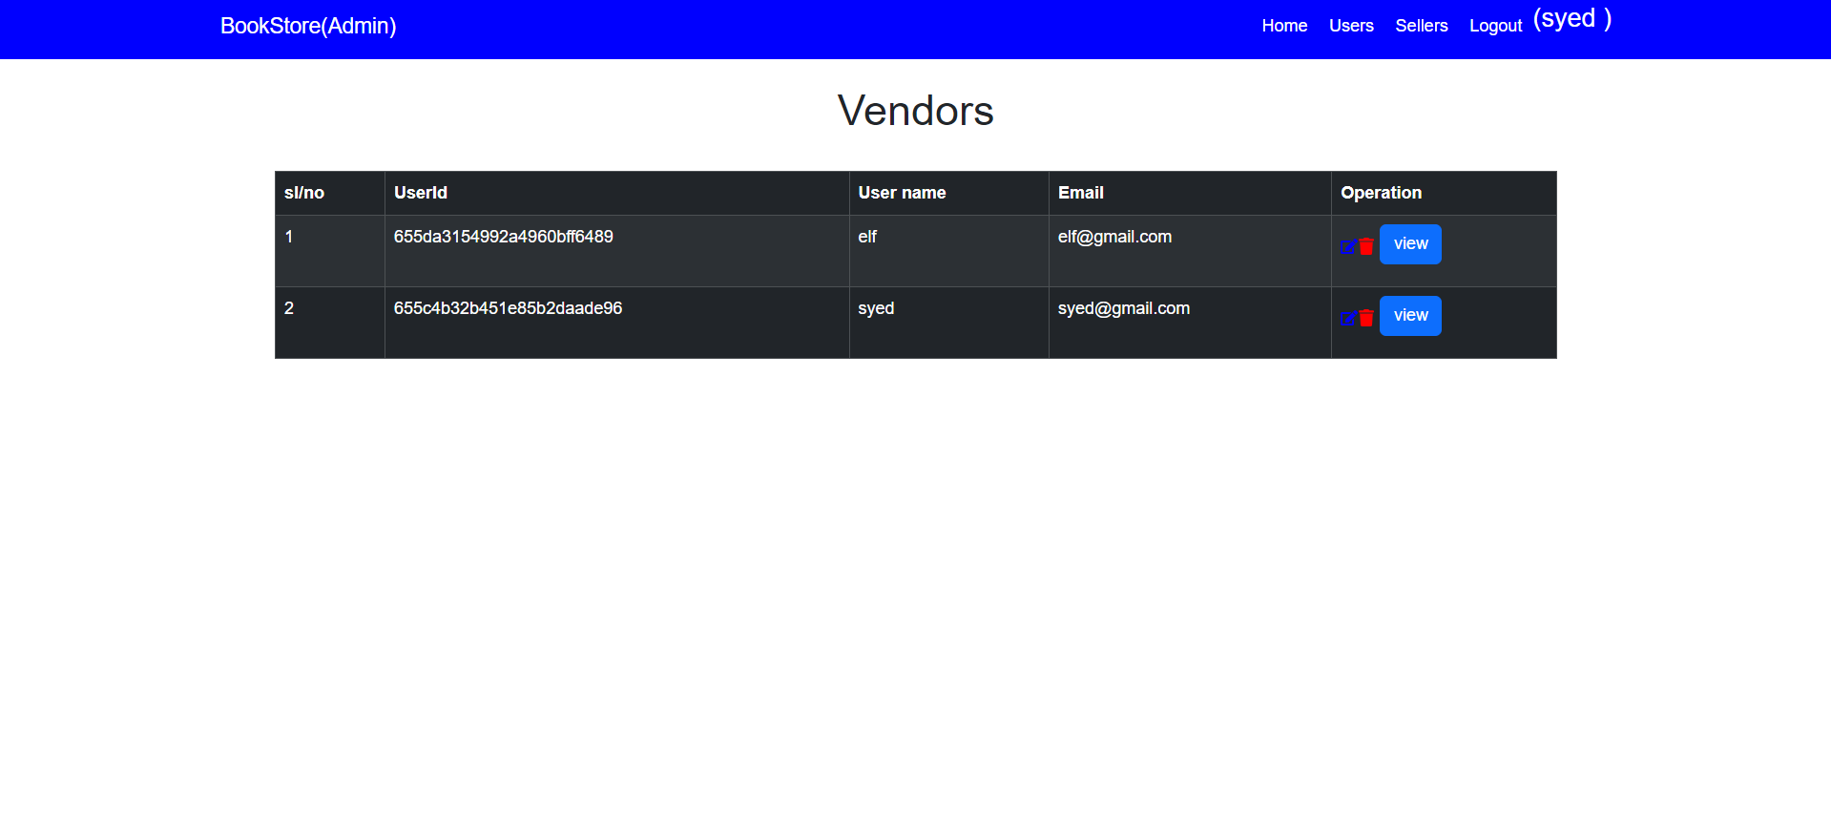

**Conclusion:**

BookNest aims to create a vibrant community where authors and readers connect through stories. By providing a seamless platform to publish, discover, and discuss books, it fosters a love for literature in the digital age. With its scalable architecture and planned enhancements like payment integration, author dashboards, and reading stats, BookNest is set to evolve into a comprehensive social library ecosystem—where stories truly nestle and thrive.