1. Write a java program to find the area of rectangle

import java.util.Scanner;

class AreaOfRectangle

{

public static void main(String[] args)

{

Scanner sc= new Scanner(System.in);

System.out.println("Enter length and breadth of a rectangle");

Float l= sc.nextFloat();

Float b= sc.nextFloat();

System.out.println("Area of a rectangle is " + (l*b));

}

}

}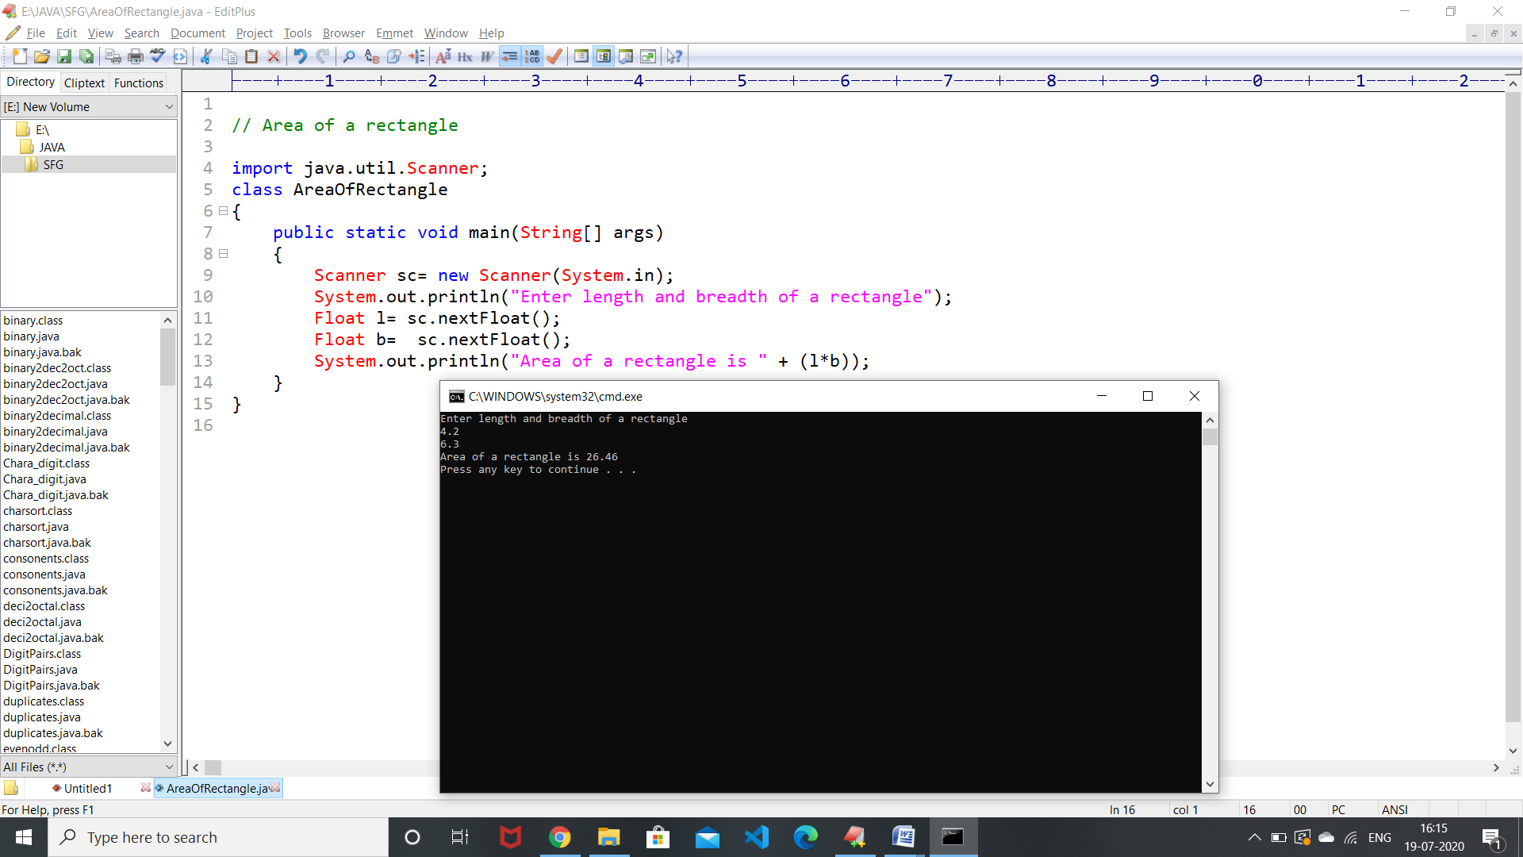

1. Write a java program to check the given no is Armstrong or not(153 is Armstrong no 1*1*1+5*5*5+3*3*3=153)

import java.util.Scanner;

class Java26

{

public static void main(String[] args)

{

Scanner sc =new Scanner(System.in);

System.out.println("enter the number");

int number = sc.nextInt();

int s=0;

int x=number;

while(number>0)

{

int r = number%10;

s = s+(r*r*r);

number = number/10;

}

if(s==x)

{

System.out.println( s +" IS A Armstrong Number");

}

else

{

System.out.println(s +" NOT A Armstrong Number");

}

}

}

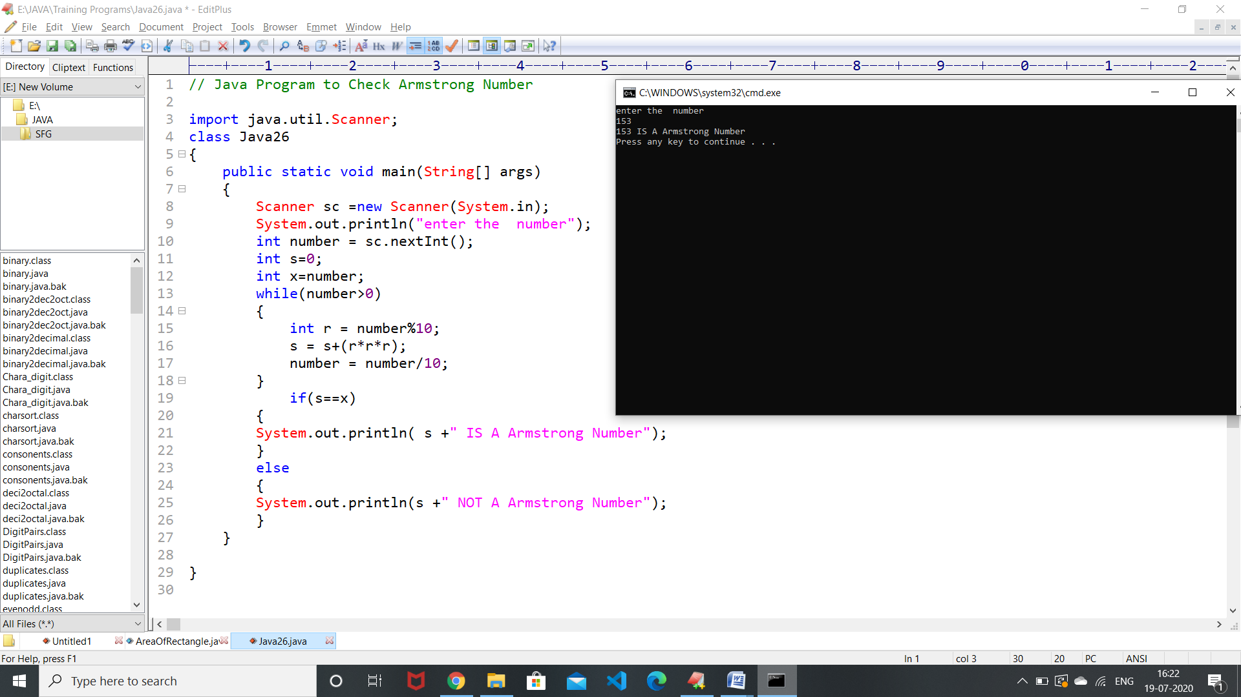

3.Write a java program to check the given no is palindrome or not.

import java.util.Scanner;

class Java22

{

public static void main(String[] args)

{

Scanner sc = new Scanner(System.in);

System.out.println("enter the number");

int number = sc.nextInt();

int s=0;

int x=number;

while(number>0)

{

int r = number%10;

s = (s*10)+r;

number = number/10;

}

if(s==x)

{

System.out.println( s + " Is A Pallindrome Number");

}

else

{

System.out.println(s+ " Is NOT A Pallindrome Number");

}

}

}

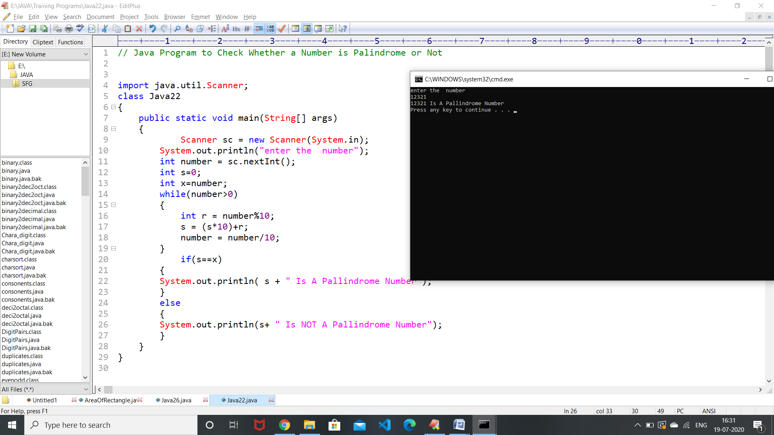

4.Write a java program to generate first N prime numbers.

import java.util.Scanner;

class Java24

{

public static void main(String[] args)

{

Scanner sc = new Scanner(System.in);

System.out.println("enter the number");

int n = sc.nextInt();

System.out.println("Prime numbera are ");

int i=1,j=2;

while(i<=n)

{

int c=0;

for(int k=2 ;k<=j/2 ; k++)

{

if(j%k== 0)

c+=1;

}

if(c>=1)

j+=1;

else if(c==0)

{

System.out.print(j+" ");

i++;

j++;

}

}

}

}

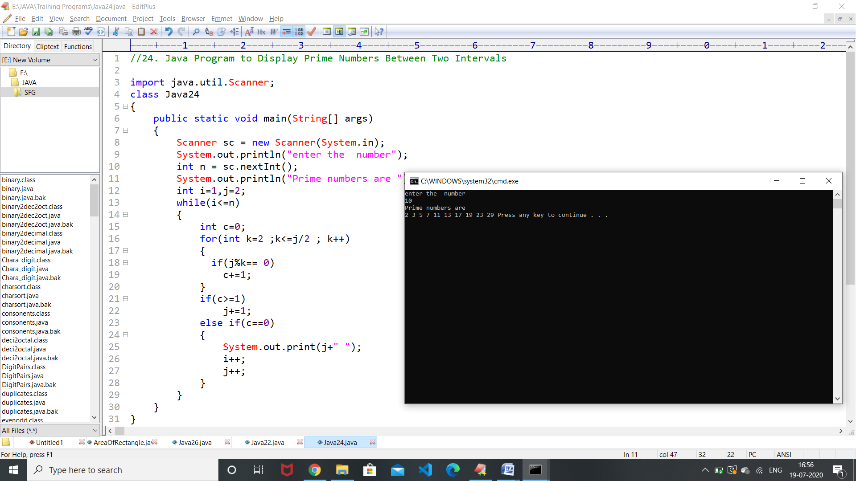

5.Write a java program to print even numbers in between given two numbers.

import java.util.Scanner;

class Java24

{

public static void main(String[] args)

{

Scanner sc = new Scanner(System.in);

System.out.println("enter the number");

int number1 = sc.nextInt();

int number2 = sc.nextInt();

System.out.println("Even numbers are ");

for(int i=number1 ;i<=number2;i++)

{

if(i%2==0)

System.out.print(i + " ");

}

}

}

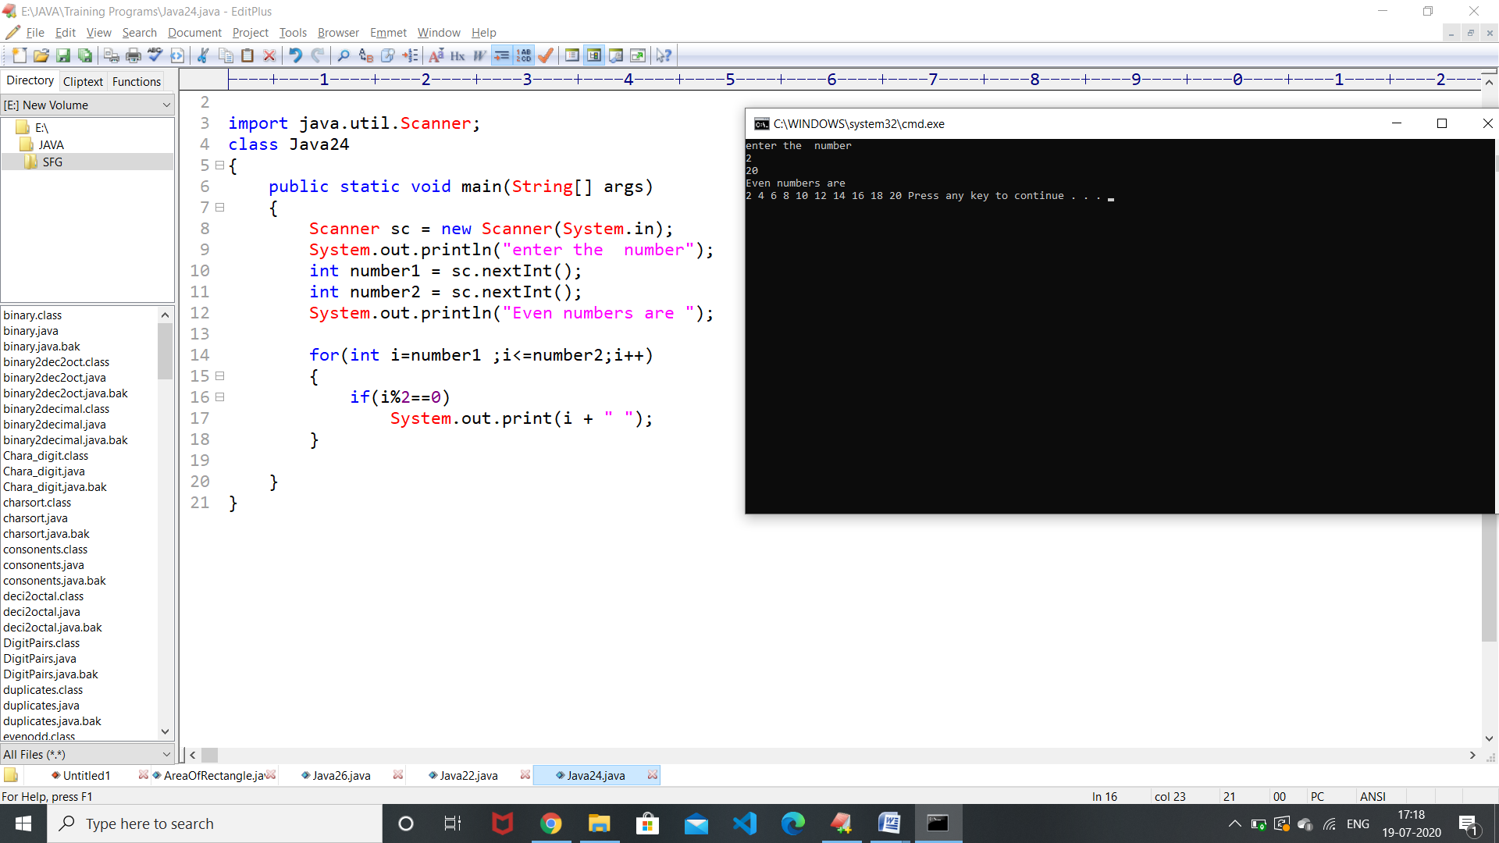

1.What is Abstraction?

**Abstraction** is one of the key concepts of **object-oriented programming** (**OOP**) language.It is about hiding unwanted details while showing the most essential information. Abstraction makes code from longer to small , because it doesn't show unnecessary things.In java, abstraction is achieved by **interfaces** and **abstract** classes.

2. What is Encapsulation?

**Encapsulation** is one of the fundamental concepts in **object-oriented programming (OOP).** It is a process of binding the code and data together into a single unit . Access modifiers are used to facilitate the [**encapsulation**](https://en.wikipedia.org/wiki/Encapsulation_(computer_programming)) of components.**ex:** A class or method to protect inner working of an object from outside world.

3.What is JDK?

The **Java** **Development Kit** (JDK) is one of three core technology packages used in Java programming, along with the JVM and the JRE. **JDK** contains tools **required** to write **Java** programs, it includes a compiler, **Java** application launcher, Appletviewer, etc. Which is used to execute a program.

4.What is JVM?

JVM (**Java Virtual Machine**) is a run time application. It is used to call the main method which is present inside a java program. It also converts a java program into byte code ( .class) file which gives a facility to the program which is called as “Write once execute anywhere”.

5.Define Inheritance.

Inheritance is a concept in JAVA where one class (Child / Derive class) acquires all the properties and behaivours of another class (Parent / Base class).

For inherit the properties of Parent class there is a keyword called as “extends”.

There are three types of Inheritance in JAVA :-

* Single Inheritance
* Multi-level Inheritance
* Hierarchical Inheritance

6.How java achieved platform independence?

The meaning of platform-independent in JAVA is that the byte code (.class ) can run on all operating systems. Different JVM is designed for different **OS** and byte code is able to run on different OS ,That makes it platform Independent.

7.Write the syntax of main function.

Main method of JAVA is entry point of any java program. The syntax for main method is : -

**public static void main(Strings[] args)**

**{**

**// statements;**

**}**

In the place of args we can write any variable.

8.What is conditional operator?

Conditional operator is a ternary operator which is generally used to evaluate a boolean expression.

It is just like if-condition, the only difference is it doesn’t want block.

**Syntax :-**

(condition) ? True : False;

If condition is true it will return left side value and if it is false it will return right side value.

9.How many data types in java?

Actually In java data-types has catogories in two types :

1. **Primitive data type :**

Boolean , int , char , short , byte , long , float , double

1. **Non – Primitive data type :**

String , Array

10.What is constant? How it is declared?

A constant is a variable whose value connot change once it has been assigned.

In Java we don’t have any built-in support for constants, but the variable modifiers static and final can be used to effectively create constant.

**Syntax :-**

* We can declare directly

datatype identifier_name = constant;

* We can declare as static

static datatype identifier_name = constant;

* We can declare as final

final datatype identifier_name = constant;