1. Matrix Addition

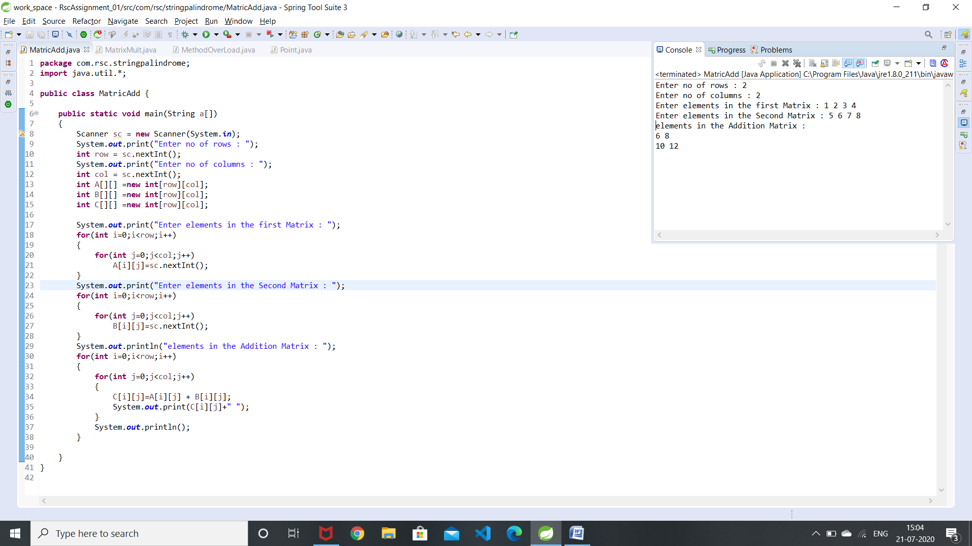

1. Matrix Multiplication

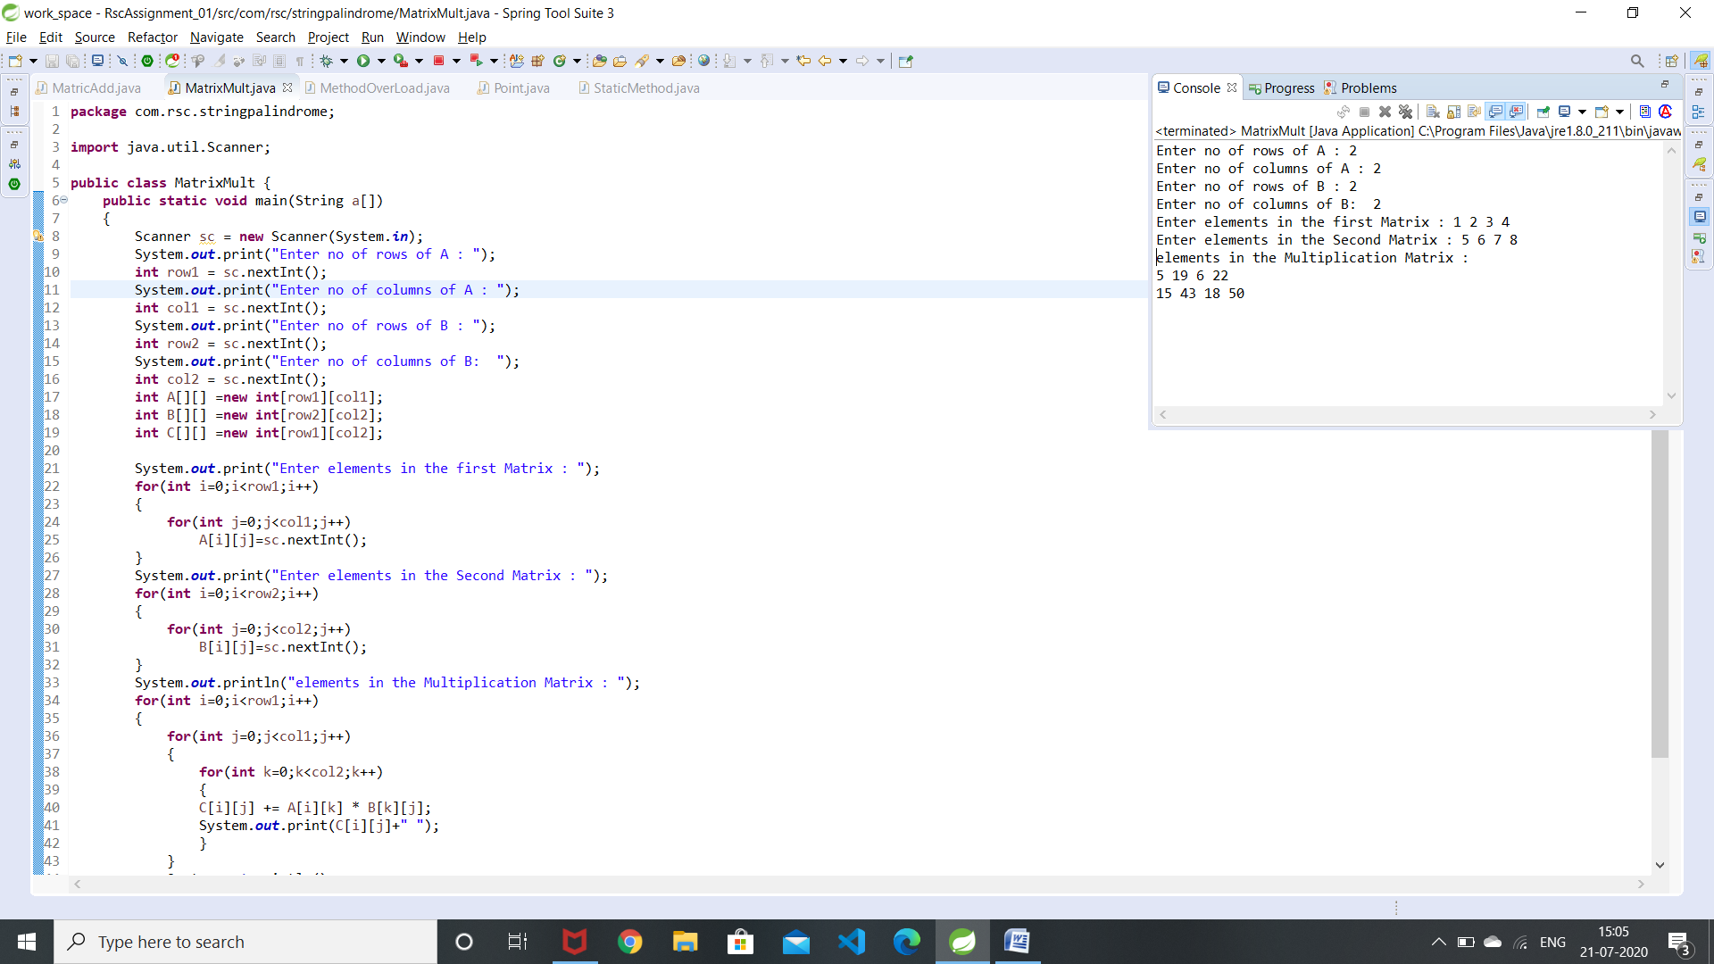

3.Method overloading

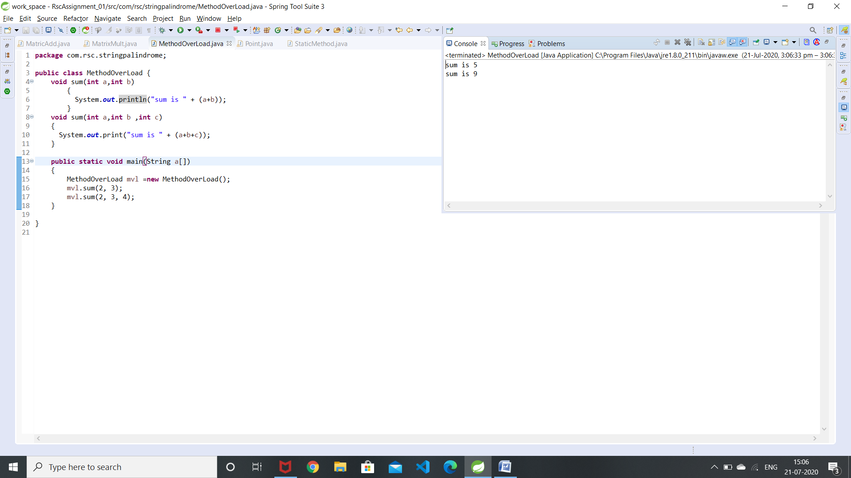

4.To create a class Point with two data members x &y and include all constructors and display.

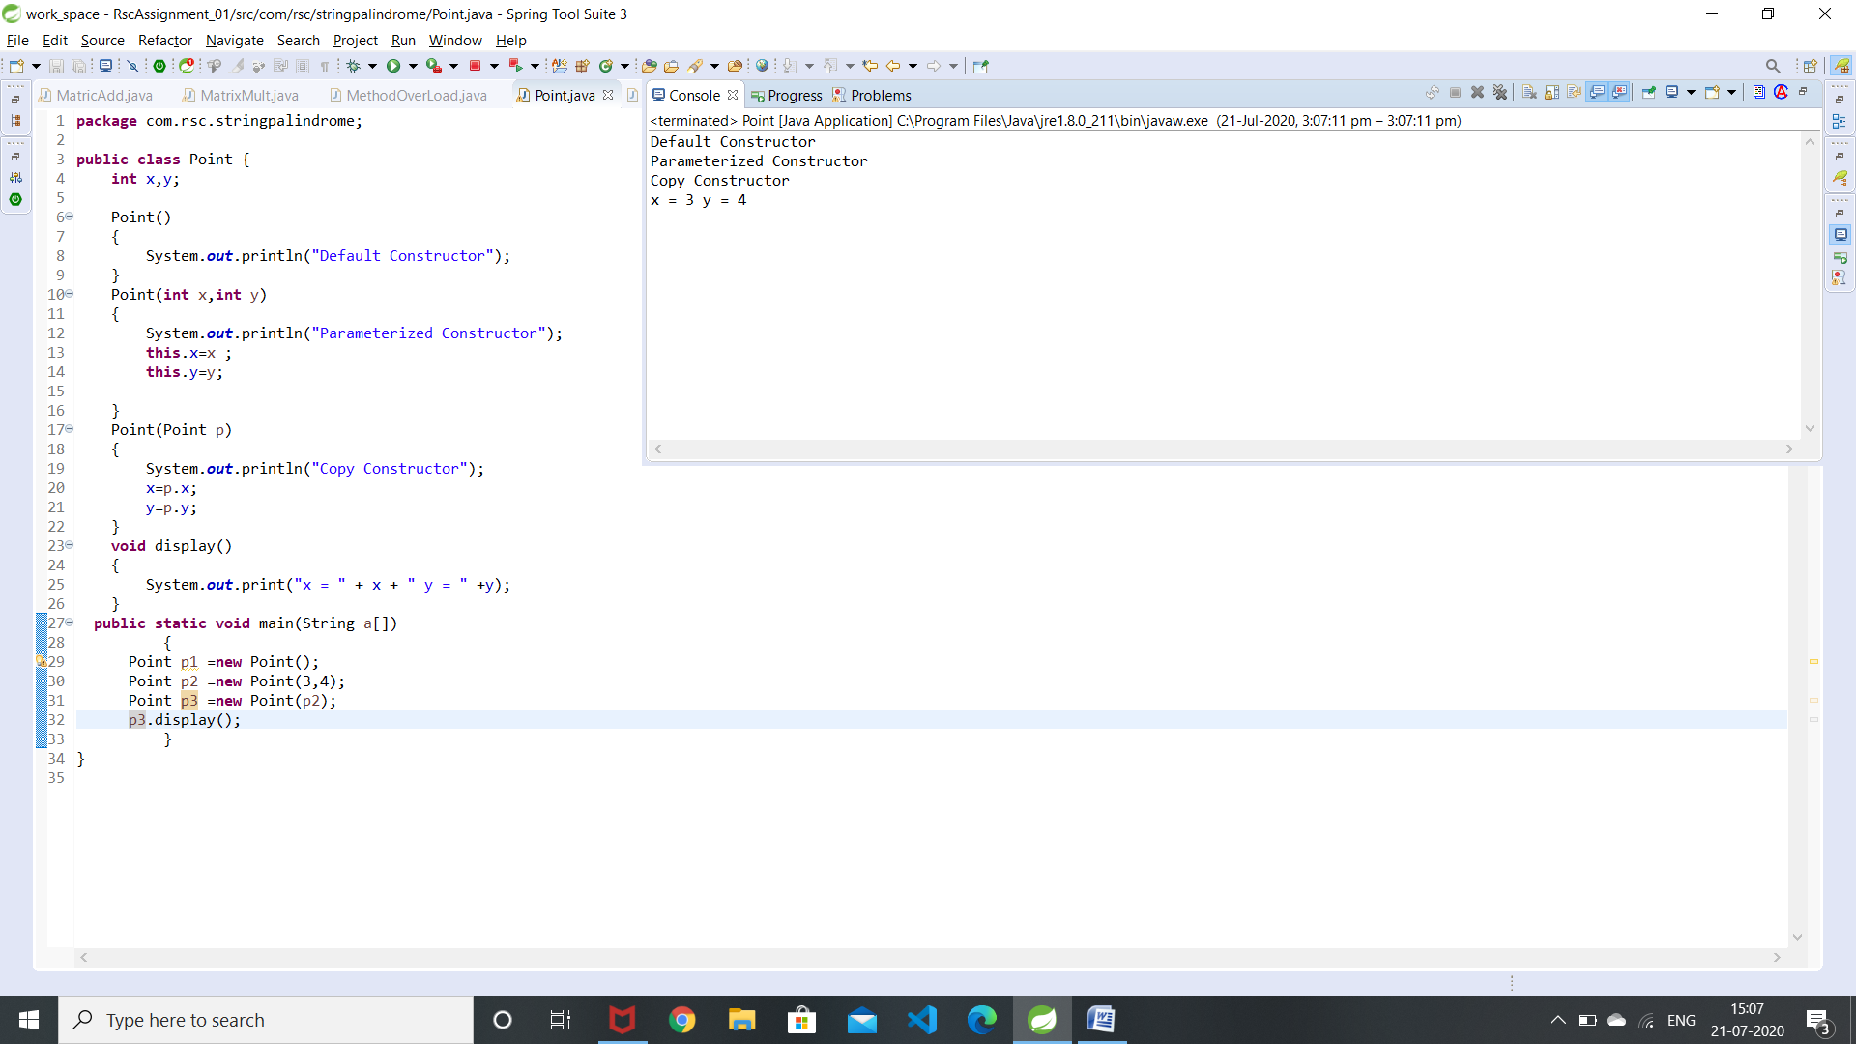

5.Static method

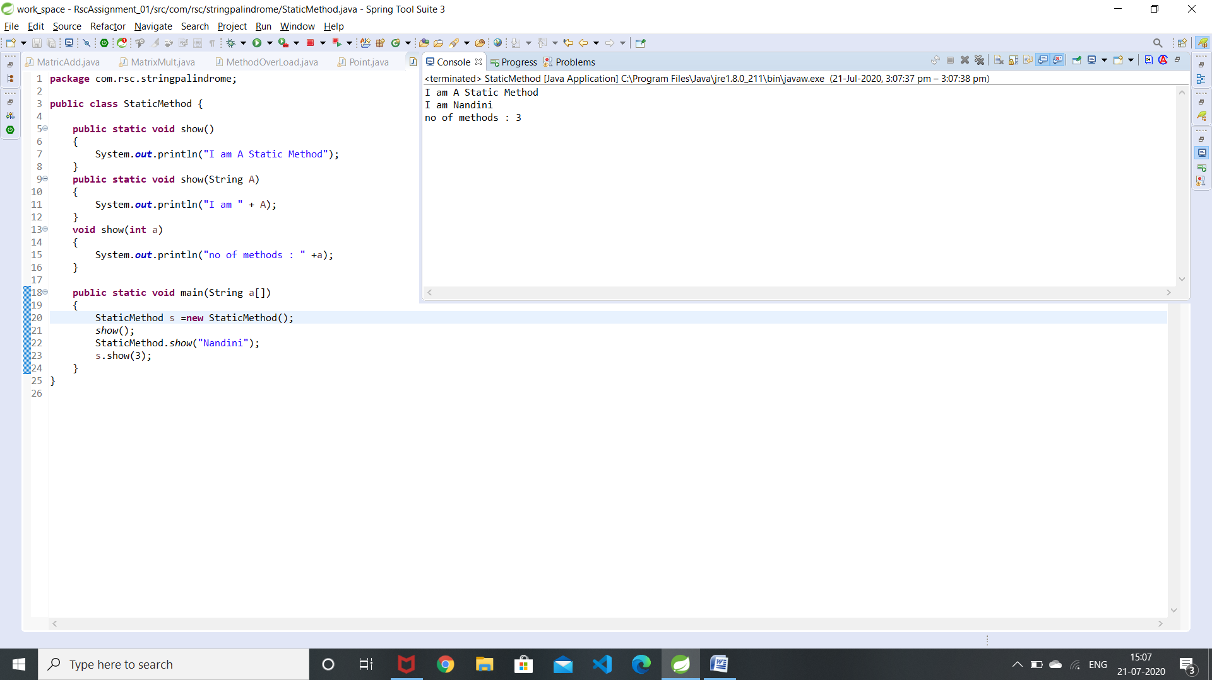

1.what is conditional statement?

**Conditional statements** help you to make a decision based on certain conditions.It is used to decide the flow of execution based on different conditions. If a condition is true, you can perform one action and if the condition is false, you can perform another action.

2.write the syntax of switch case statement?

switch( expression ) {

case value-1: Block-1;

Break;

case value-2: Block-2;

Break;

case value-n: Block-n;

Break; default: Block-1;

Break;

} Statement-x;

3.what is the difference between break and continue statement?

Both the **statements continue** and **break** works within a loop. The main **difference between** them is that **continue statement** escapes the remaining **statements** inside loop and moves to next iteration while **break statement** causes the flow to exit the loop.

4.what is looping Statement?

**Looping Statements** in programming languages is a feature which facilitates the execution of a set of instructions/functions repeatedly until a particular condition is satisfied.

5. what is the difference between while and do while statement?

**While loop** executes the code block only if the condition is True.

In **Do While loop**, the condition is tested at the end **of** the **loop**. So, the **Do While** executes the **statements in the** code block at least once even if the condition Fails.

6.what is array ? how it is created?

An **array** is a container object that holds a fixed number of values of a single type. The length of an **array** is established when the **array** is created. After creation, its length is fixed.

To create an array in Java, you use three steps:

1. Declare a variable to hold the array.
2. Create a new array object and assign it to the array variable.
3. Store things in that array.

int Variable_name[];

Variable_name = new int[size];

String s[] = new String[n];

7.What is class?

Class is a blueprint to create Objects.

Class is a collection of data members and member Functions.

one **class** can be **used** to instantiate multiple objects.

8.what is constructor?

 A **constructor in Java** is a special method that is used to initialize objects. The **constructor** is called when an object of a class is created. A constructor must not have a return type and name should be same as Class name.

9.What is the use of copy Constructor?

A **copy constructor** in a **Java** class is a **constructor** that creates an object using another object of the same **Java** class. That's helpful when we want to **copy** a complex object that has several fields, or when we want to make a deep **copy** of an existing object

10.what is the use of this keyword?

**this** keyword is used to refer the current object.The most common **use** of the this **keyword** is to eliminate the confusion between class attributes and parameters with the same name

11.what is method overloading?

**Method Overloading** is a feature that allows a class to have more than one **method** having the same name, if their argument lists are different

12.what is static variable?

**Static variable** is like a global **variable** and is available to all methods. only a single copy of **static variable** is created  are shared among all instances of a class.

13.what is access modifiers?

**Access** Specifiers in a class are used to set the accessibility of the class ,methods and class members  it sets some restrictions on the class members not to get directly accessed by the outside **functions**. **Access modifiers** are a specific part of programming language syntax used to facilitate the encapsulation of components.

14.write the difference between instance and static methods?

**Instance method** are **methods** which require an object **of** its class to be created before it can be called.

**Static methods** are the **methods** in Java that can be called without creating an object **of** class.

15.what is object ? how it is created?

Object is an instance of a class. When a class is defined, no memory is allocated but when it is instantiated (i.e. an **object** is **created**) memory is allocated.  The new keyword is used **to create** new **objects**.

Class_Name variable = new Class_Name();