

VISVESVARAYA TECHNOLOGICAL UNIVERSITY

JNANA SANGAMA, BELAGAVI-590018, KARNATAKA

TECHNICAL SEMINAR REPORT

ON

**“PRE-ENGINEERED STEEL BUILDINGS”**

*Submitted in partial fulfilment for the award of the degree**of*

*Submitted by:*

RATAN BRANDON P

1VK18CV016

*Under the guidance of*

Dr. SHASHIKUMAR C S

ASSOCIATE PROFESSOR AND HEAD

DEPARTMENT OF CIVIL ENGINEERING



Janata Education Society®

**DEPARTMENT OF CIVIL ENGINEERING**

**VIVEKANANDA INSTITUTE OF TECHNOLOGY**

**GUDIMAVU, KUMBALAGODU POST, KENGERI HOBLI, BENGALURU-560074**

**Janata Education Society®**

**VIVEKANANDA INSTITUTE OF TECHNOLOGY**

Gudimavu, Kumbalagodu Post, Kengeri Hobli, Bengaluru – 560 074

DEPARTMENT OF CIVIL ENGINEERING

CERTIFICATE

This is to certify that Technical Seminar Report entitled **“Pre Engineered Steel Buildings”** carried out by RATAN BRANDON P (1VK18CV016) the confide students of Vivekananda Institute of Technology, Bengaluru in partial fulfillment for the academic year 2021-22. It is certified that all corrections/suggestions indicated have been incorporated in the report deposited in the department library. The Technical Seminar has been approved as it satisfies the academic requirements in respect of project work prescribed for the said degree.

Signature of the Guide Signature of the Principal

**Dr. Shashikumar C S Dr. Padmanabha S**

Professor & Head Principal

Department of Civil Engineering

VKIT, Bengaluru VKIT, Bengaluru

ACKNOWLEDGEMENT

It is time for expressing our sincere gratitude towards all who are responsible for the successful completion of Technical Seminar. Firstly, we would like to express our sincere regards and heart full thanks to our guide Dr. Shashikumar C S Associate Professor and Head of Civil Engineering Department, VKIT Bengaluru, whose constant encouragement, guidance and support throughout the Technical Seminar made us to complete the Technical seminar successfully on time. Also, we would like to thank our Seminar coordinator Mrs. Chetana P Assistant Professor, VKIT Bengaluru for his support.

We take this opportunity to express our sincere words of gratitude to our beloved principal Dr. Padmanabha S for all the support and encouragement during our studies.

Last but not the least, we would like to thank our Parents and Friends who have helped us directly and indirectly in all possible ways for the success of this Technical Seminar.

**CONTENTS**

* PRE-ENGINEERED STEEL BUILDINGS
* BRIEF HISTORY
* TYPES OF PRE-ENGINEERED BUILDINGS
* DESIGN BUILD METHOD
* APPLICATIONS OF PRE-ENGINEERED BUILDINGS
* ADVANTAGES OF PRE-ENGINEERED BUILDINGS
* DIFFERENCE B/W PRE-ENGINEERED AND CONVENTIONAL STEEL BUILDINGS
* COMPONENTS OF PRE-ENGINEERED BUILDINGS
* NOMENCLATURE OF PRE- ENGINEERED BUILDINGS
* METHODOLOGY
* FOOTING AND ANCHORAGE SYSTEM
* ERECTION OF PRE-ENGINEERED BUILDINGS
* DESIGN CODES USED FOR PRE- ENGINEERED BUILDINGS
* CASE STUDY
* CONCLUSION

**CHAPTER 1:**

**PRE ENGINEERED BUILDINGS**

In structural engineering, a pre-engineered building (PEB) is designed by a PEB supplier or PEB manufacturer with a single design to be fabricated using various materials and methods to satisfy a wide range of structural and aesthetic design requirements. This is contrasted with a building built to a design that was created specifically for that building. Within some geographic industry sectors pre-engineered buildings are also called pre-engineered metal buildings (PEMB) or, as is becoming increasingly common due to the reduced amount of pre-engineering involved in custom computer-aided designs, simply engineered metal buildings (EMB).

* Tailor made building based on client’s requirement & actual design calculations using tapered sections.
* A combination of built up section, hot rolled section, cold formed elements and profiled sheets.
* Designing and Fabrication is done in factory.
* Building components are brought to site.
* Then fixed/jointed at the site.
* All connections are bolted.

**CHAPTER 2:**

**BRIEF HISTORY**

* In the 1960’s, Steel was very expensive item in USA.
* The concept of PEB originate from there.
* The idea was that, any section should be provided as per B.M.D.
* This lead to the saving in steel and development of PEB concept.

**CHAPTER 3:**

**TYPES OF PRE ENGINEERED BUILDINGS**

* CLEAR SPAN (CS) – This type of frame is the most preferred and widely used worldwide. It offer clear access to loading and stacking function within the shed. As the pillars or columns are coming at both ends, it gives a very spacious and airy look to the entire shed. We can design these sheds for a width of upto 150 meters. However the water discharge from these types of frames is on both sides of the shed as this is a TWO SLOPE frame.

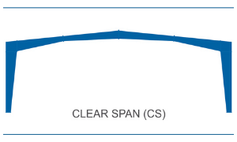

* MULTI SPAN (MS) – This type of frame is most suitable for clients who want a wide shed but do not necessarily want it to be clear span because it gives us the economy of Two Sloped Structure and the columns in between distributes the load and thus reduces the weight of the structure. It is the most economical form of frame for large span buildings. The water discharge is however done from the two side of the slope.

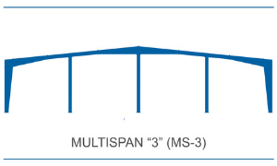

* SINGLE SLOPE (SS) – This type of frames are the preferred choice when clients wants or has restriction to drain water of both sides of the shed. It is also chosen by clients in case their existing sheds require an expansion in width but is not designed to support the load of a lean to shed. In case these sheds are very wide then is becomes economical to make the same in Multispan.

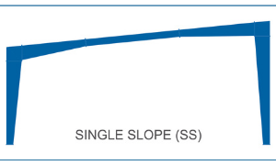

* MULTI GABLE (MG) – This type of frame is the used in case of wide shed but are a but more economical than the Multi Span frame type. It is lighter because the trusses are smaller hence economical but it comes with a rider than it may has a water discharge in the center of the shed which would require an internal drainage line, which is not preferred in most of the industries where water ingress during unplanned excess rains lead to losses.

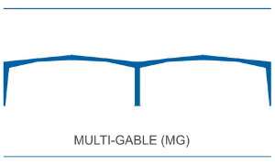

* LEAN TO (LT) – This type of frame is the most preferred type, for sheds requiring an expansion along the width. It requires the original shed to be designed such that it is able to take the load of the expanded shed along with the new shed. Lean to sheds are designed to match the roof slope of the existing shed such that the water is discharged out of the shed.

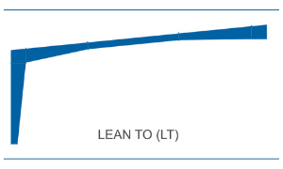

**CHAPTER 4:**

**DESIGN BUILD METHOD**

Design-build is a method of project delivery in which one entity – the design-build team – works under a single contract with the project owner to provide design and construction services. One entity, one contract, one unified flow of work from initial concept through completion. Design-build is also known as design/construct and single-source responsibility. Across the country and around the world, design-build successfully delivers office buildings, schools, stadiums, transportation and water infrastructure projects with superior results.  
  
Design-build is an alternative to design-bid-build. Under the latter approach, design and construction are split – separate entities, separate contracts, separate work.

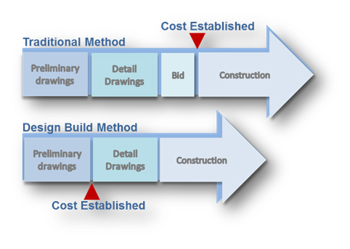

**CHAPTER 5:**

**APPLICATIONS OF PRE_ENGINEERED BUILDINGS**

* Industrial Buildings
* Warehouses
* Commercial Complexes
* Showrooms
* Offices
* Schools
* Indoor Stadiums
* Outdoor Stadiums with canopies
* Gas Stations
* Metro Stations, Bus Terminals, Parking Lots
* Primary Health Centers, Anganwadi’s
* And many more…

Indoor Stadiums

Industrial Building

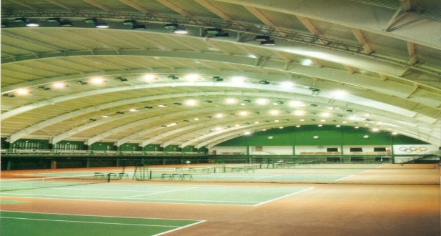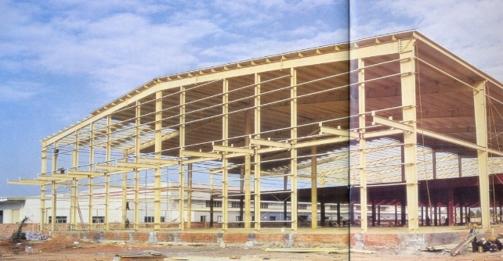

Metro Station

Aircraft Hangars

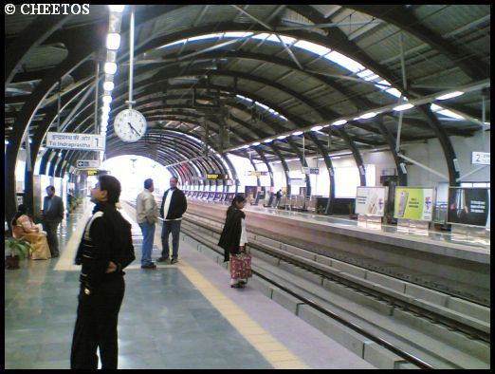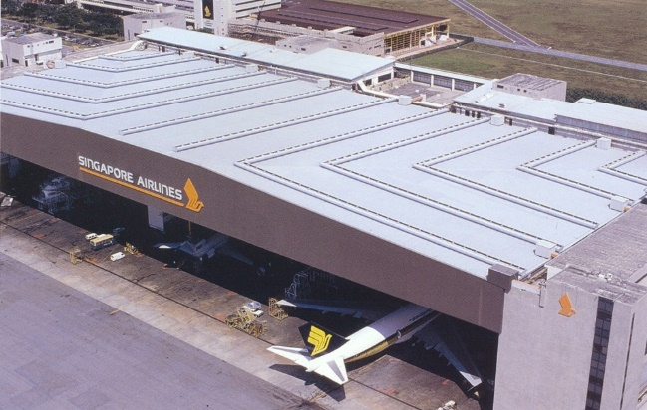

**CHAPTER 6:**

**ADVANTAGES OF PRE-ENGINEERED BUILDINGS**

* Aesthetic Appeal
* Faster Completion
* Economical
* Seismic Resistance
* Ease of Expansion
* Maintenance Free
* Large Clear Spans
* Controlled Quality
* Hassle Free

**CHAPTER 7:**

**DIFFERENCE B/W PRE-RNGINEERED AND CONVENTIONAL STEEL BUILDINGS**

|  |  |
| --- | --- |
| PRE-ENGINEERED STEEL BUILDINGS | CONVENTIONAL STEEL BUILDINGS |
| * Self-weight 30% lighter | * Self-weight More heavy |
| * Primary Member is tapered section | * Primary members are Hot rolled “I” section |
| * Secondary members are light weight rolled framed “Z” and “C” section | * Secondary members are “I” or “C” section which are heavy in weight. |
| * Delivery – average 6 to 8 weeks | * Delivery- average 20 to 26 weeks |
| * Foundation-simple design, easy to construct & light wt. | * Foundation- expensive, heavy foundation required. |
| * Erection cost and time- accurately known | * Erection cost and time- 20% more than PEB |
| * Erection process is easy, fast, step by step | * Erection process is slow and extensive field labor is required. |
| * Seismic Resistance- low weight flexible frames offer higher resistance to seismic forces | * Seismic Resistance- rigid heavy weight structures do not perform well in seismic zones |
| * Overall price -30%lower | * Overall price – Higher Price per square meter. |
| * Architecture-achieved at low cost | * Architecture- achieved at higher cost |

**CHAPTER 8:**

**COMPONENTS OF PRE-ENGINEERED BUILDINGS**

The main components of Pre-Engineered Buildings are:-

* Main Frame/Primary Frame
* Secondary Frame
* Sheeting
* Accessories
* **Primary Frame –** Pre-engineered steel building is portal frame construction comprises of primary and secondary framing and bracing system. A combination of these three elements and weather covering sheeting results in stable steel buildings instead of individual frame.
* **Secondary structural frames –** Secondary framing system is mainly purlin and girt of Z or C shapes of various sizes. In Pre-engineered buildings normally cold form Z sections are used for secondary framing to achieve high strength and lower weight. Purlins/girt are members which transfers forces and moments from one frame to another frame for overall stability of the building structure and it all acts as framing system for weather covering sheeting purpose.
* **Roof and Wall Panels –** Tin shades & Curtain Wall made of Glass & Roll-formed steel sheets usually comes in the category. From transfer of wind force and other acting loads form building frame to the foundation at certain interval. X-bracing system is used to change the direction of forces for reducing the impact of forces. Normally rod, pipes or angles are used for x-bracing purpose.
* **Sandwich Panels –** Sandwich panel is made of three layers in which a non-Aluminium Core is inserted between two aluminium sheets.
* **Weather covering for roof and walls** – In order to provide weather covering for roof and walls from external condition, steel structure need to be covered fully/partially as per functional requirements. For all purposes this covering provides access for all architectural and function requirements as well. Normally, metal profiled steel sheets are used for covering purpose. Now a day’s different colour/color combinations are used to make building more aesthetic & elegant. There are various other elements of sheeting such as flashings, trims, ridge cover, peak panel, rack trim, drip trim etc. which is made of the same material as of sheeting and equally important for weather tight functioning of the building. In addition, proper rain water gutter for collection of rainwater and down take pipe for discharge of water from gutter to the ground is also a key element to the building for overall performance of the building. All sheetings are joined together with the help of self-drilling/self-tapping screw and necessary sealing material such as butyl tape, sealant, foam filler etc. are used to make buildings more efficient.
* **Mezzanine system** – Now a day’s construction of mezzanine system is very common being used in steel building for various purposes. In most of the factory or warehouse building shop floor office, production offices, stores, maintenance office, wash rooms, canteen etc. are made above the shop floor area wherever surplus head rooms are available. This also helps in saving the floor area as well creates ease of serving being closely. This also reduces the cost of construction A typical mezzanine system is basically a joist beam construction taking support from the building columns as per availability and top of beams and joist deck slab is poured over GI decking of profiles metal sheet. A light reinforcement over decking and light concrete is used to make a permanent floor. Typical mezzanine details for various elements are shown below.
* **Anchoring** – In order to install the steel building on RCC pedestal/foundation, it is necessary to have an anchoring system suitably designed to take up various loads and forces of the building and to transfer the same to the ground through anchor bolts arrangement. Size of anchor bolts and its quantities are designed as per reactions calculated as per building design.
* **Building accessories** – There are various other building elements which may not be important structurally but very important functionally and it adds performance of the building. Skylight, wall light, Doors, windows, louvers, ventilators, turbo-vent, insulations, roof curb etc. are equally important to the smooth functioning of the building.
* **Crane system** – All pre-engineered steel buildings can be designed for crane operation provision as per operational need. There is various type of crane being used in industry for various purposes- EOT overhead crane with pendant or cabin operated, Overhung/under-slung crane system, Monorail crane or hoist system, Wall mounted crane and Jib crane.
* **Paints and finishes –** Pre-painted steel is produced on modern, high-speed coil painting lines where surface preparation prior to painting, paint application & paint curing is done on a highly automated line under optimum condition.

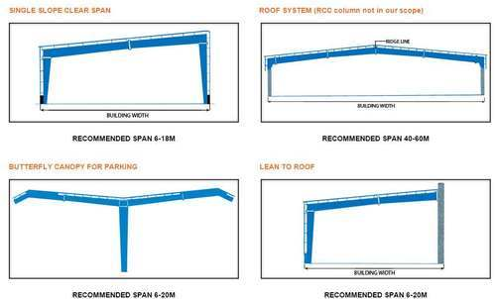

**COLUMNS AND RAFTERS** for different types of PEB.

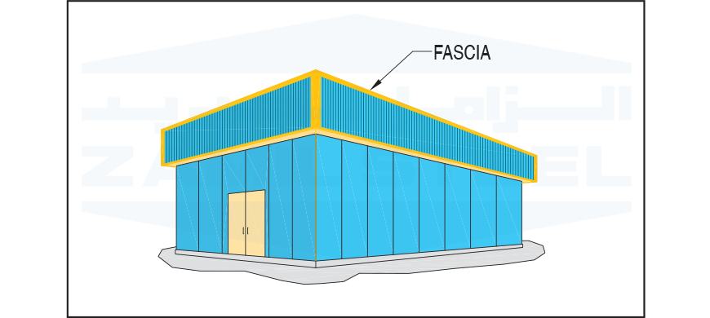

**FASCIA** is a vertical covering for the pre engineered buildings.

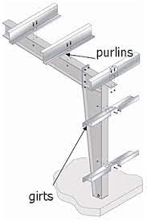

PURLINS: A purlin (or historically purline, purloyne, purling, perling) is a longitudinal, horizontal, structural member in a roof. In traditional timber framing there are three basic types of purlin: purlin plate, principal purlin, and common purlin.

GIRTS: In architecture or structural engineering, a girt, also known as a sheeting rail, is a horizontal structural member in a framed wall. Girts provide lateral support to the wall panel, primarily, to resist wind loads.

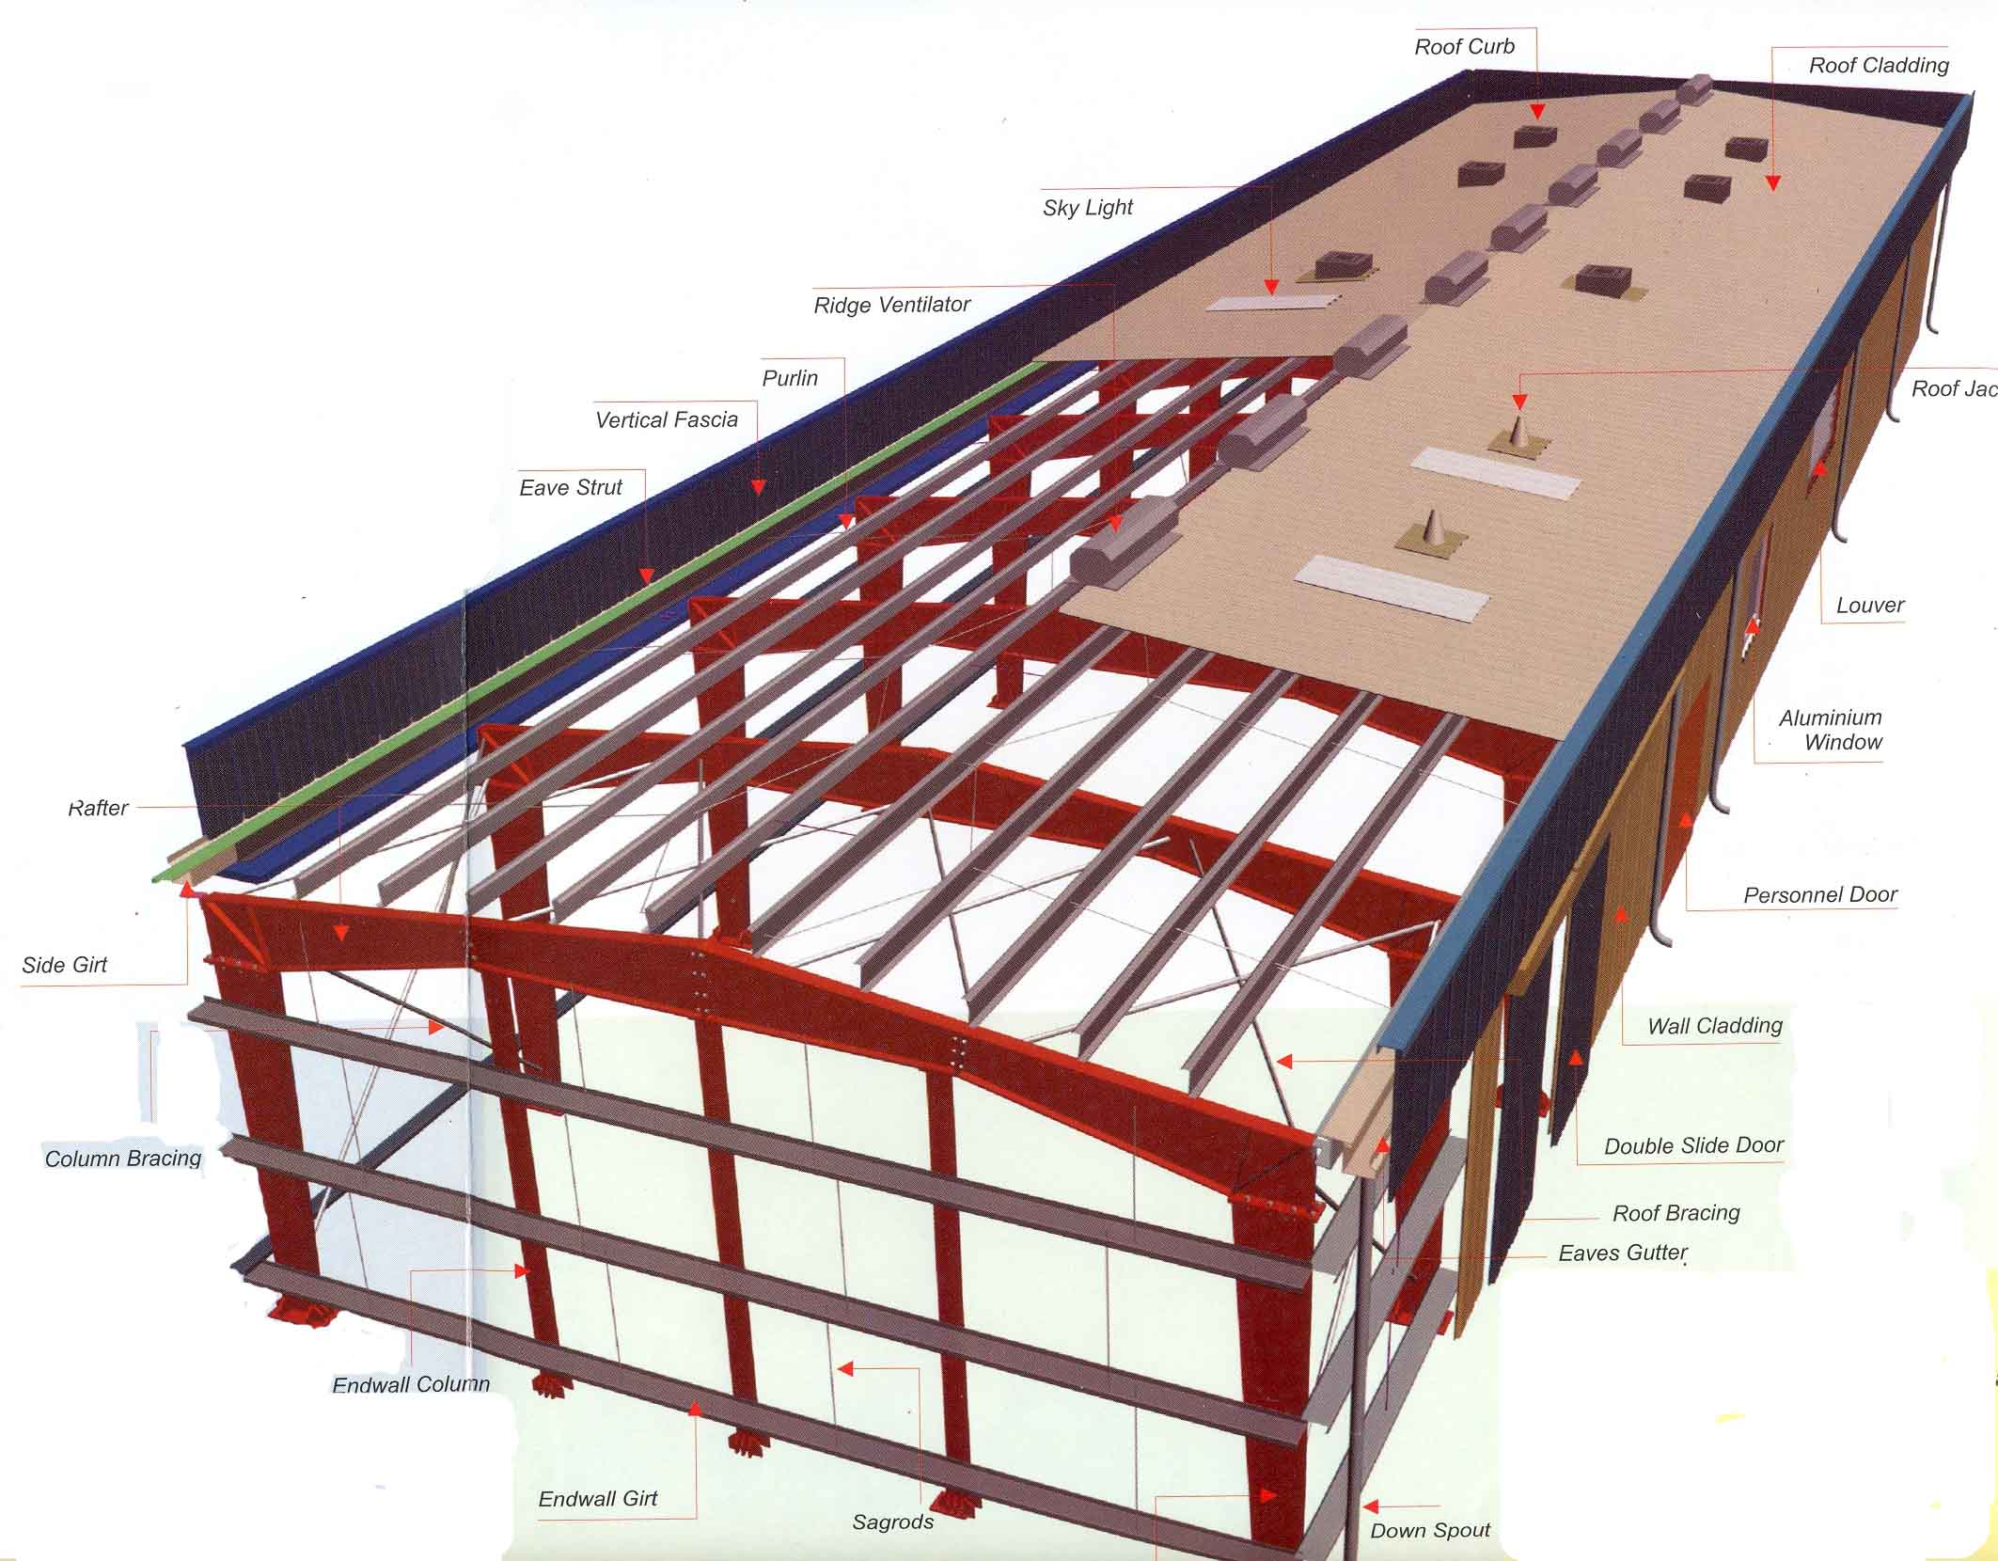

COMPONENTS OF A PRE-ENGINEERED BUILDING WITH COMPLETE STRUCTURE

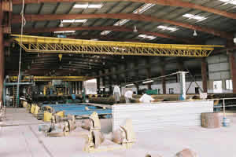**OTHER MAJOR COMPONENTS:**

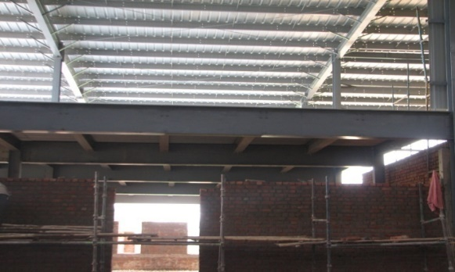

MEZZANINE FLOORS

CRANE BRACKETS & BEAMS

**CHAPTER 9:**

**NOMENCLATURE OF PRE-ENGINEERED BUILDINGS**

1)

RF = TAPERED COLUMN CLEAR SPAN

2)

BC-1 = TAPERED COLUMN MULTI-SPAN WITH 1 INTERMEDIATE COLUMN.

 3)

SSCS = SINGLE SLOPE CLEAR SPAN.



4)

SSMS-1= SINGLE SLOPE MULTI-SPAN WITH 1

INTERMEDIATE COLUMN

**CHAPTER 10:**

**METHODOLOGY**

* PEB PROCESS FLOW:
* SALES
* OMD/PMG/CSD
* DESIGN
* DETAILING
* PURCHASE
* PRODUCTION
* SHIPMENT
* ERECTION
* TYPICAL PEB PLANT LAYOUT:

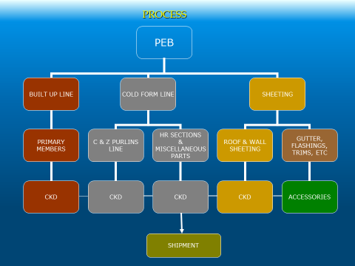

* Method Used : Stiffness Matrix Method
* Standard Code used :
  + AISC
  + ASCE
  + IS : 800
* Software used : Staad.Pro v8i, ETABS, RAM Steel
* Load Considerations & their Calculations: [Loads](https://civildigital.com/calculation-loads-building-modeling-structure-load-calculation-design-building-excel-spreadsheet/) considered in the PEB design are same as for general building structure. These are as follows ,
  + *Dead load Calculations*: It includes Self Wt. of Purlins, Roof & Wall Sheeting, insulation material & other structural component.
  + *Live / Imposed Load Calculations* : It should be Considered as per given in IS 875 (Part 2 ) for diff. type of
  + *Wind Load Calculations*: Consider the Basic wind Speed as per Area of that particular structure. Design wind Pressure is calculated as per IS 875 (Part 3). Wind Load on Roof can be UDL & calculation for this can be done as per IS875(Part 3)
  + *Seismic Load Calculations*: [Earthquake](https://civildigital.com/bhuj-earthquake-india-2001-complete-study/) Loads affect the design of structure in areas of great seismic activity. The [seismic](https://civildigital.com/dynamic-analysis-methods-seismic-bridge-design/) load can be calculated as per IS 1893-2002(Part 1).
  + *Other Moving Loads*: It can be Moving EOT Crane load or Mono Rail etc.
* *Load Combinations* : As per IS 1893 – 2002 (Part 1)
  + 7(DL ± LL)
  + 7(DL ± EL)
  + 3(DL + LL ± EL)
* Mechanism : For diff. Load Combinations structure should be checked by considering Internal work equal to External work and We will consider the following Mechanism,
  + Beam Mechanism
  + Sway Mechanism
  + Gable Mechanism
  + Combined Mechanism
* Checks Made :
  + Effect of Axial Force: Max. Load should be checked with allowable load bearing of the section. As, Max. Axial Force in Column/Axial Load causing yielding < 0.15
  + Check should also be made for [Local Buckling](https://civildigital.com/lateral-torsional-buckling-beams-lateral-deflection-torsion/) of Flanges & Webs.
  + Check for the Effect of Shear Force: Shear Force at the end of the Girder should be less than the Max. Shear Capacity.
* Design Procedure : It consist some steps, which are as follows,
  + Based on the geometry, set up section sizes and brace locations.
  + Loading Calculations: Specify the Load case & load combinations for designing of the framed [steel structure](https://civildigital.com/brittle-fracture-steel-brittle-fracture-ductile-material/).
  + Calculate S.F. & M. for each load case detail
  + By using the Standard Codes, check and compare the calculated stress with the allowable or Permissible Shear Stress & Bending Stress values.
  + Design the optimum Splice Location.
  + Made check for predicted section that it satisfy or fail for any loading conditions.
  + Now, by ending the [design](https://civildigital.com/bolted-steel-connections-practical-design-questions/) an analysis is run to achieve flange bar optimization

**CHAPTER 11:**

**FOOTING AND ANCHORAGE SYSTEM**

* FOOTING: Foundation design and construction for Pre-Engineered Buildings are important to the assembly process. To ensure optimum integrity of new building, the foundation must meet certain design criteria and load conditions. It is required that all building foundations be designed by an experienced foundation engineer, and coordinated with all local city, county and state codes. Improper foundation construction will limit the building’s performance. The foundation should be sharply formed with true corners, straight sides, and a level top. This will allow for proper seating and alignment of all building components. Strict adherence to OSHA and other local codes or laws governing “shoring of excavation to prevent accidental cave-ins” is critical. Manufacture of Building Systems will furnish anchor bolt drawings to outline basic guidelines and considerations for foundation design. The accuracy of foundation construction and anchor bolt settings is the most important factor in achieving trouble-free component alignment and fit-up.
* FOUNDATION LAYOUT SETTING ANCHOR BOLTS: Regardless of the type of foundation that is used and its specific configuration, the foundation outline should be carefully and accurately laid out before any excavation is made. Whenever possible, a transit or similar means should be used to layout the foundation perimeter. This will ensure accurate placement of corner measures and in turn, ensure a square foundation.

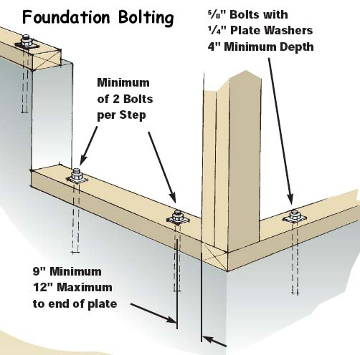

Foundation errors and mis-location of anchor bolts are among the most frequent and troublesome errors made in metal building construction. Foundation must possess the following important characteristics.

* It is recommended that the foundation be designed by an experienced foundation engineer, and coordinated with all local city, county and state codes.
* The foundation must be square, level and smooth.
* Anchor bolts must be set within +/- 1/16” of the specified anchor bolt drawing dimensions.

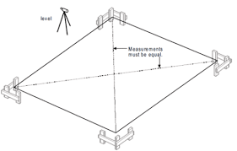

FOOTING LAYOUT

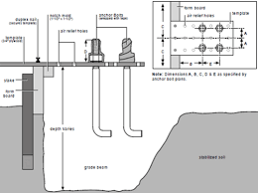

PLACING OF ANCHORAGE BOLTS

**CHAPTER 12:**

**ERECTION OF PRE-ENGINEERED BUILDINGS**

* PEB are often erected by specialized builders with extensive experience in the erection of PEB’S.
* General rules:
* Build column combing with purlins (if any), brace column together. Then, continue building rafters after adjusting column.
* Install the inside truss frames, and then proceed to erect the outside ones (according to the movement of truck crane – see the enclosed construction drawing)
* Begin erecting from the braced bay.
* Settle two construction frames at the braced position before placing new frame. This process is translated for the next frame.
* Have to have temporary brace during the erection process. Use purlins with the bracing cable to locate, and link all the rafter frames.
* Erect steel panel after adjusting rafter frame and straight purlin, clean up, and paint all scratches on the rafter and purlin.
* Use chalks or stretch attached wires to locate or mark axis positions in order to balance the steel panel when to complete the covering.
* Set foot on the bottom waves when walking on the roof. Steel panel may be crashed if stepping on the high waves, which can cause deformation or leaking.
* Do not walk on bright panels.

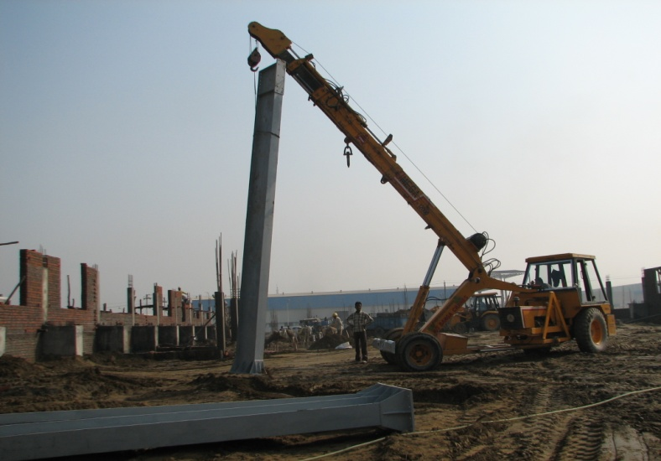

**CHAPTER 13:**

**DESIGN CODES USED FOR PRE-ENGINEERED BUILDINGS**

Following are the main design codes generally used:  
 AISC: American institute of steel construction manual  
 AISI: American iron and steel institute specifications  
 MBMA: Metal building manufacturer’s code  
 ANSI: American national standards institute specifications  
 ASCE: American society of civil engineers  
 UBC: Uniform building code  
 IS: Indian standards

**CHAPTER 14**

**CASE STUDY**

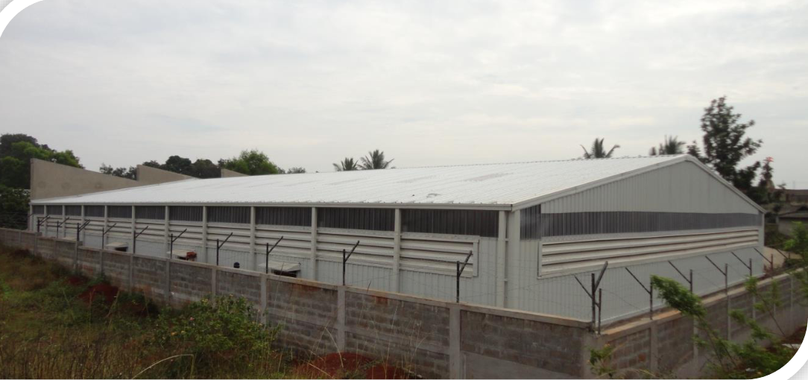

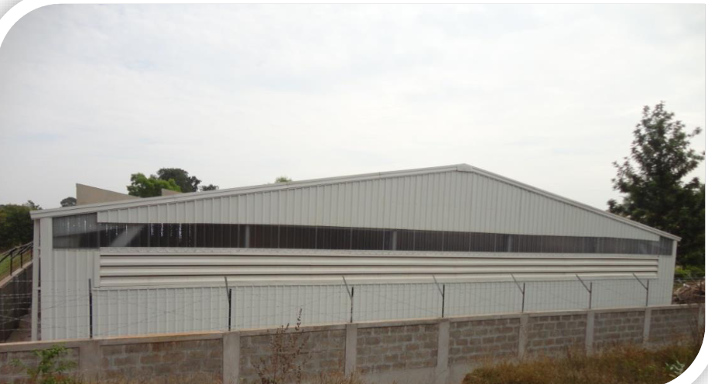

Location : Belgaum, Karnataka  
Country : India  
Project Size: 10,000 Sf

Srinivas Induction Hardening, Specialized Crankshaft Manufacturers of the Country had a requirement for storage warehouse. The project had to be completed within 2 months during Monsoon. The Elevation of the building had to be matched with the existing RCC Structure. The governing requirement of the Client was to be able to re-locate the building in a decade time and should be designed for expansions and minimal wastage during relocation. Since it was a Warehouse which would be having state of the art material handling ground service, Overhead Crane was not required and this is where Tata BlueScope PEB Lite technology made a QUALITY viz-a-viz COST impact to the client by satisfying the essential requirements of the project.  
a) Pre-engineered Structure with Pre-Punched components for Easy & fast assembly and also Re-location with very minimal Wastage.

Few of the highlighting features of the PEB-Lite solution:  
o Structural Main frame and secondary members are made from galvanized, high strength steel which ensures its corrosion free performance for years.  
o Light gauge steel frame members ensured quick and easy installation  
o Color bond® Steel used for roofing and wall cladding enhances the structural look and with long life as a complementary aspect.  
o Galvanized silver finish of the structural members adds the interior aesthetics of the building, eliminating periodic painting and maintenance works.  
o Entire system is having nut-bolted connection and all the fasteners used are protected with galvanized coating for better performance and durability of the connection system.

* Typical PEB-Lite® Design Offering for prospective Buyers:  
  o Clear Span : 3m to 21m  
  o Maximum Eave Height: : 2.1m to 7m  
  o Length :as per requirement

**CHAPTER 15:**

**CONCLUSION**

**Pre-engineered steel building construction isn't ideal for all project types**. However, if your project has the same design, pre-engineered buildings offer a lower cost, less waste, low maintenance, durability, flexible frames, and ease of expansion.