DOCUMENT TO PROGRAM PIC18F4550 FROM ARDUINO.

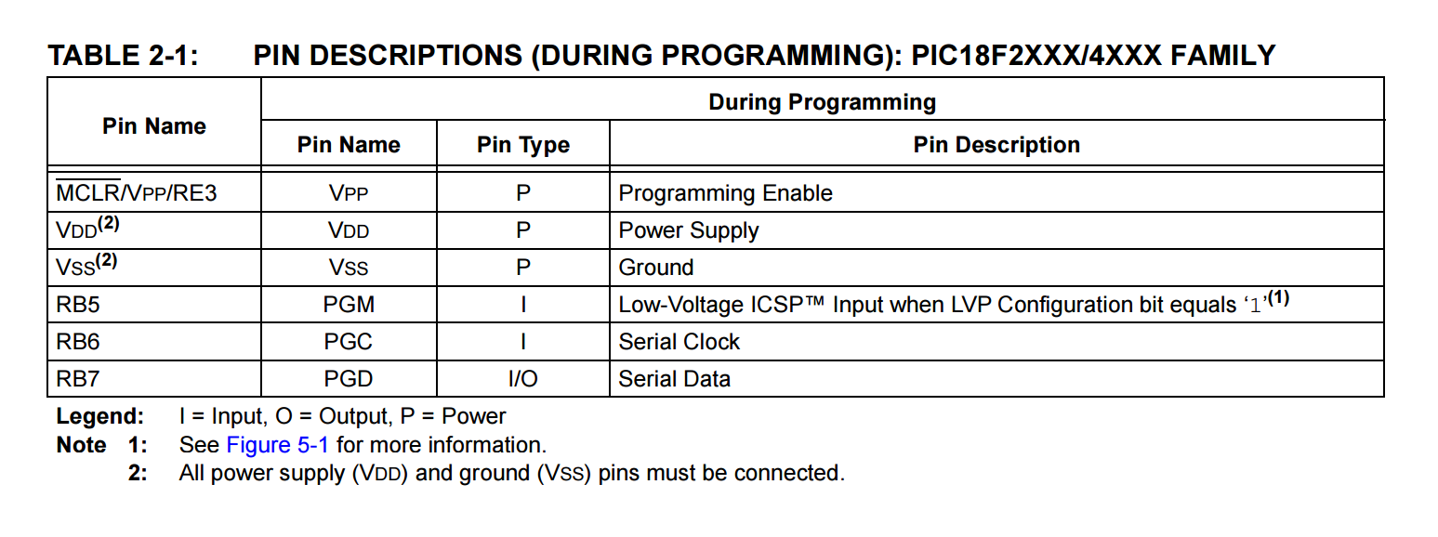

* RB5/PGM pin only used in Low-Voltage ICSP.
* LV ICSP can only be used if LVP Configuration bit is equal to 1.
* This bit can only be set by High Voltage Programming if it is not 1.

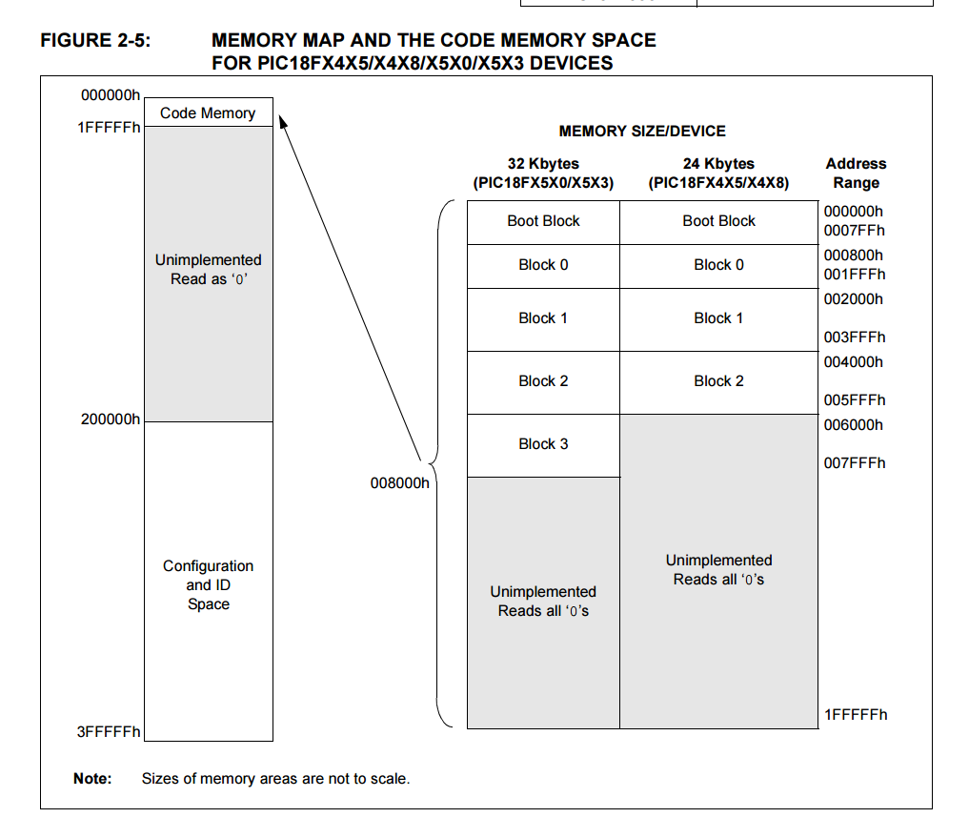

Memory Map

* Code Memory [also referred to as Program Memory] (place where your code goes) Extends from 000000h—007FFFh (32767 bytes-32KB) in four 8 KB blocks.
* There is a boot block (find out what it does) of around 2Kb which reduces block 0 to 6KB.
* In addition to the Code block there are 3 more blocks which is accessible to the user.
* These blocks can be used to store ID location, Configuration bits and Device Bits as sown below.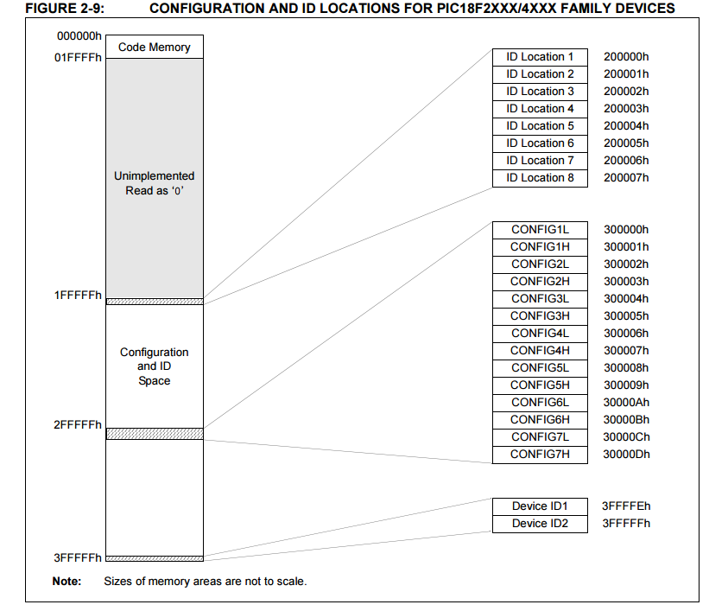
* The block can be accessed through Table Reads and Table Writes.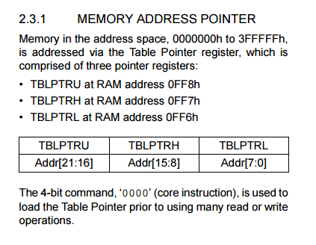

**Overview of Programming Flow**

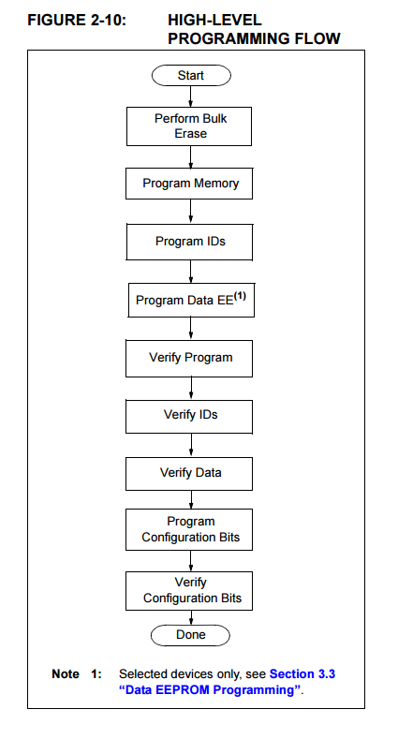

**ENTERING HIGH-VOLTAGE PROGRAM/VERIFY MODE**

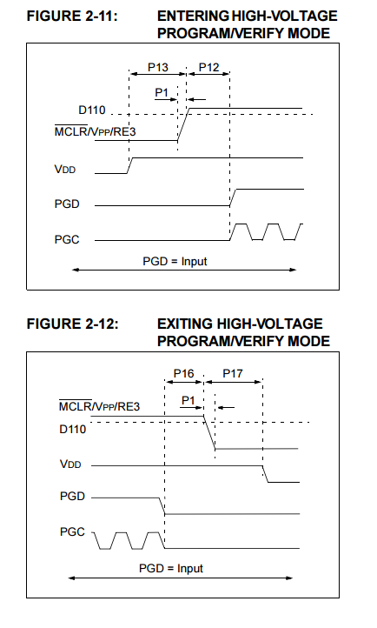

* The above figure shows how to enter high voltage programming mode. The “P” values are given below

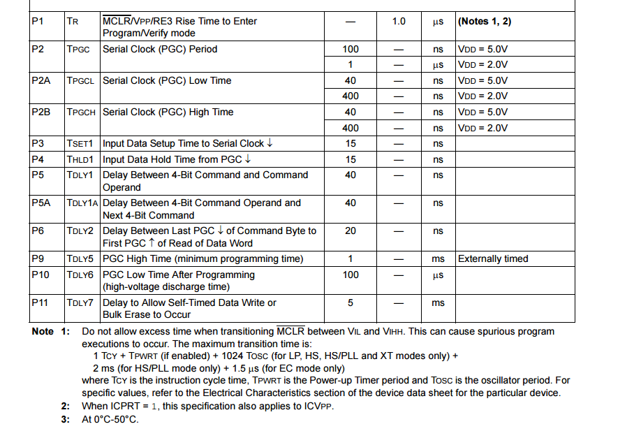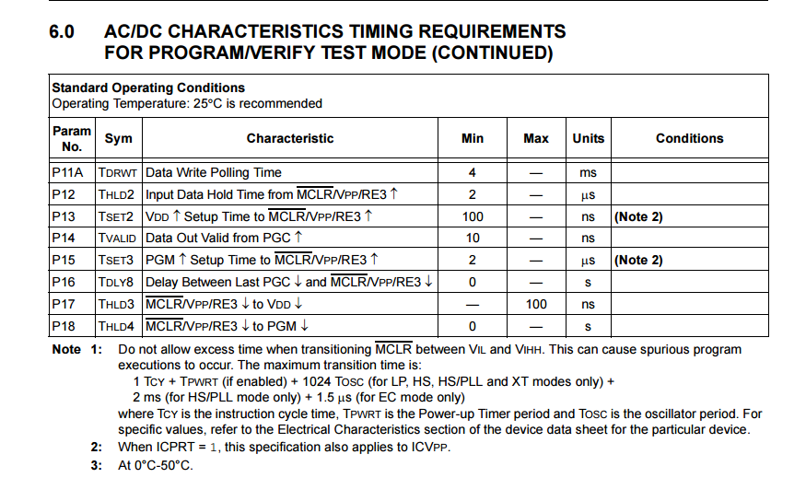

**ENTERING AND EXITING Low-Voltage ICSP Program/Verify Mode**

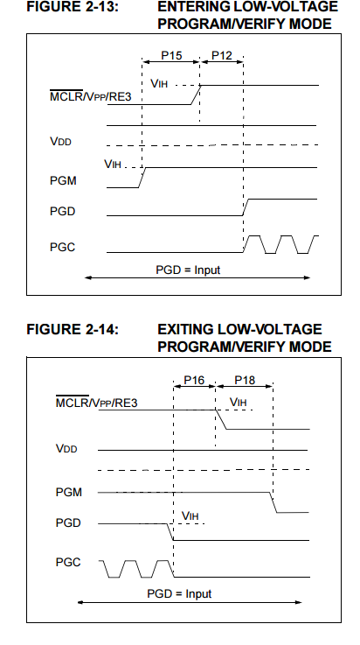

* Note the difference with High Voltage. The PGM Pin becomes a dedicated pin.

**PROGRAMMING THE DEVICE**

* PGC pin used as clock input (what are the values for the clock frequency?)
* PGD pin is used for entering the command bits and data input/output during serial operation
* Command and data are transmitted on the rising edge of PGC, latched on the falling edge of PGC and are Least Significant bit first.
* All instructions are 20 bits.

|  |  |  |  |  |  |  |  |  |  |  |  |  |  |  |  |  |  |  |  |
| --- | --- | --- | --- | --- | --- | --- | --- | --- | --- | --- | --- | --- | --- | --- | --- | --- | --- | --- | --- |
|  |  |  |  |  |  |  |  |  |  |  |  |  |  |  |  |  |  |  |  |

Command Bits Data Bits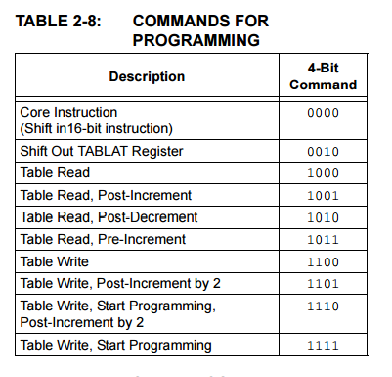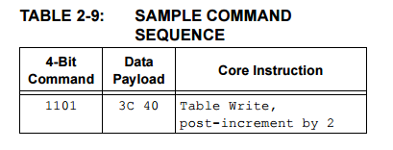

* 4 bit command MSB.
* Suppose we want to send the below instruction
* The timing diagram to the command is then

