**Nandish Bhatt**

**2201031800007**

**WT*-*Assignment1**

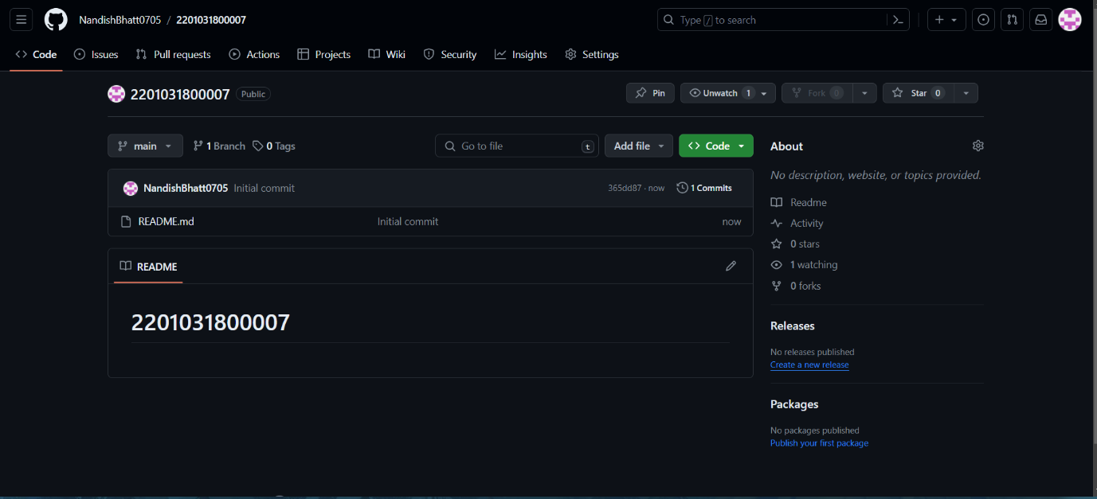

**Create a New Repository:**

1. Open your Chrome browser and go to GitHub.

2. Log in to your GitHub account.

3. Click on the "+" sign in the top right corner and select "New repository."

4. Name the repository with your enrollment number (2201031800007)

5. Initialize this repository with a README file.

6. Click "Create repository."

**Create Assignment Folders:**

1. Inside the newly created repository, click on the "Create new file" button.

2. In the file name field, type Assignment_1/README.md and click on "Commit new file."

3. Repeat the process to create Assignment_2/README.md.

4. This will create the folders in your repository.