**Building Page with Parallax effect - Using http-server - Saving Code using GIT**

Objectives of the Session:

● Usage of html5 semantic elements.

● Applying css3 styling.

● Implementing parallax effect.

● Installation and using http-server.

Objectives of the Session:

● Usage of html5 semantic elements.

● Applying css3 styling.

● Implementing parallax effect.

● Installation and using http-server.

**Objectives:**

* **Usage of HTML5 Semantic Elements**
* **Applying CSS3 Styling**
* **Implementing Parallax effect**
* **Installation and using http-server**
* **Uploading Code on GitHub**

**Prerequisites:**

* **Basic understanding of HTML5 and CSS3 (What’s new??)**

**Using http-server**

* **Installing**
  + **npm install http-server -g**
* **Static server to render HTML Pages**

**Creating HelloWorld Page**

* **Create Folder FirstDemo**
* **Open Visual Code**
* **Open Folder FirstDemo in Visual Code**
* **Create file index.html page**
* **Change the title in head section to Home Page**
* **Type html to get the Html document structure**
* **Type HelloWorld in h1 tag in body section**
* **Start html-server in Terminal using command :**
  + **http-server –c -1 [To Clear Cache on Browser]**
  + **Note the port on which http-server has started (mostly it is 8080)**
* **Run page on browser by typing :**
  + [**http://localhost:8080**](http://localhost:8080)
* **Your Page should look like**

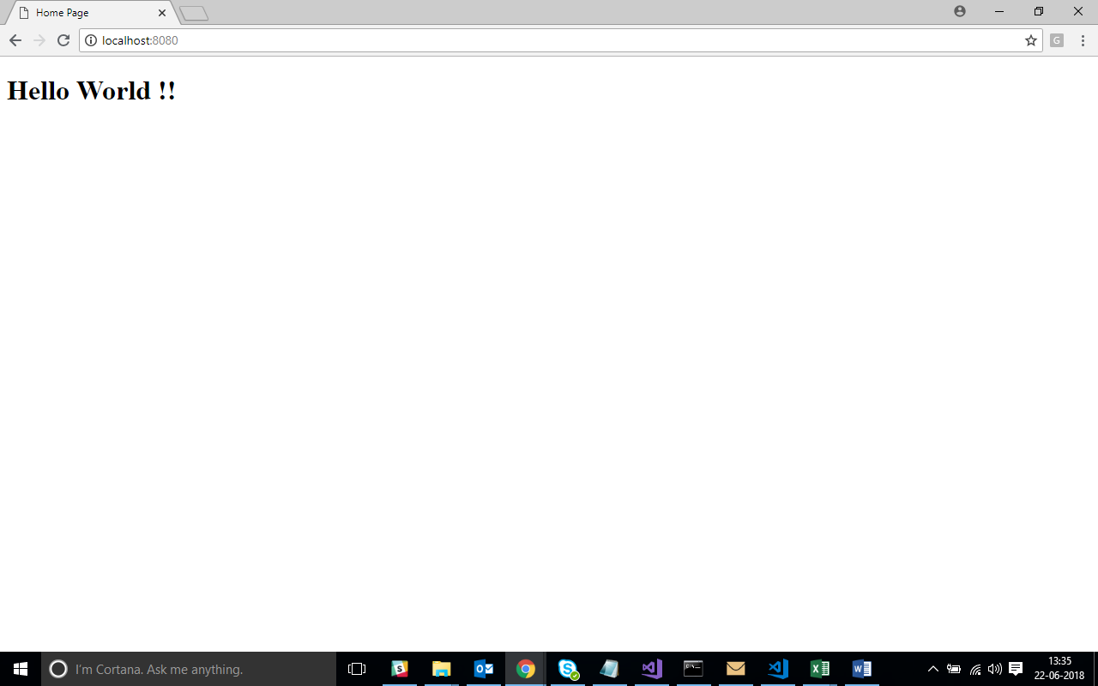

**Creating Page with Parallax Effect**

* **Add folders for images and css files**
* **Add images to images folder**
* **Change index.html file as below :**

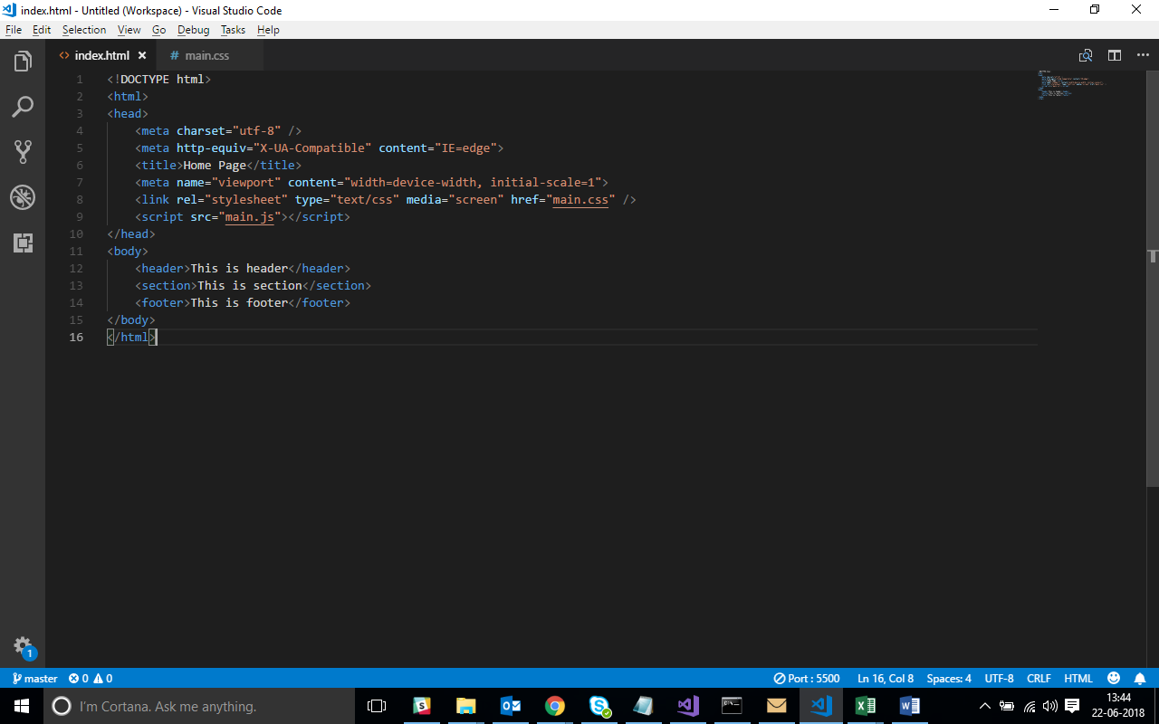

* **The output would look like :**

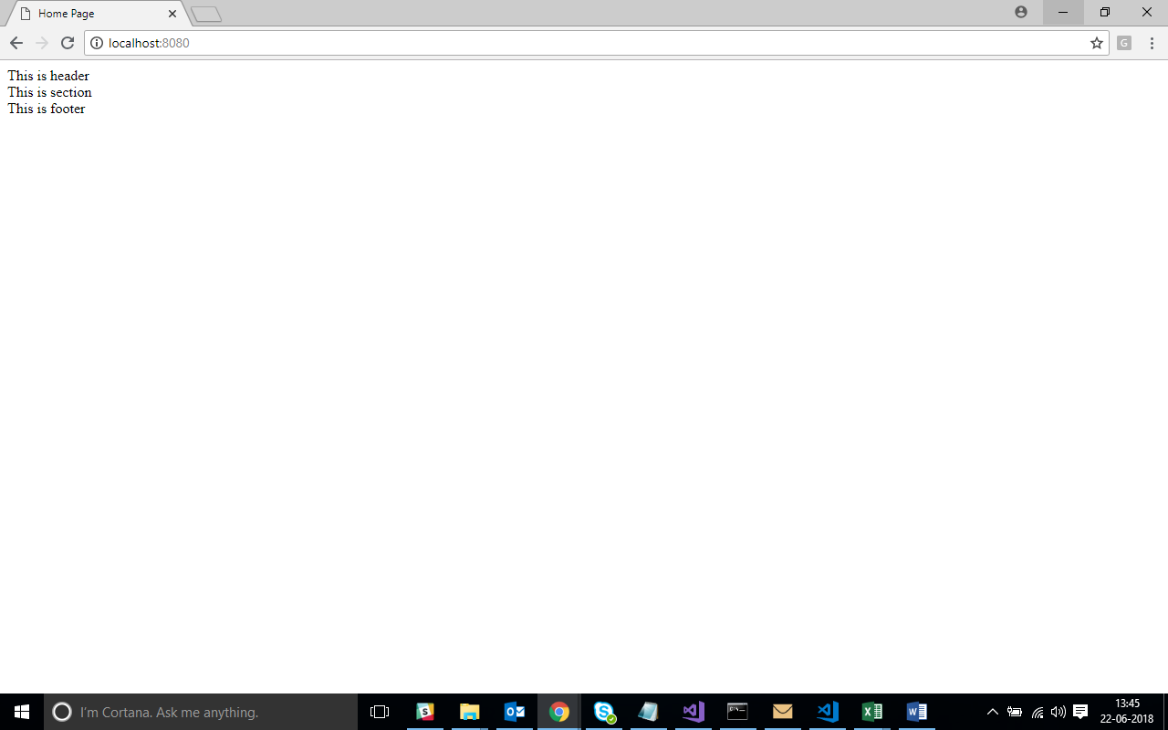

* **Add main.css file to css folder**
* **Change main.css as shown below:**

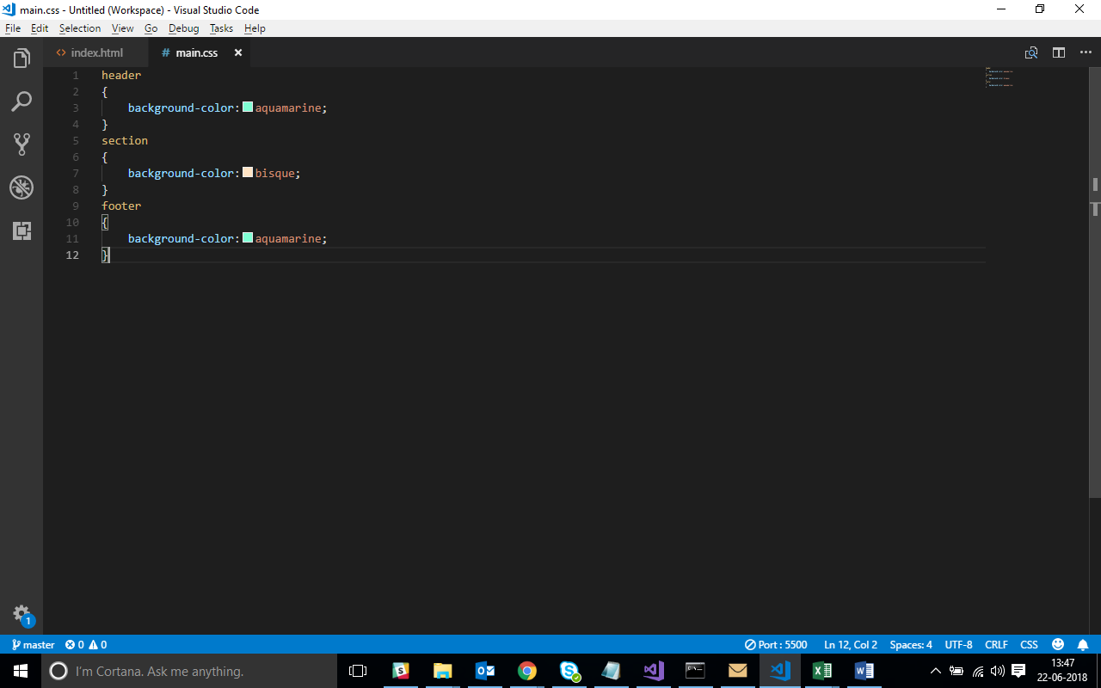

* **Link main.css file with index.html**
* **Output would be like :**

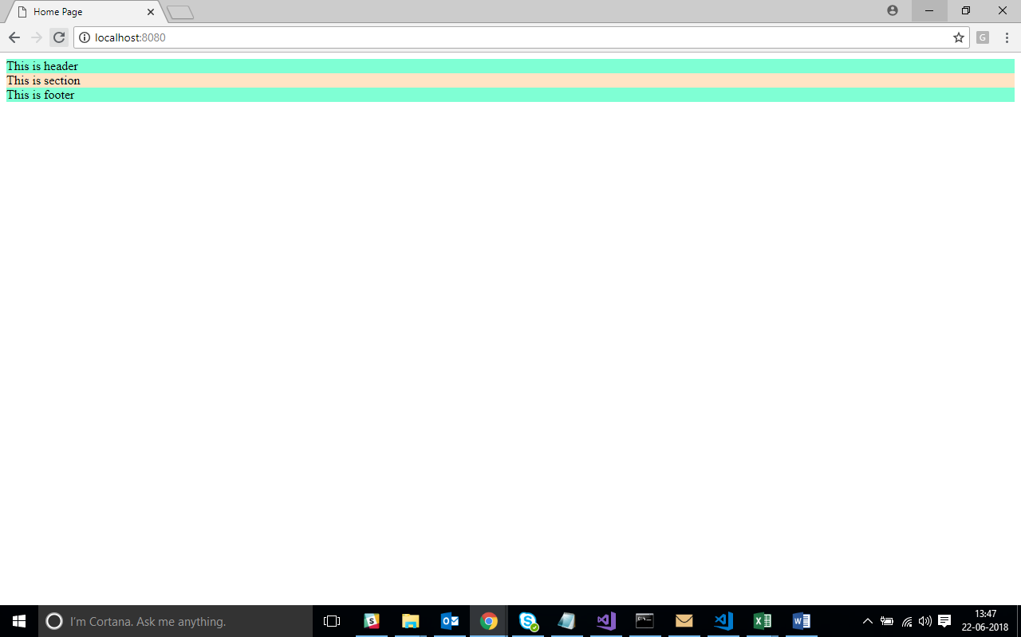

* **The stylings applied to this html document will help to understand css selectors, css units like px, em and difference between them and also understand the cascading nature of stylesheet**
* **What is margin ?**
* **Add following to main.css file :**

body

{

margin : 0;

}

* **The output shows that white space surrounding the sections has disappeared.**

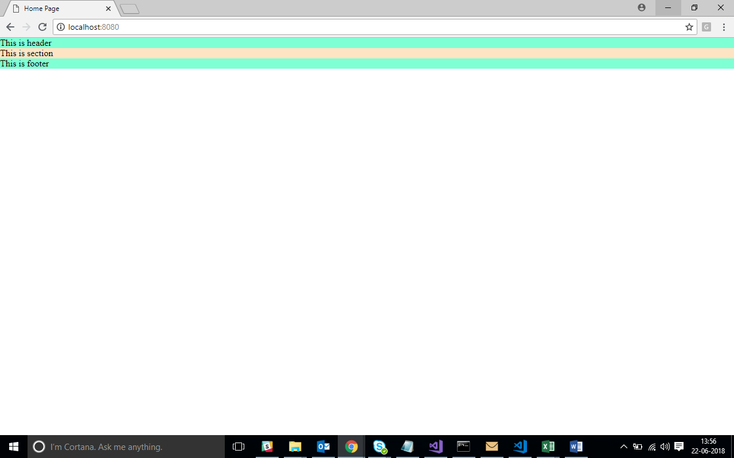

* **What is padding ?**
* **Make following changes to main.css file :**

header

{

padding : 1 em;

background-color : aquamarine;

}

section

{

padding : 1 em;

background-color : bisque;

}

footer

{

padding : 1 em;

background-color : aquamarine;

}

* **Output changes to :**

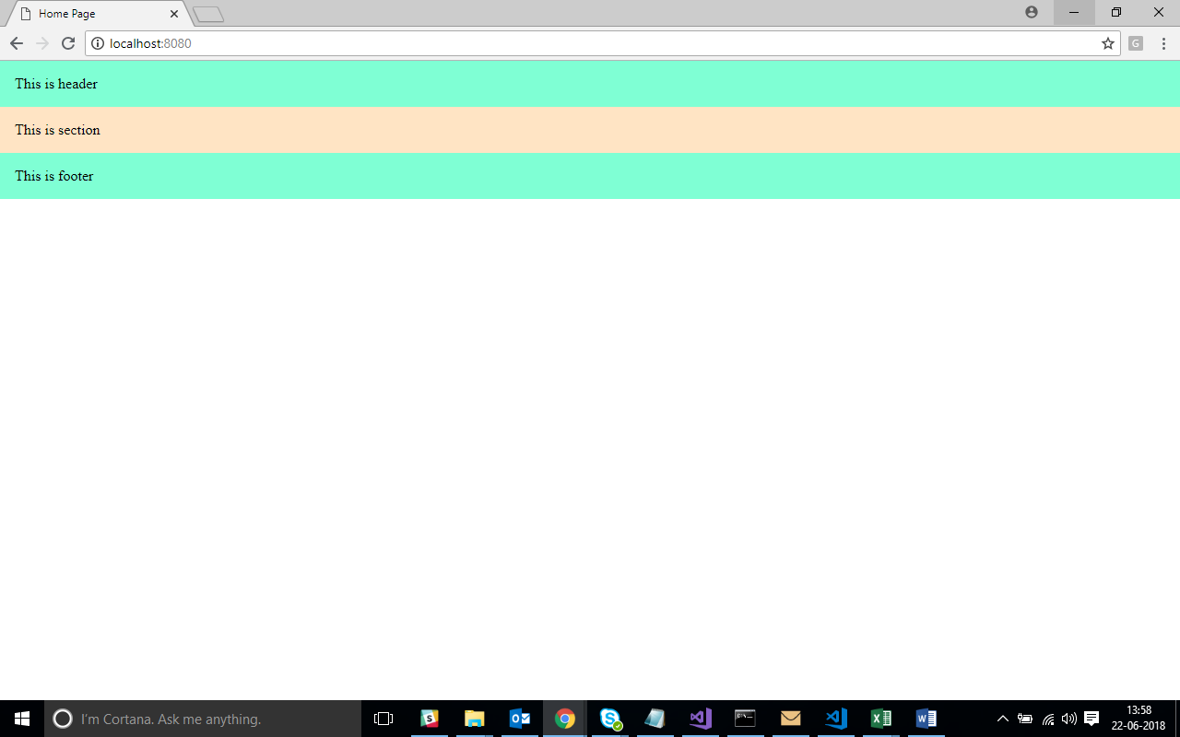

* **Pixels (px) are browser dependent. It is the absolute size that you would see on your screen.**
* **em are sort of like percentages. Ems is referring to the base text size. The value of 1 emmeans the same thing as a value of 100 percent. But you can also say it in the opposite way: A percentage value is just an em multiplied by 100.**
* **Modify the contents of header as below :**

<header>

<img src="images/fifa.jpg" width="200px" height="150px" alt="">

<h1>FIFA Fever 2018</h1>

<nav>

<ul>

<li><a href="#">Teams</a> | </li>

<li><a href="#">Schedule</a> | </li>

<li><a href="#">Contact us</a> | </li>

</ul>

</nav>

</header>

* **Following would be the output:**

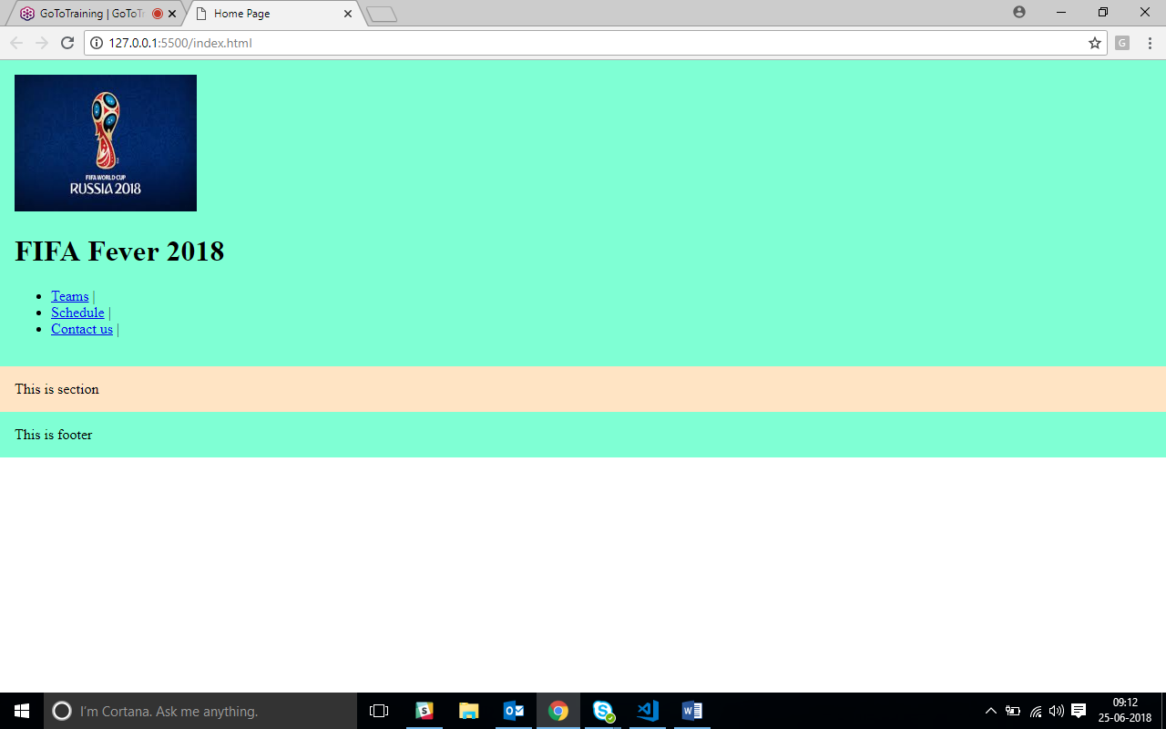

* **Now to arrange them, in proper order, we need to provide styles in stylesheet**

header

{

background-color: midnightblue;

}

header h1

{

padding:0em 8em; /* works clockwise : top-right-bottom-left*/

display: inline;

position:absolute;

color:white;

}

* Observe the changes :

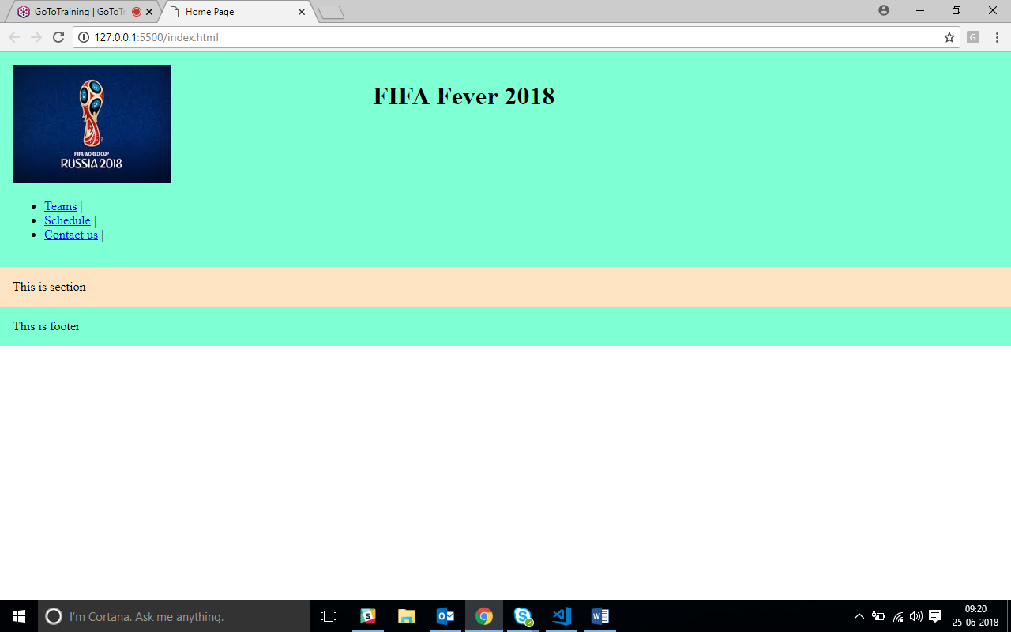

* Similarly, align the navigation bar using following css styles :

nav

{

display: inline;

position: absolute;

padding-left:48em;

}

ul

{

list-style: none;

}

nav li /* accessing li inside nav */

{

display: inline;

color:white;

font-family: serif;

}

* The output should be like :

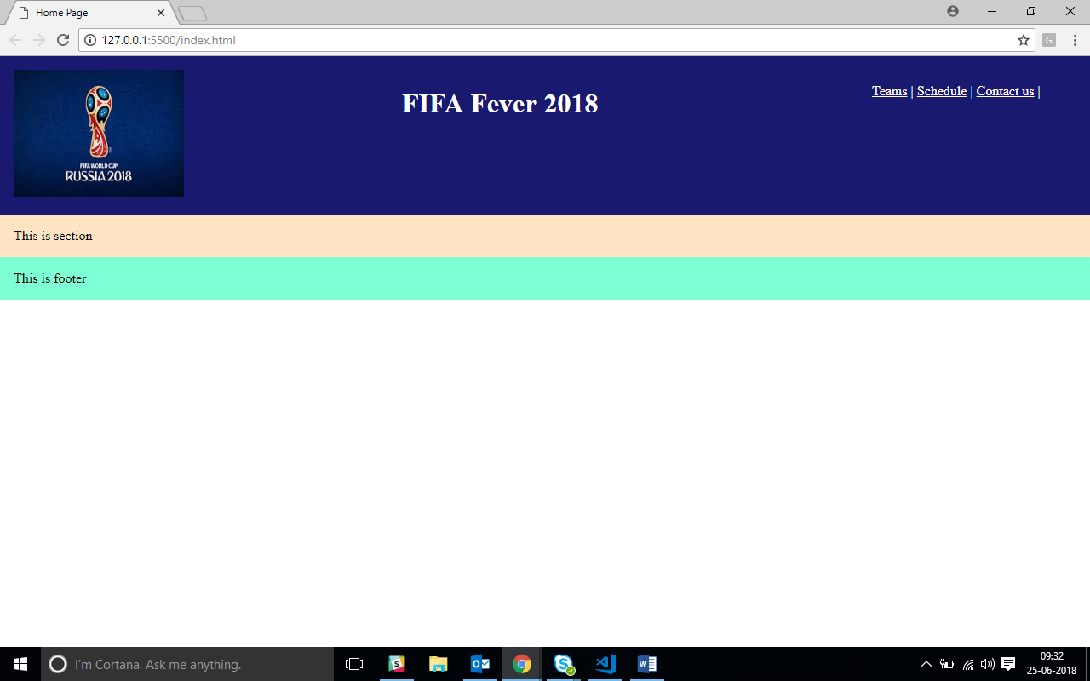

* Now to start with the section where we need to introduce parallax effect.
* Make following changes in Html file between header and footer:

<h2>PARTICIPATING TEAMS</h2>

<section class="s1">

<section class="section-inner">

<h3>Group A</h3>

<ol >

<li>Russia</li>

<li>Egypt</li>

<li>Uruguay</li>

<li>Saudi Arabia</li>

</ol>

<h3>Group B</h3>

<ol >

<li>Portugal</li>

<li>Spain</li>

<li>Morocco</li>

<li>Iran</li>

</ol>

<h3>Group C</h3>

<ol >

<li>France</li>

<li>Australia</li>

<li>Peru</li>

<li>Denmark</li>

</ol>

<h3>Group D</h3>

<ol >

<li>Argentina</li>

<!--<i class="fa fa-flag" aria-hidden="true"></i>-->

<li>Iceland</li>

<li>Croatia</li>

<li>Nigeria</li>

</ol>

</section>

<section >

<h3>Group E</h3>

<ol >

<li>Brazil</li>

<li>Switzerland</li>

<li>Costa Rica</li>

<li>Serbia</li>

</ol>

<h3>Group F</h3>

<ol >

<li>Germany</li>

<li>Mexico</li>

<li>Sweden</li>

<li>South Korea</li>

</ol>

<h3>Group G</h3>

<ol >

<li>Belgium</li>

<li>Panama</li>

<li>Tunisia</li>

<li>England</li>

</ol>

<h3>Group H</h3>

<ol >

<li>Poland</li>

<li>Senegal</li>

<li>Colombia</li>

<li>Japan</li>

</ol>

</section>

</section>

* Output would be like :

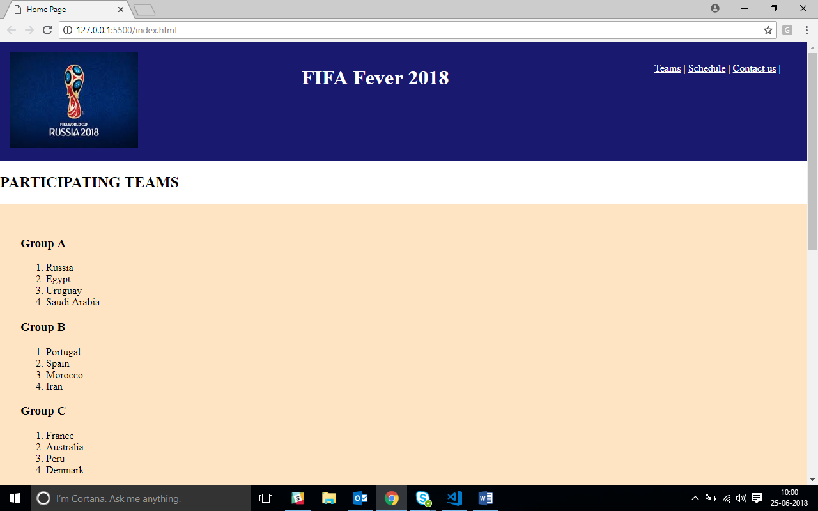

* Now let us arrange it through proper styling

.section-inner

{

float:left;

}

.s1

{

background-image:url('images/parallex-bg.jpg');

background-size:cover;

padding: 1em;

color:darkgreen;

}

* Check the output :

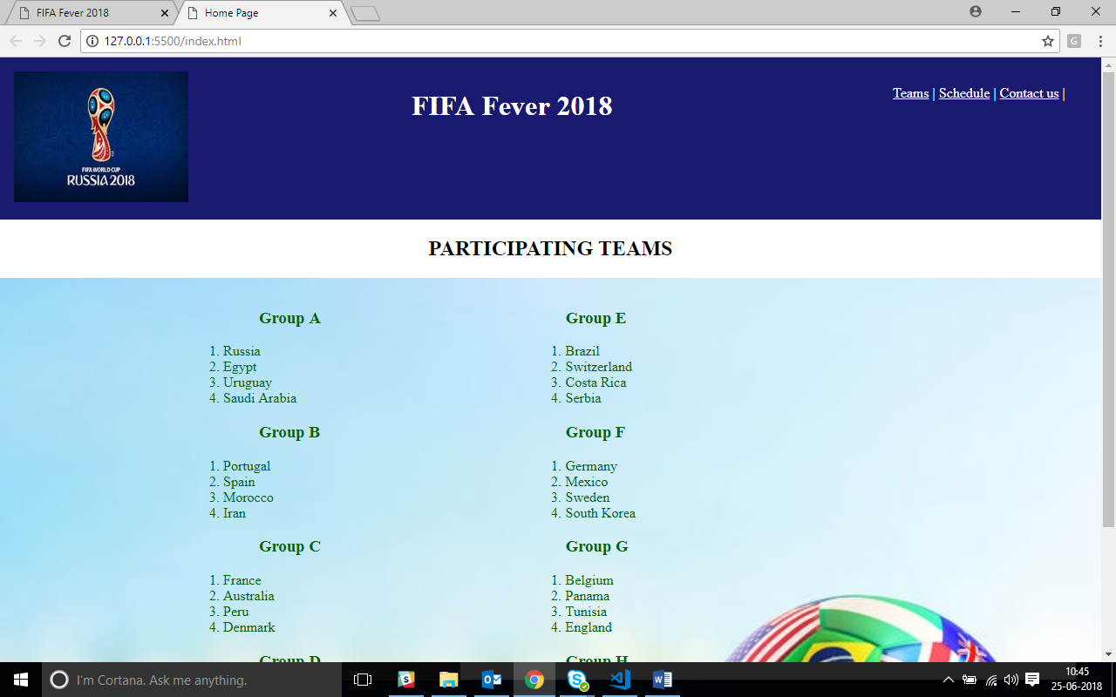

* To get the parallax effect add to .s1 following style rule :

background-attachment : fixed;

* Scroll and notice the parallax effect.
* Adding one more section below the section modifying your html as below :

<section class="s2">

</section>

* Modifying the style for section as below :

.s2

{

background-image: url('../images/ground-bg.jpg');

height:300px;

}

* Adding overlapping background in second section :

.s2

{

background-image:url('../images/fifa-mascot.jpg'), url('../images/ground-bg.jpg');

height:300px;

}

* Output would be like :

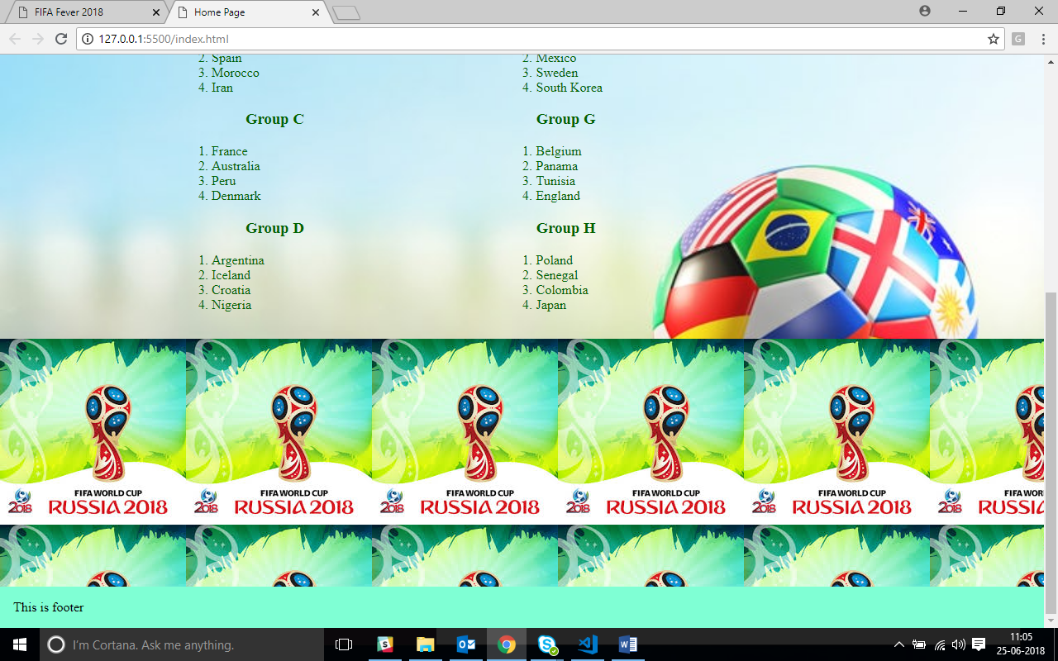

* Modify the styles to remove the repeat effect :

.s2

{

background-image:url('../images/fifa-mascot.jpg'), url('../images/ground-bg.jpg');

background-repeat: no-repeat, repeat-x; /* chk what happens with only repeat */

height:300px;

}

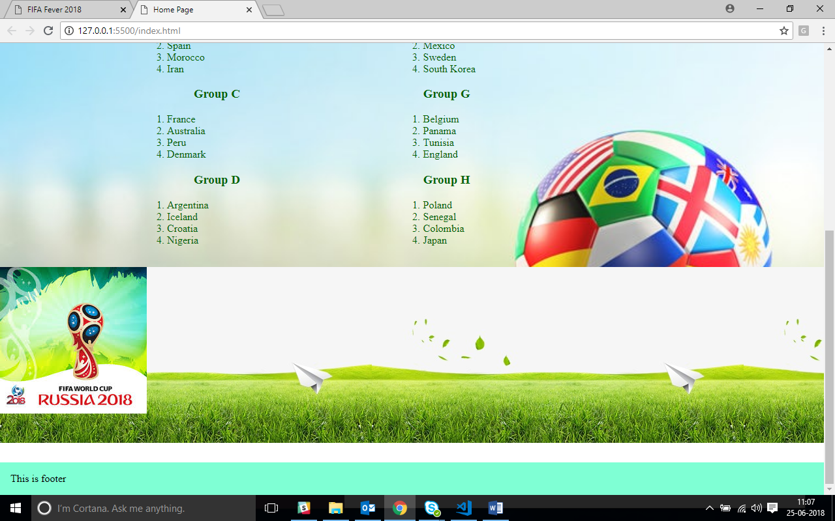

* Positioning the background :

.s2

{

background-image:url('../images/fifa-mascot.jpg'), url('../images/ground-bg.jpg');

background-repeat: no-repeat, repeat-x; /*check with only repeat*/

height:300px;

background-position:5% 50%, 0% 0%;

}

* The output for second section should look like :

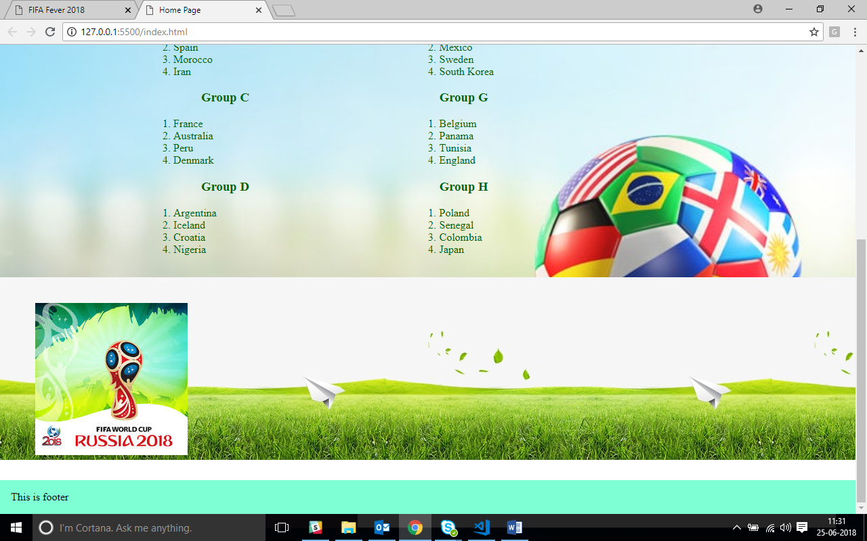

* To remove the white band above footer add following style rule to section 2 style s2 :

background-size:auto,contain;

* Other size options :
  1. background-size : cover (Covers entire background)
* Reduce the height of section 2 and observe the difference between auto and contain
* Output would be like :

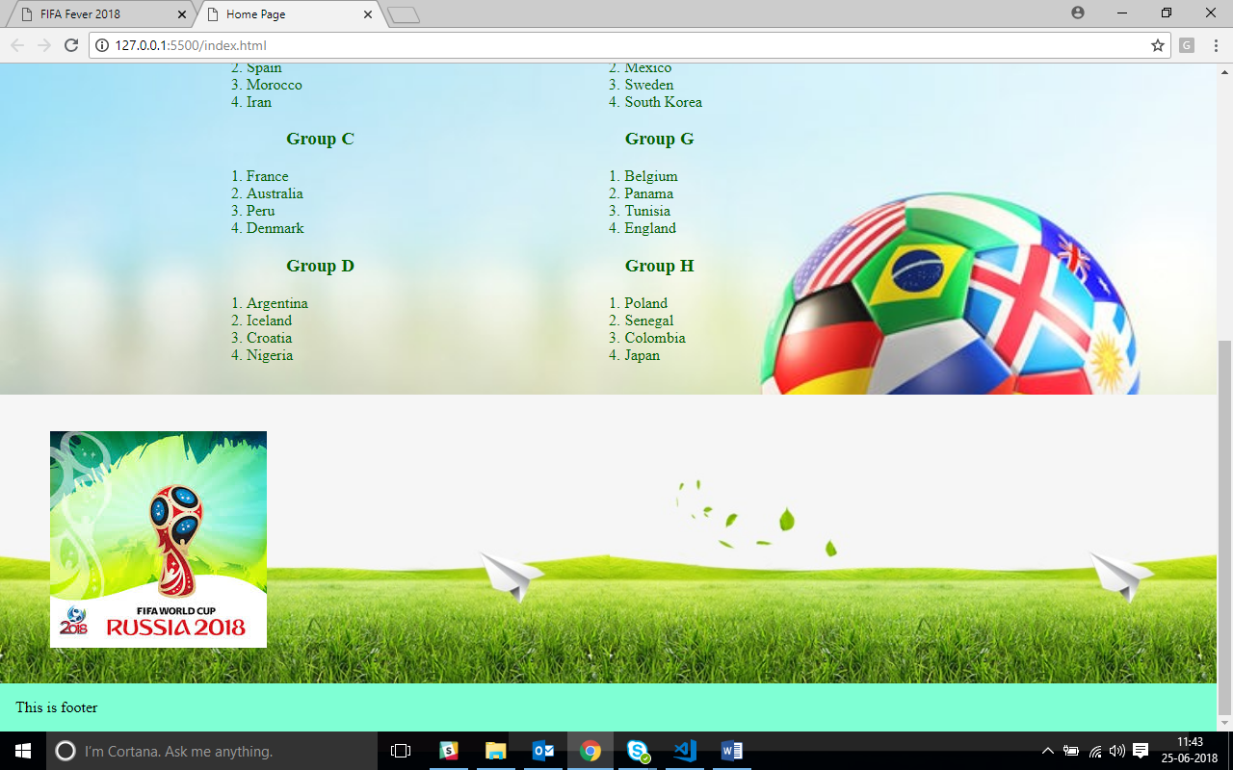

* Make html changes in footer section as below :

<footer>&copy; StackRoute</footer>

* Change the css for footer as follows :

footer

{

background-color:yellowgreen;

padding : 1em;

text-align: center;

}

* Output would be like :

