# POP LAB Programs

1. **Simulation of a Simple Calculator.**

#include<stdio.h> #include<conio.h> void main()

{

int op1,op2; char cop; clrscr();

printf("Enter the valid arithmetic expression\n"); scanf("%d%c%d",&op1,&cop,&op2); switch(cop)

{

case '+': printf("Result=%d",op1+op2); break;

case '-': printf("Result=%d",op1-op2); break;

case '*': printf("Result=%d",op1*op2); break;

case '/': printf("Result=%d",(op1/op2)); break;

case '%': printf("Result=%d",(op1%op2)); break;

default: printf("Invalid Expression\n");

}

getch();

}

Output:

*Enter the valid arithmetic expression 2+3*

**Result=5**

*Enter the valid arithmetic expression 6-4*

**Result=2**

*Enter the valid arithmetic expression 4*5*

**Result=20**

*Enter the valid arithmetic expression 8/4*

**Result=2**

# Compute the roots of a quadratic equation by accepting the coefficients. Print appropriate messages.

#include<stdio.h> #include<math.h> #include<conio.h> void main( )

{

float a, b, c, d,r1,r2; clrscr();

printf("Enter the 3 coefficients:\n"); scanf("%f%f%f", &a, &b, &c); if((a*b*c) == 0)

{

printf("Roots cannot be Determined:\n"); exit(0);

}

d = (b*b) - (4*a*c); if(d == 0)

{

printf("Roots are real and equal\n"); r1=r2= -b / (2*a);

printf("The roots are %f and %f",r1,r2);

}

else if(d>0)

{

}

else

{

}

printf("Roots are real and distinct\n"); r1= (-b + sqrt(d)) / (2*a);

r2= (-b - sqrt(d)) / (2*a);

printf("The roots are %f and %f",r1,r2);

printf("Roots are imaginary\n"); r1 = -b / (2*a);

r2 = sqrt(fabs(d)) / (2*a);

printf("The roots are %f+i%f",r1,r2); printf("The roots are %f+i%f",r1,r2);

getch();

}

*Enter the 3 coeﬃcients:*

*1 5 2*

**Roots are real and distinct**

**The roots are -0.438447 and -4.561553**

*Enter the 3 coeﬃcients:*

*4 4 1*

**Roots are real and equal**

**The roots are -0.500000 and -0.500000**

*Enter the 3 coeﬃcients:*

*5 2 4*

**Roots are imaginary**

**The roots are -0.200000+i0.871780The roots are -0.200000+i0.871780**

# An electricity board charges the following rates for the use of electricity: for the first 200 units 80 paise per unit: for the next 100 units 90 paise per unit: beyond 300 units Rs 1 per unit. All users are charged a minimum of Rs. 100 as meter charge. If the total amount is more than Rs 400, then an additional surcharge of 15% of total amount is charged. Write a program to read the name of the user, number of units consumed and print out the charges.

#include <stdio.h> #include<conio.h> void main()

{

char name[10];

float unit, charge=100; clrscr();

printf("Enter your name and unit Consumed:"); scanf("%s %f",name,&unit);

if(unit<=200)

charge=charge+unit*0.80; else if(unit<=300)

charge=charge+(unit-200)*0.90+160;

else

charge=charge+(unit-300)*1+1250;

if(charge>400)

charge=charge+charge*0.15; printf("Name:%s\ncharge:%f\n ",name,charge); getch();

}

## Output:

|  |  |
| --- | --- |
| *Enter your name: Devansh* | *Enter your name: Seena* |
| *Enter No. of unit Consumed:175* | *Enter No. of unit Consumed:445* |
| **Name:Devansh** | **Name:Seena** |
| **charge:240.000000** | **charge:1719.250000** |
| *Enter your name: Manasa* | *Enter your name: Devu* |
| *Enter No. of unit Consumed:238* | *Enter No. of unit Consumed:337* |
| **Name:Manasa** | **Name:Devu** |
| **charge:294.200012** | **charge:1595.050049** |

1. **To display the following by reading the number of rows as input.**

#include<stdio.h> #include<conio.h> void main()

{

int i,j,n;

printf("Input number of rows:"); scanf("%d",&n); for(i=0;i<=n;i++)

{

/*print blank space*/ for(j=1;j<=n-i;j++) printf(" ");

/*Numbers in ascending order*/ for(j=1;j<=i;j++) printf("%d",j);

/*Reverse order*/ for(j=i-1;j>=1;j--)

printf("%d",j);

printf("\n");

}

getch();

}

## Output:

Input number of rows:5

**1**

**121**

**12321**

**1234321**

**123454321**

1. **Implement Binary Search on Integers.**

#include<stdio.h> #include<conio.h> void main()

{

int n, a[100], i, key, high, low, mid, loc=-1; printf("Enter the size of the array\n"); scanf("%d",&n);

printf("Enter the elements of array in sorted order\n"); for(i=0;i<n;i++)

scanf("%d",&a[i]);

printf("Enter the key element to be searched\n"); scanf("%d",&key);

low=0; high=n-1;

while(low<=high)

{

mid=(low+high)/2; if(key==a[mid])

{

}

else

{

loc = mid+1; break;

if(key<a[mid])

high=mid-1;

else

}

}

low=mid+1;

if(loc>0)

printf("\n The element %d is found at %d ",key,loc);

else

printf("\nThe search is unsuccessful");

getch();

}

## Output:

Enter the size of the array 5

Enter the elements of array in sorted order 10 20 30 40 50

Enter the key element to be searched 40

**The element 40 is found at 4**

1. **Implement Matrix multiplication and validate the rules of multiplication.**

#include<stdio.h> #include<stdlib.h> #include<conio.h> void main( )

{

int m,n,p,q,row,col,k,a[3][3],b[3][3],c[3][3]; clrscr();

printf("Enter the order of matrix A\n"); scanf("%d%d",&m,&n);

printf("enter order of matrix B\n"); scanf("%d%d",&p,&q);

if(n!=p)

{

printf("Matrix Multiplication is not possible\n"); exit(0);

}

printf("Enter the elements into matrix A\n"); for(row=0;row<m;row++)

{

for(col=0;col<n;col++)

{

scanf("%d",&a[row][col]);

}

}

printf("Enter the elements into matrix B\n"); for(row=0;row<p;row++)

{

for(col=0;col<q ;col++)

{

scanf("%d",&b[row][col]);

}

}

for(row=0;row<m;row++)

{

for(col=0;col<q;col++)

{

c[row][col]=0; for(k=0;k<n;k++)

{

c[row][col]= c[row][col]+a[row][k]*b[k][col];

}

}

}

printf("The elements of matrix A are\n"); for(row=0;row<m;row++)

{

for(col=0;col<n;col++)

{

printf("%d",a[row][col]);

}

printf("\n");

}

printf("The elements of matrix B are\n"); for(row=0;row<p;row++)

{

for(col=0;col<q;col++)

{

printf("%d",b[row][col]);

}

printf("\n");

}

printf("Product of Matrix A and B is\n"); for(row=0;row<m;row++)

{

for(col=0;col<q;col++)

{

printf("%d",c[row][col]);

}

printf("\n");

}

getch();

}

## Output:

Enter the order of matrix A

Enter the elements into matrix A

Enter the elements into matrix B

**The elements of matrix A are**

**The elements of matrix B are**

**Product of Matrix A and B is**

|  |  |  |  |
| --- | --- | --- | --- |
| 3 3 | **1** | **2** | **3** |
| enter order of matrix B | **1** | **2** | **3** |
| 3 3 | **1** | **2** | **3** |

|  |  |  |  |
| --- | --- | --- | --- |
| 1 2 3 | **3** | **2** | **1** |
| 1 2 3 | **3** | **2** | **1** |
| 1 2 3 | **3** | **2** | **1** |

|  |  |  |  |  |
| --- | --- | --- | --- | --- |
| 3 2 1 |  | **18** | **12** | **6** |
| 3 2 1 |  | **18** | **12** | **6** |
| 3 2 1 |  | **18** | **12** | **6** |

1. **Compute sin(x)/cos(x) using Taylor series approximation. Compare your result with the built-in library function. Print both the results with appropriate inferences.**

#include<stdio.h> #include<math.h> #include<conio.h> int main( )

{

int i;

float x,t,sum,sum1,y; clrscr();

printf("Enter the angle\n"); scanf("%f",&x);

y=x; x=3.1428*(x/180.0);

sum=x; t=x; i=1;

do

{

i=i+2;

t=(-t*x*x)/((i-1)*i); sum=sum+t;

}while(fabs(t)>0.00005);

printf("sin(%f) using taylor series=%f\n",y,sum); sum1=sin(x);

printf("Using inbuilt function sin(%f)=%f",y,sum1); getch();

}

## Output:

*Enter the angle 45*

**Sin (45.000000) using taylor series=0.707320 Using inbuilt function sin(45.000000)=0.707320**

1. **Sort the given set of N numbers using Bubble sort.**

#include<stdio.h> #include<conio.h> void main()

{

int i,j,n,temp; int a[20];

clrscr();

printf("enter the value of n"); scanf("%d",&n);

printf("Enter the numbers in unsorted order:\n"); for(i=0;i<n;i++)

scanf("%d", &a[i]);

// bubble sort logic for(i=0;i<n;i++)

{

for(j=0;j<(n-i)-1;j++)

{

if( a[j]>a[j+1])

{

temp=a[j]; a[j]=a[j+1]; a[j+1]=temp;

}

}

}

printf("The sorted array is\n"); for(i=0;i<n;i++)

{

printf("%d\n",a[i]);

}

getch();

}

## Output:

*enter the value of n 6*

*Enter the numbers in unsorted order: 4 5 3 2 1 6*

***The sorted array is 1***

***2***

***3***

***4***

***5***

***6***

1. **Write functions to implement string operations such as compare, concatenate, and find string length. Use the parameter passing techniques.**

#include<stdio.h> #include<string.h> #include<conio.h>

void compare(char [ ],char [ ]); void concat(char [ ],char [ ]); void length(char *[ ]);

void main( )

{

int n,digit; clrscr();

char str1[10],str2[10]; do

{

printf("press 1-compare 2-concatenate 3-length of string"); printf("\n enter your choice= ");

scanf("%d",&n); switch(n)

{

case 1:printf("enter first string="); scanf("%s",str1);

printf("enter second string="); scanf("%s",str2); compare(str1,str2);

break;

case 2: printf("enter first string="); scanf("%s",str1);

printf("enter second string="); scanf("%s",str2); concat(str1,str2);

break;

case 3:printf("enter string="); scanf("%s",str1); length(&str1);

break;

default: printf("wrong choice"); break;

}

printf("\n Do you want to continue(1/0)? "); scanf("%d", &digit);

}while(digit==1); getch();

}

void compare(char str1[ ],char str2[ ])

{

int i;

i=strcmp(str1,str2); if(i==0)

printf("strings are equal\n ");

else

}

printf("string are not equal\n");

void concat(char str1[ ],char str2[ ])

{

strcat(str1,str2);

printf("concatenate string=%s",str1);

}

void length(char *str1[ ])

{

int len; len=strlen(str1);

printf("the length of string=%d",len);

}

## Output:

*press 1-compare 2-concatenate 3-length of string enter your choice= 1*

*enter ﬁrst string=Seena enter second string=Seena* **strings are equal**

*Do you want to continue(1/0)? 1*

*press 1-compare 2-concatenate 3-length of string enter your choice= 2*

*enter ﬁrst string=Devansh enter second string=Manasa*

**concatenate string=DevanshManasa**

*Do you want to continue(1/0)? 1*

*press 1-compare 2-concatenate 3-length of string enter your choice= 3*

*enter string=Dhanalakshmi*

**the length of string=12**

*Do you want to continue(1/0)? 0*

1. **Implement structures to read, write and compute average- marks of the students, list the students scoring above and below the average marks for a class of N students.** #include<stdio.h>

#include<conio.h> struct student

{

char usn[10]; char name[10]; float m1,m2,m3; float avg,total;

};

void main()

{

struct student s[20]; int n,i;

float avg,sum=0.0; clrscr();

printf("Enter the number of student="); scanf("%d",&n);

for(i=0;i<n;i++)

{

printf("Enter the detail of %d students\n",i+1); printf("\n Enter USN=");

scanf("%s",s[i].usn); printf("\n Enter Name="); scanf("%s",s[i].name);

printf("Enter the three subject score\n"); scanf("%f%f%f",&s[i].m1,&s[i].m2,&s[i].m3);

s[i].total=s[i].m1+s[i].m2+s[i].m3; s[i].avg=s[i].total/3;

}

for(i=0;i<n;i++)

{

if(s[i].avg>=35)

printf("\n %s has scored above the average marks",s[i].name);

else

}

printf(“\n %s has scored below the average marks”,s[i].name);

getch();

}

## Output:

*Enter the number of student=3 Enter the detail of 1 students*

*Enter USN=3BR22DS300*

*Enter Name=BITM*

*Enter the three subject score 87 67 75*

*Enter the detail of 2 students Enter USN=3BR22DS301*

*Enter Name=DATASCIENCE Enter the three subject score 67 98 58*

*Enter the detail of 3 students Enter USN=3BR22DS303*

*Enter Name=DUMMY*

*Enter the three subject score 35 25 29*

**BITM has scored above the average marks DATASCIENC has scored above the average marks DUMMY has scored below the average marks**

1. **Develop a program using pointers to compute the sum,mean and standard deviation of all elements stored in an array of N real numbers.**

#include<stdio.h> #include<math.h> #include<conio.h> int main()

{

int n,i;

float x[20],sum,mean; float variance , deviation; clrscr();

printf("Enter the value of n \n"); scanf("%d",&n);

printf("enter %d real values \n",n); for (i=0;i<n;i++)

{

scanf("%f",(x+i));

}

sum=0; for(i=0;i<n;i++) sum= sum+*(x+i);

printf("sum=%f\n",sum); mean=sum/n;

sum=0; for(i=0;i<n;i++)

{

sum=sum+(*(x+i)-mean)*(*(x+i)-mean);

}

variance = sum/n; deviation=sqrt(variance); printf("mean(Average)=%f\n",mean); printf("variance=%f\n",variance);

printf("standard deviation=%f\n",deviation); retrun 0;

}

## Output:

*Enter the value of n 5*

*enter 5 real values*

*4.6 5.7 2.2 3.4 6.1*

**sum=22.000000**

**mean(Average)=4.400000 variance=2.092000**

**standard deviation=1.446375**

1. **Write a C program to copy a text file to another, read both the input file name and target file name.**

#include<stdio.h> #include<conio.h> void main()

{

FILE *fp1,*fp2;

char ch, sfile[10],dfile[10]; clrscr();

printf("Enter the source file\n"); gets(sfile);

printf("Enter teh destination file\n"); gets(dfile);

fp1=fopen(sfile,"r"); fp2=fopen(dfile,"w"); if(fp1==NULL||fp2==NULL)

printf("File doesnot exists");

else

{

}

while((ch=fgetc(fp1))!=EOF) fputc(ch,fp2);

printf("File copied\n");

getch();

}

## Output:

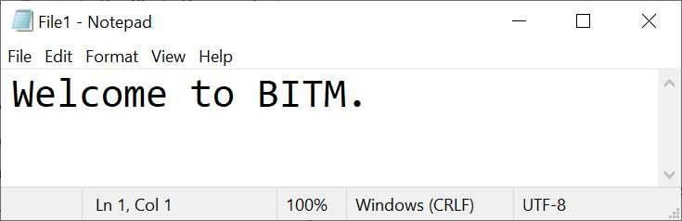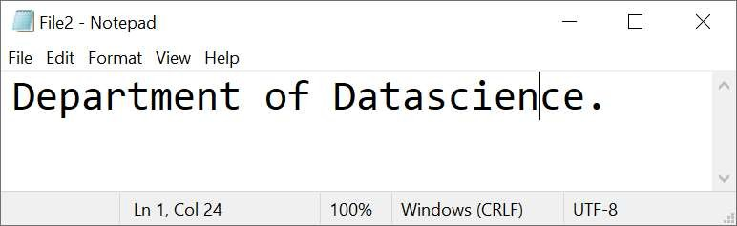

**Enter the source file File1.txt**

**Enter teh destination file File2.txt**

**File copied**

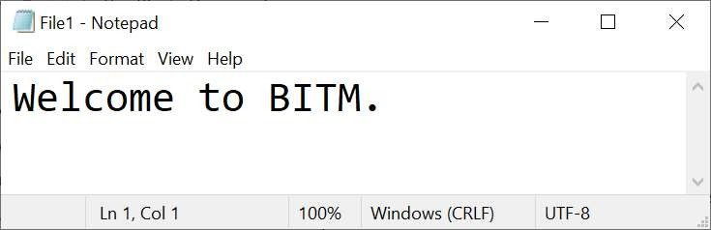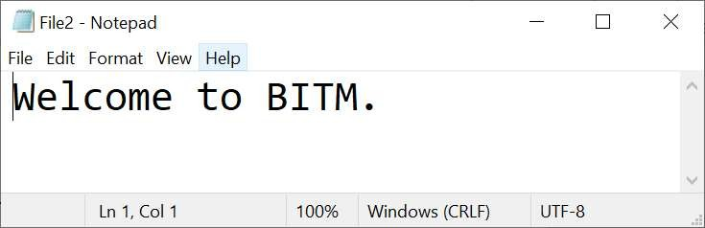

************************End of Lab Program********************************