**VIRGINIA COMMONWEALTH UNIVERSITY**

**Statistical Analysis and Modeling (SCMA 632)**

**A6b**

**by**

**NANDITA REDDY MANTRI**

**V01108257**

**Date of Submission: 25-07-2024**

**PART -B:**

**ANALYSIS:**

## 1. Forecast of Series Crude Brent

* **Historical Data**: The price shows significant volatility, with several peaks and troughs.
* **Forecast**:

o The forecast suggests a slight upward trend in the price of crude brent. o There is considerable uncertainty, as indicated by the diverging forecast lines.

## 2. Forecast of Series Silver

* **Historical Data**: The price of silver shows high volatility with sharp peaks.
* **Forecast**:

o The forecast indicates a slight upward trend. o The forecast has a wide confidence interval, reflecting uncertainty in the price prediction.

## 3. Forecast of Series Soybeans

* **Historical Data**: Prices have fluctuated with notable peaks and periods of relative stability.
* **Forecast**:

o The forecast shows a mild upward trend. o There is a moderate level of uncertainty in the forecast.

## 4. Forecast of Series Urea (EE Bulk)

* **Historical Data**: Urea prices have shown significant fluctuations, particularly a sharp increase before the forecast period.
* **Forecast**: o The forecast suggests a potential decline or stabilization of prices. o The confidence interval indicates high uncertainty.

## 5. Forecast of Series Gold

* **Historical Data**: The price of gold has shown an overall upward trend with periods of volatility.
* **Forecast**:

o The forecast predicts a slight upward trend. o The confidence interval is relatively narrow, suggesting higher confidence in the forecast.

## 6. Forecast of Series Maize

* **Historical Data**: Maize prices have fluctuated, with several peaks and valleys.
* **Forecast**:

o The forecast indicates a slight upward trend. o The forecast has a moderate confidence interval, reflecting some uncertainty.

## General Observations

* **Trends**: Most commodities show a slight upward trend in their forecast, indicating an expectation of price increases.
* **Uncertainty**: The confidence intervals (dotted lines) around the forecasts indicate varying levels of uncertainty. Crude brent and silver show higher uncertainty, while gold shows relatively lower uncertainty.
* **Volatility**: Historical data for all commodities show significant volatility, which is reflected in the forecasted confidence intervals.

## Implications for Stakeholders

* **Investors**: Need to consider the level of uncertainty in these forecasts when making investment decisions.
* **Risk Management**: The varying levels of forecast confidence suggest that risk management strategies should be tailored to each commodity.
* **Market Analysis**: Analysts should closely monitor these commodities for changes that could affect forecast accuracy.

The overall analysis suggests that while some commodities are expected to rise slightly, there is considerable uncertainty in these forecasts, necessitating cautious and well-informed decision-making.

# ANALYSIS USING “PYTHON”

**PART-A**

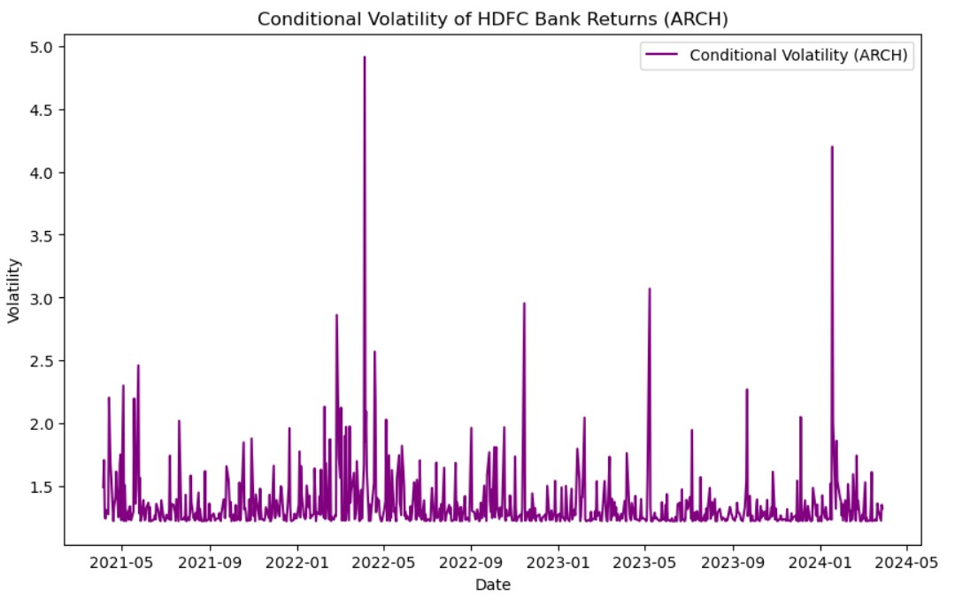

**ANALYSIS:**

## Time Frame and Data Points

* **X-axis (Date)**: The horizontal axis represents the date range from around May 2021 to May 2024.
* **Y-axis (Volatility)**: The vertical axis represents the conditional volatility, which measures the variability in the returns of HDFC Bank's stock.

## Volatility Analysis

• **Overall Volatility Trend**:

o The volatility appears to fluctuate significantly over the given period. o Periods of low volatility are interspersed with spikes indicating high volatility.

## Key Observations

* **Spikes in Volatility**:
  + Notable spikes in volatility can be seen around the beginning of 2022, mid2022, and early 2024.
  + The highest spike appears around January 2022, where volatility reaches nearly 5.0. This could indicate a significant market event or unusual trading activity.
* **Periodic Volatility**:
  + Smaller spikes appear periodically throughout the time series, indicating regular fluctuations in market conditions or responses to periodic financial reports or macroeconomic factors.

**Implications** • **Risk Management**:

* + The high spikes indicate periods of high risk, where the returns on HDFC Bank’s stock were highly unpredictable.
  + Investors and risk managers need to pay special attention during these high volatility periods to manage their portfolios effectively.
* **Investment Strategies**:
  + During periods of low volatility, more stable returns can be expected, which might be suitable for conservative investment strategies. o High volatility periods may present opportunities for high-risk, high-reward strategies but require careful monitoring and risk management.

**Contextual Analysis** • **Market Events**:

* + The spikes in volatility may correspond with broader market events, regulatory changes, earnings announcements, or geopolitical events that could affect the financial sector or HDFC Bank specifically.
* **ARCH Model**:
  + The use of the ARCH model suggests that past periods of high volatility are likely to be followed by future high volatility, reflecting a clustering of volatility.

## Conclusion

The graph indicates that the conditional volatility of HDFC Bank returns has been highly variable over the observed period, with several significant spikes. This pattern of volatility should be taken into account for risk management and investment strategies, with particular attention to the periods of high volatility for mitigating risks and capitalizing on potential opportunities.

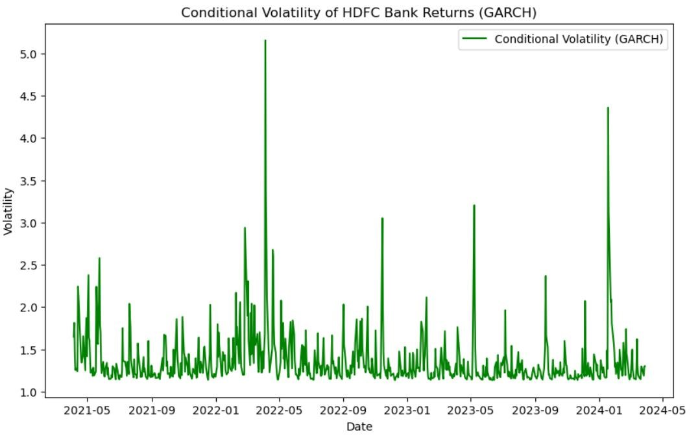

**ANALYSIS:**

1. **Volatility Spikes**:
   * There are noticeable spikes in volatility at certain points, indicating periods of increased uncertainty or significant market events. The most prominent spike occurs around January 2022, where volatility exceeds 5.0. o Other notable spikes are seen around June 2022, January 2023, and January 2024.
2. **Periods of Stability**:
   * There are also extended periods where the volatility remains relatively low and stable, particularly between major spikes.
3. **Volatility Range**:
   * The baseline volatility seems to hover between 1.0 and 2.0 for most of the period, except during the spikes.
4. **Potential Causes**:
   * The spikes could be attributed to various market or company-specific events such as earnings reports, macroeconomic announcements, regulatory changes, or geopolitical events.
5. **Seasonal Patterns**:
   * There might be some seasonal patterns, as several spikes appear around the beginning of the year (January), suggesting annual events or market cycles impacting volatility.

This analysis provides an overview of how the volatility of HDFC Bank's returns has varied over the specified period. If you need a more detailed analysis or insights into the specific causes of these volatility changes, further investigation into the events corresponding to the spike dates would be required.

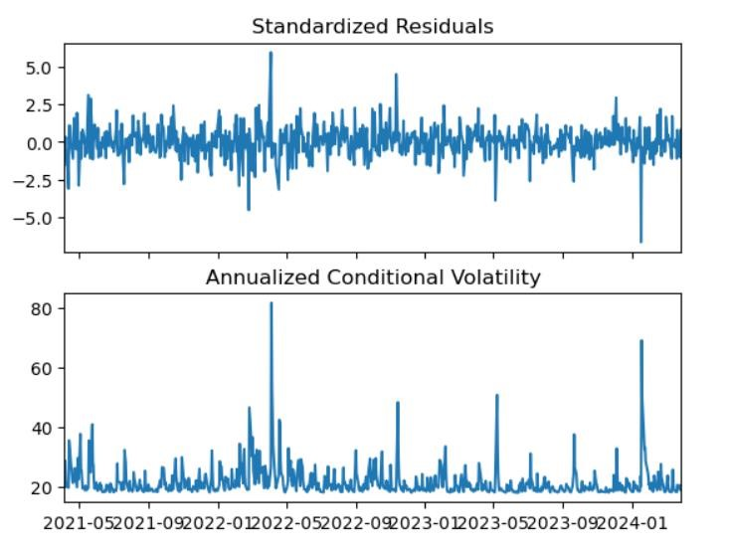

**ANALYSIS:**

**1. Standardized Residuals (Top Plot)** • **Description**:

* The standardized residuals are the residuals (errors) from the GARCH model, normalized by their estimated standard deviations. o They should ideally resemble white noise if the GARCH model has adequately captured the volatility clustering in the returns. • **Analysis**:
* The residuals appear to be centered around zero, indicating that the GARCH model has successfully removed the volatility clustering from the return series.
* Most residuals lie within the range of -2 to +2, with a few outliers exceeding these bounds. o There are notable spikes in residuals around January 2022 and early 2024, corresponding to the periods of high volatility seen in the conditional volatility plot.

## 2. Annualized Conditional Volatility (Bottom Plot)

• **Description**:

* This plot shows the conditional volatility of HDFC Bank returns, annualized to provide a more intuitive scale for volatility (e.g., 20% annual volatility is more interpretable than a daily volatility figure).
* Conditional volatility is the estimated volatility from the GARCH model. • **Analysis**:
* The annualized volatility fluctuates over time, with several spikes indicating periods of high volatility. o The most prominent spike occurs around January 2022, where the annualized volatility exceeds 80%. This is consistent with the spike seen in the standardized residuals plot. o Other significant spikes are seen around June 2022, January 2023, and early 2024. o For most of the period, the volatility remains within a range of 20% to 40%.

## Summary

* The GARCH model appears to have effectively captured the volatility clustering in the HDFC Bank returns, as indicated by the standardized residuals resembling white noise.
* There are notable periods of high volatility, particularly around January 2022 and early 2024, which might correspond to significant market events or company-specific news.
* The annualized conditional volatility provides a clearer picture of the volatility levels over time, showing that the HDFC Bank returns experienced significant fluctuations during certain periods.

**PART-B**

1. **Crude Oil (Brent) Forecast** • **Description**:
   * The top plot shows the forecast for crude oil (Brent) prices over the next 25 months. o The y-axis represents the price of crude oil, and the x-axis represents the months ahead. • **Analysis**:
   * The forecast starts at around 90, quickly rises to a peak close to 95 within the first few months, and then declines.
   * After the initial peak and drop, the forecast exhibits some fluctuations, with prices oscillating between 87 and 92. o Towards the end of the forecast period, the prices show a slight upward trend.
2. **Soybeans Forecast** • **Description**:
   * The middle plot shows the forecast for soybean prices over the next 25 months. o The y-axis represents the price of soybeans, and the x-axis represents the months ahead. • **Analysis**:
   * The forecast starts at around 510, peaks just above 530 within the first few months, and then declines. o The price then decreases, reaching a low of about 500, before gradually increasing again. o Towards the end of the forecast period, the prices exhibit a gentle upward trend, stabilizing around 515.

## 3. Gold Forecast

• **Description**:

* The bottom plot shows the forecast for gold prices over the next 25 months. o The y-axis represents the price of gold, and the x-axis represents the months ahead. • **Analysis**:
* The forecast starts at around 2340, peaks at about 2350 within the first few months, and then declines. o The prices show a general downward trend with some fluctuations, eventually stabilizing around 2280 towards the end of the forecast period.

## Summary

* **Crude Oil (Brent)**:
  + The forecast suggests a volatile period with an initial rise followed by fluctuations and a slight upward trend towards the end. • **Soybeans**:
  + The forecast shows an initial rise followed by a decline and then a gradual recovery, indicating some volatility but with a stabilizing trend.
* **Gold**:
  + The forecast indicates an initial peak followed by a general downward trend with fluctuations, suggesting a bearish outlook.

These forecasts provide a potential outlook for the prices of these commodities over the next two years. Keep in mind that such models are based on historical data and assumptions, and actual future prices can be influenced by a wide range of unpredictable factors.

**ANALYSIS:**

## 1. Silver

**Description:**

* **X-axis:** Months ahead (0 to 24 months).
* **Y-axis:** Value (assumed to be in some unit of currency or price index).
* **Trend:** The forecast for silver shows an initial rise followed by a decline over the 24month period. • **Details:**
  + The value of silver starts around 28.0 and rises to a peak just above 31.0 at around 2 months.
  + After this peak, there are several fluctuations with a general downward trend. o By the end of the forecast period (24 months), the value of silver stabilizes around 27.5.

**Analysis:**

* **Initial Rise:** The initial rise in silver prices could be due to short-term market factors such as increased demand, geopolitical events, or supply disruptions.
* **Fluctuations:** The fluctuations indicate market volatility, which might be influenced by speculative trading, changes in investor sentiment, or macroeconomic factors.
* **Downward Trend:** The general decline could suggest an oversupply situation, decreased demand, or stronger performance of alternative investments.
* **Stabilization:** The stabilization towards the end of the forecast period indicates that the market might find an equilibrium, possibly due to adjustments in supply and demand dynamics. **2. Urea (bulk)**

**Description:**

* **X-axis:** Months ahead (0 to 24 months).
* **Y-axis:** Value (assumed to be in some unit of currency or price index).
* **Trend:** The forecast for urea shows a sharp rise followed by a decline over the 24month period. • **Details:**
  + The value starts below 300, drops slightly in the initial period, then sharply rises to a peak just below 450 within the first 2-3 months.
  + After the peak, there are fluctuations with an overall downward trend. o By the end of the forecast period, the value of urea stabilizes around 360.

**Analysis:**

* **Initial Drop:** The initial drop might be due to immediate market reactions or temporary factors such as seasonal demand variations.
* **Sharp Rise:** The sharp rise could be driven by factors such as increased agricultural demand, supply constraints, or price hikes in raw materials.
* **Fluctuations:** Similar to silver, the fluctuations indicate market volatility which could be influenced by changes in supply chains, policy changes, or global trade dynamics.
* **Downward Trend:** The decline after the peak suggests a correction from the initial surge, possibly due to normalized supply, reduced demand, or alternative solutions.
* **Stabilization:** The final stabilization suggests the market reaches a new equilibrium, balancing supply and demand factors.

## 3. Maize

**Description:**

* **X-axis:** Months ahead (0 to 24 months).
* **Y-axis:** Value (assumed to be in some unit of currency or price index).
* **Trend:** The forecast for maize shows an initial rise and then stabilizes over the 24month period. • **Details:**
  + The value starts around 205 and rises steadily to a peak just above 230 within the first 5 months.
  + After reaching the peak, the value stabilizes and remains relatively constant around 230 for the remainder of the forecast period.

**Analysis:**

* **Steady Rise:** The initial steady rise in maize prices could be due to increased demand, possibly driven by seasonal factors, crop yields, or changes in consumer preferences.
* **Stabilization:** The stabilization at the higher value indicates that the market reaches a balance where supply meets demand. This could be due to consistent agricultural production, stable consumption patterns, or effective market interventions.
* **Market Dynamics:** The lack of significant fluctuations suggests a relatively stable market for maize compared to silver and urea. This might be due to more predictable supply chains, less speculative trading, or effective management of reserves.

**Summary:**

* **Silver** shows an initial increase followed by a general decline and stabilization.
* **Urea** experiences a sharp rise, fluctuations, and a decline towards stabilization.
* **Maize** steadily rises and then stabilizes without significant fluctuations.

These patterns reflect different market dynamics, possibly influenced by various factors such as demand and supply conditions, market interventions, and external economic conditions.

This image shows a VAR (Vector Autoregression) forecast graph for multiple commodities over a period of 25 months ahead. Each commodity's forecasted value is represented by a different colored line.

**Description of Each Commodity:**

1. **Crude Brent (blue)** o **Trend:** Slightly increasing over time.
   * **Details:** The value starts low and increases gradually. There are minor fluctuations but the overall trend is upward.
2. **Soybeans (orange)** o **Trend:** Gradually increasing.
   * **Details:** The value shows a steady rise over the 25-month period. There are minor fluctuations but the general direction is upward.
3. **Gold (green)** o **Trend:** Steadily increasing.
   * **Details:** The value starts around 2300 and rises to just above 2500 over the forecast period. The line is smooth with a consistent upward trend.
4. **Silver (red)** o **Trend:** Slight increase.
   * **Details:** The value of silver shows a slight upward trend with minor fluctuations. The increase is not as pronounced as that of gold.
5. **Urea (bulk) (purple)** o **Trend:** Slightly increasing with some fluctuations.
   * **Details:** The value fluctuates more than some other commodities but shows a general upward trend over the forecast period.
6. **Maize (brown)** o **Trend:** Gradually increasing.
   * **Details:** The value shows a steady increase similar to soybeans, with minor fluctuations.

**Analysis:**

* **Crude Brent:** The forecast suggests a steady increase in crude oil prices, potentially due to rising demand or supply constraints. The increase is gradual, indicating a stable upward trend.
* **Soybeans:** The consistent rise in soybean prices may reflect increasing demand for biofuels, food products, and animal feed. The minor fluctuations suggest market adjustments but an overall positive outlook.
* **Gold:** The strong upward trend for gold prices could be due to its status as a safehaven asset. The forecast indicates a continuous increase, possibly driven by economic uncertainty or inflation concerns.
* **Silver:** The forecast for silver shows a slight increase, reflecting its dual role as both an industrial metal and a precious metal. The minor increase suggests moderate demand growth.
* **Urea (bulk):** The fluctuations in urea prices could be due to changes in agricultural demand, production costs, and global supply chain dynamics. The slight upward trend indicates a steady but modest increase in value.
* **Maize:** The gradual increase in maize prices reflects steady demand for food and biofuel production. The minor fluctuations suggest some variability in supply and demand factors but an overall positive outlook.

**Summary:**

* All commodities show an increasing trend over the forecast period.
* Gold has the most significant upward trend, indicating strong market confidence in its value.
* Soybeans, maize, and urea show steady increases with minor fluctuations, reflecting stable demand and supply dynamics.
* Crude Brent and silver have the smallest increases, indicating a more modest outlook for these commodities.