Name: Nanditha Prabakar

**Question – 47:**

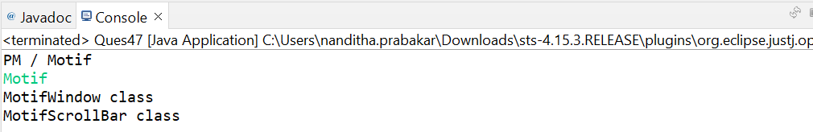

**Window.java:**

**package** test4;

**public** **interface** Window {

**void** wclass();

}

**class** PMWindow **implements** Window {

@Override

**public** **void** wclass() {

System.***out***.println("PMWindow class");

}

}

**class** MotifWindow **implements** Window {

@Override

**public** **void** wclass() {

System.***out***.println("MotifWindow class");

}

}

**Scrollbar.java:**

**package** test4;

**public** **interface** ScrollBar {

**void** wclass();

}

**class** PMScrollBar **implements** ScrollBar {

@Override

**public** **void** wclass() {

System.***out***.println("PMScrollBar class");

}

}

**class** MotifScrollBar **implements** ScrollBar {

@Override

**public** **void** wclass() {

System.***out***.println("MotifScrollBar class");

}

**WidgetFactory.java:**

**package** test4;

**public** **interface** WidgetFactory {

Window createWindow();

ScrollBar createScrollBar();

}

**PMWidgetFactory.java:**

**package** test4;

**public** **class** PMWidgetFactory **implements** WidgetFactory {

@Override

**public** Window createWindow() {

**return** **new** PMWindow();

}

@Override

**public** ScrollBar createScrollBar() {

**return** **new** PMScrollBar();

}

}

**MotifWidgetFactory.java:**

**package** test4;

**public** **class** MotifWidgetFactory **implements** WidgetFactory {

@Override

**public** Window createWindow() {

**return** **new** MotifWindow();

}

@Override

**public** ScrollBar createScrollBar() {

**return** **new** MotifScrollBar();

}

}

**Application.java:**

**package** test4;

**public** **class** Application {

**private** Window window;

**private** ScrollBar scrollbar;

**public** Application(WidgetFactory factory) {

window = factory.createWindow();

scrollbar = factory.createScrollBar();

}

**public** **void** wclass() {

window.wclass();

scrollbar.wclass();

}

}

**Ques47.java:**

**package** test4;

**import** java.util.Scanner;

**public** **class** Ques47 {

**private** **static** Application configure() {

Application app;

WidgetFactory factory;

Scanner input = **new** Scanner(System.***in***);

System.***out***.println("PM / Motif");

String inp = input.next();

**if** (inp == "pm"){

factory = **new** PMWidgetFactory();

} **else** {

factory = **new** MotifWidgetFactory();

}

app = **new** Application(factory);

**return** app;

}

**public** **static** **void** main(String[] args) {

Application app = *configure*();

app.wclass();

}

}