Name: Nanditha Prabakar

**Question – 50:**

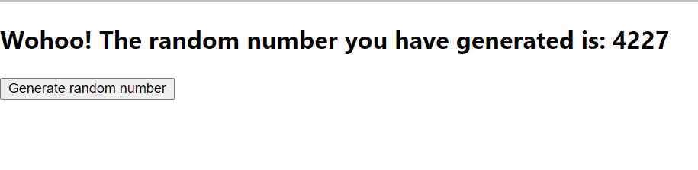

import './App.css';

import {useState} from 'react';

const App = () => {

  const [num, setNum] = useState(0);

  function randomNumberRange(min, max) {

    return Math.floor(Math.random() * (max - min + 1)) + min;

  }

  const handleClick = () => {

    setNum(randomNumberRange(10, 5000));

  };

  return (

    <div>

      <h2>Wohoo! The random number you have generated is: {num}</h2>

      <button onClick={handleClick}>Generate random number</button>

    </div>

  );

};

export default App;