Bettercap ARP Spoofing Practical Documentation
Tool Name: Bettercap
Installation Command: sudo apt-get install bettercap
This document demonstrates the practical usage of Bettercap for ARP spoofing and network monitoring in a controlled lab environment. The screenshots below show interface configuration, Bettercap usage, ARP spoofing commands, and packet analysis using Wireshark.

Commands and Usage
Purpose | Command
To know all interfaces | ip a
To select interface | bettercap -iface eth0
To check all active modules | help
To check connected network | net.probe on
To check ARP spoof help | help arp.spoof
To attack router | set arp.spoof.fullduplex true
To choose target machine | set arp.spoof.targets <ip>
To start ARP spoofing | arp.spoof on
To verify spoofed MAC in Windows | Open CMD → arp -a

Practical Steps Performed
- Checked the routing table and network interface details using route -n and ip a.
- Started Bettercap with the selected interface eth0.
- Verified Bettercap modules and active services.
- Enabled network probing to identify devices connected to the local network.
- Viewed ARP spoofing module help and configuration options.
- Enabled fullduplex ARP spoofing mode.
- Selected the target IP address for spoofing.
- Started ARP spoofing and monitored the traffic.
- Captured packets in Wireshark and verified SMB/NetBIOS traffic from the target machine.

Attached Screenshots

Routing table and interface configuration
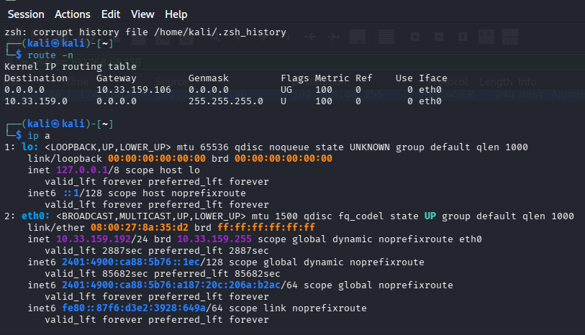

Bettercap initialization and module listing
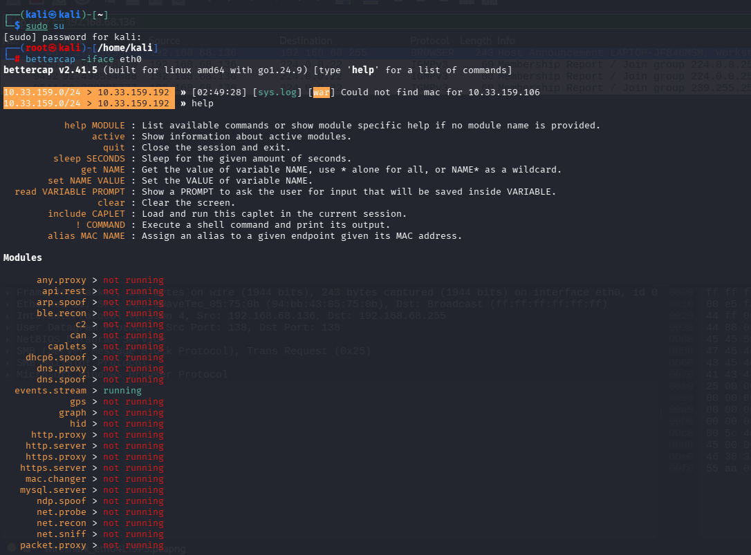

Network discovery and mDNS traffic monitoring
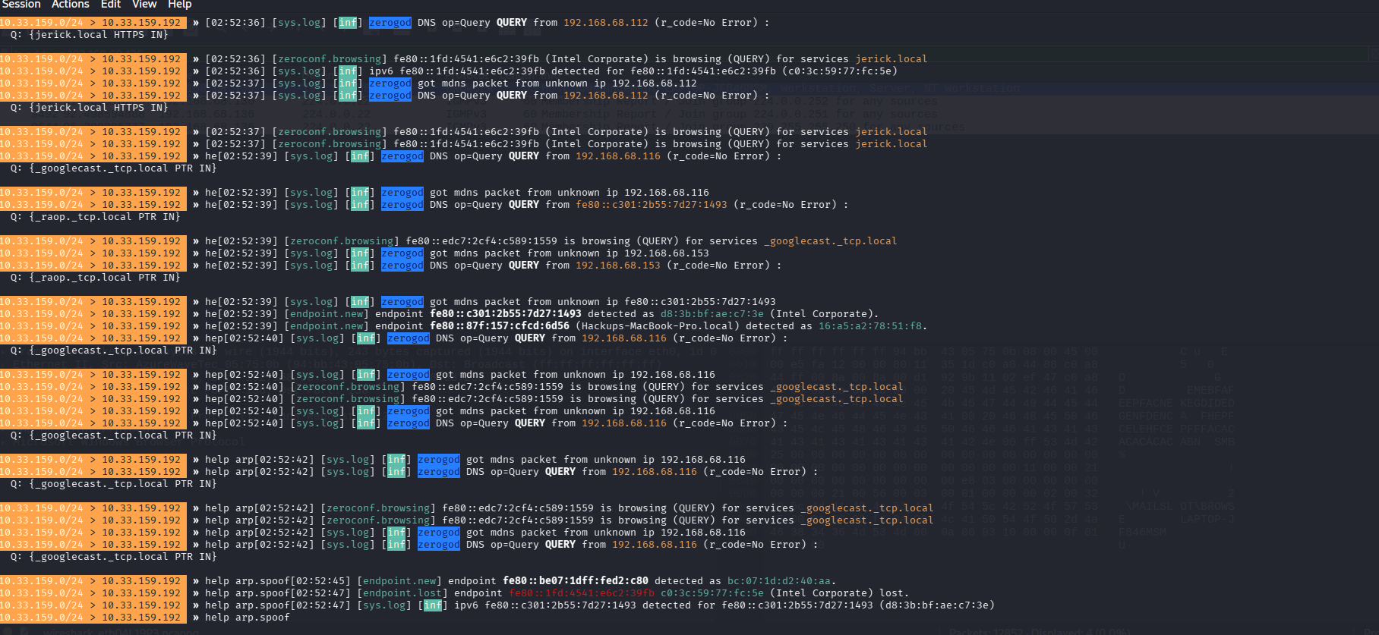

ARP spoofing configuration and target detection
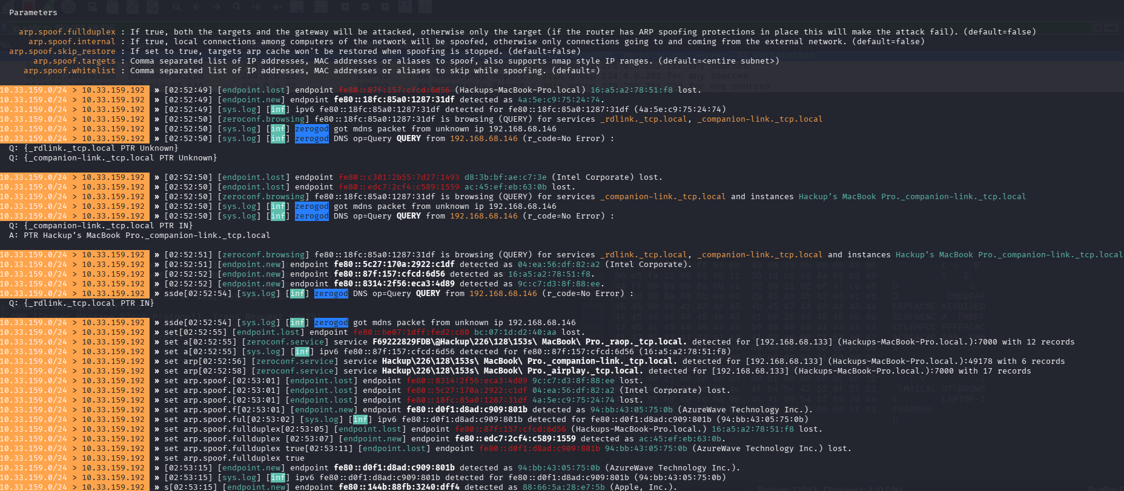

Bettercap logs during spoofing activity
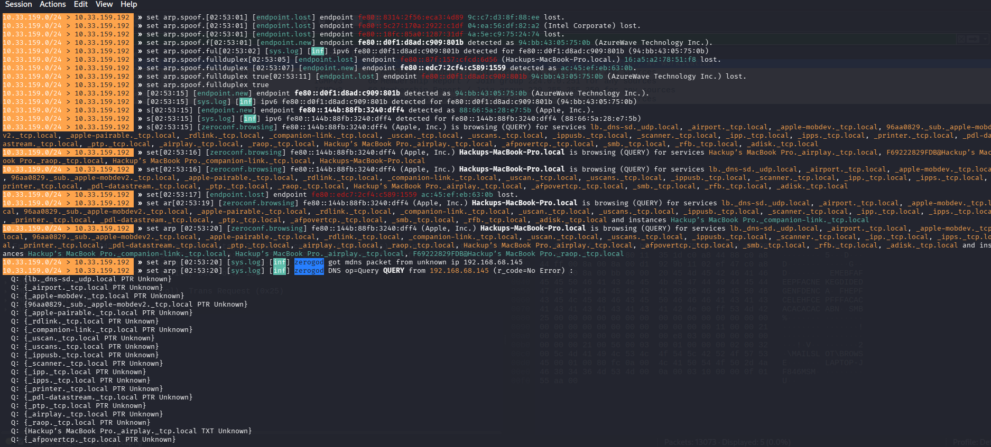

Wireshark packet capture verification
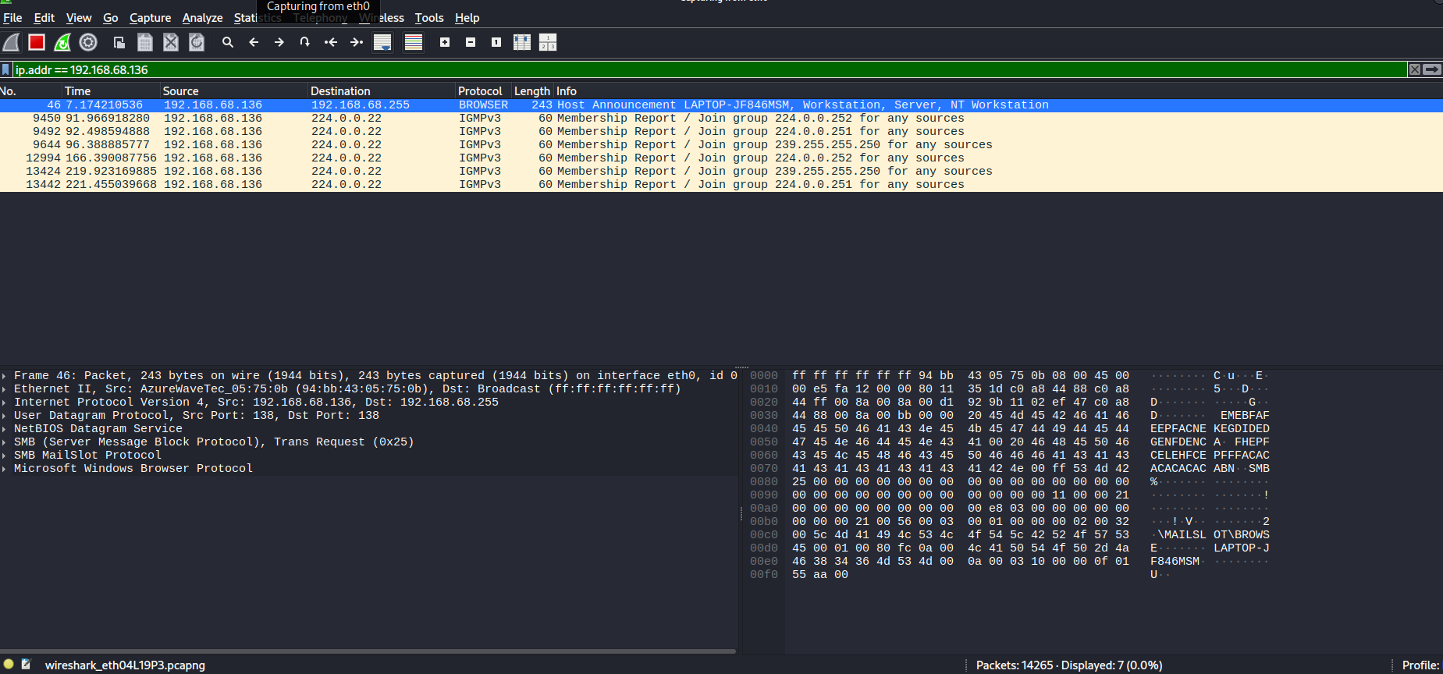

Conclusion
Using Bettercap, ARP spoofing was successfully configured in a controlled environment. Network traffic from the target machine was observed and verified through Wireshark packet analysis. This practical exercise helped in understanding man-in-the-middle concepts, ARP behavior, and packet inspection techniques.

