FORESIGHT
GAN Model Comparison Report
Class-conditional DCGAN for training-only augmentation, and a controlled comparison of real-only, conventional-augmentation and real-plus-GAN training.

Project: Foresight — visual produce-spoilage estimation (research prototype)
Document: A — GAN model comparison
Date: 15 October 2026
Workspace: /Users/nandu/Downloads/foresight
Deployed model: vit_b16_primary@epoch9 (backend/models/foresight_vit.pt)
Every number in this document is generated by releases/final_review/build/build_reports.py from saved run logs and result files; nothing is hand-entered. Labels such as NOT RUN, NOT AVAILABLE, BLOCKED or SIMULATED mark results that do not exist.

Contents
1 Summary of findings
2 Dataset and split used for the GAN
3 Architecture, objective and hyperparameters
4 Synthetic sample generation and quality checks
5 Comparison protocol
6 Results
7 Earlier single-seed comparison (v1, superseded)
8 Interpretation and conclusion
9 Limitations
10 Reproducibility

(Right-click → Update Field in Word if the contents list appears empty.)

1 Summary of findings
- A class-conditional DCGAN (64×64, 12 conditions = produce × spoilage) was trained on the training split only (3,177 images, 41 epochs, 12.0 min budget) and generated 480 images (40 per condition).
- Quality is limited. The deployed classifier (trained on real images only) recognises the intended produce type in only 34.6% of GAN images and the intended spoilage label in 77.7%; within-condition diversity is 0.79× that of real images. No memorisation was detected.
- Controlled comparison (ViT-S/16, identical configuration, seeds 42/43/44, same untouched test split): real-only 0.914 ± 0.006, conventional augmentation 0.928 ± 0.007, real + GAN 0.919 ± 0.018 test spoilage macro-F1 (mean ± SD).
- Paired per-seed difference GAN − conventional augmentation: -0.009 (per seed: +0.000, +0.008, -0.035). With three seeds this is not evidence of a reliable benefit; see Section 7.

2 Dataset and split used for the GAN
The GAN uses only the training partition of split v1 (session-grouped, duplicate-aware, seed 42): 3,177 unique sRGB images. Validation (1,087) and test (1,071) images were never shown to the GAN, and generated images were only ever added to classifier training sets.
Table 1. GAN training images per condition (training split only).
Condition (produce / label) | Train images
Banana/Not spoiled | 85
Banana/Spoiled | 102
Carrot/Not spoiled | 68
Carrot/Spoiled | 220
Guava/Not spoiled | 117
Guava/Spoiled | 170
Indian Gooseberry/Not spoiled | 544
Indian Gooseberry/Spoiled | 323
Mango/Not spoiled | 154
Mango/Spoiled | 68
Tomato/Not spoiled | 1224
Tomato/Spoiled | 102
Total | 3177

3 Architecture, objective and hyperparameters
Generator G(z, c): the noise vector z ∈ R¹⁰⁰ is concatenated with a 50-d embedding of the condition c and passed through 5 transposed-convolution blocks (512→256→128→64→3 channels, BatchNorm + ReLU, tanh output) to a 64×64 RGB image. Discriminator D(x, c): the condition is embedded as a 64×64 plane and concatenated to the image as a 4th channel, then 5 strided convolutions (64→128→256→512→1, BatchNorm + LeakyReLU 0.2) produce one logit.
Objective (non-saturating conditional GAN): L_D = −E[log D(x,c)] − E[log(1 − D(G(z,c),c))] with one-sided label smoothing (real target 0.9); L_G = −E[log D(G(z,c),c)]. Both are implemented with BCEWithLogitsLoss.
Table 2. GAN hyperparameters (actual values from artifacts/experiments/gan/train_summary.json).
Hyperparameter | Value
Resolution | 64×64
Conditions | 12
Latent dimension | 100
Optimiser | Adam 2e-4 betas(0.5,0.999)
Batch size | 64
Real-label smoothing | 0.9
Augmentation during GAN training | random horizontal flip
Epochs completed | 41
Time budget | 12.0 min (Apple M5, MPS)
Seed (training / generation) | 42 / 43
Generated images | 480 (40 per condition), upsampled to 256×256 bicubic
Source: ml/experiments/gan.py
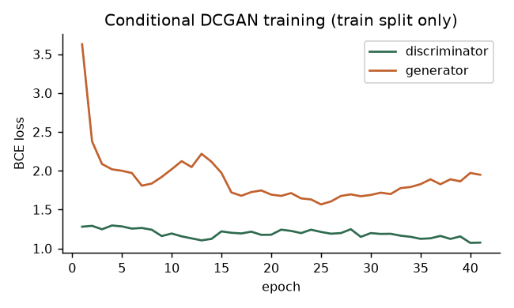
Figure 1. Discriminator and generator losses per epoch. The losses stay in a stable band without collapse of either player, but stable GAN losses do not imply sample quality.

4 Synthetic sample generation and quality checks
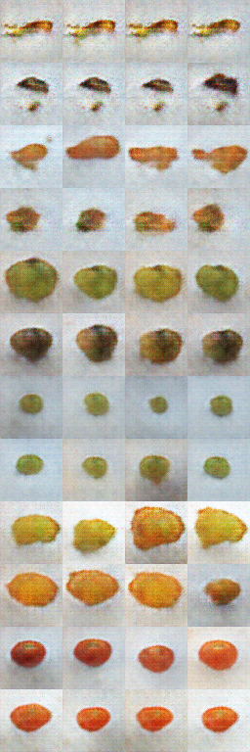
Figure 2. Fixed-noise samples after training; each row is one condition in the order Banana-NS, Banana-S, Carrot-NS, Carrot-S, Guava-NS, Guava-S, Gooseberry-NS, Gooseberry-S, Mango-NS, Mango-S, Tomato-NS, Tomato-S.
Visual review (human, qualitative): most rows resemble the intended produce in overall colour and shape, and Spoiled rows are darker/browner for banana, carrot and guava. Samples are blurry at 64×64 and lack surface detail; the banana rows show very low within-row variation. The quantitative checks below show that this visual resemblance is not sufficient for a classifier trained on real images. FID was NOT RUN: with 480 images at 64×64 it would not be a reliable estimate.
Table 3. Memorisation check: nearest-neighbour L2 distance at 64×64 (pixel range [−1, 1]).
Comparison | Mean | Median | Minimum
Generated → nearest real training image (same condition) | 21.97 | 22.53 | 8.85
Real training image → nearest other real image (same condition) | 13.23 | 12.76 | 3.75
Source: artifacts/experiments/gan/generation_summary.json
Generated images are on average further from their nearest training image than real images are from each other (real images are close because each capture session contains 17 near-identical views), so there is no evidence of copying.
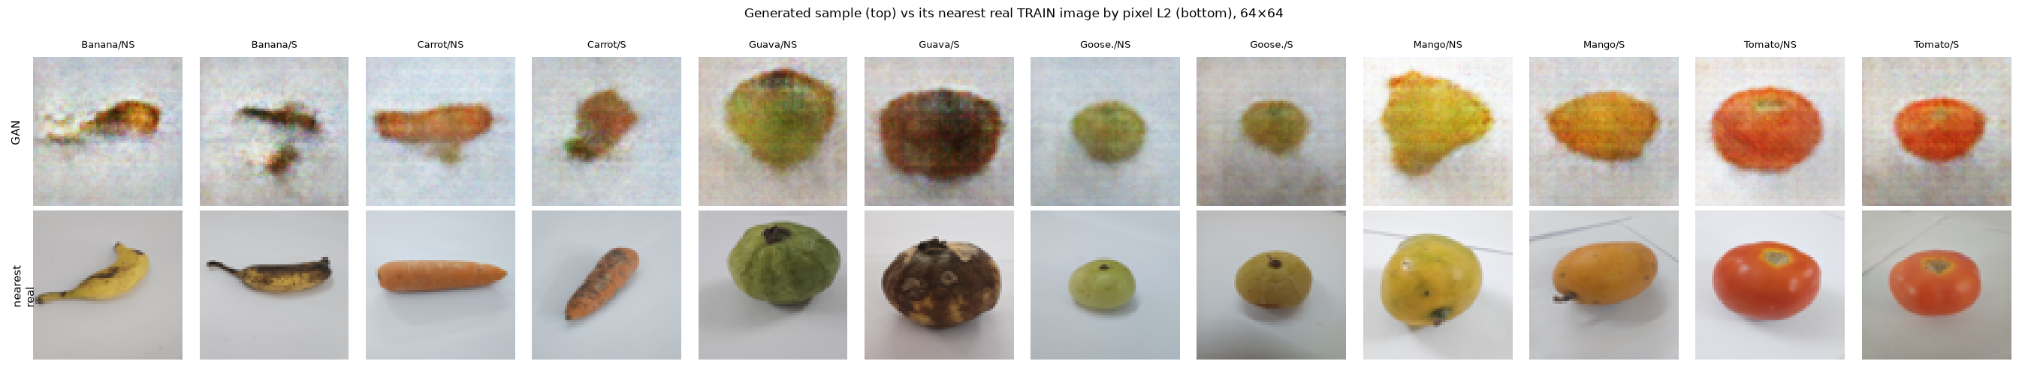
Figure 3. One generated sample per condition (top) and its nearest real training image (bottom).
Table 4. Within-condition diversity (mean pairwise L2 at 64×64).
Condition | Generated | Real (40 sampled) | Ratio
Banana/Not spoiled | 13.33 | 32.29 | 0.41
Banana/Spoiled | 18.43 | 43.55 | 0.42
Carrot/Not spoiled | 28.12 | 35.47 | 0.79
Carrot/Spoiled | 22.80 | 36.29 | 0.63
Guava/Not spoiled | 31.93 | 32.46 | 0.98
Guava/Spoiled | 31.06 | 37.21 | 0.83
Indian Gooseberry/Not spoiled | 23.88 | 25.65 | 0.93
Indian Gooseberry/Spoiled | 23.83 | 27.17 | 0.88
Mango/Not spoiled | 28.12 | 33.72 | 0.83
Mango/Spoiled | 30.89 | 32.99 | 0.94
Tomato/Not spoiled | 33.51 | 36.70 | 0.91
Tomato/Spoiled | 30.07 | 32.36 | 0.93
Source: artifacts/experiments/gan/quality_checks.json
Diversity: a ratio of 1 means generated images vary as much as real ones. The lowest ratios are Banana/Not spoiled (0.41) and Banana/Spoiled (0.42), i.e. partial mode collapse for these conditions; most other conditions are between 0.8 and 1.0.
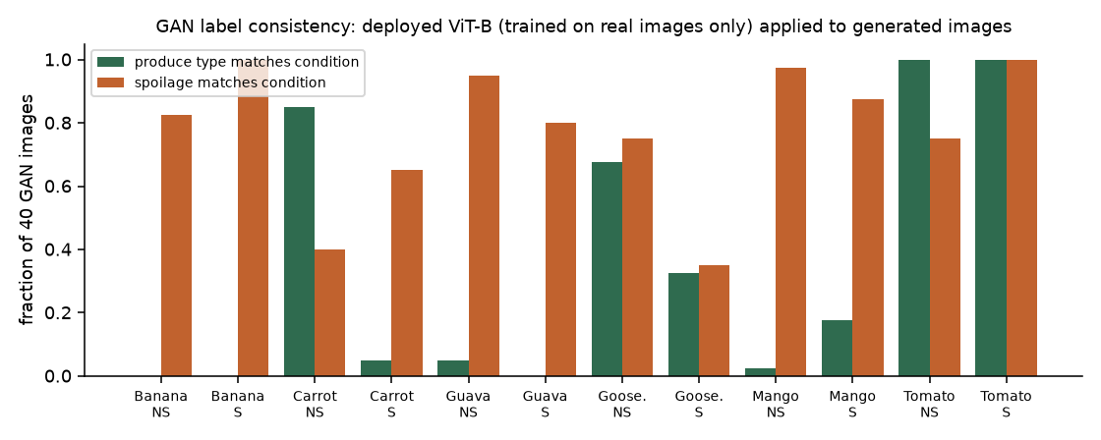
Figure 4. Label consistency: fraction of the 40 images per condition for which the deployed ViT-B/16 predicts the conditioning produce type and spoilage label.
Table 5. Label consistency of GAN images under the deployed classifier.
Condition | n | Produce type matches | Spoilage matches
Banana/Not spoiled | 40 | 0 (0%) | 33 (82%)
Banana/Spoiled | 40 | 0 (0%) | 40 (100%)
Carrot/Not spoiled | 40 | 34 (85%) | 16 (40%)
Carrot/Spoiled | 40 | 2 (5%) | 26 (65%)
Guava/Not spoiled | 40 | 2 (5%) | 38 (95%)
Guava/Spoiled | 40 | 0 (0%) | 32 (80%)
Indian Gooseberry/Not spoiled | 40 | 27 (68%) | 30 (75%)
Indian Gooseberry/Spoiled | 40 | 13 (32%) | 14 (35%)
Mango/Not spoiled | 40 | 1 (2%) | 39 (98%)
Mango/Spoiled | 40 | 7 (18%) | 35 (88%)
Tomato/Not spoiled | 40 | 40 (100%) | 30 (75%)
Tomato/Spoiled | 40 | 40 (100%) | 40 (100%)
Overall | 480 | 34.6% | 77.7%

Interpretation: Tomato conditions are recognised perfectly, Carrot-NS and Gooseberry-NS partly; Banana, Guava and Mango samples are almost never recognised as their intended produce. Many GAN images therefore carry labels that a real-data classifier disagrees with, i.e. they are noisy training examples.

5 Comparison protocol
All conditions use the same classifier and evaluation protocol; only the training-set composition changes. This controlled study ("ablation v2") replaces an earlier single-seed comparison (Section 8) that used a learning rate too high for ViT-S and became unstable.
Table 6. Controlled configuration (identical for every condition and seed).
Setting | Value
Classifier | ViT-S/16 (vit_small_patch16_224.augreg_in21k_ft_in1k), produce head (6) + spoilage head (2)
Optimiser / LR | AdamW, backbone 2e-5, heads 2e-4, weight decay 0.01, 1-epoch warm-up + cosine
Batch / epochs / early stopping | 32 / ≤10 / patience 4 on validation composite macro-F1
Split | v1 session-grouped; validation 1,087; test 1,071 (untouched until after selection)
Seeds | 42, 43, 44 (classifier seed; the same 480 GAN images are used for every seed)
Conditions | (i) real only, no augmentation; (ii) real + conventional augmentation (crop, flips, ±15° rotation, brightness/contrast ±0.15); (iii) as (ii) + 480 GAN images
Metrics | accuracy, macro precision, macro recall, macro-F1, ROC-AUC (spoilage); produce macro-F1

6 Results
Table 7. Test-set results, mean ± sample SD over seeds (spoilage head unless stated).
Condition | Seeds | Train images | Spoilage accuracy | Macro precision | Macro recall | Macro-F1 | ROC-AUC | Produce macro-F1
Real only (no augmentation) | 3 (42, 43, 44) | 3177 | 0.927 ± 0.006 | 0.924 ± 0.014 | 0.907 ± 0.010 | 0.914 ± 0.006 | 0.971 ± 0.005 | 1.000 ± 0.000
Real + conventional augmentation | 3 (42, 43, 44) | 3177 | 0.939 ± 0.005 | 0.944 ± 0.008 | 0.916 ± 0.013 | 0.928 ± 0.007 | 0.981 ± 0.003 | 1.000 ± 0.000
Real + conventional aug. + 480 GAN images | 3 (42, 43, 44) | 3657 | 0.932 ± 0.014 | 0.932 ± 0.016 | 0.909 ± 0.021 | 0.919 ± 0.018 | 0.976 ± 0.007 | 1.000 ± 0.000
Source: artifacts/runs/abl2_*/eval/test_clean_0_none.json
Table 8. Per-run details (validation used only for model selection).
Run | Seed | Train n | Epochs run | Best epoch (val) | Best val spoil mF1 | Test acc. | Test spoil mF1 | Test AUC | Train min | Infer. ms/img
abl2_aug_s42 | 42 | 3177 | 10 | 9 | 0.932 | 0.941 | 0.929 | 0.982 | 14.1 | 4.91
abl2_aug_s43 | 43 | 3177 | 10 | 6 | 0.935 | 0.934 | 0.921 | 0.983 | 13.9 | 5.04
abl2_aug_s44 | 44 | 3177 | 9 | 5 | 0.945 | 0.943 | 0.934 | 0.977 | 13.8 | 5.16
abl2_gan_s42 | 42 | 3657 | 9 | 5 | 0.957 | 0.939 | 0.930 | 0.969 | 14.3 | 4.84
abl2_gan_s43 | 43 | 3657 | 10 | 8 | 0.954 | 0.940 | 0.929 | 0.984 | 16.6 | 4.72
abl2_gan_s44 | 44 | 3657 | 8 | 4 | 0.951 | 0.915 | 0.899 | 0.974 | 14.5 | 5.25
abl2_noaug_s42 | 42 | 3177 | 10 | 9 | 0.957 | 0.933 | 0.919 | 0.976 | 13.7 | 4.85
abl2_noaug_s43 | 43 | 3177 | 7 | 3 | 0.958 | 0.927 | 0.916 | 0.968 | 9.6 | 4.54
abl2_noaug_s44 | 44 | 3177 | 7 | 3 | 0.954 | 0.922 | 0.908 | 0.967 | 10.9 | 5.13
Source: data/ablation_all_runs.csv
Table 9. Paired per-seed differences in test spoilage macro-F1.
Comparison | Mean difference (per seed)
Conventional aug − real only | +0.013 (per seed: +0.010, +0.004, +0.026)
GAN − conventional aug | -0.009 (per seed: +0.000, +0.008, -0.035)
GAN − real only | +0.005 (per seed: +0.010, +0.012, -0.009)

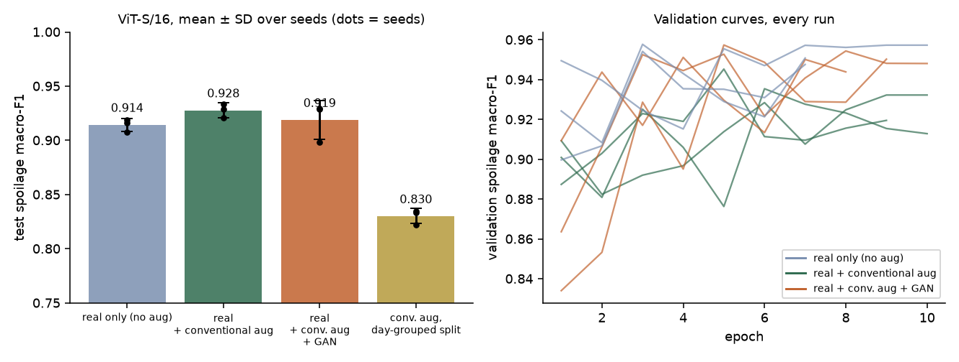
Figure 5. Left: test spoilage macro-F1 per condition (bars = mean, whiskers = SD, dots = seeds; the day-split bar belongs to Document C). Right: validation spoilage macro-F1 curves of every run.
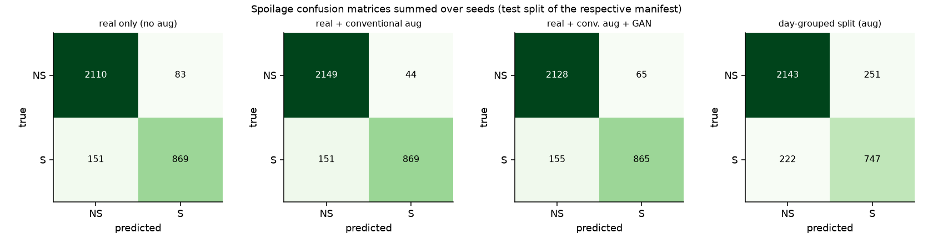
Figure 6. Spoilage confusion matrices summed over the three seeds (NS = Not spoiled, S = Spoiled).
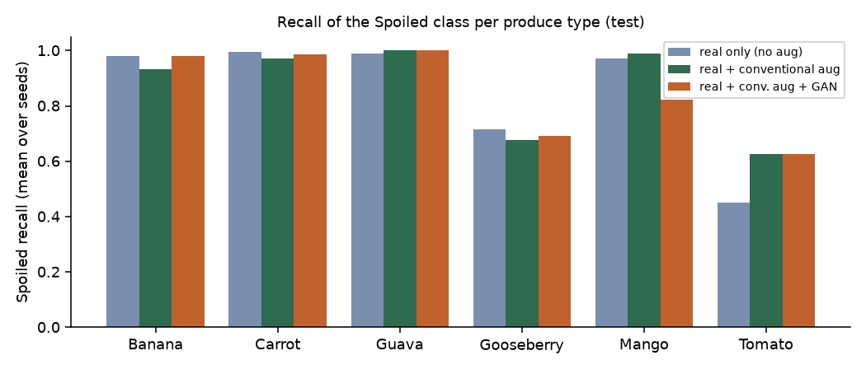
Figure 7. Recall of the Spoiled class per produce type, averaged over seeds.
Table 10. Spoiled-class recall per produce type (mean over seeds).
Produce | Real only | Conv. aug | Conv. aug + GAN
Banana | 0.980 | 0.931 | 0.980
Carrot | 0.995 | 0.971 | 0.985
Guava | 0.990 | 1.000 | 1.000
Indian Gooseberry | 0.716 | 0.676 | 0.693
Mango | 0.971 | 0.990 | 0.824
Tomato | 0.451 | 0.627 | 0.627

Table 11. Computational cost (measured).
Item | Value
GAN training | 41 epochs in 12.0 min on Apple M5 (MPS), concurrent with other jobs
Classifier training per run (mean over seeds) | noaug: 11.4 ± 2.1 min; aug: 13.9 ± 0.1 min; gan: 15.2 ± 1.3 min
Training images per epoch | noaug: 3,177; aug: 3,177; gan: 3,657
Batched test inference (ms/image) | noaug: 4.84 ± 0.30; aug: 5.04 ± 0.12; gan: 4.94 ± 0.28

7 Earlier single-seed comparison (v1, superseded)
Table 12. v1 runs (ViT-S/16, lr 5e-5, seed 42). Best-validation values are validation results, not test results.
Condition | Run | LR | Epochs | Best epoch | Best val spoil mF1 | Val spoil mF1 per epoch | Test spoil mF1
Real only | vit_s16_noaug | 5e-05 | 10 | 6 | 0.954 | 0.854, 0.906, 0.895, 0.935, 0.941, 0.954, 0.947, 0.950, 0.949, 0.949 | 0.926
Conv. aug | vit_s16_aug | 5e-05 | 5 | 1 | 0.934 | 0.934, 0.857, 0.841, 0.894, 0.911 | 0.879
Conv. aug + GAN | vit_s16_aug_gan | 5e-05 | 10 | 9 | 0.962 | 0.829, 0.914, 0.939, 0.906, 0.938, 0.940, 0.950, 0.944, 0.962, 0.959 | 0.937

In v1 the conventional-augmentation run reached its best validation spoilage macro-F1 (0.934) at epoch 1, then oscillated and early-stopped at epoch 5; its test spoilage macro-F1 was 0.879. Because a single unstable run cannot support conclusions, v1 is reported for transparency only and the controlled v2 study above is used for all conclusions.

8 Interpretation and conclusion
Across 3 paired seeds, adding the GAN images changed test spoilage macro-F1 by -0.009 (per seed: +0.000, +0.008, -0.035) relative to conventional augmentation alone. The sign is not consistent across seeds, so no reliable effect of GAN augmentation can be claimed.
This is consistent with the quality checks: only 34.6% of GAN images are recognisable as their intended produce by a real-data classifier, so they mostly act as weakly-labelled noise. Any small effect should not be attributed to realistic synthetic data. Conclusion: the GAN pipeline is implemented and evaluated, but GAN augmentation is not shown to improve spoilage classification on TR-6 and is not used by the deployed model.

9 Limitations
- 64×64 generation upsampled to 256×256 — far below the resolution at which decay texture is visible.
- Three classifier seeds and a single GAN seed; GAN variance is not captured.
- FID/KID not computed; quality judged by classifier consistency, nearest-neighbour distance, diversity ratio and visual review.
- All comparisons share the specimen-leakage limitation of TR-6 (Document D, Section 2).

10 Reproducibility
- .venv/bin/python ml/experiments/gan.py train --minutes 12 then gan.py generate --per-class 40
- .venv/bin/python ml/experiments/extra_analyses.py gan_quality
- ./ml/run_ablation_v2.sh (3 conditions × seeds 42–44; resumable)
- Artefacts: artifacts/experiments/gan/ (checkpoint cdcgan.pt, generated_manifest.csv, summaries), artifacts/runs/abl2_*

