FORESIGHT
Final Results and Model Metrics Report
Consolidated, evidence-traced results of the complete Foresight system.

Project: Foresight — visual produce-spoilage estimation (research prototype)
Document: D — Final results and model metrics
Date: 15 October 2026
Workspace: /Users/nandu/Downloads/foresight
Deployed model: vit_b16_primary@epoch9 (backend/models/foresight_vit.pt)
Every number in this document is generated by releases/final_review/build/build_reports.py from saved run logs and result files; nothing is hand-entered. Labels such as NOT RUN, NOT AVAILABLE, BLOCKED or SIMULATED mark results that do not exist.

Contents
1 Dataset audit and preprocessing
2 Models and checkpoints
3 Training history
4 Test-set performance of the selected checkpoint
5 Model comparison and ablations
6 Noise robustness and denoising
7 GAN augmentation
8 K-means clustering
9 Explainability
10 Inference latency and resources
11 API / UI integration results
12 Conclusions

(Right-click → Update Field in Word if the contents list appears empty.)

1 Dataset audit and preprocessing
Table 1. TR-6 audit (re-run 2026-10-15; identical to the 2026-10-12 audit).
Quantity | Value
Files / size | 21,653 / 19.77 GiB
Valid JPEGs (sRGB / thermal) | 21,626 (10,676 / 10,950); corrupt 0
Methane files / records | 18 / 26,928
Unique image contents | 10,776
Exact-duplicate groups / excess copies | 10,589 / 10,850
Classified images byte-identical to a Normal image | 10,796
Cross-label (Spoiled & Not_spoiled) content groups | 170
Verified cross-modal pairs | 0
Source: dataset-preparation/tr6-audit/output_rerun_2026-10-15/audit_summary.json
Preprocessing: content-level de-duplication by SHA-256; spoilage label = Classified folder label (dataset-provided, not independently verified); conflicting contents excluded; thermal excluded (RGB app); each eligible image decoded once with EXIF orientation correction and resized to shorter side 256 (artifacts/cache/srgb_256), then resized to 224×224 and normalised with the backbone's pretrained mean/std. The backend applies the same steps to uploads (test R03).
Table 2. Eligibility and exclusions (unique contents).
Category | Count
Unique image contents | 10,776
conflicting spoilage labels | 170
modality out of scope thermal | 5,084
no spoilage label normal only | 187
Eligible sRGB samples | 5,335

Table 3. Train / validation / test sample counts and class distributions.
Class | Train | Validation | Test
Banana | 187 | 68 | 68
Carrot | 288 | 85 | 85
Guava | 287 | 118 | 103
Indian Gooseberry | 867 | 272 | 272
Mango | 222 | 85 | 85
Tomato | 1326 | 459 | 458
Not spoiled | 2192 | 747 | 731
Spoiled | 985 | 340 | 340
Total | 3177 | 1087 | 1071

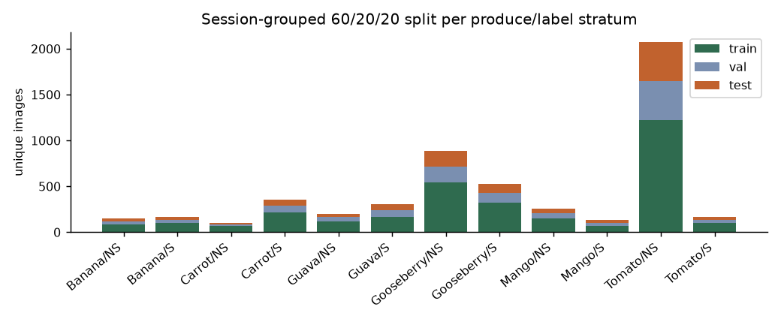
Figure 1. Session-grouped 60/20/20 split per produce × label stratum.

2 Models and checkpoints
Table 4. Models implemented, trained and deployed.
Model | Role | Trained? | Checkpoint | Used in app?
ViT-B/16 two-head (86 M params) | produce type + spoilage | YES (12 epochs) | artifacts/runs/vit_b16_primary/best.pt | YES (deployed copy)
ViT-S/16 two-head (22 M params) | ablations | YES (16 runs) | artifacts/runs/abl2_*, day2_*, vit_s16_* | research only
Conditional DCGAN | training-only augmentation | YES | artifacts/experiments/gan/cdcgan.pt | research only
DnCNN (depth 17) | denoising experiment | YES | artifacts/experiments/dncnn*/dncnn.pt | research only
Logistic regression ×2 | baselines | YES | metrics only | research only
K-means | exploratory clustering | YES (fit on train) | metrics only | research only
U-Net | decay segmentation | NOT RUN | — | BLOCKED
YOLO | detection | NOT RUN | — | NOT IMPLEMENTED
Shelf-life regressor | regression | NOT RUN | — | BLOCKED

3 Training history
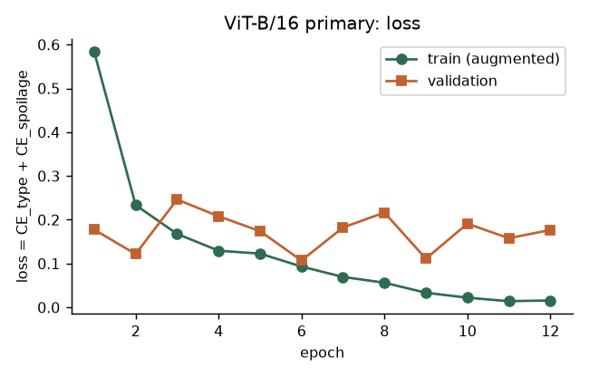
Figure 2. Training (augmented) and validation loss of the deployed ViT-B/16.
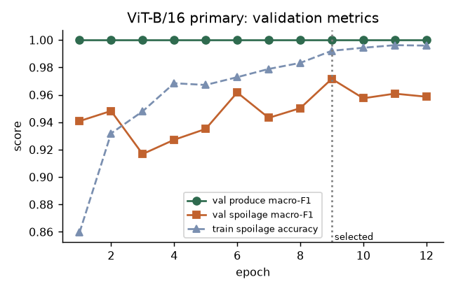
Figure 3. Validation macro-F1 per epoch; the selected checkpoint (epoch 9) is marked.
Table 5. Primary training history (from artifacts/runs/vit_b16_primary/history.json).
Epoch | Train loss | Val loss | Val produce mF1 | Val spoil mF1 | Seconds
1 | 0.584 | 0.177 | 1.000 | 0.941 | 221.7
2 | 0.234 | 0.122 | 1.000 | 0.948 | 353.2
3 | 0.168 | 0.246 | 1.000 | 0.917 | 482.6
4 | 0.129 | 0.208 | 1.000 | 0.927 | 242.8
5 | 0.123 | 0.174 | 1.000 | 0.935 | 247.7
6 | 0.093 | 0.107 | 1.000 | 0.962 | 252.4
7 | 0.069 | 0.182 | 1.000 | 0.943 | 262.0
8 | 0.056 | 0.216 | 1.000 | 0.950 | 248.5
9 | 0.033 | 0.111 | 1.000 | 0.972 | 249.1
10 | 0.022 | 0.191 | 1.000 | 0.957 | 249.0
11 | 0.014 | 0.158 | 1.000 | 0.961 | 241.6
12 | 0.016 | 0.177 | 1.000 | 0.959 | 230.8

4 Test-set performance of the selected checkpoint
Table 6. Held-out test metrics (n = 1,071; evaluated once after selection).
Head | Accuracy | Macro precision | Macro recall | Macro-F1 | Weighted-F1 | ROC-AUC
Produce type (6) | 1.0000 | 1.0000 | 1.0000 | 1.0000 | 1.0000 | 1.0000
Spoilage (2) | 0.9608 | 0.9667 | 0.9430 | 0.9536 | 0.9603 | 0.9893

Table 7. Per-class test metrics.
Head | Class | Precision | Recall | F1 | Support
Spoilage | Not spoiled | 0.9527 | 0.9918 | 0.9718 | 731
Spoilage | Spoiled | 0.9806 | 0.8941 | 0.9354 | 340
Produce | Banana | 1.0000 | 1.0000 | 1.0000 | 68
Produce | Carrot | 1.0000 | 1.0000 | 1.0000 | 85
Produce | Guava | 1.0000 | 1.0000 | 1.0000 | 103
Produce | Indian Gooseberry | 1.0000 | 1.0000 | 1.0000 | 272
Produce | Mango | 1.0000 | 1.0000 | 1.0000 | 85
Produce | Tomato | 1.0000 | 1.0000 | 1.0000 | 458

Statistical interpretation: a cluster bootstrap over the 64 test capture sessions (2,000 resamples) gives 95% intervals of [0.903, 0.988] for spoilage macro-F1, [0.919, 0.990] for accuracy and [0.773, 0.984] for Spoiled recall. Images inside a session are highly correlated, so these session-level intervals are the honest uncertainty, much wider than an image-level interval would suggest.
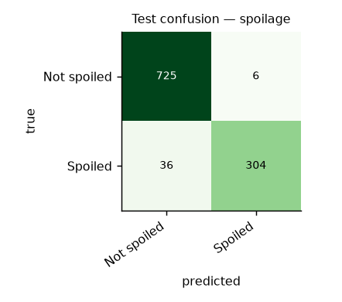
Figure 4. Test confusion matrix — spoilage.
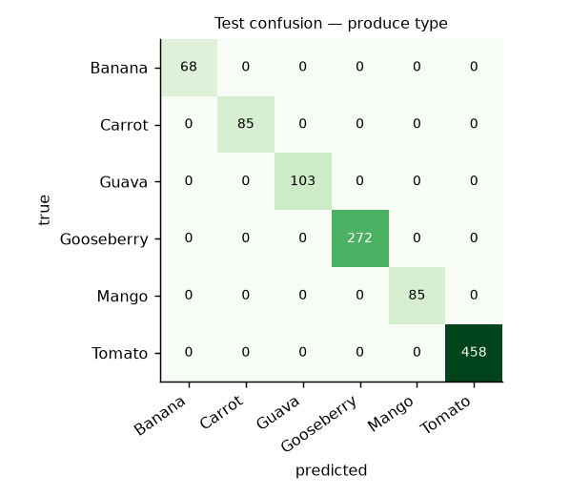
Figure 5. Test confusion matrix — produce type.
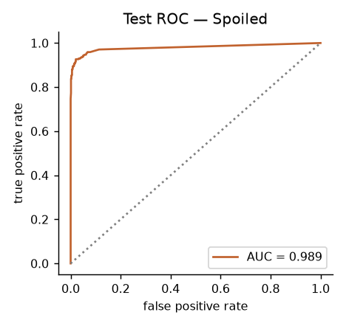
Figure 6. Test ROC curve for the Spoiled class.
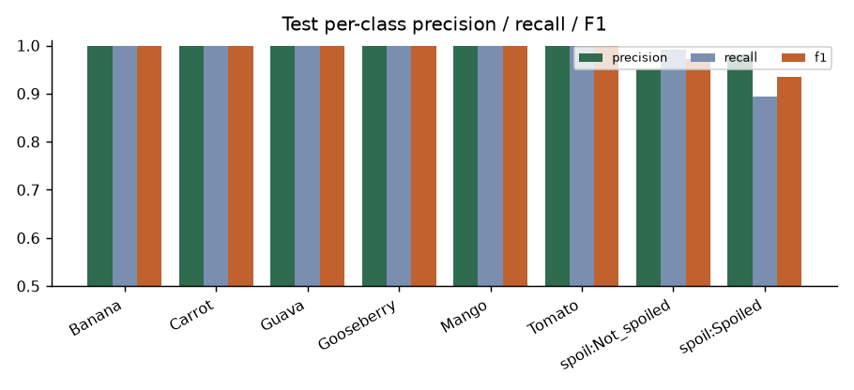
Figure 7. Per-class precision, recall and F1 on the test split.
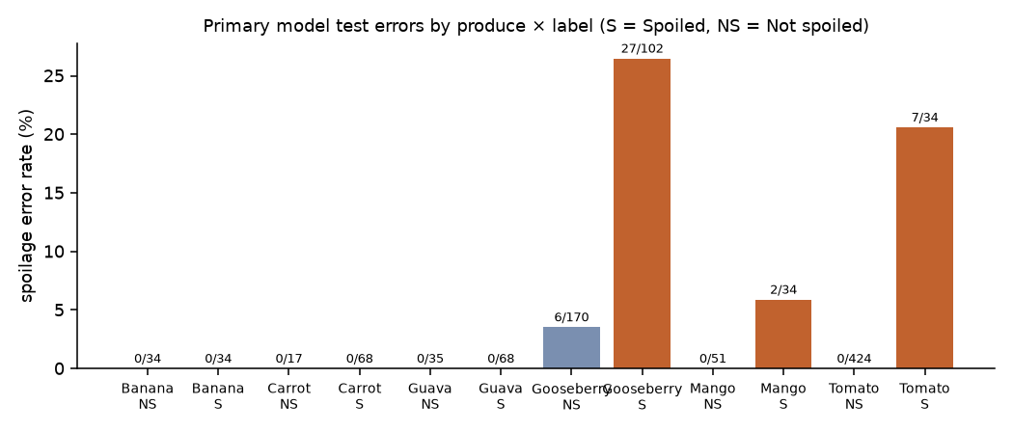
Figure 8. Test spoilage error rate per produce × label stratum.
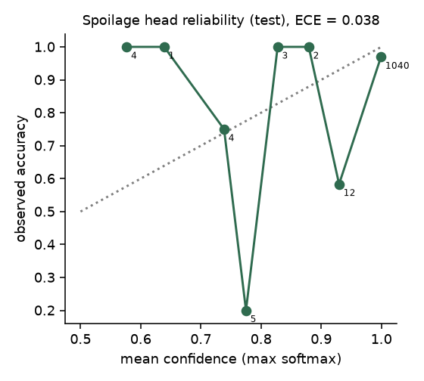
Figure 9. Reliability diagram for the spoilage head (ECE = 0.038); numbers are images per bin.
Calibration: expected calibration error is 0.038, but this is dominated by the many easy, correct, confident predictions; 88% of the 42 errors were made with confidence ≥ 0.90 (mean confidence of wrong predictions 0.959). Confidence scores are therefore not a reliable warning signal and are shown in the UI as uncalibrated.

5 Model comparison and ablations
Table 8. Comprehensive model comparison on the same test split (spoilage).
Model | Runs | Spoilage macro-F1 | Spoilage ROC-AUC
Colour histogram + LogReg | 1 run | 0.828 | 0.885
Frozen ViT-B + LogReg | 1 run | 0.916 | 0.979
ViT-S/16 real only | 3 seeds | 0.914 ± 0.006 | 0.971 ± 0.005
ViT-S/16 + conv. aug | 3 seeds | 0.928 ± 0.007 | 0.981 ± 0.003
ViT-S/16 + conv. aug + GAN | 3 seeds | 0.919 ± 0.018 | 0.976 ± 0.007
ViT-B/16 + conv. aug (deployed) | 1 run | 0.954 | 0.989

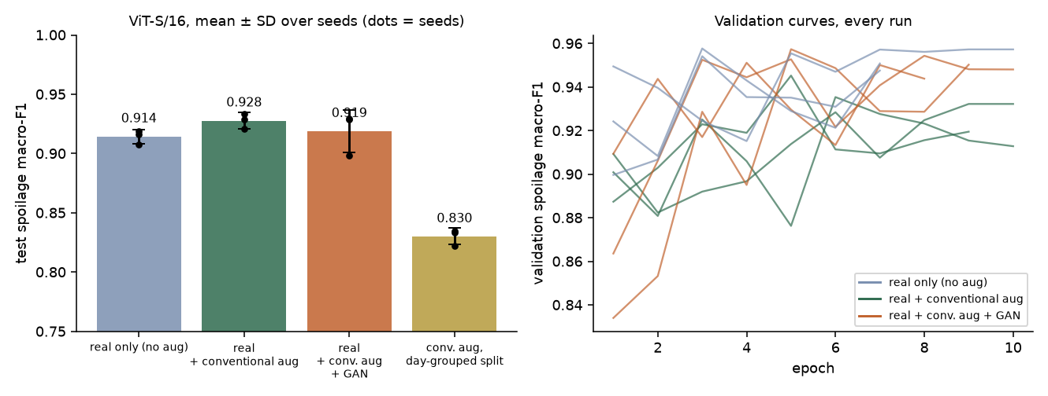
Figure 10. Controlled ViT-S/16 comparison (3 seeds) and validation curves; details in Documents A and C.

6 Noise robustness and denoising
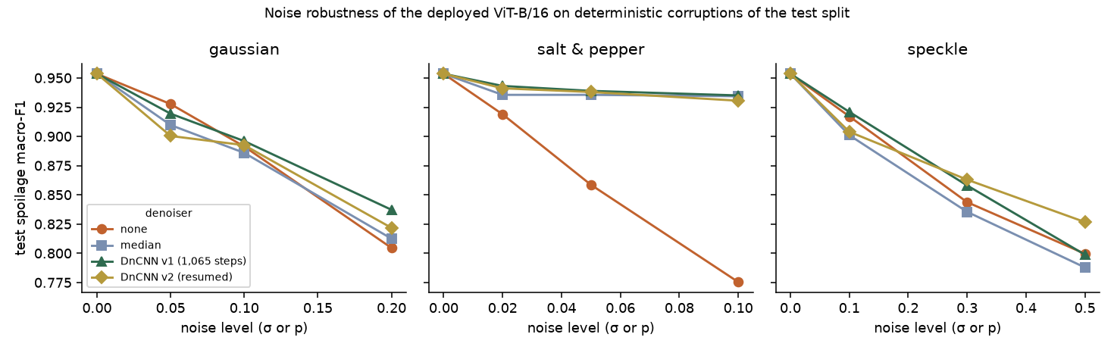
Figure 11. Test spoilage macro-F1 under synthetic noise with and without denoising.
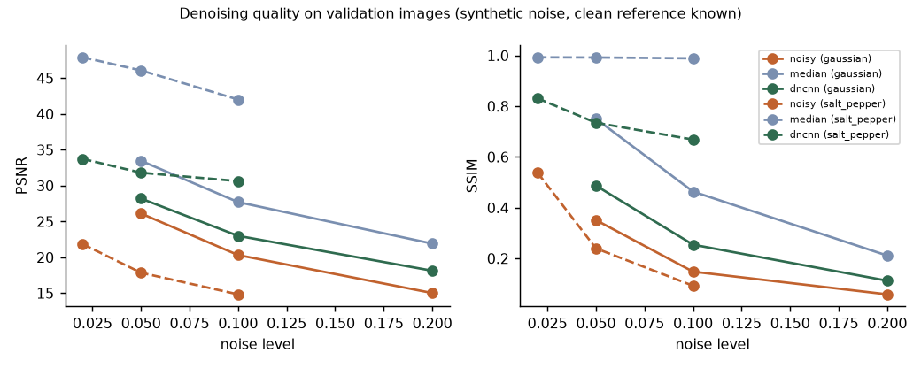
Figure 12. Paired PSNR / SSIM of DnCNN v1 and the median filter on validation images.

7 GAN augmentation
See Document A. GAN images were recognised as their intended produce by the deployed classifier in only 34.6% of cases; the controlled comparison is in the model-comparison table above.
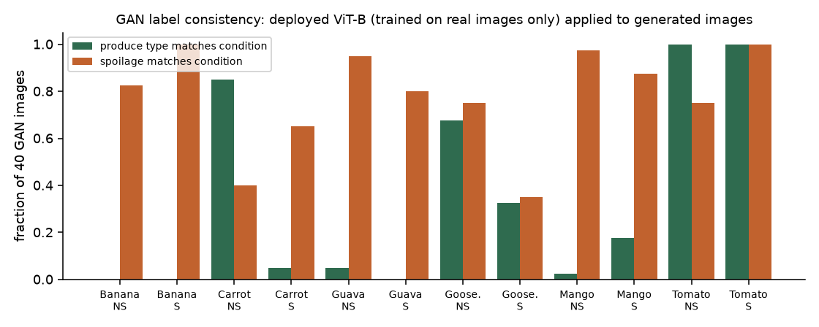
Figure 13. GAN label consistency under the deployed classifier.

8 K-means clustering
Table 9. K-means alignment with labels (clusters fitted on train only; k chosen by silhouette without labels).
Features | k selected (silhouette) | k / split | ARI produce | NMI produce | ARI spoilage | NMI spoilage
vit_frozen | 8 | k6_test | 0.966 | 0.950 | 0.199 | 0.141
vit_frozen | 8 | k8_test | 0.894 | 0.921 | 0.215 | 0.156
vit_frozen | 8 | k12_test | 0.853 | 0.863 | 0.221 | 0.210
colorhist | 12 | k6_test | 0.580 | 0.501 | 0.151 | 0.106
colorhist | 12 | k12_test | 0.403 | 0.487 | 0.076 | 0.111

Unsupervised structure in frozen ViT features is dominated by produce type (k = 6 recovers it almost exactly), not by spoilage; clusters are exploratory and not ground truth.
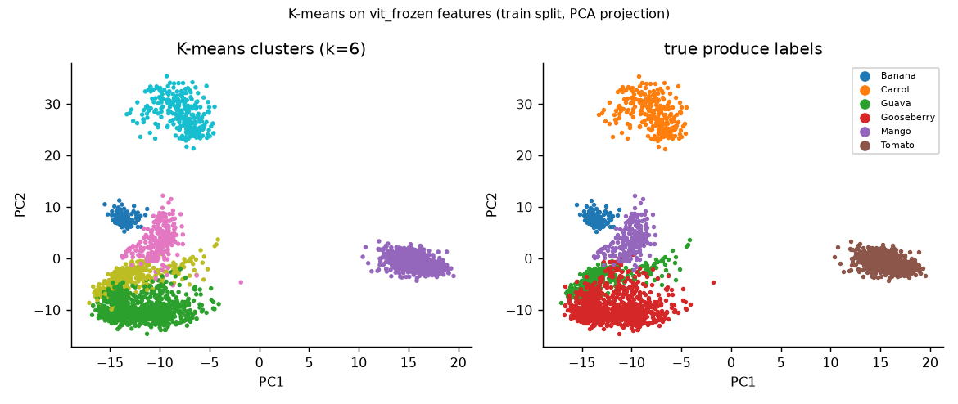
Figure 14. K-means (k = 6) on frozen ViT features, PCA projection of the training split, coloured by cluster (left) and true produce (right).

9 Explainability
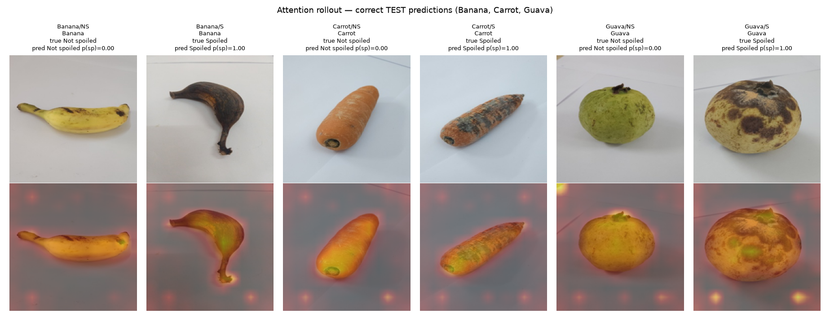
Figure 15. Attention rollout on correct test images, Banana / Carrot / Guava (Document B).
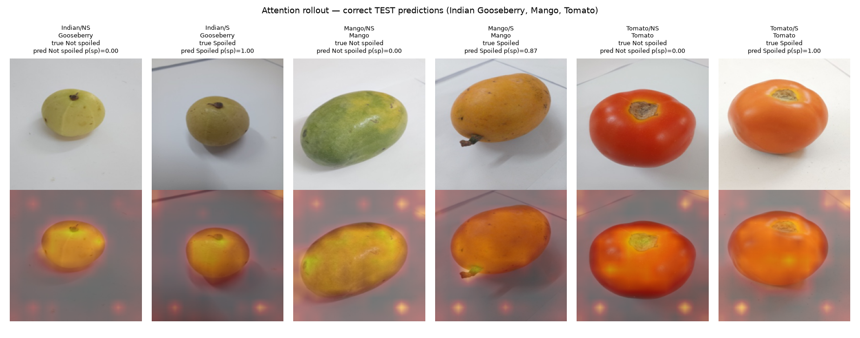
Figure 16. Attention rollout on correct test images, Indian Gooseberry / Mango / Tomato.
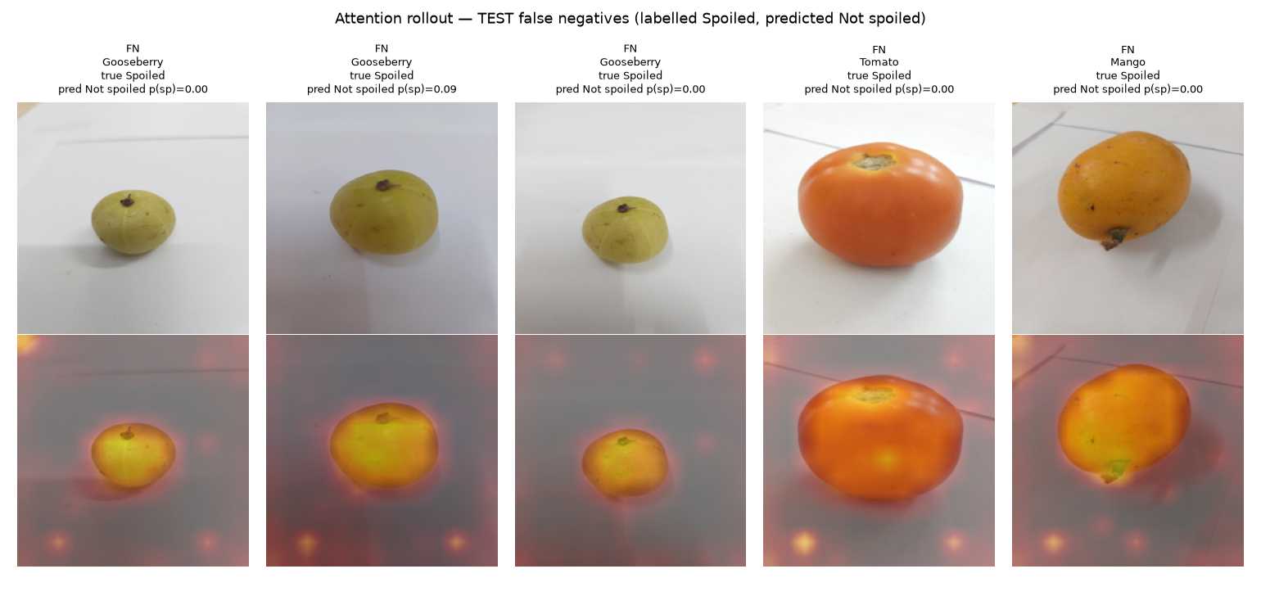
Figure 17. Attention rollout on test false negatives.

10 Inference latency and resources
Table 10. Measured latency and resource use (Apple M5, 16 GB).
Measurement | Value
ViT-B/16 parameters / checkpoint | 85,804,808 / 343.3 MB
ViT-S/16 parameters / checkpoint | 21,668,744 / 86.7 MB
ViT-B/16 single-image forward, CPU / MPS (median) | 200.8 / 59.1 ms
ViT-S/16 single-image forward, CPU / MPS (median) | 35.5 / 35.2 ms
ViT-B/16 batched test inference (MPS) | 14.4 ms/image
End-to-end /api/analyze (1.9 MB upload, n = 60) | median 61 ms, p95 77 ms
Backend physical memory footprint | 712.4 MB (peak 1300 MB)
Primary training time | 54.7 min (12 epochs, MPS)

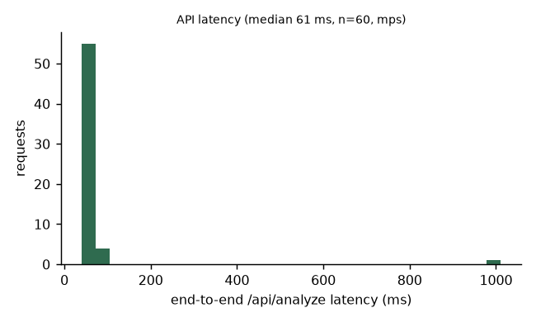
Figure 18. Distribution of end-to-end API latency in the E2E smoke test.

11 API / UI integration results
The React UI calls the FastAPI backend, which loads the selected checkpoint once at startup. In the end-to-end test 60 held-out full-resolution originals were analysed via HTTP: produce correct 60/60, spoilage correct 57/60; 11/11 E2E checks passed and 44/44 UI-consumed fields were present in real responses. Limitations: single-item mode only; no shelf-life or decay-area output; mock mode exists but is off by default and labelled.

12 Conclusions
- A genuine ViT-B/16 classifier was trained on 5,335 de-duplicated TR-6 images and reaches test spoilage macro-F1 0.954 (session-bootstrap 95% CI 0.903–0.988) and perfect produce classification; it is integrated and serving real predictions.
- Performance is optimistic for real-world use: specimens recur across splits, a day-grouped split lowers performance (Document C), lab backgrounds are uniform, and confidence is poorly calibrated on errors.
- The weakest point is recall of 'Spoiled' for Indian Gooseberry and Tomato, plausibly because date-based labels precede visible decay.
- Segmentation, shelf-life and detection remain blocked by missing annotations, not by code.

