FORESIGHT
XAI Analysis Report
Attention-rollout explanations for the deployed ViT-B/16 spoilage classifier, with faithfulness and stability tests.

Project: Foresight — visual produce-spoilage estimation (research prototype)
Document: B — Explainable AI analysis
Date: 15 October 2026
Workspace: /Users/nandu/Downloads/foresight
Deployed model: vit_b16_primary@epoch9 (backend/models/foresight_vit.pt)
Every number in this document is generated by releases/final_review/build/build_reports.py from saved run logs and result files; nothing is hand-entered. Labels such as NOT RUN, NOT AVAILABLE, BLOCKED or SIMULATED mark results that do not exist.

Contents
1 Model and motivation
2 Method
3 Representative predictions and explanations
4 Failure cases
5 Faithfulness test (deletion)
6 Stability test
7 Class-specific observations
8 Limitations
9 Reproducibility

(Right-click → Update Field in Word if the contents list appears empty.)

1 Model and motivation
The deployed model is a ViT-B/16 fine-tuned on TR-6 sRGB images with a produce-type head and a spoilage head (test spoilage macro-F1 0.954). Because its outputs are used to advise people about food, users and reviewers need to see which image regions drive a prediction, and developers need to detect shortcuts (e.g. background, tray edges, lighting) that would not generalise.

2 Method
Attention rollout (Abnar & Zuidema, 2020). For each of the 12 transformer blocks the softmax attention A_l = softmax(QKᵀ/√d_k) is taken (12 heads averaged), the identity is added for the residual path and rows are renormalised: Â_l = (mean_h A_l + I) / rowsum. The rollout R = Â_12 · … · Â_1 is computed and the CLS-token row over the 196 patch tokens is reshaped to 14×14, min–max normalised and bilinearly upsampled onto the 224×224 input.
Grad-CAM was not used: it is designed for convolutional feature maps, and for ViTs requires ad-hoc reshaping of token gradients; attention rollout is the established architecture-native choice. The same implementation is served by the API (backend/inference.py, ?xai=true) and shown in the UI, and is used offline in ml/experiments/xai_rollout.py and xai_extended.py. Attention weights are captured with forward hooks on each block's attn_drop with fused attention disabled.

3 Representative predictions and explanations
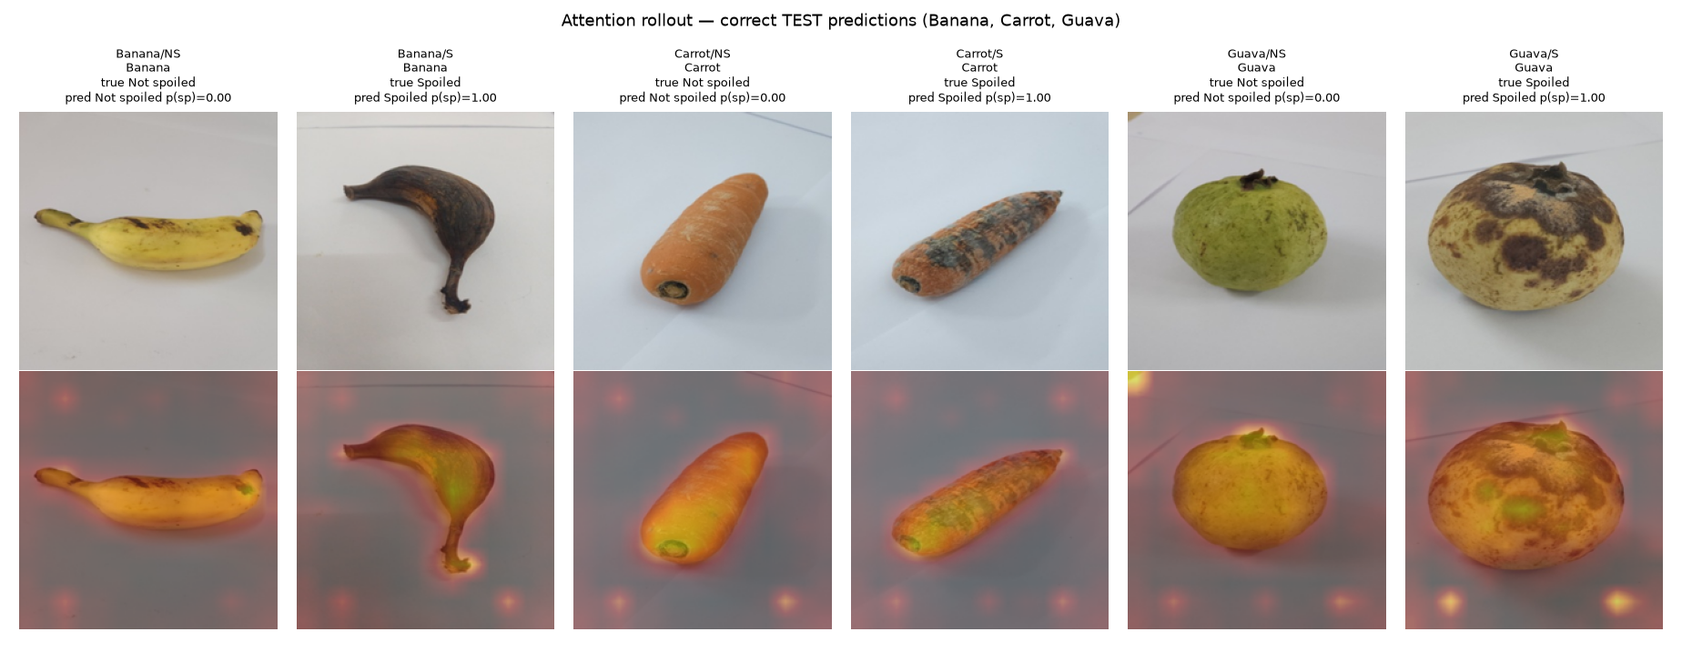
Figure 1. Correctly classified test images (Banana, Carrot, Guava; one per produce × spoilage stratum): input (top) and attention-rollout overlay (bottom) with the model's spoilage probability.
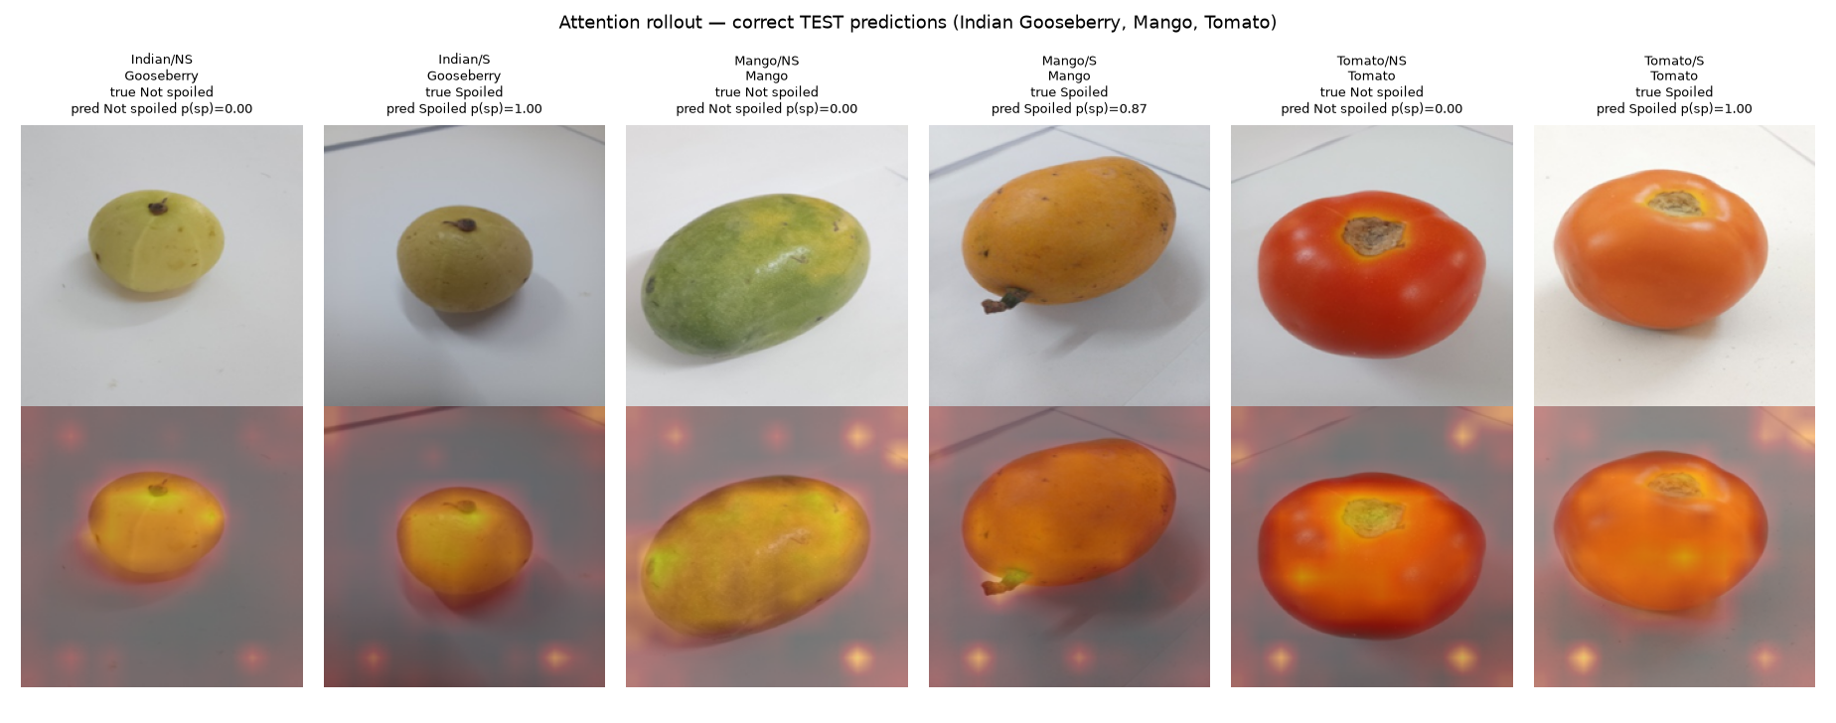
Figure 2. Correctly classified test images (Indian Gooseberry, Mango, Tomato).
Table 1. Inputs and actual model outputs shown in the class gallery (all from the untouched test split).
Stratum | Source file (TR-6) | True | Predicted | p(Spoiled)
Banana/NS | Banana/Not_spoiled/sRGB_images/20250911_142826.jpg | Not spoiled | Not spoiled | 0.0000
Banana/S | Banana/Spoiled/sRGB_images/20250918_134018.jpg | Spoiled | Spoiled | 1.0000
Carrot/NS | Carrot/Not_spoiled/sRGB_images/20250726_145305.jpg | Not spoiled | Not spoiled | 0.0000
Carrot/S | Carrot/Spoiled/sRGB_images/20250804_090448.jpg | Spoiled | Spoiled | 1.0000
Guava/NS | Guava/Not_spoiled/sRGB_images/20250627_084013.jpg | Not spoiled | Not spoiled | 0.0000
Guava/S | Guava/Spoiled/sRGB_images/20250704_083538.jpg | Spoiled | Spoiled | 1.0000
Indian/NS | Indian_Gooseberry/Not_spoiled/sRGB_images/20250808_142504.jpg | Not spoiled | Not spoiled | 0.0000
Indian/S | Indian_Gooseberry/Spoiled/sRGB_images/20250815_165038.jpg | Spoiled | Spoiled | 1.0000
Mango/NS | Mango/Not_spoiled/sRGB_images/20250920_162532.jpg | Not spoiled | Not spoiled | 0.0000
Mango/S | Mango/Spoiled/sRGB_images/20250929_092043.jpg | Spoiled | Spoiled | 0.8675
Tomato/NS | Tomato/Not_spoiled/sRGB_images/20250813_091049.jpg | Not spoiled | Not spoiled | 0.0000
Tomato/S | Tomato/Spoiled/sRGB_images/20251003_130059.jpg | Spoiled | Spoiled | 1.0000

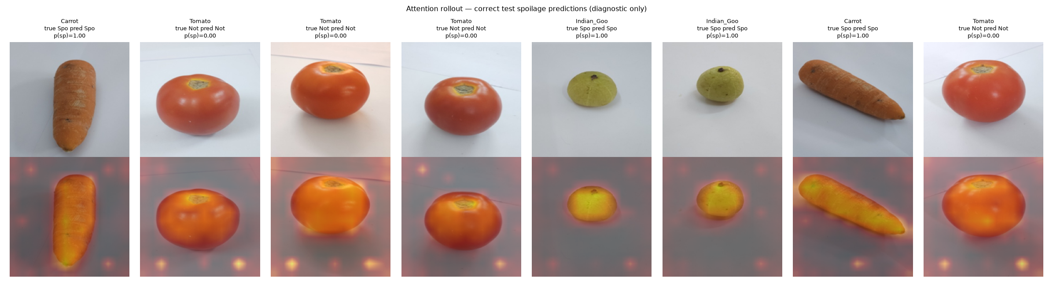
Figure 3. Randomly sampled correct test spoilage predictions.

4 Failure cases
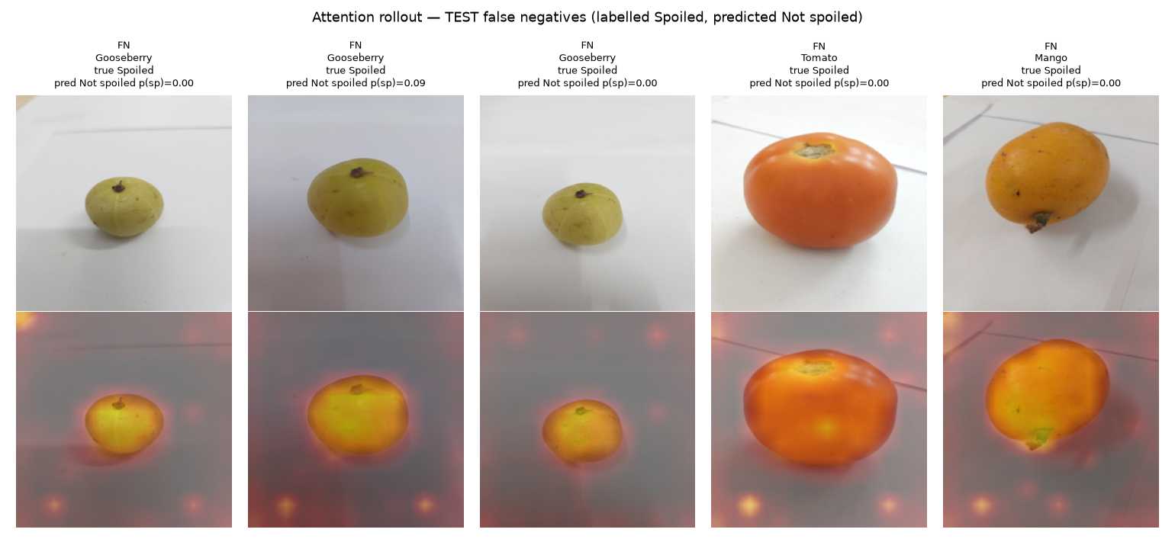
Figure 4. Representative test false negatives (labelled Spoiled, predicted Not spoiled).
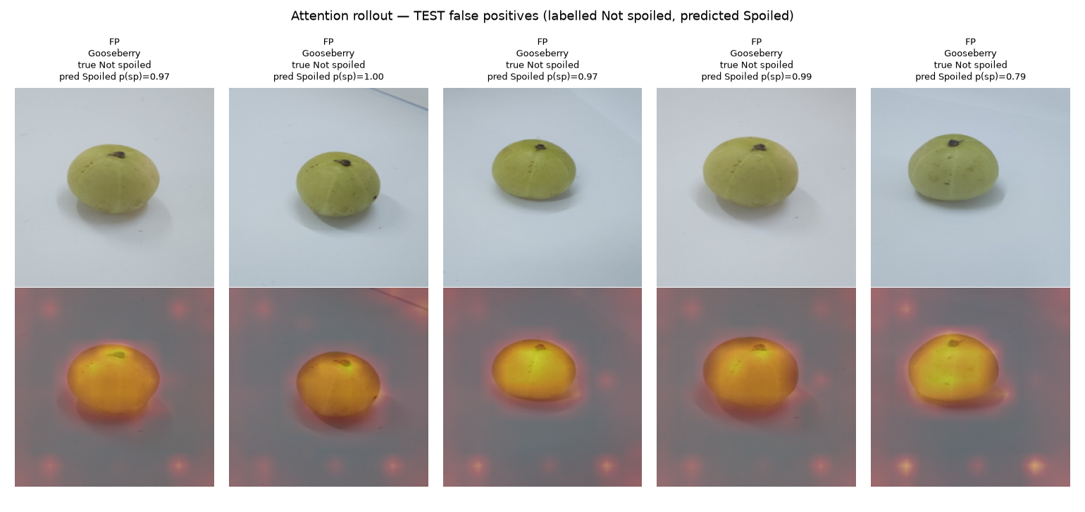
Figure 5. Representative test false positives (labelled Not spoiled, predicted Spoiled).
Table 2. Failure cases shown above.
Type | Produce | Source file | p(Spoiled)
FN | Indian Gooseberry | Indian_Gooseberry/Spoiled/sRGB_images/20250814_134333.jpg | 0.0000
FN | Indian Gooseberry | Indian_Gooseberry/Spoiled/sRGB_images/20250814_165625.jpg | 0.0939
FN | Indian Gooseberry | Indian_Gooseberry/Spoiled/sRGB_images/20250814_134241.jpg | 0.0001
FN | Tomato | Tomato/Spoiled/sRGB_images/20251003_085051.jpg | 0.0031
FN | Mango | Mango/Spoiled/sRGB_images/20250929_092050.jpg | 0.0000
FP | Indian Gooseberry | Indian_Gooseberry/Not_spoiled/sRGB_images/20250807_131718.jpg | 0.9711
FP | Indian Gooseberry | Indian_Gooseberry/Not_spoiled/sRGB_images/20250808_090006.jpg | 0.9999
FP | Indian Gooseberry | Indian_Gooseberry/Not_spoiled/sRGB_images/20250808_090020.jpg | 0.9673
FP | Indian Gooseberry | Indian_Gooseberry/Not_spoiled/sRGB_images/20250807_131723.jpg | 0.9863
FP | Indian Gooseberry | Indian_Gooseberry/Not_spoiled/sRGB_images/20250809_093931.jpg | 0.7919

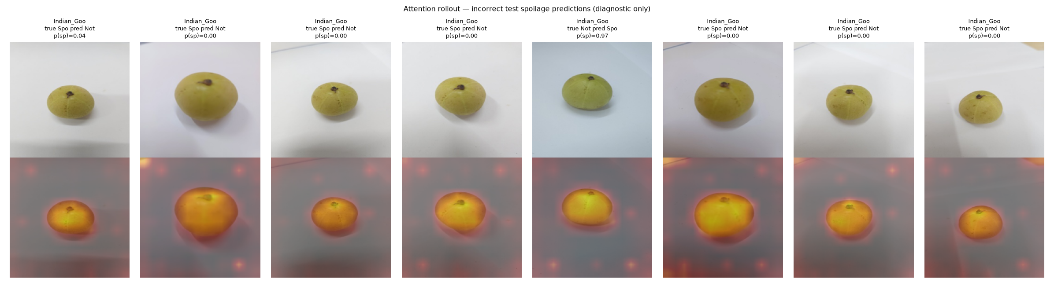
Figure 6. Additional randomly sampled incorrect test spoilage predictions.
Of 42 test errors, 27 are Indian Gooseberries labelled Spoiled that the model calls Not spoiled. In the overlays the attention lies on the fruit, not the background, and the fruits themselves look visually fresh. This points to the label definition — TR-6 spoilage folders follow capture date, and early-'Spoiled' gooseberries show no visible decay — rather than to a background shortcut. The model is also over-confident on these errors: 88% of all errors were made with confidence ≥ 0.90.

5 Faithfulness test (deletion)
Table 3. Deletion test: replace 20% of patches with the mean pixel and measure the drop in predicted-class probability.
Patches occluded | Mean drop | Median drop
Top-20% rollout patches | 0.192 | 0.0039
Random 20% patches | 0.020 | 0.0000
Source: n = 240 test images; Wilcoxon signed-rank p = 2.3e-30; artifacts/experiments/xai/xai_summary.json
Occluding the regions highlighted by rollout reduces confidence about 10× more than occluding random regions (p = 2.3e-30), which is evidence that the maps point at regions the model actually uses. Medians are near zero because most predictions are saturated (p ≈ 1), so for many images neither occlusion changes the output.

6 Stability test
Table 4. Explanation stability: Spearman correlation of 14×14 rollout maps.
Comparison | Mean ρ | Median ρ | 10th percentile ρ
Image vs horizontally flipped copy (map flipped back) | 0.950 | 0.953 | 0.922
Image vs copy with Gaussian noise σ = 0.02 | 0.962 | 0.965 | 0.943
Baseline: two different test images | 0.593 | 0.610 | –
Source: n = 150 test images; spoilage prediction unchanged under flip 97.3%, under noise 96.7%

7 Class-specific observations
- Banana, Carrot, Guava: attention covers the whole fruit including dark/spotted regions; no test errors on these produce types.
- Indian Gooseberry: attention is on the fruit, but labelled-Spoiled fruits often look fresh; 27/102 Spoiled test images missed.
- Tomato: 7/34 Spoiled missed; attention concentrates on the fruit body and stem scar.
- Mango: 2/34 Spoiled missed.
- All classes: isolated bright spots appear on the plain background near image borders. These are a known ViT artefact (high-norm background tokens used as internal registers) and should not be read as evidence the model uses the background; the deletion test shows the dominant relevance is on the fruit.

8 Limitations
- Attention rollout is an approximation: it ignores the MLP blocks and value vectors, and attention is not proof of causal reasoning.
- There are no human-reviewed decay masks, so overlap between explanations and true decay regions cannot be measured.
- Explanations are diagnostic aids for developers and users; they do not make a prediction correct and must not be presented as a food-safety assessment.

9 Reproducibility
- .venv/bin/python ml/experiments/xai_rollout.py --run artifacts/runs/vit_b16_primary (panels, deletion test)
- .venv/bin/python ml/experiments/xai_extended.py (class gallery, failure cases, stability)
- Live: POST /api/analyze?xai=true returns the overlay as a PNG data URI; shown in each result card.

