FORESIGHT
Ablation Study Report
Controlled experiments on training strategy, augmentation, GAN data, split design, noise and denoising.

Project: Foresight — visual produce-spoilage estimation (research prototype)
Document: C — Ablation study
Date: 17 October 2026
Workspace: /Users/nandu/Downloads/foresight
Deployed model: vit_b16_primary@epoch9 (backend/models/foresight_vit.pt)
Every number in this document is generated by releases/final_review/build/build_reports.py from saved run logs and result files; nothing is hand-entered. Labels such as NOT RUN, NOT AVAILABLE, BLOCKED or SIMULATED mark results that do not exist.

Contents
1 Experiment matrix
2 Common protocol
3 AB1 — Baselines versus fine-tuning
4 AB2 and AB3 — Augmentation and GAN data (controlled, 3 seeds)
5 Superseded single-seed runs (v1)
6 AB4 — Split design sensitivity
7 AB5 and AB6 — Noise robustness and denoising
8 AB7 — Backbone size (confounded)
9 Conclusions
10 Limitations

(Right-click → Update Field in Word if the contents list appears empty.)

1 Experiment matrix
Table 1. Ablation experiments, hypotheses and status.
ID | Hypothesis | Variable changed | Held constant | Status
AB1 | Fine-tuning beats fixed features | frozen features + logistic regression vs fine-tuned ViT | split v1, test set | COMPLETE
AB2 | Conventional augmentation improves generalisation | train-time augmentation on/off | ViT-S, LR, epochs, split, seeds 42–44 | COMPLETE
AB3 | GAN images add useful training signal | +480 GAN images | as AB2 (with conv. aug) | COMPLETE
AB4 | Session split over-estimates temporal generalisation | session- vs day-grouped split | ViT-S, conv. aug, LR, seeds 42–44 | COMPLETE
AB5 | Spoilage prediction degrades under image noise | Gaussian / salt-and-pepper / speckle, 3 levels each | deployed ViT-B, test set | COMPLETE
AB6 | Denoising restores performance | none / median 3×3 / DnCNN v1 / DnCNN v2 | as AB5 | COMPLETE
AB7 | Larger backbone is better | ViT-S/16 vs ViT-B/16 | split, aug (LR/batch differ — confounded) | COMPLETE (confounded)

2 Common protocol
- Split v1: session-grouped, duplicate-aware, seed 42 — 3,177 train / 1,087 val / 1,071 test unique sRGB images.
- Model selection (checkpoint/epoch) uses only validation composite macro-F1 = mean(produce macro-F1, spoilage macro-F1). The test set is evaluated once per selected checkpoint.
- Primary metric: test spoilage macro-F1 (class-imbalanced task); secondary: accuracy, macro precision/recall, ROC-AUC, produce macro-F1.
- Validation scores are labelled as validation and are never reported as test accuracy.

3 AB1 — Baselines versus fine-tuning
Table 2. Baselines and the deployed model on the same test split.
Model | Features / training | Produce mF1 | Spoil acc. | Spoil macro-P | Spoil macro-R | Spoil mF1 | Spoil AUC
E0a | HSV colour histogram (512-d) + logistic regression (C by val) | 0.866 | 0.857 | 0.846 | 0.816 | 0.828 | 0.885
E0b | frozen ImageNet ViT-B/16 CLS embedding + logistic regression | 1.000 | 0.930 | 0.936 | 0.902 | 0.916 | 0.979
E4 | ViT-B/16 fine-tuned end to end (deployed) | 1.000 | 0.961 | 0.967 | 0.943 | 0.954 | 0.989

Fine-tuning improves spoilage macro-F1 by +0.038 over the frozen-feature probe, which in turn is +0.088 above colour histograms. Produce type is already perfectly separable with frozen features. These are single runs; the seed-to-seed SD of test spoilage macro-F1 measured in AB2 ranges from 0.006 to 0.018, which bounds how much single-run differences can be trusted.

4 AB2 and AB3 — Augmentation and GAN data (controlled, 3 seeds)
Hypotheses: (AB2) conventional augmentation improves test spoilage macro-F1 over real-only training; (AB3) adding 480 class-conditional GAN images improves it further. Configuration: Document A, Table 'Controlled configuration'.
Table 3. Test results, mean ± SD over seeds.
Condition | Seeds | Train images | Spoilage accuracy | Macro precision | Macro recall | Macro-F1 | ROC-AUC | Produce macro-F1
Real only (no augmentation) | 3 (42, 43, 44) | 3177 | 0.927 ± 0.006 | 0.924 ± 0.014 | 0.907 ± 0.010 | 0.914 ± 0.006 | 0.971 ± 0.005 | 1.000 ± 0.000
Real + conventional augmentation | 3 (42, 43, 44) | 3177 | 0.939 ± 0.005 | 0.944 ± 0.008 | 0.916 ± 0.013 | 0.928 ± 0.007 | 0.981 ± 0.003 | 1.000 ± 0.000
Real + conventional aug. + 480 GAN images | 3 (42, 43, 44) | 3657 | 0.932 ± 0.014 | 0.932 ± 0.016 | 0.909 ± 0.021 | 0.919 ± 0.018 | 0.976 ± 0.007 | 1.000 ± 0.000

Table 4. Paired per-seed differences (test spoilage macro-F1).
Comparison | Mean (per seed)
Conventional aug − real only | +0.013 (per seed: +0.010, +0.004, +0.026)
GAN − conventional aug | -0.009 (per seed: +0.000, +0.008, -0.035)

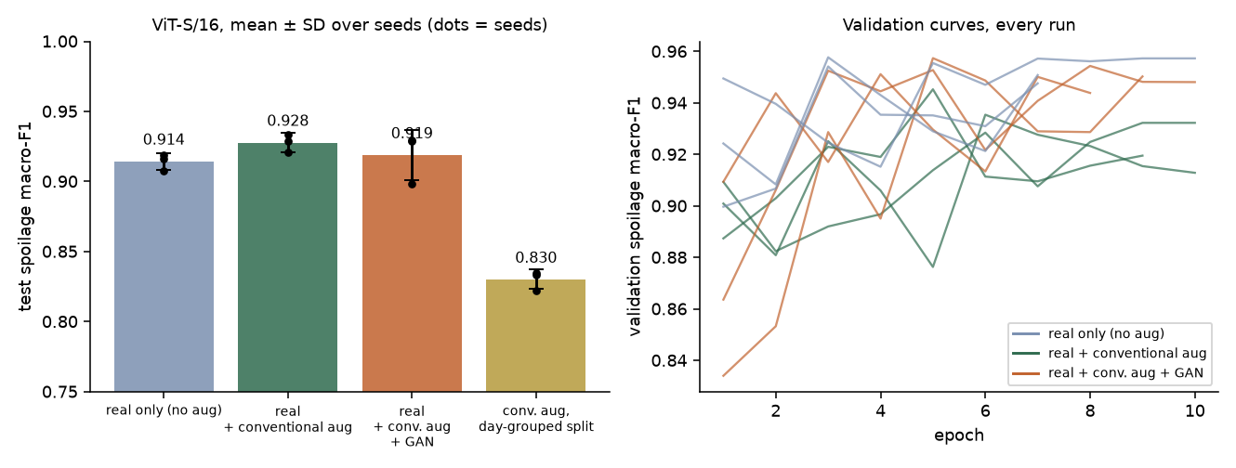
Figure 1. Test spoilage macro-F1 per condition (mean ± SD, dots = seeds) and validation curves of every run.
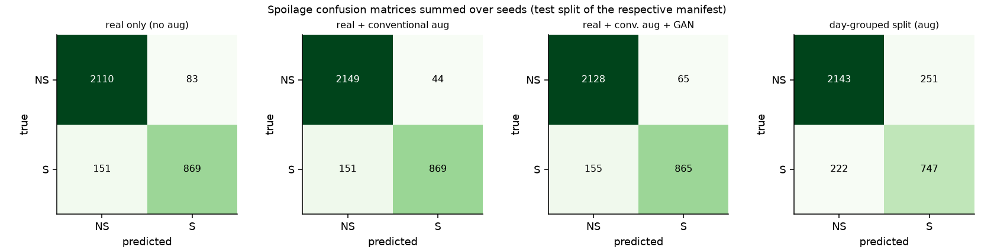
Figure 2. Spoilage confusion matrices summed over seeds.
Finding (AB2): conventional augmentation changed test spoilage macro-F1 by +0.013 (per seed: +0.010, +0.004, +0.026). The direction is consistent across seeds. Finding (AB3): see Document A — GAN images are mostly not recognisable as their intended class, and any change is within seed variation unless stated otherwise.

5 Superseded single-seed runs (v1)
Table 5. v1 ablation runs (lr 5e-5, seed 42).
Run | Epochs | Best epoch (val) | Best val spoil mF1 | Test spoil mF1 | Note
vit_s16_noaug | 10 | 6 | 0.954 | 0.926
vit_s16_aug | 5 | 1 | 0.934 | 0.879 | unstable: best validation at epoch 1
vit_s16_aug_gan | 10 | 9 | 0.962 | 0.937
vit_s16_aug_daysplit | 10 | 6 | 0.956 | 0.812

The v1 conventional-augmentation run peaked on validation at epoch 1 (val spoilage macro-F1 0.934) and oscillated afterwards; its test spoilage macro-F1 was 0.879. This instability (learning rate 2.5× the primary's) made v1 unsuitable for conclusions; v2 fixes the learning rate and adds seeds.

6 AB4 — Split design sensitivity
Why split design matters for TR-6: the dataset stores every Classified image twice (byte-identical copy in Normal), each capture session has 17 near-identical views of one fruit, and spoilage labels follow capture date. Leakage was measured directly for four split schemes without training any model:
Table 6. Measured leakage of test items into training for different split schemes.
Split scheme | Test items | Exact byte duplicate in train | Same capture session in train | Same produce & day in train
random split of raw sRGB files (Classified + Normal copies), seed 42 | 2088 | 59.8% | 100.0% | 100.0%
random split of de-duplicated contents (no grouping), seed 42 | 1045 | 0.0% | 99.9% | 100.0%
session-grouped split v1 (used for all main results) | 1071 | 0.0% | 0.0% | 76.2%
day-grouped sensitivity split | 1121 | 0.0% | 0.0% | 1.5%
Source: data/split_leakage_comparison.csv
A random split of the raw files would put an exact copy of ~60% of test images into training and a near-identical view of every test image into training, so it would grossly over-estimate accuracy. The session-grouped split removes duplicate and same-session leakage but most test images still share a produce/day with training; the day-grouped split removes almost all of it.
Table 7. Day-grouped versus session-grouped split, identical configuration (ViT-S/16, conv. aug, lr 2e-5), seeds 42–44.
Split | Seeds | Train n | Test n | Spoil acc. | Spoil mF1 | Spoil AUC | Produce mF1
Session-grouped (v1) | 3 | 3177 | 1071 | 0.939 ± 0.005 | 0.928 ± 0.007 | 0.981 ± 0.003 | 1.000 ± 0.000
Day-grouped (sensitivity) | 3 | 3076 | 1121 | 0.859 ± 0.007 | 0.830 ± 0.007 | 0.909 ± 0.015 | 0.996 ± 0.006

Paired per-seed difference (day − session): -0.098 (per seed: -0.096, -0.086, -0.112). Note the two splits have different test images, so this compares generalisation conditions rather than identical test sets.
Earlier single run (v1 configuration, lr 5e-5): day-grouped test spoilage macro-F1 0.812 vs 0.879 session-grouped (best validation 0.956 at epoch 6 — a large validation–test gap).

7 AB5 and AB6 — Noise robustness and denoising
Table 8. Test spoilage macro-F1 under deterministic corruptions (clean: 0.954).
Corruption | Level | No denoiser | Median 3×3 | DnCNN v1 | DnCNN v2
gaussian | 0.05 | 0.928 | 0.910 | 0.920 | 0.900
gaussian | 0.1 | 0.891 | 0.886 | 0.896 | 0.893
gaussian | 0.2 | 0.805 | 0.813 | 0.837 | 0.822
salt & pepper | 0.02 | 0.919 | 0.936 | 0.943 | 0.941
salt & pepper | 0.05 | 0.859 | 0.936 | 0.939 | 0.938
salt & pepper | 0.1 | 0.776 | 0.934 | 0.935 | 0.931
speckle | 0.1 | 0.917 | 0.901 | 0.921 | 0.904
speckle | 0.3 | 0.844 | 0.836 | 0.858 | 0.863
speckle | 0.5 | 0.800 | 0.788 | 0.799 | 0.827
Source: data/noise_robustness.csv
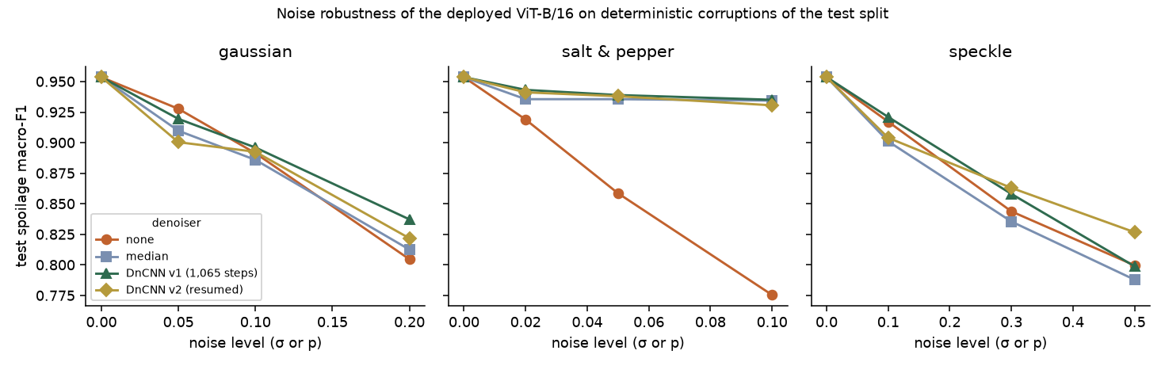
Figure 3. Spoilage macro-F1 versus noise level for each denoiser.
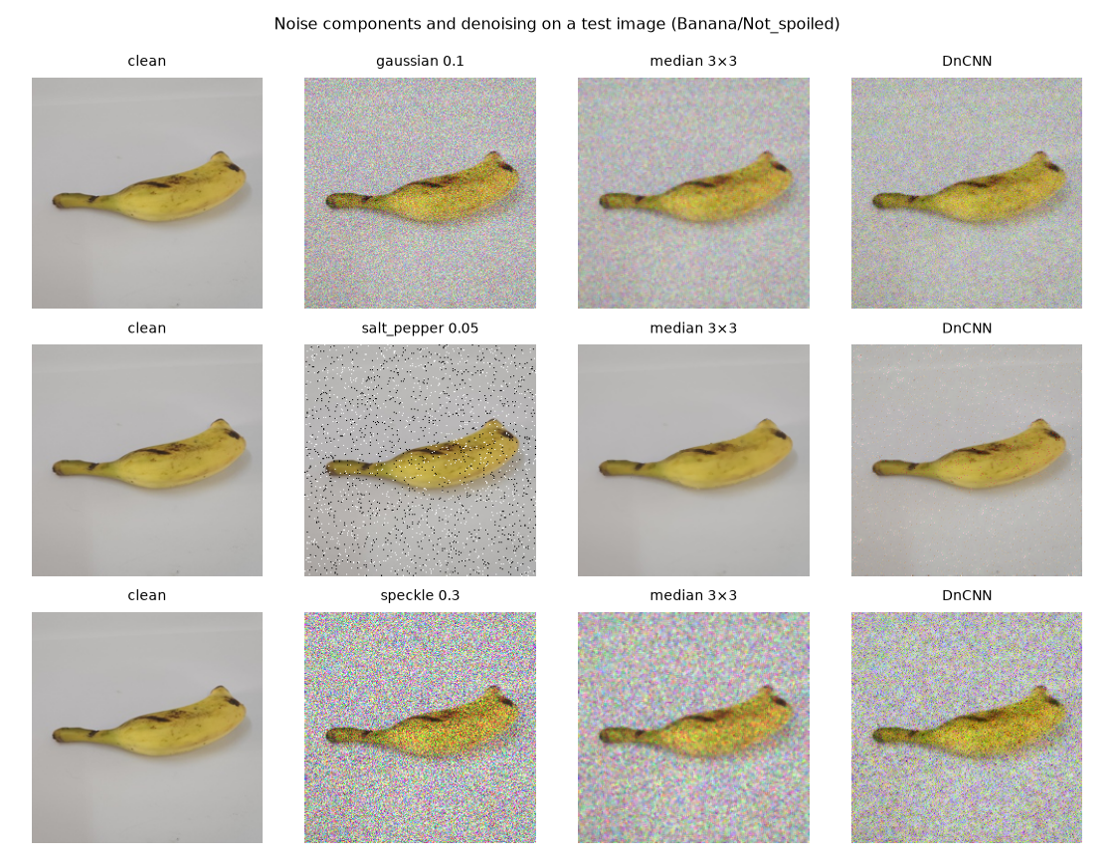
Figure 4. Example corruption and denoising outputs on one test image.
Table 9. Paired denoising quality on validation images (PSNR, dB; clean reference known).
Corruption | Level | Noisy | Median | DnCNN v1 | DnCNN v2
gaussian | 0.05 | 26.11 | 33.46 | 28.19 | 27.37
gaussian | 0.1 | 20.31 | 27.70 | 22.99 | 26.57
gaussian | 0.2 | 15.02 | 21.90 | 18.12 | 23.30
salt_pepper | 0.02 | 21.84 | 47.89 | 33.72 | 32.69
salt_pepper | 0.05 | 17.85 | 46.06 | 31.80 | 31.33
salt_pepper | 0.1 | 14.83 | 42.00 | 30.62 | 30.05
Source: artifacts/experiments/dncnn*/dncnn_results.json
Findings: spoilage is far more sensitive to noise than produce type (produce macro-F1 stays ≥ 0.964 in every condition). Salt-and-pepper noise is the most damaging without denoising but is almost fully repaired by a 3×3 median filter; Gaussian and speckle noise degrade performance smoothly and denoising helps little or hurts slightly at low noise. DnCNN v1 trained for only 1,065 steps and is worse than the median filter on PSNR in every condition; DnCNN v2 resumed training to 3,821 steps. The intrinsic noise of TR-6 photographs (σ ≈ 0.0032 at full resolution) is far below the tested levels (σ ≥ 0.05), so these are stress tests, not estimates of field performance.

8 AB7 — Backbone size (confounded)
ViT-S/16 with conventional augmentation (v2) reached 0.928 ± 0.007 test spoilage macro-F1; the deployed ViT-B/16 reached 0.954 (one seed). Learning rate, batch size and number of epochs also differ between the two (ViT-B: batch 16, 12 epochs), so this is not a clean single-factor ablation.

9 Conclusions
- Fine-tuning a pretrained ViT is the single most important factor (AB1).
- Conventional augmentation gave a small gain (+0.013 (per seed: +0.010, +0.004, +0.026)), positive on every seed; adding GAN images gave -0.009 (per seed: +0.000, +0.008, -0.035), not consistent across seeds, so no benefit of GAN augmentation is established (AB2/AB3).
- Split design dominates apparent performance: the day-grouped split lowers test spoilage macro-F1 by -0.098 (per seed: -0.096, -0.086, -0.112) at identical configuration (AB4); random splits would leak duplicates and are invalid.
- Robustness to strong noise is limited for spoilage; median filtering is a cheap, effective defence for impulse noise (AB5/AB6).

10 Limitations
- Three seeds per condition; confidence intervals are wide.
- One GAN seed.
- All results are on lab images of a small number of specimens.
- Backbone comparison is confounded.

